|  |  |  |  |
| --- | --- | --- | --- |
|  | United Nations | ECE/TRANS/WP.29/GRBP/2020/18 | |
| _unlogo | **Economic and Social Council** | | Distr.: General  24 June 2020  Original: English |

**Economic Commission for Europe**

Inland Transport Committee

**World Forum for Harmonization of Vehicle Regulations**

**Working Party on Noise and Tyres**

**Seventy-second session**

Geneva, 7–9 September 2020

Item 2 of the provisional agenda

**UN Regulation No. 41 (Noise emissions of motorcycles)**

Proposal for amendments to the 04 series of amendments to UN Regulation No. 41

Submitted by the experts from the International Motorcycle Manufacturers Association[[1]](#footnote-1)\*

The text reproduced below was prepared by the expert from the International Motorcycle Manufacturers Association (IMMA), in order to align the 04 series of amendments to UN Regulation No. 41 with standard ISO10844:2014. It is based upon UN Regulation No. 41 up to Supplement 7. The modifications to the Regulation are marked in bold for new or strikethrough for deleted characters.

I. Proposal

*Table of Contents, Annexes,* amend to read:

"4 ~~Specifications for the test site~~**Test track layout"**

*Paragraph 12.3.,* amend to read:

“12.3. Contracting Parties applying this Regulation shall not refuse to grant **type approvals in accordance with any of the preceding series of amendments to this regulation or** extensions **thereof.** ~~of approval in accordance with the preceding series of amendments to this Regulation which shall be conducted on the test site of Annex 4 or~~**. However, the specification of the test track may conform to** ISO10844:2014.”

*Annex 3,*

*Paragraph 1.2.1.*, amend to read:

"1.2.1. Test site

The test site shall consist of a central acceleration section surrounded by a substantially level test area. The acceleration section shall be level; its surface shall be dry and so designed that rolling noise remains low.

On the test site the variations in the free sound field between the sound source at the centre of the acceleration section and the microphone shall be maintained to within 1 dB(A). This condition will be deemed to be met if there are no large objects which reflect sound, such as fences, rocks, bridges or buildings, within 50 m of the centre of the acceleration section. The road surface covering of the test site shall conform ~~to the requirements of Annex 4 or~~ to ISO10844:2014.

The microphone shall not be obstructed in any way which could affect the sound field, and no person may stand between the microphone and the sound source. The observer carrying out the measurements shall take up position so as not to affect the readings of the measuring instrument."

*Annex 4,*

*Title,* amend to read:

“~~Specifications for the test site~~~~1~~ **Test track layout**”

*Footnote 1 to the title,* to be deleted.

*Footnote 2 to paragraph 1.,* to be deleted.

*Footnote 3 to paragraph 2.2.,* to be deleted.

*Paragraph 1., 2., and 2.1. to 2.5.,* to be deleted.

*Paragraphs 3., 3.1., 3.2., 3.2.1., 3.2.1.1. to 3.2.1.4., and 3.2.2.,* to be deleted.

*Figure 1*, amend to read:

Figure 1

**Test track layout with dimensions in meters**

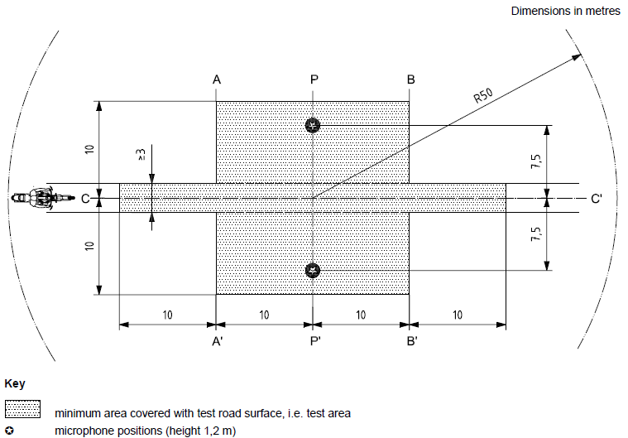

Key

|  |  |
| --- | --- |
|  | Minimum area covered with test road surface, i.e. test area |
|  | Microphone positions (height 1,2m) |

*Figure 2 and Table 1,* to be deleted.

*Paragraph 4., 4.1. to 4.3., 5. and 5.1. to 5.3.,* to be deleted.

*Paragraph 6., 6.1., 6.1.1. to 6.1.6., 6.1.6.1. to 6.1.6.7. and 6.2.,* to be deleted.

II. Justification

As from 20 January 2021, the specifications for the test site reproduced in Annex 4 will not be valid anymore but will be substituted by the provisions of ISO10844:2014.

The date of 20 January 2021 derives from 60 months after the entry into force of Supplement 3 to the 04 series of amendments, according to paragraph 12.9. below:

*"12.9. As from 60 months after the date of entry into force of Supplement 3 to the 04 series of amendments to this Regulation, Contracting Parties applying this Regulation shall grant type approvals only if the vehicles type to be approved meets the requirements of this Regulation as amended by Supplement 3 to the 04 series of amendments to this Regulation."*

This proposal aims to align the 04 series of amendments to UN regulation No. 41 with ISO 10844:2014, eliminating provisions which are carried over from ISO 10844:1998, except for Figure 1 of Annex 4 which is referred to as explanations of the test track layout.

IMMA would like to replace the current Figure 1 of Annex 4 with the one in higher resolution.

1. \* In accordance with the programme of work of the Inland Transport Committee for 2020 as outlined in proposed programme budget for 2020 (A/74/6 (part V sect. 20) para 20.37), the World Forum will develop, harmonize and update UN Regulations in order to enhance the performance of vehicles. The present document is submitted in conformity with that mandate. [↑](#footnote-ref-1)