|  |  |  |  |
| --- | --- | --- | --- |
|  | United Nations | ECE/TRANS/WP.29/2020/45 | |
| _unlogo | **Economic and Social Council** | | Distr.: General  19 December 2019  Original: English |

**Economic Commission for Europe**

Inland Transport Committee

**World Forum for Harmonization of Vehicle Regulations**

**180th session**

Geneva, 10–12 March 2020

Item 14.2.3 of the provisional agenda

**Consideration and vote by AC.3 of draft UN GTRs  
and/or draft amendments to established UN GTRs**

**Proposal for amendments to a UN GTR, if any**

Proposal for Amendment 3 to UN Global Technical Regulation No. 6 (Safety glazing))

Submitted by the experts from the Working Party on General Safety[[1]](#footnote-1)\*

The text reproduced below was adopted by the Working Party on General Safety (GRSG) at its 117th session (ECE/TRANS/WP.29/GRSG/96, para. 23). It is based on ECE/TRANS/WP.29/GRSG/2019/33 as amended by GRSG-177-43. It is submitted to the World Forum for Harmonization of Vehicle Regulations (WP.29) and to the Executive Committee (AC.3) of the 1998 Agreement for consideration at their March 2020 sessions.

Amendment 3 to UN Global Technical Regulation No. 6   
(Safety glazing))

Annex 7.1. paragraph 7.1.3.3., amend to read:

"7.1.3.3. Determination of the Test Areas for Category 1-2 and 2 Vehicles using the "O" Point.

7.1.3.3.1. The straight line OQ which is the horizontal straight line passing through the eye point “O” and perpendicular to the median longitudinal plane of the vehicle.

7.1.3.3.2. Zone I is the zone determined by the intersection of the windscreen with the four planes defined below:

In addition, opaque obscuration can be exempted in Zone I. It is the limited area~~s~~ where it is intended that a sensing device, e.g. a rain-drop detector, rear view mirror or autonomous sensors, will be bonded to the inner side of the windscreen. The opaque obscuration where such devices may be applied is defined in paragraph 7.1.3.3.3. of this annex.

P1 a vertical plane passing through point O and forming an angle of 15° to the left of the median longitudinal plane of the vehicle;

P2 a vertical plane symmetrical to P1 about the median longitudinal plane of the vehicle.

If this is not possible (in the absence of a symmetrical median longitudinal plane, for instance) P2 shall be the plane symmetrical to P1 about the longitudinal plane of the vehicle passing through point O.

P3 a plane passing through a transverse horizontal line containing O and forming an angle of 10° above the horizontal plane;

P4 a plane passing through a transverse horizontal line containing O and forming an angle of 8° below the horizontal plane;

**Figure 4  
Determination of Zone I**

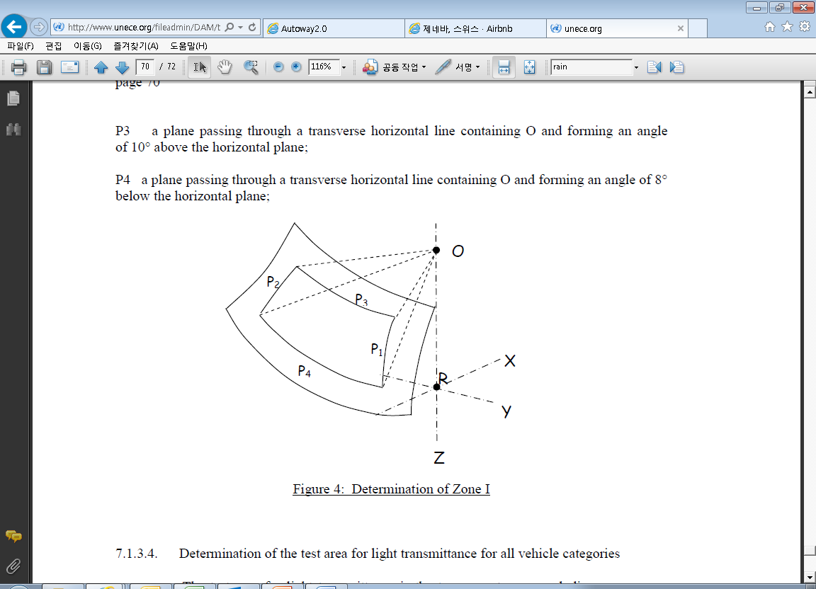

7.1.3.3.3. Determination of the opaque obscuration

P5 a plane passing through a transverse horizontal line containing O and forming an angle of 5° above the horizontal plane.

P6 a vertical plane passing through O and inclined at 20° to the right of the X axis in the case of left-hand drive vehicles and to the left of the X axis in the case of right-hand drive vehicles.

P7 a plane symmetrical to P6 in relation to the longitudinal median plane of the vehicle.

7.1.3.3.3.1. Any opaque obscuration bounded downwards by P5 and laterally by P6 and P7. (See Figure 4(a))

**Figure 4(a)  
Zone I (example of a left-hand steering control vehicle)**  
(Upper obscuration area as defined in paragraph 7.1.3.3.3.1.)

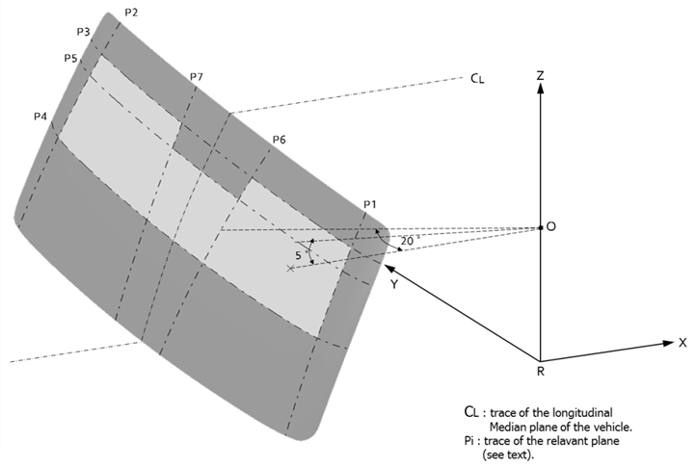"

1. \* In accordance with the programme of work of the Inland Transport Committee for 2020 as outlined in proposed programme budget for 2020 (A/74/6 (part V sect. 20) para 20.37), the World Forum will develop, harmonize and update UN Regulations in order to enhance the performance of vehicles. The present document is submitted in conformity with that mandate. [↑](#footnote-ref-1)