|  |  |  |  |
| --- | --- | --- | --- |
|  | United Nations | ECE/TRANS/WP.29/2020/28 | |
| _unlogo | **Economic and Social Council** | | Distr.: General  19 December 2019  Original: English |

**Economic Commission for Europe**

Inland Transport Committee

**World Forum for Harmonization of Vehicle Regulations**

**180th session**

Geneva, 10–12 March 2020

Item 4.8.17 of the provisional agenda

**1958 Agreement:  
Consideration of draft amendments to existing   
UN Regulations submitted by GRSG**

Proposal for 01 series of amendments to UN Regulation No. 62 (Anti-theft (mopeds/motorcycles))

Submitted by the experts from the Working Party on General Safety[[1]](#footnote-1)\*

The text reproduced below was adopted by the Working Party on General Safety (GRSG) at its 117th session (ECE/TRANS/WP.29/GRSG/96, para. 43). It is based on ECE/TRANS/WP.29/GRSG/2019/24. It is submitted to the World Forum for Harmonization of Vehicle Regulations (WP.29) and to the Administrative Committee (AC.1) for consideration at their March 2020 sessions.

01 series of amendments to UN Regulation No. 62 (Anti-theft (mopeds/motorcycles))

*Insert a new paragraph 5.12.,* to read:

"5.12. Electromagnetic compatibility

Electromechanical and electronic devices to prevent unauthorized use, where fitted, shall comply with the following requirements regarding electromagnetic compatibility.

Tests shall be performed according to the relevant technical prescriptions and transitional provisions of UN Regulation No. 10, 06 series of amendments and according to the immunity test methods described in Annex 6 and according to the emission test methods described in Annexes 4 and 5."

*Insert a new paragraph 12.,* to read:

"12. Transitional provisions

12.1. As from the official date of entry into force of the 01 series of amendments, no Contracting Party applying this Regulation shall refuse to grant or refuse to accept type approvals under this Regulation as amended by the 01 series of amendments.

12.2. As from 1 September 2022, Contracting Parties applying this Regulation shall not be obliged to accept type approvals to the preceding series of amendments, first issued after 1 September 2022.

12.3. Until 1 September 2024, Contracting Parties applying this Regulation shall accept type approvals to the preceding series of amendments, first issued before 1 September 2022.

12.4. As from 1 September 2024, Contracting Parties applying this Regulation shall not be obliged to accept type approvals issued to the preceding series of amendments to this Regulation."

*Annex 2,* amend to read:

"Annex 2

Arrangements of the approval marks

# Model A

(See paragraphs 4.1.4. and 4.2.4. of this Regulation)

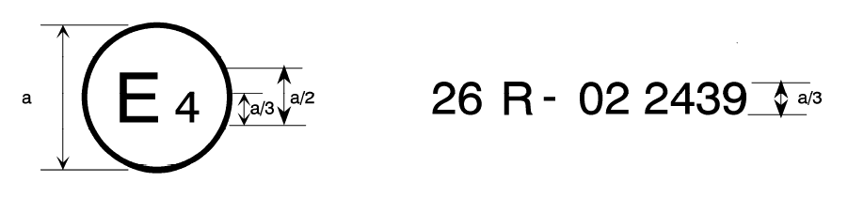

**62**

**011**

a= 8 mm min

The above approval mark affixed to a vehicle shows that the vehicle type concerned has been approved in the Netherlands (E 4) pursuant to Regulation No. 62 and under approval number 012439. The first two digits of the approval number indicate that, at the time of approval, Regulation No. 62 as amended by the 01 series of amendments.

# Model B

# (See paragraph 4.1.5. of this Regulation)

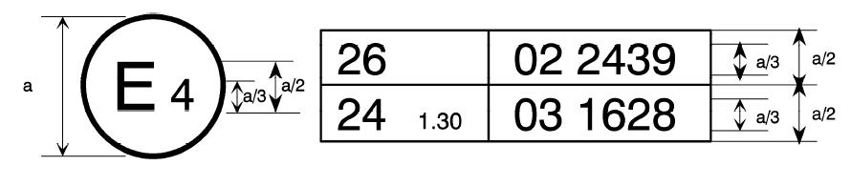

06 1628

10

62

01 2439

a= 8 mm min

The above approval mark affixed to a vehicle shows that the vehicle type concerned has been approved in the Netherlands (E 4) pursuant to Regulation No. 62and Regulation No. 10. The first two digits of the approval numbers indicate that, at the dates when the respective approvals were given, Regulation No. 62 included the 01 series of amendments, while Regulation No. 10 already included the 06 series of amendments."

1. \* In accordance with the programme of work of the Inland Transport Committee for 2020 as outlined in proposed programme budget for 2020 (A/74/6 (part V sect. 20) para 20.37), the World Forum will develop, harmonize and update UN Regulations in order to enhance the performance of vehicles. The present document is submitted in conformity with that mandate.. [↑](#footnote-ref-1)