|  |  |  |  |
| --- | --- | --- | --- |
|  | United Nations | ECE/TRANS/WP.29/2020/27 | |
| _unlogo | **Economic and Social Council** | | Distr.: General  19 December 2019  Original: English |

**Economic Commission for Europe**

Inland Transport Committee

**World Forum for Harmonization of Vehicle Regulations**

**180th session**

Geneva, 10–12 March 2020

Item 4.8.16 of the provisional agenda

**1958 Agreement:  
Consideration of draft amendments to existing   
UN Regulations submitted by GRSG**

Proposal for the 02 series of amendments to UN Regulation No. 55 (Mechanical couplings)

Submitted by the experts from the Working Party on General Safety[[1]](#footnote-1)\*

The text reproduced below was adopted by the Working Party on General Safety (GRSG) at its 117th session (ECE/TRANS/WP.29/GRSG/96, para. 38). It is based on ECE/TRANS/WP.29/GRSG/2019/6 as amended by GRSG-117-25. It is submitted to the World Forum for Harmonization of Vehicle Regulations (WP.29) and to the Administrative Committee (AC.1) for consideration at their March 2020 sessions.

**02 series of amendments to UN Regulation No 55 (Mechanical couplings)**

*Paragraph 13.*, amend to read:

"13. Transitional provisions

*After paragraph 13.,* insert new paragraphs 13.1. to 13.5.,to read:

13.1. As from the official date of entry into force of the 02 series of amendments, no Contracting Party applying this Regulation shall refuse to grant or refuse to accept type approvals under this Regulation as amended by the 02 series of amendments.

13.2. As from 1 September 2021, Contracting Parties applying this Regulation shall not be obliged to accept type approvals issued to the preceding series of amendments to this Regulation.

13.3. Notwithstanding paragraph 13.2., Contracting Parties applying this Regulation shall continue to accept type approvals of mechanical coupling devices and components issued according to the preceding series of amendments to this Regulation.

13.4. Notwithstanding paragraph 13.2., Contracting Parties applying this Regulation shall continue to accept type approvals issued according to the preceding series of amendments to this Regulation, for the vehicles which are not affected by the changes introduced by the 02 series of amendments.

13.5. Contracting Parties applying this Regulation shall not refuse to grant type approvals according to any preceding series of amendments to this Regulation or extensions thereof."

*Annex 3*, amend to read:

"Annex 3

Example of an arrangement of the approval mark

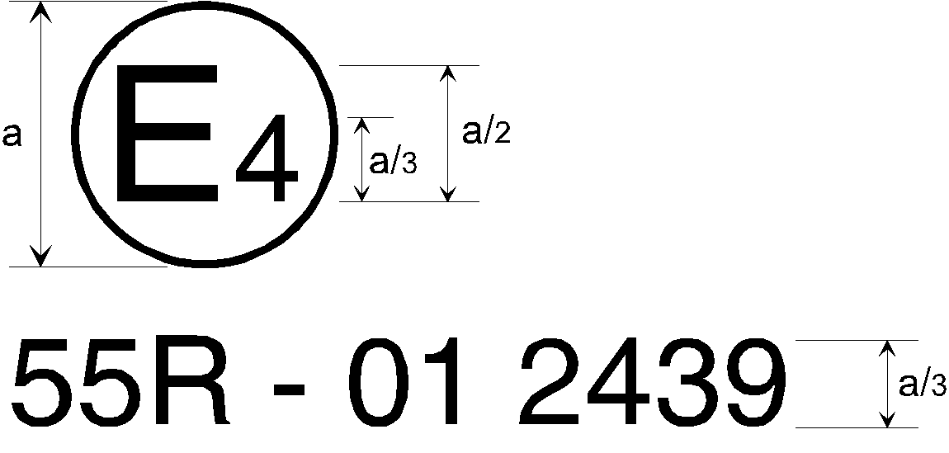

2

a = 8 mm minimum

The mechanical coupling device or component or vehicle bearing the approval mark shown above is a device or component approved in the Netherlands (E 4), under approval number 2439, meeting the requirements of the 02 series of amendments to this Regulation.

*Note:* The approval number and additional symbols shall be placed close to the circle and either above or below the letter "E", or to the right or left of that letter. The digits of the approval number shall be on the same side of the letter "E" and face in the same direction. The use of Roman numerals as approval numbers should be avoided so as to prevent any confusion with other symbols."

*Annex 7, paragraph 1.1.4.*, amend to read:

"1.1.4. When the trailer …… release key which is supplied by the manufacturer. In such a case, the motor-vehicle's user instructions (e.g. owner's manual, vehicle handbook) shall clearly specify that the removable or repositionable mechanical coupling device shall always be removed or repositioned when it is not in use.

If the installed…"

1. \* In accordance with the programme of work of the Inland Transport Committee for 2020 as outlined in proposed programme budget for 2020 (A/74/6 (part V sect. 20) para 20.37), the World Forum will develop, harmonize and update UN Regulations in order to enhance the performance of vehicles. The present document is submitted in conformity with that mandate.. [↑](#footnote-ref-1)