|  |  |  |  |
| --- | --- | --- | --- |
|  | United Nations | ECE/TRANS/WP.29/2020/57 | |
| _unlogo | **Economic and Social Council** | | Distr.: General  2 April 2020  Original: English |

**Economic Commission for Europe**

Inland Transport Committee

**World Forum for Harmonization of Vehicle Regulations**

**181st session**

Geneva, 23-25 June 2020

Item 4.6.8 of the provisional agenda

**1958 Agreement:  
Consideration of draft amendments to existing   
UN Regulations submitted by GRSP**

Proposal for Supplement 6 to the 02 series of amendments to UN Regulation No. 129 (Enhanced Child Restraint Systems)

Submitted by the Working Party on Passive Safety [[1]](#footnote-2)\*

The text reproduced below was adopted by the Working Party on Passive Safety (GRSP) at its sixty-fifth session (ECE/TRANS/WP.29/GRSP/66, para. 40). ECE/TRANS/WP.29/GRSP/2019/34, as amended by Annex VIII to the report. It is submitted to the World Forum for Harmonization of Vehicle Regulations (WP.29) and to the Administrative Committee (AC.1) for consideration at their June 2020 sessions.

*Paragraph 6.3.1.1*., amend to read:

"6.3.1.1. The Enhanced Child Restraint System manufacturer shall declare in writing that the toxicity of materials used in the manufacture of restraint systems and accessible to the restrained child is in conformity with the test requirements of EN 71-3:2019, for a Category III material as defined in paragraph 4.2. Table 2 and following the test method of paragraph 7.2., specifically paragraph 7.2.2., Table 3, Category III sampling method. Tests confirming the validity of the declaration may be carried out at the discretion of the Technical Service."

*Paragraph 6.3.2.,* amend to read:

"6.3.2. General characteristics

The manufacturer shall declare the maximum and minimum stature of the child that may use each configuration of the Enhanced Child Restraint System.

The stature range shall be verified by measuring the internal geometric characteristics according to paragraph 6.3.2.1., while the external dimensions are adjusted to fit within the applicable size envelope according to paragraph 6.3.2.2."

*Paragraph 6.3.2.2.2.,* amend to read:

"6.3.2.2.2. Non-Integral Class Enhanced Child Restraint Systems

The maximum external dimensions for the width, height and depth of the Enhanced Child Restraint System and the locations of the ISOFIX anchorages system if any, with which its attachments shall engage, shall be defined by the i-Size booster seat fixture as defined in paragraph 2.17.2. of this Regulation.

(a) i-Size booster seat Enhanced Child Restraint Systems shall fit within the ISO/B2 size envelope;

(b) Specific vehicle booster seat Enhanced Child Restraint Systems shall fit:

(i) In vehicle(s) specified in a list; or

(ii) At least in one of ISO/B2 –ISO/B3 size envelope as described in Annex 17, Appendix 5 of UN Regulation No. 16.

When conducting this assessment, the non-integral Enhanced Child Restraint System shall be adjusted to accommodate children of 135 cm stature (height, depth and width dimensions as defined in Annex 18) or to the largest size of its declared stature range if the upper limit is below 135 cm. If the Non-integral Enhanced Child Restraint System is capable of being adjusted to different positions of seat surface inclination, the fitting assessment shall be done in at least one position. If other positions of inclination are outside the limits of the applicable size envelope, the user manual shall indicate that the child restraint may not fit in all approved vehicles when used in one of these positions. If the Non-integral Enhanced Child Restraint System has a declared stature range above 135 cm, and if it is necessary to adjust the child restraint outside the limits of the applicable size envelope for such adjustments (height, depth and width dimensions), the user manual shall indicate that the child restraint may not fit in all approved vehicles when used in one of these positions.

In such cases, an Enhanced Child Restraint System shall still be categorised as an i-Size booster seat for the entire declared stature range, including statures above 135 cm, provided it fits within the applicable size envelope when adjusted for a child of 135 cm stature. If the maximum child stature that fits within the envelope is less than 135 cm, the booster seat shall be categorised as specific vehicle for statures included in the declared range that no longer fit within the envelope."

*Paragraph 6.6.4.3.1.,* amendto read:

"6.6.4.3.1. Injury assessment criteria for frontal and …

| *...* | *...* | *...* | *...* | *...* | *...* | *...* | *...* | *...* |
| --- | --- | --- | --- | --- | --- | --- | --- | --- |
| *...* | *...* |  | *...* | *...* | *...* | *...* | *...* | *...* |
| Resultant head acceleration  3 ms | *...* | *...* | *...* | *...* | *...* | *...* | *...* | *...* |
| *...* | *...* | *...* | *...* | | | | |  |
| *...* | *...* | *...* |  | | | | |  |
| Resultant chest acceleration 3 ms | *...* | *...* | *...* | *...* | *...* | *...* | *...* | *...* |
| *...* | *...* | *...* | *...* | *...* | | | | |
| *...* | *...* | *...* | *...* | *...* | *...* | *...* | *...* | *...* |

*…*"

*Paragraph 6.6.4.4.2.,* amend to read:

"6.6.4.4.2. When Enhanced Child Restraint Systems …, the head performance criterion (HPC) and the resultant head acceleration 3 ms shall be ... "

Amend *Paragraph 6.6.4.5.2.* to read:

" 6.6.4.5.2. Additional injury assessment criteria for lateral impact

# …

| *...* | *...* | *...* | *...* | *...* | *...* | *...* | *...* | *...* |
| --- | --- | --- | --- | --- | --- | --- | --- | --- |
| *...* | *...* |  | *...* | *...* | *...* | *...* | *...* | *...* |
| Resultant head acceleration  3 ms | *...* | *...* | *...* | *...* | *...* | *...* | *...* |
| *...* | *...* | *...* | *...* | | | | | |
| *...* | *...* | *...* | *...* | | | | | |

*...* "

*Paragraph 8.1.,* amendto read:

" 8.1. The test report shall record the results of all tests and measurements including the following test data:

(a) …

…

(i) The following dummy criteria: HPC, Resultant head acceleration Cum 3 ms, Upper neck tension force, Upper neck moment, Resultant chest acceleration Cum 3 ms, Chest deflection, Abdominal pressure (in frontal and rear impact), and …"

*Paragraph 9.2.2.,* amendto read:

"9.2.2. Dynamic tests for lateral impact

The monitoring of resultant head acceleration ... "

*Annex 6-Appendix 2*

*Paragraph 2.,* amend to read:

"2. Enhanced Child Restraint Systems in the i-Size and specific vehicle categories shall use the following anchorage points: H1 and H2."

*Annex 18,* amend to read:

"Annex 18

Geometrical dimensions of Enhanced Child Restraint Systems

…

Table 1

|  |  |  |  |  |  |  |  |
| --- | --- | --- | --- | --- | --- | --- | --- |
| *Applicable to all ECRS* | | | | | |  | *Additional internal dimensions for ECRS with impact shield systems* |
| … | … | … | … | … | … | … |  |

Figure 2 **ECRS Measurement Device - Side and Front View of the measuring device**

*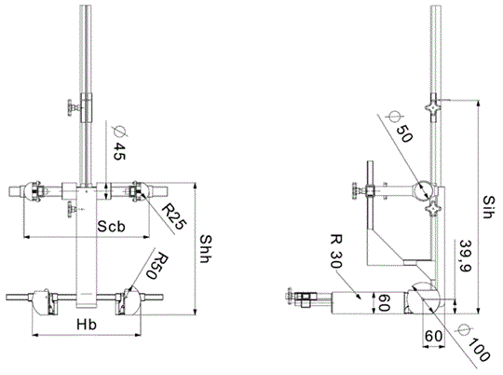*

All dimensions in mm

Figure 3 **Side and Front View of the measuring device for measurements applicable to Enhanced Child Restraint Systems that feature an impact shield**

|  |  |
| --- | --- |
|  |  |

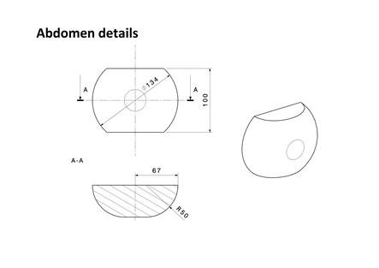

All dimensions in mm

Internal geometry assessment method

This method describes how to conduct the internal geometry assessment, as required by paragraph 6.3.2.1., to verify the stature range of the Enhanced Child Restraint System declared by the manufacturer.

This assessment shall be carried out for each of the following:

(a) For each ECRS orientation (e.g. rearward and forward facing);

(b) For each ECRS type (e.g. integral and non-integral);

(c) For any removable insert (e.g. for use as described by manufacturer’s instructions);

(d) For each occupant restraint method (e.g. harness and shield).

The internal geometry assessment should be conducted with the ECRS placed on a flat surface or connected to a base in the case of ECRS modules.

For integral or non-integral ECRS the device shown in Annex 18, Figure 2 shall be used.

For ECRS with an impact shield the device shown in Annex 18, Figure 3 shall be used.

The mass of the devices described in Figure 2 and Figure 3 shall be 10 kg +/- 1 kg.

1. Determining the Minimum Occupant size

The ECRS should be adjusted to fit the smallest occupant (i.e. headrest height, harness height adjustment, appropriate insert, internal padding, impact shield position), while still fitting within the required ISO volumetric envelope as defined in paragraph 6.3.2.2.

The measurement device shall then be placed in the ECRS. The device shall be aligned centrally to the ECRS.

All measurements shall be taken with the device base in contact with the seat pan of the ECRS and the device backrest in contact with the backrest of the ECRS. All lateral dimensions shall be measured under a contact force of 50 N with the devices described in Figure 2 and Figure 3 of this annex.

The measurements shall be taken in the following order:

1.1. Minimum Shoulder Height (E1)

…

1.1.2. For non-integral ECRS

This measurement shall be taken when the top of the shoulder height cylinders of the device are aligned without interference with the lowest part of the headrest. A 2 cm tolerance may be subtracted from the minimum shoulder height measurement.

1.1.3. For ECRS with an impact shield

This measurement shall be taken when the top of the shoulder height cylinders of the device are aligned without interference with the lowest part of the headrest. A 2 cm tolerance may be subtracted from the minimum shoulder height measurement.

…

2. Determining the Maximum Occupant Size

The measurement … to the ECRS.

All measurements shall be taken with the device base in contact with the seat pan of the ECRS and the device backrest in contact with the backrest of the ECRS. All lateral dimensions shall be measured under a contact force of 50 N with the devices described in Figure 2 and Figure 3 of this annex.

The measurements shall then be taken in the following order:

…"

*Annex 24*

*Paragraph 3,* amend to read:

"3. The retracting belt shall be fitted to the anchorages on the test bench, described in Annex 6, Appendix 2 as follows:

(a) Belt anchorage A1 shall be fitted to trolley anchorages B0 (outboard);

(b) Belt anchorage A2 shall be fitted to trolley anchorage A (inboard);

(c) Belt pillar loop P shall be fitted to trolley anchorage C;

(d) Belt retractor R shall be fitted to trolley anchorage such that the spool centre line is positioned on Re.

The value of X in Figure 1 below is 200 ± 5 mm. The effective strap length between A1 and the centre line of the retractor spool Re (when the webbing is fully extracted including the minimum length of 150 mm for testing of Enhanced Child Restraint System**)** shall be 2,820 ± 5 mm when measured in a straight line without load and on a horizontal surface. With the Enhanced Child Restraint System installed, there shall be a minimum of 150 mm of strap length on the retractor spool."

1. \* In accordance with the programme of work of the Inland Transport Committee for 2020 as outlined in proposed programme budget for 2020 (A/74/6 (part V sect. 20) para 20.37), the World Forum will develop, harmonize and update UN Regulations in order to enhance the performance of vehicles. The present document is submitted in conformity with that mandate. [↑](#footnote-ref-2)