|  |  |  |  |
| --- | --- | --- | --- |
|  | United Nations | ECE/TRANS/WP.29/2020/53 | |
| _unlogo | **Economic and Social Council** | | Distr.: General  2 April 2020  Original: English |

**Economic Commission for Europe**

Inland Transport Committee

**World Forum for Harmonization of Vehicle Regulations**

**181st session**

Geneva, 23-25 June 2020

Item 4.6.4 of the provisional agenda

**1958 Agreement:  
Consideration of draft amendments to existing   
UN Regulations submitted by GRSP**

Proposal Supplement 18 to the 04 series of amendments to UN Regulation No. 44 (Child restraint systems)

Submitted by the Working Party on Passive Safety [[1]](#footnote-2)\*

The text reproduced below was adopted by the Working Party on Passive Safety (GRSP) at its sixty-fifth session (ECE/TRANS/WP.29/GRSP/66, para. 26). It is based on ECE/TRANS/WP.29/GRSP/2019/23 as amended by Annex V to the report and ECE/TRANS/WP.29/GRSP/2019/28. It is submitted to the World Forum for Harmonization of Vehicle Regulations (WP.29) and to the Administrative Committee (AC.1) for consideration at their June 2020 sessions.

*Insert a new paragraph 1.2.*, to read:

"1.2. This Regulation explicitly forbids child restraint systems in the form of belt guides and other sitting devices that are dangerous and can harm children in the event of a vehicle collision, irrespective of any test results obtained in accordance with paragraph 8.

In particular, it concerns belt guides and sitting devices meant for children of a mass from 15 kg to 36 kg that connect to or attach onto the lap belt portion as well as the torso belt portion of a 3-point adult safety belt system with the aim to alter the adult safety belt routing by for example pulling down the torso belt portion or squeezing together the torso belt portion and lap belt portion. Examples of such non-compliant devices are shown below.

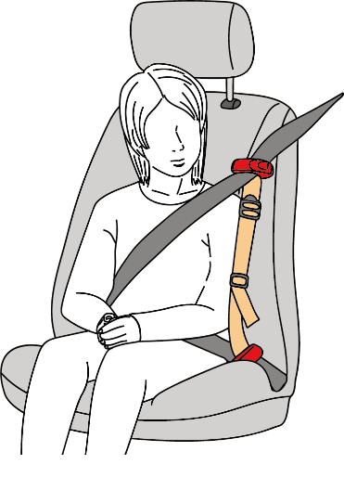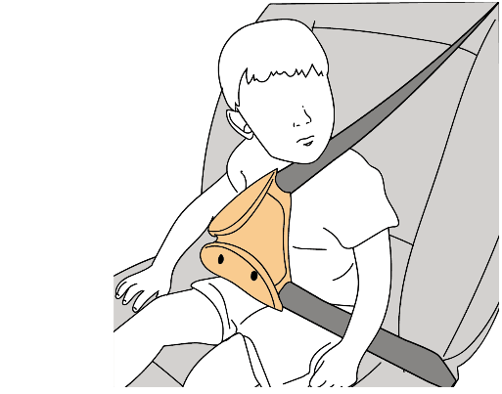

It also concerns sitting devices that are unusable by a child unless they are properly inflated or other compact sitting devices that attempt to guide the lap belt portion by keeping it down or forward, just above the seat cushion, rather than to significantly elevate the child in relation to the vehicle’s normal seating position and the corresponding adult safety belt effective lower anchorages."

*Paragraph 6.1.3.*, amend to read:

"6.1.3. According to the category which it belongs to, the child restraint shall be secured to the vehicle structure or to the seat structure.

# **Possible configurations for approval Groups / categories table**

| *Group category* | | *Universal (1)* | | *Semi-universal (2)* | | *Restricted* | | *Specific vehicle* | |
| --- | --- | --- | --- | --- | --- | --- | --- | --- | --- |
| *CRS* | *ISOFIXCRS* | *CRS* | *ISOFIXCRS* | *CRS* | *ISOFIXCRS* | *CRS* | *ISOFIXCRS* |
| 0 | Carry-cot | A(3) | NA | A(3) | A(3) | A(3) | NA | A(3) | A(3) |
|  |  |  |  |  |  |  |  |  |
| Rearward facing | A(3) | NA | A(3) | A (3) | A(3) | NA | A(3) | A(3) |
| 0+ | Rearward facing | A(3) | NA | A(3) | A(3) | A(3) | NA | A(3) | A(3) |
| I | Rearward facing | A(3) | NA | A(3) | A(3) | A(3) | NA | A(3) | A(3) |
| Forward facing (integral) | A(3) | A(3) | A(3) | A(3) | A(3) | NA | A(3) | A(3) |
| Forward facing (non-integral) | NA | NA | NA | NA | NA | NA | NA | NA |
| Forward facing (non-integral – see paragraph 6.1.12.) | A(3) | NA | A(3) | NA | A(3) | NA | A(3) | A(3) |
| II | Rearward facing | A(3) | NA | A(3) | NA | A(3) | NA | A(3) | A(3) |
| Forward facing (integral) | A(3) | NA | A(3) | NA | A(3) | NA | A(3) | A(3) |
| Forward facing  (non-integral) | A(3) | NA | A(3) | NA | A(3) | NA | A(3) | A(3) |
| III | Rearward facing | A(3) | NA | A(3) | NA | A(3) | NA | A(3) | A(3) |
| Forward facing (integral) | A(3) | NA | A(3) | NA | A(3) | NA | A(3) | A(3) |
| Forward facing  (non-integral) | A(3) | NA | A(3) | NA | A(3) | NA | A(3) | A(3) |
| *With:*  CRS: Child restraint system  A: Applicable  NA: Not Applicable  \_\_\_\_\_\_\_\_\_\_\_\_\_\_\_\_\_\_\_\_\_\_  (1) ISOFIX universal CRS means forward facing restraints for use in vehicles with positions equipped with ISOFIX anchorages system and a top tether anchorage.  (2) ISOFIX semi universal CRS means:  • Forward facing restraints equipped with support leg or  • Rearward facing restraints equipped with a support leg or a top tether strap for use in vehicles with positions equipped with ISOFIX anchorages system and a top tether anchorage if needed  • Or rearward facing restraints, supported by the vehicle dashboard, for use in the front passenger seat equipped with ISOFIX anchorages system,  • Or lateral facing position restraint equipped if needed with an anti-rotation device for use in vehicles with positions equipped with ISOFIX anchorages system and top tether anchorage if needed.  …  (3)New approvals and extensions will be granted in accordance with paragraphs 17.16 to 17.23. | | | | | | | | | |

"

*Amend paragraph 17.15.*, to read:

"17.15. As from the official date of entry into force of Supplement 18 to the 04 series of Amendments of this Regulation, Contracting Parties applying this Regulation may prohibit the placing on the market of non-compliant devices and child restraint systems which do not meet the requirements of the 04 series of Amendments of this Regulation."

*Insert new paragraphs 17.22. to 17.25.*, to read:

"17.22. As from 1 September 2021, Contracting Parties applying this Regulation shall not be obliged to accept type approvals issued according to this Regulation, first issued after 1 September 2021.

17.23. Until 1 September 2023, Contracting Parties applying this Regulation shall accept type approvals issued according to the 04 series of amendments to this Regulation, first issued before 1 September 2021.

17.24. As from 1 September 2023, Contracting Parties applying this Regulation shall not be obliged to accept type approvals issued in accordance with this Regulation.

17.25. Notwithstanding paragraph 17.24., Contracting Parties applying this Regulation shall continue to accept type approvals of vehicle specific "built in" or specific vehicle "built in" child restraint systems issued according to the 04 series of amendments to this Regulation."

1. \* In accordance with the programme of work of the Inland Transport Committee for 2020 as outlined in proposed programme budget for 2020 (A/74/6 (part V sect. 20) para 20.37), the World Forum will develop, harmonize and update UN Regulations in order to enhance the performance of vehicles. The present document is submitted in conformity with that mandate. [↑](#footnote-ref-2)