|  |  |  |  |
| --- | --- | --- | --- |
|  | United Nations | ECE/TRANS/WP.29/AC.3/55 | |
| _unlogo | **Economic and Social Council** | | Distr.: General  31 December 2019  Original: English |

**Economic Commission for Europe**

Inland Transport Committee

**World Forum for Harmonization of Vehicle Regulations**

**180th session**

Geneva, 10-12 March 2019

Item 18.6 of the provisional agenda

**Progress on the development of new UN GTRs   
and of amendments to established UN GTRs:**

**UN GTR No. 6 (Safety Glazing)**

Authorization to develop an amendment  
to UN Global Technical Regulation No. 6 (Safety Glazing)

Submitted by the representative from Republic of Korea[[1]](#footnote-2)\*

The text reproduced below was submitted by the representative of Republic of Korea to adapt the UN Global Technical Regulation (UN GTR) No. 6 to the technical progress. It was adopted by the Executive Committee (AC.3) of the 1998 Agreement at its November 2019 session (ECE/TRANS/WP.29/1149, para. 136). It is based on ECE/TRANS/WP.29/2019/123. This authorization is transmitted to the Working Party on General Safety Provisions (GRSG). This document, if adopted, shall be appended to the UN GTR in accordance with the provisions of paragraphs 6.3.4.2., 6.3.7. and 6.4. of the 1998 Agreement.

Request for authorization to develop an amendment to global technical regulation No. 6 (Safety Glazing)

A. Objective

1. The objective of this proposal is to develop, in the framework of the 1998 Agreement, an amendment to UN Global Technical Regulation (UN GTR) No. 6 on Safety Glazing to exempt in Zone I the possible opaque obscuration in the test area on the windscreen of Category 1-2 and 2 vehicles which is used for installation of those devices such as rain-drop sensor, inside mirror or autonomous vehicle sensors, etc.

B. Background

2. In the 116th session of the Working Party on General Safety Provisions (GRSG)  
(1-5 April 2019), the expert from Republic of Korea introduced GRSG-116-30 and   
GRSG-116-31 on the need to exempt in Zone I the possible opaque obscuration which is defined in paragraph 7.1.3.2.4. of the annexes 7.1. The expert from Germany principly agreed the proposed amendments, adding that the opaque obscuration had to be clearly defined. The expert from Finland affirmed the necessity for similar amendments in UN Regulation No. 43.

C. Subject of amendment

3. The amendment to UN GTR No. 6 shall include:

(a) Amendment of Part A - Statement of technical rationale and justification;

(b) Amendment of Part B - Text of the global technical regulation, in particular:

(i) Amendment of text in clauses 7.1.3.3.2. to exempt in Zone I the possible opaque obscuration in the test area on the windscreen of Category 1-2 and 2 vehicles which is defined in paragraph 7.1.3.2.4. of Annex 7.1.

(ii) Annex 7.1. “Procedures for determining test areas on windscreens of Category 1-1 vehicles in relation to the "V" Points and Category 1-2 and 2 vehicles in relation to the "O" point.”

(iii) Para. 7.1.3.2. Determination of two test areas for Category 1-1 vehicles using the "V" points

(iv) Para. 7.1.3.3. Determination of the Test Areas for Category 1-2 and 2 Vehicles using the "O" Point

(v) Para. 7.1.3.3.2. Zone I is the zone determined by the intersection of the windscreen with the four planes defined below:

In addition, opaque obscuration can be exempted in Zone I. It is the limited areas where it is intended that a sensing device, e.g. a rain-drop detector, rear view mirror or autonomous vehicle sensors, will be bonded to the inner side of the windscreen. The opaque obscuration where such devices may be applied is defined in paragraph 7.1.3.2.4.(Figure 2(a) or Figure 2(b)) of this annex.

P1 a vertical plane passing through 0 and forming an angle of 15° to the left of the median longitudinal plane of the vehicle;

P2 a vertical plane symmetrical to P1 about the median longitudinal plane of the vehicle.

If this is not possible (in the absence of a symmetrical median longitudinal plane, for instance) P2 shall be the plane symmetrical to P1 about the longitudinal plane of the vehicle passing through point O.

P3 a plane passing through a transverse horizontal line containing O and forming an angle of 10° above the horizontal plane;

P4 a plane passing through a transverse horizontal line containing O and forming an angle of 8° below the horizontal plane;

Figure 4  
**Determination of Zone 1**

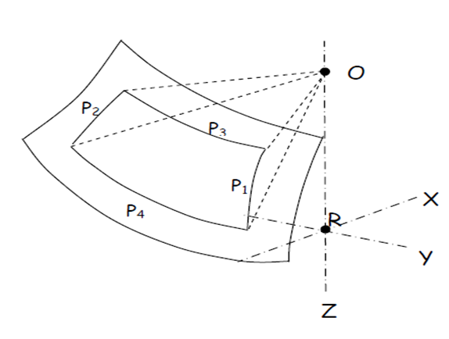

(c) Any further refinements or corrections as deemed appropriate.

D. Organization of process and timeline

4. The proposal will be drafted by the experts from Republic of Korea. The amendments to the proposal will be developed in cooperation with all interested GRSG experts. The meetings of interested experts are not planned, but will be organized, if necessary.

5. The proposed action plan:

(a) October 2019: Consideration of the proposal (working document) at the 117th GRSG session;

(b) April 2020: Consideration of the final proposal and its possible adoption at the 118th GRSG session;

(c) November 2020: Adoption of the proposal by AC.3, if no remaining issues had existed.

6. The progress of works will be reported to AC.3 at its November 2019 March, and June 2020 sessions.

1. \* In accordance with the programme of work of the Inland Transport Committee for 2020 as outlined in proposed programme budget for 2020 (A/74/6 (part V sect. 20) para 20.37), the World Forum will develop, harmonize and update UN Regulations in order to enhance the performance of vehicles. The present document is submitted in conformity with that mandate. [↑](#footnote-ref-2)