|  |  |  |  |
| --- | --- | --- | --- |
|  | United Nations | ECE/TRANS/WP.11/2020/14 | |
| _unlogo | **Economic and Social Council** | | Distr.: General  27 July 2020  Original: English |

**Economic Commission for Europe**

Inland Transport Committee

**Working Party on the Transport of Perishable Foodstuffs**

**Seventy-sixth session**

Geneva, 13-16 October 2020

Item 6 (b) of the provisional agenda

**Proposals of amendments to ATP:**

**new proposals**

Proposals for amendment of the ATP by the informal working group on the improvement of the approval system of ATP equipment and thermal appliances

Transmitted by the Government of the Netherlands on behalf of the informal working group

|  |
| --- |
| *Summary* |
| **Executive summary**: The informal working group meet several times between sessions of the WP.11 to discuss issues that would hinder the approval of equipment. In this document proposals for amendment are given by the working group for approval. A report of the working group describing discussions and justifications for the amendment will follow as an informal document. |
| **Decision to be taken:** Approval of proposals |
| **Related documents:** ECE/TRANS/WP.11/2019/16 |
|  |

Introduction

1. The informal working group met 5 times between the beginning of May and July 2020 by video conferencing to discuss pending issues of the report of the working group in document ECE/TRANS/WP.11/2019/16 as discussed in the October 2019 session of WP.11, documents ECE/TRANS/WP.11/2019/2 and ECE/TRANS/WP.11/2019/3 and issues concerning the approval of Multi Temperature - Multi Compartment equipment.

2. A report of the informal working group, giving details of the discussions in the group and justifications for the proposals in this document, will be provided as an informal document.

Proposals for amendment of the ATP by the Informal Working Group.

Proposal 1 – Date of construction/manufacture

Annex 1, Appendix 2, section 8

3. For Model reports 1A&B amend the text “Date of construction” to read “Date of construction (month/year)

4. For Model reports 4A to 4C, 5, 6, 7, 8, 9, 10, 11 amend the text “Year of manufacture” to read “Date manufacture (month/year).

5. For Model test report No 12 amend the text “Date of manufacture” to read “Date of manufacture month/year).

Proposal 2 – Consistency of wording - English version only

Annex 1, Appendix 2 section 8 Model No. 12

6. Replace “Self-contained/not self-contained” by “Drive independent/dependent”.

Proposal 3 – Definitions

Annex 1

7. Introduce a new section 7 with the heading “Definitions”.

8. Introduce the following new definition alphabetical order (depending on language):

*Equipment means* an assembly of parts forming an insulated body and its supportive structure needed for carriage on road and rail. Thermal appliances may be part of the assembly.

*Heating appliance means* a thermal appliance that generates thermal energy to increase(heat) the temperature inside.

*Mechanically heated and refrigerated appliance means* a mechanical refrigerating appliance that is able to decrease(cool) or increase(heat) the temperature inside the equipment that is tested to certify both the capacity to cool and to heat.

*Mechanically refrigerating appliance means* a thermal appliances that generates thermal energy to decrease (cool) the temperature inside the equipment by a mechanical drive system.

*Refrigerating appliance means* a thermal appliance that generates thermal energy to decrease (cool) the temperature inside the equipment by melting, evaporation or sublimation of for example natural ice, brine (eutectic) liquefied gas or dry-ice.

*Thermal appliance means* a device to generate thermal energy, to decrease(cool) or increase(heat) the temperature inside the equipment.

Proposal 4 – Multi Temp-Multi Compartment equipment

9. Introduce a new sentence at the end of Annex 1, Appendix 1 paragraph 3 (b).to read;

“For Multi Temperature, Multi Compartment equipment also the declaration of conformity (see 7.3.6) shall be provided.”

10. Introduce a new sentence at the end of Annex 1, Appendix 1, paragraph 3 (c) to read;

“For Multi Temperature, Multi Compartment equipment also a calculation sheet (see 7.3.6) based on the iterative method shall be provided.”

11. Amend the second paragraph of 7.3.6 by deleting the last section to read:

“It shall be considered that all the positions of the bulkheads have been dimensioned if the wall positions from the smallest to the largest compartment sizes are checked by iterative methods ~~whereby no input step change in surface area is greater than 20%~~.”

12. Amend the third paragraph of 7.3.6 by adding a new last sentence to read:

“The declaration shall conform to the lay-out given in Model No. 14 of this Appendix.”

13. In Annex 1, Appendix 2 section 8 add a new Model No. 14 as reproduced in the Annex to this document.

Annex 1

Model No. 14

Declaration of conformity for Multi Temperature – Multi compartment equipment

Supplementary document tot the Certificate of Compliance as per Annex 1, appendix 2 paragraph 7.3.6

Top view sketch of the lay-out of the equipment :

Indicating:

-front and rear, numbering of compartments

-lay-out of the compartments with fixed and movable bulkheads and the following dimensions in centimeters: inside dimensions of the body, thickness and lengths of the bulkheads.

-most extreme position of movable dividing walls

- Position of the host unit(s) and evaporators

-material of the floor .

(Example of top view sketch)

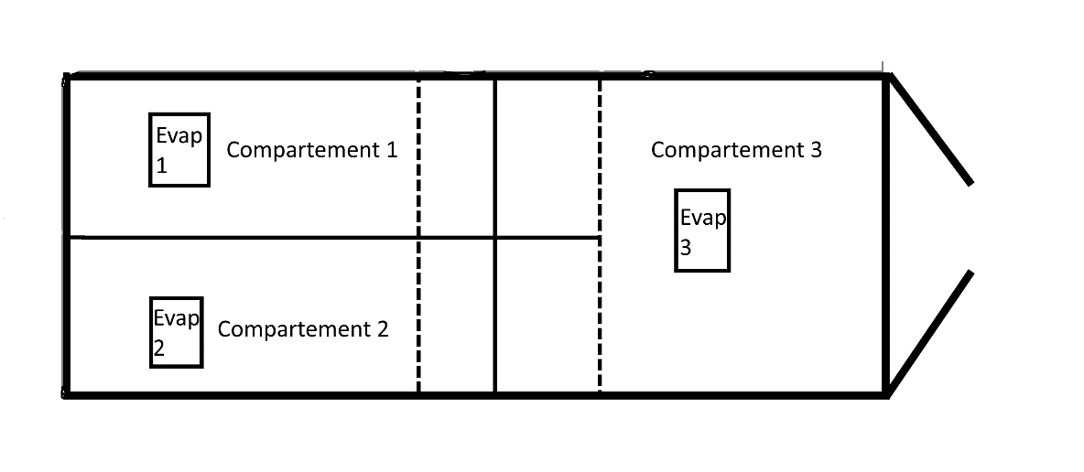

Insulated body:  
ATP test report number:  
Make:  
Serial number:

Host unit:  
ATP Test report number:  
Make:  
Serial Number:

Evaporators:  
ATP test report number:  
Make:  
Type:

Remarks:

(for example limitations in compartment temperatures or dimensions, use of particular accessories as curtains etc.)

Authentication

Name of competent authority:  
Address:  
Telephone number:  
E-mail address:

Date and Place of signature Stamps signature, and name signing officer.