Informal document No.12
Distr.: General
6 March 2020

Original: English
Economic Commission for Europe
Inland Transport Committee
Global Forum for Road Traffic Safety
Eightieth session
Geneva, 9-13 March 2020
Item 4 of the provisional agenda
Convention on Road Signs and Signals (1968):
Group of Experts on Road Signs and Signals

Final report
Submitted by the Chair of the Group of Experts on Road Signs and Signals and Secretariat
This document contains the final report of the Group of Experts on Road Signs and Signals as well as comments (displayed in the margin) provided by Lithuania, Norway, Slovakia, Switzerland, and Sweden and possible responses.

Background
1. This document contains the draft final report to be submitted by the Group of experts to the Global Forum for Road Traffic Safety (WP1).
II. Introduction
2. The Group of Experts on Road Signs and Signals (thereafter referred to as the Group) had been mandated to focus on two major tasks:
- Task 1: Assess internal inconsistencies of the 1968 Convention on Road Signs and Signals (thereafter referred to as “Convention”) and the 1971 European Agreement supplementing the 1968 Convention on Road Signs and Signals (thereafter referred to as “European Agreement”) as well as the coherence of these two international legal instruments, and
- Task 2: Take stock of the existing national legislation in the Contracting Parties to both legal instruments and describe and assess the degree of implementation of these instruments in the Contracting Parties.
3. The assessment of the Group referred to under Task 1 is based on the following: chapter I and II of the Convention (“General provisions” & “Road signs”);
- chapter V of the Convention (“Miscellaneous” – for what the road signs are concerned);
annex 1 & 3 of the Convention (“Road signs” & “Reproduction in colour of signs, symbols and panels referred to in annex 1”);
- the annex and the appendix of the European Agreement.
4. To deliver on Task 2, the Group had agreed at its second session to carry out a sign-by-sign assessment focusing on deviation identification and description, deviation evaluation, recommendations and assignment of “in-conformity indicators” for both images and definitions in included in the Convention and the European Agreement. While carrying out this assessment, which at times required detailed analysis of the provisions of both legal instruments, the Group identified some inconsistencies and inaccuracies, discussed them and suggested specific amendments to the text of the Convention and the European Agreement.
5. In carrying out its tasks, the Group analysed the implementation of the Convention and the European Agreement on the basis of information provided by 36 Contracting Parties to the UNECE Road Signs Management System. These were: Albania, Austria, Azerbaijan, Belgium, Bosnia and Herzegovina, Chile, Croatia, Czechia, Denmark, Finland, France, Germany, Greece, Hungary, Islamic Republic of Iran, Italy, Kuwait, Latvia, Lithuania, Luxembourg, Montenegro, Netherlands, Nigeria, Poland, Portugal, Republic of Moldova, Romania, Russian Federation, Serbia, Slovakia, Sweden, Switzerland, Tunisia, Ukraine, Uzbekistan, Viet Nam.
6. As a result of the Group’s work, this report contains:
III. Report
Section 1
Conclusions and recommendations regarding the inconsistencies and inaccuracies identified by the Group in the provisions of the Convention and the European Agreement
The Group of Experts identified inconsistencies and inaccuracies (i.e. issues) in the text of the Convention and the European Agreement as provided below:
Issue 1
There are cases in the Convention when specific signs are not assigned a specific name code. Also, the current system for name coding appears to be missing internal logic. To this end, the Group recommends to change the sign numbering system (see subsection 1.2 of this document on amendments to Annex 1 and 3 of the Convention), for example “A, 1 a” becomes “A-01.1”.
Issue 2
The objective of the European Agreement is to achieve greater uniformity vis-à-vis the Convention in the rules governing road signs, signals and symbols. Yet, in a number of cases the European Agreement introduces signs that are not contained in the Convention. This can be seen as an expansion of the scope of the European Agreement vis-à-vis the Convention. To this end, the Group of Experts recommends that all signs except F, 16 (see issue 35) provided in the European Agreement are added to the Convention through appropriate amendments. These are signs C, 3 m, C, 3 n, E, 17 a, E, 17 b, F, 14 and F, 15 (see subsection 1.2 of this document on amendments to Annex 1 and 3 of the Convention, its section C, paragraph II.1, section E, paragraph II.14 and section F, paragraph II.2, and subsection 1.3 of this document on amendments to the European Agreement, its Annex, points 19, 23 and Appendix to the Annex of the European Agreement)
Issue 3
Article 5, paragraph 1 stipulates that the “Convention differentiates between the following classes of road signs” and some classes “are sub-divided” further. There appears need to provide consistent names for all these resulting “classes”, “sub- classes” and “Groups” (“sub sub-classes”). To this end, the Group recommends to re-name the heading in Article 5, paragraph 1 (c) (ii) (see subsection 1.1 of this document on an amendment to the Convention, Article 5, paragraph 1 (c) (ii)).
Issue 4
While Article 5, paragraph 1 c (ii) distinguishes six “Groups” of the G “sub-class” signs, two of these “Groups” – road identification and place identification signs – are not mentioned again in the Convention, i.e. there is no information in Annex 1 about them nor are the images of signs for these Groups reproduced in Annex 3. This requires to be rectified. To this end, the Group recommends introducing new section 3 (Road identification signs) and new section 4 (Place identification signs) and adjust the numbering of subsequent points in Section G of Annex 1 (see subsection 1.2 of this document on amendments to Annex 1 and 3 of the Convention, its section G, paragraph II.3 and II.4 and subsection 1.3 of this document on an amendment to the European Agreement, its Annex, points 10 and 25bis).
Issue 5
The additional panels are classified under the class of informative signs. Instead, they should be a class of its own. To this end, the Group recommends an amendment to Article 5 of the Convention (see subsection 1.1 of this document on an amendment to the Convention, Article 5, paragraph 1 (c) (iii) and paragraph 1 (d).
Issue 6
Article 5, paragraph 2, (a) of the Convention stipulates that “Where this Convention allows a choice between several signs or several symbols Contracting Parties undertake to adopt only one of such signs or symbols for the whole of their territories”. In order to have consistency in the ground colors of signs of the same category (where the Convention allows a choice between colors) within Contracting Parties, there is need to expand this obligation to the ground color of signs. To this end, the Group recommends an amendment to Article 5, paragraph 2 (a) (see subsection 1.1 of this document on an amendment to the Convention, Article 5, paragraph 2 (a)).
Issue 7
Specific terms such as “band” and “bar” (and adjectives used with these expressions), “strip” and “rim”, “word” and “inscription”, “plate” and “panel”, “rectangular panel” and “additional panel” are either used inconsistently or incorrectly. To this end, the Group recommends amending provisions of the Convention and the European Agreement in which these terms are not correctly used (see subsection 1.1 of this document on amendments to the Convention, Article 8, Article 27; subsection 1.2 of this document on amendments to Annex 1 of the Convention, its section A, paragraph II.3, II.29; section C, paragraph II.10; Section, D paragraph II.8; section E, paragraphs II.4, II.7, II.8, II.10, II.12, II.15; section F, paragraph II.2; section G, paragraphs II.6.E, II.6.I, II.6.K; subsection 1.2 of this document on amendments to Annex 2, Chapter III, TRANSVERSE MARKINGS, paragraph B.32; subsection 1.3 of this document on amendments to the European Agreement, its Annex, points 7 and 26; and subsection 1.4 of this document on amendments to the Protocol on Road Markings, its Annex, point 7).
Issue 8
1. The images reproduced in the Convention or the European Agreement do not follow any consistent approach in using a separation between two dark or two light colours. Similarly, there is no consistent approach to using outer rims on the signs of the Convention and the European Agreement. To this end, the Group recommends using, if deemed necessary by a Contracting Party, a thin light-coloured (e.g. white) separation between two dark colours used on the sign (e.g. blue and red) or a dark-coloured separation between two light colours. The Group proposed relevant amendments to Article 7, paragraph 4 (see subsection 1.1 of this document on amendments to the Convention, Article 7, paragraph 4).
2. Moreover, the Group recommends using, if deemed necessary by a Contracting Party, a white or yellow and black or dark blue rim at the outer edge to enhance conspicuity of signs and proposes adding relevant provision to this end (see subsection 1.1 of this document on an amendment to the Convention, Article 7, new paragraph 4bis).
3. The Group further recommends that images of the Convention signs contain the thin separation and the rims at the outer edge for signs with no borders (see subsection 1.2 of this document on amendments to Annex 1 and 3 of the Convention, images in sections B, D, E, G and H).
Issue 9
1. Article 8, paragraph 1 requires that signs are based on the use of shapes, and colours characteristics specific for each class. However, there are “special regulations signs” (classified under the “regulatory signs” class) and “direction, position and indication signs” (classified under “informative signs” class) which use the same shapes and colours.
2. It should be noted that in the original text of the Convention, there was no “special regulations” signs sub-class, and all of the signs currently in that sub-class were part of “informative signs” class.
3. While it does not seem sensible to change general characteristics of either E or G sub-classes, the relevant provisions could be improved.
4. In addition, since “Other information signs”, except the Groups of place identification signs and indication signs, are often used with different ground and symbol colours depending on the classification of roads on which they are placed or they point to, or points of interest they point to (relevant for advance direction and direction signs), the possibility of doing so should be clarified in the Convention.
5. To this end, the Group recommends amending Annex 1, Section G, paragraph I.1 and I.2 and introduce a new paragraph I.3 as well as adjusting the remaining paragraphs (see subsection 1.2 of this document on amendments to Annex 1 and 3 of the Convention, Section G, paragraph I)
Issue 10
Article 8, paragraph 3 allows placing signs within a rectangular panel on which additional inscriptions can also be placed to facilitate the interpretation of signs. At the same time, such sign, in accordance with this provision, can be confused with the zonal validity sign defined in Annex 1, section E, paragraph II.8. To this end, the Group recommends amending Article 8, paragraph 3 as well as point 7 of the European Agreement (see subsection 1.1 of this document on amendments to the Convention, Article 8, paragraph 3 and subsection 1.3 of this document on amendments to the European Agreement, its Annex, point 7).
Issue 11
Articles 9 through 21, at times, provide detailed information which describes the signs of sections A through G. Such descriptive information rather belongs in Annex 1. To this end, the Group recommends amendments to Articles 9 through 21 and to the relevant provisions of the Annex 1 (see subsection 1.1 of this document on an amendment to the Convention, Articles 9 through 21 and subsection 1.2 of this document on amendments to Annex 1 of the Convention; section A, paragraph I, paragraphs II.20, II.29; section B, paragraphs 1, 2, 3 and 4; section E, paragraphs II.7, II.9, II.10; section G, paragraphs I.5, I.6 and I.7; and subsection 1.3 of this document on amendments to the Agreement, its Annex, points 3, 9, 9bis, 10 and 25bis).
Issue 12
1. Annex 1 is not consistent in providing definitions and descriptions for signs. To this end, the Group recommends revising Annex 1 to make the definitions and descriptions of signs consistent.
2. Therefore the Group recommends:
- including images of permitted sign variants in Annex 1 directly after sign definition and/or description and deleting Annex 3;
- removing redundant options such as possibility of depicting the percentage as a “ratio” and define signs such as A,2a, and A,2b as A,2 as well as A,3a and A,3b as A,3;
- clarifying the models of Section F, the first model being a blue or green rectangular shape with a white square placed in the centre (as the current reproduction of the F panel in Annex 3). This model should be used for F-section signs with inscriptions. The second model should be a blue or green square with a white square placed in the centre. The area of the white square inside should not be greater than 2/3 of the area of the ground;
- renaming sign F,8 to “Picnic Site or Rest Area”.
(see subsection 1.2 of this document on amendments to Annex 1 and 3 of the Convention; and subsection 1.3 of this document on amendments to the European Agreement, its Annex, points 17, 18,19, 21, 22, 23, 24 and 26).
Issue 13
1. The provisions on symbol reversibility appear to be unclear. Some signs in sections A and C contain provisions saying that the symbol of these signs may be reversed, if appropriate. In addition, there is a provision contained at the end of Annex 1 as “Note appropriate to the whole of Annex 1” stating that in countries where traffic keeps to the left, symbols shall be reversed as appropriate. To this end, in order to clarify the reversibility provisions, the Group recommends introducing three types of reversibility provisions: optional reversibility, mandatory reversibility due to left-hand direction of traffic, and optional reversibility due to left-hand direction of traffic. The signs listed below have been Grouped accordingly.
2. Optional reversibility: A, 8; A, 10; A, 11; A, 12; A, 13; A, 14; A, 15; A, 24 and A, 31 and E, 12; E, 15; E, 16; G, 23 and new signs G, 25 and G, 27.
3. Mandatory reversibility due to left-hand direction of traffic A, 22 and A, 23, B 5 and B, 6; C, 12; C, 13aa; C, 13ba; C, 13bb and 17d; D, 3; E, 18; G, 19; G, 22 and redesigned signs G, 1 c; G, 2 b and G, 4 b.
4. Optional reversibility due to left-hand direction of traffic: A, 26 a, and A, 27.
(see subsection 1.2 of this document on amendments to Annex 1 and 3 of the Convention; and reversibility provisions provided for each of the signs listed above as well as the deletion of the Note at the end of Annex 1).
Issue 14
1. The Convention provides for some signs – e.g. signs for warning of intersections – many examples which may give the impression that the list of examples permitted in the Convention is exhaustive. The Group believes that the number of examples should be one or two. To this end, the Group recommends in case of the signs for warning of intersections to only keep examples A, 18 a and b and A, 19 a and b (see see subsection 1.2 of this document on an amendment to Annex 1 of the Convention, section A, paragraphs II.18 and II.19).
2. The Group further agreed that electronic Convention on Road Signs and Signals (e- CoRSS) should provide other types of intersections.
Issue 15
The Convention contains two provisions on a sign or combination of signs that should be used to warn of placement of sign B, 1 or signs B, 2 at the intersection. To this end, the Group recommends simplifying the text of the Convention and amending its Annex 1, Section A, paragraph 20 by removing the symbols A, 20; A,21 a; and A, 21 b and by introducing relevant combination of signs and/or sign in Section B, paragraphs 1 and 2 (see subsection 1.2 of this document on an amendment to Annex 1 of the Convention, section A, Paragraphs II.20 and section B, paragraphs 1 and 2 and subsection 1.3 of this document on amendments to the European Agreement, its Annex, points 9 and 17).
Issue 16
Annex 1, Section A, paragraph II.28 provides three models for signs to be placed in immediate vicinity of level crossing when in fact there are two models and for each model two signs depending whether the level-crossing is with one or two and more tracks. To this end, the Group recommends clarifying the paragraph 28 by proposing an amendment to it (see subsection 1.2 of this document on an amendment to Annex 1 of the Convention, section A, paragraph II.28 and subsection 1.3 of this document on an amendment to the Agreement, its Annex, point 17).
Issue 17
1. The Group recommends deleting the Note of Section B while inserting its provision in Section B paragraphs 1, 2, 3 and 4 and deleting the Note in Section C and introducing its amended content in Section C, paragraph I (see subsection 1.2 of this document on an amendment to Annex 1 of the Convention, section B, paragraph 1, 2, 3 and 4 and section C, new paragraph I.3 and deletion of the “Note”).
2. As to the use of the bar on the signs C, 3; C, 4; and C,15, the provision of the Convention should allow the flexibility whether the bar should be placed behind or in front of the symbol. The above noted signs should however in the Convention be depicted with a bar of an appropriate width (relatively narrower compared to the existing signs) and placed behind the symbols.
Issue 18
The units such as “tonnes” or “meters” are placed on images of signs in an inconsistent way, i.e. with or without the space between the digit and the unit. To this end, the Group recommends that when such units are used, there should be a space separating them from the digit to increase sign legibility (see subsection 1.2 of this document on an amendment to Annex 1 of the Convention, new images for signs C, 5, C, 6, C, 7, C, 8).
Issue 19
The Convention at times limits for no specific reason the number of colours permitted on specific signs vis-à-vis the colours defined in the general characteristics (eg. Section C, paragraph II.9(a)(ii)). Sometimes the colours defined in the general characteristics do not cover the colours permitted under specific signs. To this end, the Group recommends amending the relevant provisions of the Convention to name the appropriate colours (see subsection 1.2 of this document on amendment to Annex 1 and 3 of the Convention, section C, paragraph II.10; section E, paragraph II; section F, paragraph I).
Issue 20
The Convention appears not to follow any internal consistency as to the order of signs, e.g. signs C, 3 are followed by C, 4 (where C, 4 signs contain multiple symbols of C, 3 signs) versus D, 4; D, 5; and D, 6 which are not directly followed by the signs that contain their corresponding symbols. Instead, signs D, 11 a and D, 11 b contain multiple symbols of D, 4; D, 5 and D, 6. To this end, the Group recommends improving the order of signs in the Convention by amending relevant provisions (see subsection 1.2 of this document on amendments to Annex 1 and 3 of the Convention, section D, paragraphs II.7 and II.11; section E paragraphs II.3and II.4)
Issue 21
Sign D, 8 ends the regulation introduced by sign D, 7 while there are no signs that end the regulations started by signs D, 4; D, 5; D, 6; D, 9 and D, 11. To this end, the Group recommends creating end of regulations signs for signs D, 4; D, 5; D, 6; D, 9 and D, 11 (see subsection 1.2 of this document on amendments to Annex 1 and 3 of the Convention, Section D, paragraphs II.4-7 and II.9).
Issue 22
The provisions on general characteristics and symbols for D signs (Section D, paragraph I), stipulates colours (i.e. blue ground and yellow symbol) that are not used by the Contracting Parties. Section D, paragraph I also allows mandatory signs to be white with a red rim. To this end, the Group recommends amending the Convention to retain only the blue ground and white symbol for Section D signs (see subsection 1.2 of this document on amendments to Annex 1 and 3 of the Convention, Section D, paragraph I).
Issue 23
Signs E,2a and E,2b are defined by Article 26bis paragraph 2, and Section E, sub-section II, paragraph 2. The Group believes this to be erroneous and recommends amending Article 26bis and paragraph II.2 of Section E of Annex 1 to include a reference to the additional panel H,5 or the symbol of a bus or other type of road user (see subsection 1.1 of this document on amendments to the Convention, Article 26bis paragraph 2 and subsection 1.2 of this document on amendments to Annex 1 and 3 of the Convention, section E, paragraph II.2).
Issue 24
The end of regulations signs are described inconsistently across the Convention and the European Agreement. For example, the sign provisions for E,5b and E,6b contained in Annex 1, section E, paragraphs II.5 and II.6 do not inform how these signs should look like. This is contrary to the provisions for E,8a or E,8b signs. To this end, the Group recommends amending the provisions to make them consistent and specific for all signs notifying of the end of regulations (see subsection 1.2 of this document on amendments to Annex 1 and 3 of the Convention, section D, paragraph II.4-9, section E, paragraphs II.5-9 and II.14).
Issue 25
1. The depictions of E, 11; E, 15 and E, 16 signs do not follow the general characteristics of E signs. To this end, the Group recommends changing the depictions to be in line with the general characteristics of E signs (see subsection 1.2 of this document on amendments to Annex 1 and 3 of the Convention, section E, paragraphs II.9 and II.13).
2. Furthermore, signs E, 15 and E, 16 do not include any definition of what the special regulations are that should apply with these signs. To this end, the Group recommends amending paragraph II.13 of Section E, Annex 1 by inserting a reference to special traffic rules that may apply (see subsection 1.2 of this document on amendments to Annex 1 and 3 of the Convention, section E, paragraph II.13).
Issue 26
Annex 1, Section G, paragraph I, contrary to its title, does not only provide general characteristics of Section G signs. It also provides more detailed information on some specific signs (see paragraph I.3) that should, more appropriately, be placed elsewhere. To this end, the Group recommends deleting paragraph I.3 of Section G, Annex 1, while amending Annex 1, Section G, paragraphs II and III, provisions referred to as ‘NOTE’ in the current text of the Convention (see subsection 1.2 of this document on amendments to Annex 1 and 3 of the Convention, section G, paragraphs I, II.1 and II.2).
Issue 27
1. Annex 1, Section G, paragraph I.4 provides general information on signs indicating temporary conditions such as road works, diversion or detours. This type of signs, however, is not mentioned again in Annex 1, Section G, paragraph V (Indication signs). To this end, the Group recommends deleting paragraph I.4 of the current text of the Convention and adding signs indicating temporary conditions to the Group of indication signs (see subsection 1.2 of this document on amendments to Annex 1 and 3 of the Convention, section G, paragraph I and II.6.N).
2. The Group also recommends including in the Convention a sign notifying to “crash through gates when a vehicle is trapped between closed gates at a level crossing” (see subsection 1.2 of this document on amendment to Annex 1 and 3 of the Convention, section G, paragraph II.6.M).
Issue 28
Annex 1, Section G, paragraph II.1 (General case) refers to examples of advance direction signs in Annex 3. The Group believe that there is a need to provide more representative examples. To this end, the Group recommends amending Annex 1, Section G, paragraph II (see subsection 1.2 of this document on amendments to Annex 1 and 3 of the Convention, Section G, paragraph II.1).
Issue 29
Annex 1, Section G, paragraphs III.1 and III.2 refer to examples of direction signs in Annex 3. The Group believe that there is a need to provide more representative examples. To this end, the Group recommends amending Annex 1, Section G, paragraph III (subsection 1.2 of this document on amendments to Annex 1 and 3 of the Convention, section G, paragraph II.2).
Issue 30
Annex 1, Section G, paragraph V.5 refers to a symbol G, 16 that is not otherwise defined in the Convention. The Group believes that this should be rectified. and. To this end, the Group recommends to use a sign rather than a symbol instructing/advising the use of snow chains/snow tyres respectively by amending Annex 1, Section G, paragraph V.5 of the current text of the Convention (see subsection 1.2 of this document on amendments to Annex 1 and 3 of the Convention, section G, paragraphs II.6.E and F).
Issue 31
Annex 1, Section G, paragraph V.3 provides the definition of the sign G, 13. However, it does not prescribe the colours to be used on this sign which implies that all the colours applicable to G section signs for the ground and symbol are permitted. The same issue applies to current paragraphs V.5 through V.10. To this end, the Group recommends amending Annex 1, section G, paragraph V (subsection 1.2 of this document on amendments to Annex 1 and 3 of the Convention, section G, paragraph II.6).
Issue 32
The provision on general characteristics of the additional panels, Annex 1, Section H, paragraph 1 is unclear with respect to their use, colours and placement. To this end, the Group recommends amending this provision (see subsection 1.2 of this document on amendments to Annex 1 and 3 of the Convention, section H, paragraph I and subsection 1.3 of this document on amendments to the European Agreement, its Annex, point 27).
Issue 33
1. The provisions relevant to signs H,3 and H,4 in Section C, paragraph II.9(c) are unclear. Similarly, the provisions related to signs, H,5, H,6, H,7, H,8 and H,9 are not clear or not precise. To this end, the Group recommends clarifying these provisions by amending them (see subsection 1.2 of this document on amendments to Annex 1 and 3 of the Convention, section C, paragraph II.10 (Additional Provisions applying to prohibition or restriction of standing and parking) and section H paragraphs II.2-6).
2. The images depicted in the current text of Annex 1 are erroneously reversed for H, 4 a and H, 4 c, which should be rectified.
3. Since the additional panels H,3 and H,4 are also used in conjunction with the E, 14a sign, the Group of Experts believes that the provisions pertaining to H,3 and H,4 panels should specify this possibility. To that end, the Group of Experts recommends amending Annex 1, section H, paragraph II.2.
Issue 34
The point 4 of the European Agreement allows for a transitional period from the entry into force of the European Agreement, while the Convention allows for a transitional period for the entry into force of the Convention for a Contracting Party. As such the provision of the European Agreement does not allow for any transitional period anymore for new Contracting Parties. To this end, the Group recommends amending point 4 of the European Agreement to make it possible for a new Contracting Party to have transitional periods (see subsection 1.3 of this document on amendments to the European Agreement, its Annex, point 4).
Issue 35
The Convention is missing some important signs, symbols and some additional sign variants. To this end, the Group recommends amending the Convention in the following way (as described in subsection 1.2 of this document on amendments to Annex 1 and 3 of the Convention):
- the symbols of a person and zebra crossing are the only symbols to be used in A,12a and E,12a signs (see subsection 1.1 of this document on the amendment to the Convention, Article 27(4) as well as subsection 1.2 of this document on amendments to Annex 1 and 3 of the Convention, section A, paragraph 12 and section E, paragraph 10 and subsection 1.3 of this document on an amendment to the European Agreement, its Annex, point 17);
- A,12b is a new sign to warn of the section of road frequented by pedestrians (see subsection 1.2 of this document on amendments to Annex 1 and 3 of the Convention, section A, paragraph 12, sign A,12b);
- B,5 and B,6 provide alternative designs (see subsection 1.2 of this document on amendments to Annex 1 and 3 of the Convention, section B, paragraphs II.5 and II.6);
- Provide additional examples of signs showing an integer and a number with a decimal point or comma for signs C,5, C,6, C,7 and C,8. In the Convention, the depiction of signs with the should be illustrated with a comma (e.g. not “2.5” but “2,5”) (see subsection 1.2 of this document on amendments to Annex 1 and 3 of the Convention, section C, paragraph II.1, signs C,5, C,6, C,7 and C,8);
- Provide sign D,2c as a variant of D,2 with arrows pointing to left and right for passing an obstacle (see subsection 1.2 of this document on amendments to Annex 1 and 3 of the Convention, section D, paragraph II.2, sign D,2c);
- Allow symbols from the signs C,3m and C,3n of the European Agreement to be used on the D,10 sign given that signs C,3m and C,3n are to be moved to the Convention (see issue 2) (see subsection 1.2 of this document on amendments to Annex 1 and 3 of the Convention, section D, paragraph 10);
- The existing sign E,14b denoting that parking is available with an option to change to other transport is to be replaced by the new sign. This sign contains a light-coloured symbol: “P + R” with two horizontal lines placed below and above “P + R” (see subsection 1.2 of this document on amendments to Annex 1 and 3 of the Convention, section E, paragraph 12, sign E,14b). This symbol should be the only allowed symbol to indicate places where parking of vehicles is authorized with an option to change to other (more than one) transport means to Contracting Parties of the European Agreement through amending the point 22 of the European Agreement (see subsection 1.3 of this document on an amendment to the Agreement, its Annex, point 22);
- Create a new G, 25 sign signifying to crash through gates (see also issue 26);
- Create new signs G,26-G,29 as signs for temporary conditions (see also issue 26);
- Create new signs F,19a-F,19c as signs showing multiple facilities or service signs (see subsection 1.2 of this document on amendments to Annex 1 and 3 of the Convention, section F, paragraph II.3);
- Create a new additional panel H,10 to be used in combination with B,1 sign to warn of a distance to a B,2 “STOP” sign placed at the intersection (see subsection 1.2 of this document on amendments to Annex 1 and 3 of the Convention, section H, paragraph II.7).
Issue 36
The Convention contains signs that appear not to be used. To this end, the Group recommends deleting from the Convention or the European Agreement the following signs/symbols:
- A, 12a and A, 12b are to be deleted (see subsection 1.2 of this document on amendments to Annex 1 and 3 of the Convention, section A, paragraph 12);
- A,17b and A,17c are to be deleted however their use is still in conformity with the Convention (see subsection 1.2 of this document on amendments to Annex 1 and 3 of the Convention, section A, paragraph II.17);
- A,18d through A,18g are to be deleted (see also issue 13) (see subsection 1.2 of this document on amendments to Annex 1and 3 of the Convention, section A, paragraph II.18);
- A,19c are to be deleted (see also issue 13) (see subsection 1.2 of this document on amendments to Annex 1 and 3 of the Convention, section A, paragraph II.19);
- A,20-A,21 are to be deleted (see also issue 14) (see subsection 1.2 of this document on amendments to Annex 1 and 3 of the Convention, section A, paragraph II.20 and Section B, paragraphs 1 and 2 and subsection 1.3 of this document on an amendment to the European Agreement, its Annex, point 9);
- B,2b is to be deleted (see subsection 1.2 of this document on amendments to Annex 1 and 3 of the Convention, section B, paragraph 2);
- The variants of B,3 and B,4 with the orange colour option for inside square are to be deleted (see subsection 1.2 of this document on amendments to Annex 1 and 3 of the Convention, section B, paragraph 3);
- E,7d and E,8d are to be deleted as they replicate E,7a and E,8a (see subsection 1.2 of this document an amendments to Annex 1 and 3 of the Convention, section E, paragraph II.7 and subsection 1.3 of this document on an amendment to the European Agreement, its Annex, point 22);
- E,12b and E,12 c are to be deleted (see subsection 1.2 of this document on amendments to Annex 1 and 3 of the Convention, section E, paragraph II.10 and subsection 1.3 of this document on amendments to the European Agreement, its Annex, point 22);
- E,18a is to be deleted (see subsection 1.2 of this document on amendments to Annex 1 and 3 of the Convention, section E, paragraph II.15);
- F,1c is to be deleted (see subsection 1.2 of this document on amendments to Annex 1 and 3 of the Convention, section F, paragraph II.1);
- F,9 is to be deleted as it is a non-road traffic sign (see subsection 1.2 of this document on amendments to Annex 1 and 3 of the Convention, section F, paragraph II.2, sign F,9);
- F,12 is to be replaced by signs showing multiple facilities or service signs (see issue 34) (see subsection 1.2 of this document on amendments to Annex 1 and 3 of the Convention, section F, paragraph II.2, sign F,12);
- F,16 is to be deleted as it is a non-road traffic sign (subsection 1.3 of this document on amendments to the European Agreement, its Annex, point 23);
- G,11b is to be deleted as it replicates G,11a (see subsection 1.2 of this document on amendments to Annex 1 and 3 of the Convention, section G, paragraph II.6.A).
Issue 37
In the Convention, there are some signs and symbols that contain unnecessary details which compromise their legibility. The Group believed that some symbols should be modernized or made more abstract and, when applicable, made gender-neutral. To this end, the Group recommends the following:
- All symbols depicting motor vehicles are to be made more abstract and modern-looking (see subsection 1.2 of this document on amendments to Annex 1 and 3 of the Convention, section A, images in the current text of the Convention A, 2c; A, 2d; A, 3c; A, 3d; A, 6; A, 8; A, 9; A, 10a; A, 10b; A, 14; A, 24; A, 27; section C, images for C, 3a; C, 3b; C, 3c; C, 3d; C, 3e; C, 3f; C, 3g; C, 3h; C, 3i; C, 3j; C, 3k; C, 3l; C, 3m; C, 3n; C, 9; C, 10; C, 13; C, 17c; C, 17d; Section D, images for D, 4 and D, 10, section E, images for E, 6a and E, 6b; E,14c; E, 15; E, 16; section G, image for G,18;
- Symbols depicted on signs A, 12 and A, 13 are to be made more abstract and gender-neutral (see subsection 1.2 of this document on amendments to Annex 1 and 3 of the Convention, section A, images for A, 12 and A, 13);
- The symbol depicted on the sign A, 14 is to be amended by retaining the bicycle only (see subsection 1.2 of this document on amendments to Annex 1 and 3 of the Convention, section A, image for A, 14);
- The symbols depicted on the sign A, 15 are to be made more abstract (see subsection 1.2 of this document on amendments to Annex 1 and 3 of the Convention, section A, images for A, 15);
- The symbols depicted on the signs A, 16; C, 3i; C, 3k; D, 11; E, 12 are to be amended consistent with the changes made to the symbols depicted on the signs A, 12 by making them more abstract (see subsection 1.2 of this document on amendments to Annex 1 and 3 of the Convention, section A, image for A, 16, section C, images for C, 3i, C, 3k, section D, image for D, 11 and section E, image for E, 12);
- The symbol depicted on the signs A, 17 is to be amended by adding a narrow dark strip around each traffic light circle (see subsection 1.2 of this document on amendments to Annex 1 and 3 of the Convention, section A, image for A, 17);
- The symbol depicted on the sign A, 22 is to be amended by inserting greater space between the arrows and enlarging the arrow heads (see subsection 1.2 of this document on amendments to Annex 1 and 3 of the Convention, section A, image A, 22);
- The symbols depicted on the signs A, 23; D, 3; E, 3a; E, 3b to be amended by enlarging the arrow heads (see subsection 1.2 of this document on amendments to Annex 1 and 3 of the Convention, section A, image for A, 23, section D, image for D, 3, section E, images for E, 3a and E, 3b);
- The symbol depicted on the sign A, 25 is to be replaced by the symbol which depicts a rail track and a modern gate (ref. to a sign used in Chile) (see subsection 1.2 of this document on amendments to Annex 1 and 3 of the Convention, section A, image for A, 25);
- The symbol depicted on the signs B, 5 and B, 6 are to be amended by enlarging the arrow heads and making the arrows of the same width (see subsection 1.2 of this document on amendments to Annex 1 and 3 of the Convention, section B, images for B, 5 and B, 6);
- The symbol depicted on the signs C,3f is to be amended by making it clearer that the prohibition is aimed at trailers other than single axle trailers by adding a second axle on the trailer (see subsection 1.2 of this document on amendments to Annex 1 and 3 of the Convention, section C, image for signs C, 3f);
- The symbols depicted on the signs C, 7 and C, 8 are to be amended by modifying the depiction of unit from upper to lower case (“t”) and for C, 8 changing the arrow to arrowhead only while making the digit larger (see subsection 1.2 of this document on amendments to Annex 1 and 3 of the Convention, section C, images for C,7 and C,8);
- The symbol depicted on the sign C, 9 is to be amended by replacing the arrows with arrowheads only and by making the digit larger (see subsection 1.2 of this document on amendments to Annex 1 and 3 of the Convention, section C, image for C, 9);
- The symbols depicted on signs C, 14; D, 7; and D, 8 are to be amended by centering the digit and inserting a reasonable space between the digits (see subsection 1.2 of this document on amendments to Annex 1 and 3 of the Convention, section C, image for C, 14 and section D, images for D, 7 and D, 8);
- The symbol depicted on the sign D, 5 is to be amended by making the symbol more abstract (see subsection 1.2 of this document on amendments to Annex 1 and 3 of the Convention, section D, image for D, 5);
- The symbol depicted on the sign E, 4 is to be amended by removing road markings (their use is optional) (see subsection 1.2 of this document on amendments to Annex 1 and 3 of the Convention, section E, image for E, 4);
- The signs E, 10c and E, 10d are no longer to be depicted in the Convention; only one example of a sign having zonal validity is to be shown in the Convention;
- The symbols depicted on the sign E, 13b are to be amended by simplifying the bed and by moving the cross to the center (see subsection 1.2 of this document on amendments to Annex 1 and 3 of the Convention, section E, image for E, 13b);
- The symbol depicted on the sign F, 4 is to be amended by making the filling station more abstract (see subsection 1.2 of this document on amendments to Annex 1 and 3 of the Convention, section F, image for F,4);
- The symbol depicted on the sign F, 8 is to be amended by improving the depiction of the table and by adding a person. (see subsection 1.2 of this document on amendments to Annex 1 and 3 of the Convention, section F, image for F, 8);
- The symbol depicted on the sign G, 13 is to be amended by increasing the space between the symbol and the bottom edge of the sign (see subsection 1.2 of this document on amendments to Annex 1 and 3 of the Convention, section G, image for G,13);
- All signs that use inscription “Km” (kilometre) are to be written with lower case (i.e. “km”).
Issue 38
1. The essence of the Convention is the principle of harmonization. Thereto the Convention, where it grants some flexibility to the Contracting Parties (Articles 5, §2 & Article 8, §2), requires that Contracting Parties shall endeavour to secure a regional agreement. This applies in case the Convention allows a choice between several signs or several symbols (or colors) or in case any sign or symbol not prescribed in the Convention is adopted.
2. The problem is that it is not clear what is understood by a regional agreement nor is it clear what the procedure is to secure such an agreement. The Group believed that it is crucial that a structure is put in place that facilitates and expedites compliance. To this end, the Group recommends the following:
3. The Global Forum for Road Traffic Safety should establish clarity on what a regional agreement is, how exactly countries can secure such a regional agreement and put a system in place which facilitates the securing of a regional agreement. The Global Forum for Road Traffic Safety should also assess if an amendment of the Convention is necessary thereto.
Issue 39
1. Road signs with abstract image content may be difficult to comprehend and recall. The Group believed that the Contracting Parties should take this into account in the driver education. To this end, the Group recommends the following:
2. Contracting Parties should consider enhancing driver knowledge of road signs with special emphasis on signs with abstract image content. Contracting Parties may also wish to examine whether driving outside their country necessitates a better understanding of signs not used locally.
1.1 Proposal for amending specific provisions of the Convention
1. The Group of Experts recommends a number of amendments to the provisions of the Convention. The additions are in bold while the deletions are struck through.
2. Only amendments which are proposed by the Group of Experts are listed in this section. An article (or its paragraphs or subparagraphs), which is not listed, remains unchanged. Amendments to Annex 1 and 3 are provided in section 1.2.
Article 1
Definitions
² See footnote
{² Additional definition introduced in the Annex of the European Agreement (see point 3)[deleted]}
(b)bis “ 'Residential area' means an specially-designed area where special traffic rules apply and which is signposted as such at its entries and exits.”
Article 2
Annexes to the Convention
The annexes to this Convention, namely:
Annex 1: Road signs;
Section A: Danger warning signs;
Section B: Priority signs;
Section C: Prohibitory or restrictive signs;
Section D: Mandatory signs;
Section E: Special regulation signs;
Section F: Information, facilities or service signs;
Section G: Direction, position or indication signs Other information signs;
Section H: Additional panels;
and
Annex 2: Road markings;
Annex 3: Reproduction in colour of signs, symbols and panels referred to in Annex 1; and Annex 2 are integral parts of this Convention.
Article 5
(b) Regulatory signs: these signs are intended to inform road-users of special
obligations, restrictions or prohibitions with which they must comply; they are subdivided into:(i) Priority signs;
(ii) Prohibitory or and restrictive signs;
(iii) Mandatory signs;
(iv) Special regulation signs;
(c) Informative signs: these signs are intended to guide road-users while they are travelling or to provide them with other information which may be useful; they are subdivided into:
(i) Information, facilities or service signs;
(ii) Direction, position or indication signs Other information signs:
- Advance direction signs;
- Direction signs;
- Road identification signs;
- Place identification signs;
- Confirmatory signs;
- Indication signs;
(iii) Additional panels.
(d) Additional panels: these signs, only used with other signs, provide additional information.
2. Where this Convention allows a choice between several signs, or several symbols, or several colours,
(a) Contracting Parties undertake to adopt only one of such signs or symbols for the whole of their territories and only one of such colours for the signs of category A and C and the relevant signs of category B for the whole of their territories and only one of such colours for the signs indicating temporary conditions for the whole of their territories;
Article 6
2. All signs shall apply to the drivers from for whom they are intended over the whole width of the carriageway open to traffic. However, signs may be made to apply to only one or to several lanes of the carriageway when lanes are defined by longitudinal markings. In this case, one of the following three options shall be used:
(c) Signs E, 1 or E, 2 described in Annex 1, section E, subsection II, paragraphs 1 (REGULATION OR DANGER WARNING APPLYING TO A LANE) and 2 (LANE RESERVED FOR BUSES and LANE RESERVED FOR A SPECIFIC TYPE OF ROAD USER) to this Convention or signs G, 11 and G, 12 described in Annex 1, section G, subsection VII, paragraphs 6 A (DIRECTION OF LANES) and B (END OR CLOSURE OF A LANE) 1 and 2 will be placed on the edge of the carriageway.
Article 7
4. Dark or light graphic elements of different colours in the signs may should preferably be differentiated by means of contrasting light or dark white or yellow and black or dark blue narrow strips respectively.
4(bis) White or yellow and black or dark blue rims may be used at the edge to enhance conspicuity of signs. For additional panels, it is possible to replace a black or a dark blue rim with a red rim.
Article 8:
3. Nothing in this Convention shall prohibit the addition, mainly in order to facilitate the interpretation of signs, of an inscription in a rectangular an additional panel below the sign or in a rectangular panel containing the sign; such an inscription may also be placed on the sign itself, if this does not make the sign more difficult to understand for drivers who cannot understand the inscription⁸.
4. Where the competent authorities consider it advisable to make the meaning of a sign or symbol more explicit or to limit the application of a sign to certain periods, this can be done by inscriptions on the sign as provided in Annex 1 to this Convention or on an additional panel. If regulatory signs are to be restricted to certain road-users or if certain road-users are to be exempt from the regulation, this is done through additional panels according to Annex 1, section H, subsection II, paragraph 3 (ROAD USER PANEL) and 4 (PERSON WITH DISABILITIES PANEL) 4 (panels H, 5a ; H, 5b ; and H, 6).
Article 9:
1. Section A, subsection I of Annex 1 to this Convention indicates provides the models for danger warning signs; Section A, subsection II indicates the symbols to be placed on these signs and gives some instructions for their use , describes the danger warning signs and gives their meaning. In conformity with Article 46, paragraph 2 of this Convention, each State shall notify the Secretary-General whether it has selected Aa or Ab as the model one (equilateral triangle) or model two (square with one diagonal vertical) for danger warning signs.⁹
4. The distance between the sign and the beginning of a dangerous section of road may be shown in an additional panel H, 1 of Annex 1, section H to this Convention and placed in accordance with the provisions of that section; this information must shall be given when the distance between the sign and the beginning of the dangerous section of road cannot be judged by drivers and or is not what they might normally expect. This distance shall be shown in accordance with Annex 1, Section H, subsection II, paragraph 1 (DISTANCE PANEL).
5. Danger warning signs may be repeated, particularly on motorways and roads treated as motorways. Where they are repeated, the distance between the sign and the beginning of the dangerous section of road shall be shown in accordance with the provisions of paragraph 4 of this Article.
However, with respect to danger warning signs giving warning of and distance to swing opening bridges and level crossings, it shall be open to Contracting Parties may to apply the following provisions: use A signs specific for approaches to opening bridges and level crossings, which are described rectangular panel having its longer sides vertical and bearing three oblique red bars on a white or yellow ground, may be placed below any danger warning signs. bearing one of the symbols A, 5; A, 25; A, 26 or A, 27 described in Annex 1, section A, subsection II, paragraphs 5, 25, 26 and 27 to this Convention, provided that additional signs consisting of panels of the same shape bearing respectively one or two oblique red bars on a white or yellow ground are set up at about one third and two thirds of the distance between the sign and the railway line. These signs may be repeated on the opposite side of the carriageway. The panels mentioned in this paragraph are further depicted in Annex 1, section A, subsection II, paragraph 29 of Annex 1 to this Convention.
6. If a danger warning sign is used to give warning of a danger on a section of road of some length (e.g. a series of dangerous bends or a section of carriageway in bad condition) and if it is considered desirable to show the length of that section, this shall be done in accordance with on an additional panel H, 2 of Annex 1, section H, subsection II, paragraph 1 (LENGTH INDICATION PANEL). to this Convention, placed in accordance with the provisions of that section.
Article 10
Priority signs
1. The signs for notifying or informing road-users of the special rules of priority at intersections are described in Annex 1, section B, paragraphs 1 to 4. signs B, 1; B, 2; B, 3 and B, 4.
2. The signs described in Annex 1, section B, paragraphs 1 (GIVE WAY) and 2 (STOP) shall be placed at the intersection, if possible level with the point at which vehicles must stop or beyond which they must not pass when giving way. They may be placed elsewhere than at an intersection if the competent authorities consider it necessary. The sign of paragraph 2 shall be set up only if the competent authorities consider it advisable to require drivers to stop, in particular because of the poor visibility, for drivers, of the sections of the road, on either side of the intersection, which they are approaching.
3. The sign described in Annex 1, section B, paragraph 3 (PRIORITY ROAD) shall may be placed at the beginning of the road and repeated after each intersection; it may also be set up before or at the intersection.
4. The sign described in Annex 1, section B, paragraph 4 (END OF PRIORITY) shall be placed at the approach to the point from where the sign of Annex 1, section B, paragraph 3 (PRIORITY ROAD) ceases to apply.
5. The sign of Annex 1, section B, paragraph 4 (END OF PRIORITY) may be repeated one or more times in advance of the point where the priority ends; the sign or signs set up in advance of that point shall be placed together with an additional panel described in Annex 1, section H, paragraph 1 (DISTANCE PANEL).
6. If warning of an intersection is given on a priority road by danger warning signs bearing one of the A, 19 symbols described in Annex 1, Section A, subsection II, paragraph 19, or if at the intersection the road is a priority road and has been signposted as such by sign B, 3 as provided in provided in Annex 1, section B, paragraph 3 (PRIORITY ROAD) 7, signs B, 1 or B, 2 provided in Annex 1, section B, paragraphs 1 (GIVE WAY) and 2 (STOP) shall be placed at the intersection on all the other roads; however, the placing of those signs B, 1 or B, 2 shall not be mandatory on roads such as paths or earth-tracks where drivers are required to give way at the intersection even in the absence of such signs.
27. The signs for informing road-users of a rule of priority on narrow sections of road are signs B, 5 and B, 6. These signs are described in Annex 1, section B, paragraphs 5 (PRIORITY FOR ONCOMING TRAFFIC) and 6 (PRIORITY OVER ONCOMING TRAFFIC). to this Convention.
2. Sign B, 1 "GIVE WAY", shall be used to notify drivers that, at the intersection where the sign is placed, they must give way to vehicles on the road they are approaching.
3. Sign B, 2, "STOP", shall be used to notify drivers that, at the intersection where the sign is placed, they shall stop before entering the intersection and give way to vehicles on the road they are approaching. In conformity with Article 46, paragraph 2, of this Convention, each State shall notify the Secretary-General whether it has selected B, 2a or B, 2b as the model for the "STOP" sign.¹⁰
{¹⁰ See also point 9 of the Annex of the European Agreement[deleted]}
4. Sign B, 1 or B, 2 may be placed elsewhere than at an intersection if the competent authorities consider it necessary.
5. Signs B, 1 and B, 2 shall be placed at the intersection, if possible level with the point at which vehicles must stop or beyond which they must not pass when giving way.
6. To give advance warning of sign B, 1 the same sign supplemented by an additional panel H, 1, described in Annex 1, section H to the Convention, shall be used. To give advance warning of sign B, 2, sign B, 1, supplemented by a rectangular panel bearing the "STOP" symbol and a figure indicating the distance to the sign B, 2 shall be used.¹¹
{¹¹ See also point 9 of the Annex of the European Agreement[deleted]}
7. Sign B, 3, "PRIORITY ROAD", shall be used to notify users of a road that, at intersections of that road with other roads, the drivers of vehicles moving along or coming from such other roads are required to give way to vehicles moving along that road. This sign may be set up at the beginning of the road and repeated after each intersection; it may also be set up before or at the intersection. Where sign B, 3 has been set up on a road, sign B, 4, "END OF PRIORITY", shall be placed at the approach to the point where the road ceases to have priority over other roads.
Sign B, 4 may be repeated one or more times in advance of the point where the priority ends; the sign or signs set up in advance of that point shall then bear an additional panel H, 1 of Annex 1, section H.
8. If warning of an intersection is given on a road by a danger warning sign bearing one of the A, 19 symbols, or if at the intersection the road is a priority road and has been marked as such by signs B, 3 as provided in paragraph 7 of this Article, a sign B, 1 or B, 2 shall be placed at the intersection on all the other roads; however, the placing of signs B, 1 or B, 2 shall not be mandatory on roads such as paths or earth-tracks where drivers are required to give way at the intersection even in the absence of such signs.
A sign B, 2 shall be set up only if the competent authorities consider it advisable to require drivers to stop, in particular because of the poor visibility, for drivers, of the sections of the road, on either side of the intersection, which they are approaching.
ARTICLE 13
Provisions applying generally to the signs described in Annex 1, sections C, and D to this ConventionSpecial regulation signs
Section E of Annex 1 to this Convention describes the special regulation signs and gives their meaning.
Article 13bis
Special regulation signsProvisions applying generally to the signs described in Annex 1, sections C, and D and E to this Convention
1. Prohibitory, restrictive and mandatory as well as special regulation signs shall be placed in the immediate vicinity of the point where the obligation, restriction, or prohibition or special regulation begins or takes effect and may be repeated if the competent authorities consider it necessary. Nevertheless, if the competent authorities consider it advisable for reasons of visibility or in order to give users advance warning, these signs may be placed at a suitable distance in advance of the point where the obligation, restriction, or prohibition or special regulation applies .An additional panel H, 1 of in accordance with Annex 1, section H, subsection II, paragraph 1 (DISTANCE PANEL), unless provided otherwise shall be placed under signs set up in advance of the point where the obligation, restriction or prohibition applies.
2. Regulatory Prohibitory, restrictive, and mandatory signs placed level with or shortly after a sign indicating the beginning of a built-up area shall mean that the rule applies throughout the built-up area, unless a different rule is notified by other signs on certain sections of the road in the built-up area.
3. Prohibitory and restrictive signs shall apply as from the place they are displayed until the point where a contrary sign is displayed, otherwise until the next intersection. If the prohibition or restriction should continue to be applied after the intersection the sign shall be repeated in accordance with provisions in domestic legislation. ShallIf, however, these signs, as well as a mandatory or a special regulation sign are placed on be used on zonal validity signs,
4. Where a regulatory sign applies to all roads in a zone (zonal validity), it shall be displayed in the way described in Annex 1, section E, subsection II, paragraph 8 (a) to this Convention., they will apply to all roads in the a zone to the point where signs indicating the exit from athe zone are set up.
5. The exit from the zones referred to in paragraph 4 above shall be indicated in the way
described in Annex 1, of section E, subsection II, paragraph 8 (b) of this Convention.
ARTICLE 13 bis
Special regulation signs
1. Section E of Annex 1 to this Convention describes the special regulation signs and gives their meaning.
2. Signs E, 7a; E, 7b; E, 7c or E, 7d and E, 8a; E, 8b; E, 8c or E, 8d shall notify road-users that the general regulations governing traffic in built-up areas in the territory of the State apply from signs E, 7a; E, 7b; E, 7c; or E, 7d to signs E, 8a; E, 8b; E, 8c; or E, 8d except in so far as different regulations may be notified by other signs on certain sections of road in the built-up area. However, sign B, 4 shall always be placed on a priority road marked with sign B, 3 if that road ceases to have priority where it passes through the built-up area. The provisions of Article 14, paragraphs 2, 3 and 4 apply to these signs.¹²
{¹² See also point 9bis of the Annex of the European Agreement[deleted]}
2 bis. Sign E, 11a shall be used for tunnels of 1,000 m or more and in cases provided for by domestic legislation. For tunnels of 1,000 m or more, the length shall be included either in the lower part of the sign, or on an additional panel H, 2, as described in Annex 1, section H. The name of the tunnel may be indicated according to Article 8, paragraph 3 of this Convention.
3. Signs E, 12a; E, 12b or E, 12c shall be placed at pedestrian crossings when the competent authorities consider it advisable.
4. The special regulations signs shall be set up, with due regard to the requirements of Article 6, paragraph 1, only where the competent authorities consider it essential. They may be repeated; an additional panel placed below the sign may show the distance between the sign and the point which it indicates; this distance may also be inscribed on the lower part of the sign itself
Article 14
1. Sections F and G of Annex 1 to this Convention describe the signs which convey useful information to road-users, or give examples of such signs, and also give some instructions for their use.
2. The inscription of words on informative signs (ii) of Article 5, paragraph 1 (c), in countries not using the Latin alphabet shall be both in the national language and in the form of a transliteration into the Latin alphabet reproducing as closely as possible the pronunciation in the national language.
3. In countries not using the Latin alphabet, the words in Latin characters may be entered either on the same sign as the words in the national language or on a repeat sign.
4. A sign shall not bear inscriptions in more than two languages.
Article 15
Advance direction signs
Advance direction signs shall be placed at such distance from the intersection as will make them most effective both by day and by night, having regard to road and traffic conditions, including the normal speed of vehicles and the distance at which the sign is visible; this distance need not exceed about 50 meters (55 yards) in built-up areas but shall be not less than 500 meters (550 yards) on motorways and other roads carrying fast traffic. The signs may be repeated. An additional panel placed below the sign may show the distance between the sign and the intersection; this distance may also be shown on the lower part of the sign itself.
Article 16
Direction signs
1. One Direction signs shall be placed near or at an intersection and may bear the names of several places; the names shall then appear one below the other on the sign. The letters used for one place name may be larger than those used for the others only if the place in question is the largest of them.
2. When distances are shown, the figures expressing them shall be inscribed at the same height as the place name. On direction signs which are arrow-shaped, these figures shall be placed between the place-name and the point of the arrow; on rectangular-shaped signs they shall be placed after the place-name.
Article 17
Road identification signs
The signs used to identify roads either by their number, made up of figures, letters or a combination of figures and letters, or by their name, shall consist of that number or that name framed in a rectangle or shield. However, Contracting Parties having a route classification system may replace the rectangle by a route classification symbol.
Road identification signs shall be placed along roads which they identify. They may be also placed on advance direction signs, direction signs or confirmatory signs.
Article 18
Place identification signs
Place identification signs may be used placed to show the frontier between two countries or the boundary between two administrative divisions of the same country or the name of a river, mountain pass, beauty spot, etc. These signs shall differ conspicuously from the signs referred to in Article 13 bis, paragraph 2, of this Convention¹³ Annex 1, Section E, subsection II paragraph 7 (BEGINNING OF A BUILT-UP AREA and END OF A BUILT-UP AREA).
{¹³ See also point 10 of the Annex of the European Agreement[deleted]}
Article 19
Confirmatory signs
Confirmatory signs are used placed to confirm the direction of a road where the competent authorities consider it necessary, e.g. at the exit from a large built-up area. They shall bear the name of one or more places, as provided in Article 16, paragraph 1, of this Convention. Where distances are shown, the figures expressing them shall be placed after the name of the locality.
Article 20
[Deleted]
Indication signs
Indication signs are placed to provide advisory information to road-users.
Article 21
Provisions applying generally to informative signs
1. The informative signs referred to in Articles 15 to 19 of this Convention shall be set up where the competent authorities consider it advisable. The other informative signs Information, facilities or service signs and indication signs shall be set up, with due regard for the requirements of Article 6, paragraph 1, only where the competent authorities consider it essential; in particular, signs F, 2 to F, 7 shall be set up only on roads on which facilities for indicating emergency repairs, refuelling, accommodation and refreshments shall be set up only on roads on which these facilities are rare.
2. Informative signs may be repeated. An additional panel placed below the sign may show the distance between the sign and the point which it indicates; this distance may also be inscribed on the lower part of the sign itself.
Article 22
[Deleted]
Section H of Annex 1 to this Convention describes the additional panels and gives their meaning.
Article 23
Signals for vehicular traffic,
11 (a) Where green or red lights are placed above traffic lanes shown by longitudinal markings on a carriageway having more than two lanes, the red light shall mean that traffic may not proceed along the lane over which it is placed and the green light shall mean that traffic may so proceed. The red light thus placed shall be in the form of two inclined crossed bars a form of X and the green light in the form of an arrow pointing downwards.
13. In cases where traffic light signals apply to cyclists only, this restriction may be clarified, if to do so is necessary in order to avoid confusion, by including the silhouette of a cycle in the traffic light signal itself or by using a traffic light signal of small size supplemented by an additional panel rectangular plate showing a cycle. Such an additional panel used in conjunction with the traffic light can be placed below, above or beside it.
Article 26 BIS
2. When a lane is reserved for regular public transport service vehicles the worded road marking shall be the word "BUS" or the letter "A". The sign indicating such a line lane described in Annex 1, section E, subsection II, paragraph 2 (LANE RESERVED FOR BUSES) shall be of the square type described in annex 1, section E, or of the round type described in annex 1, section D, of the present include the additional panel showing the symbol of a bus of the type described in Annex 1, section H, paragraph 3 (ROAD USER PANEL) of this Convention or only the symbol of a bus. Diagrams 28a and 28b shown in aAnnex 2 to this Convention are examples of markings for a lane reserved for regular public transport service vehicles.
Article 27
1.²⁰ A transverse marking consisting of a continuous line across one or more traffic lanes shall mark the line behind which drivers are required to stop by the sign described in Annex 1, section B, paragraph 2 (STOP) in B, 2, “STOP”, referred to in Article 10, paragraph 3, of this Convention, to stop.
Such a marking may also be used to show the line behind which drivers may be required to stop by a light signal, or by a signal given by an authorized official directing traffic, or before a level-crossing. The world “STOP” inscription may be marked on the carriageway in advance of the markings accompanying sign B, 2 described in Annex 1, section B, paragraph 2 (STOP).
2. Unless this is technically impossible, the transverse marking described in paragraph 1 of this Article shall be placed on the carriageway wherever a sign B, 2 described in Annex 1, section B, paragraph 2 (STOP), is set up.
3.²¹ A transverse marking consisting of a broken line across one or more traffic lanes shall show the line which vehicles may not normally pass when giving way in compliance with the sign described in Annex 1, section B, paragraph 1 (GIVE WAY)B, 1 "GIVE WAY", referred to in Article 10, paragraph 2, of this Convention. In advance of such a marking, a triangle with broad sides, having one side parallel to the marking and the opposite vertex pointing towards approaching vehicles, may be marked on the carriageway to symbolize this sign B, 1.
4. To mark pedestrian crossings, relatively broad stripes, parallel to the axis of the carriageway shall should preferably be used.
Article 31
Marking Signs for of road works
Article 33
3. In accordance with Article 10, paragraph 24, of this Convention, sign B, 2, "STOP" described in Annex 1, section B, paragraph 2 (STOP), may be set up at a level-crossing which has neither gates, half-gates nor light signals giving warning of the approach of trains; at level-crossings where this sign is displayed, drivers shall stop at the stop line or, in the absence of such a line, level with the sign and not move off again until they have ascertained that no train is approaching.
Article 35
2. At all level-crossings which have neither gates nor half-gates there shall be placed, in the immediate vicinity of the railway line, sign A, 28 as described in Annex 1, section A described in Annex 1, section A, subsection II, paragraph 28 (LEVEL-CROSSINGS). If there is a light signal giving warning of the approach of trains or sign described in Annex 1, section B, paragraph 2 (STOP)B, 2, "STOP", LEVEL-CROSSINGS sign A, 28 shall be placed on the same support as the light signal or STOP sign B, 2. Placing of LEVEL-CROSSINGS sign A, 28 is not mandatory at:
(a) An intersection between a road and a railway track at which rail traffic proceeds very slowly and road traffic is regulated by a railwayman officer making the necessary hand signals; or
(b) An intersection between a railway track and either an earth-track (dirt road) where traffic is very light, or a footpath.
Article 36
1. Because of the special danger presented by level-crossings, the Contracting Parties undertake:
(a) To have one of the danger warning signs bearing one of the symbols A, 25; A, 26 or A, 27 described in Annex 1, section A, subsection II, paragraph 25 (LEVEL-CROSSINGS WITH GATES), paragraph 26 (OTHER LEVEL-CROSSINGS) or paragraph 27 (INTERSECTION WITH A TRAMWAY LINE) placed in advance of all level-crossings; however, no sign needs to be set up:
(i) In special cases which may arise in built-up areas;
(ii) On earth-tracks (dirt roads) and paths where power-driven vehicular traffic is exceptional.
Article 46
2. (a) At the time of depositing its instrument of ratification or accession, every State shall, by notification addressed to the Secretary-General, declare for the purposes of the application of this Convention:
(i) Which of the models one or two Aa and Ab it chooses as a danger warning sign (Article. 9, paragraph. 1), and
(ii) Which of the models B, 2a and B, 2b it chooses as a stop sign (Art.10, para.3).
1.2 Proposals suggesting amendments to Annexes 1, 2 and 3 of the Convention
The Group of Experts also recommends a number of amendments to Annex 1.
Annex 1
Please see ECE/TRANS/WP.1/2019/5 for amendments to Annex 1.
Annex 2
1. The Group of Experts recommends a number of amendments to Annex 2. The additions are in bold while the deletions are struck through.
2. Only amendments which are proposed by the Group of Experts are listed in this section. An article (or its paragraphs or subparagraphs), which is not listed, remains unchanged.
Chapter III
TRANSVERSE MARKINGS,
B. STOP LINES
32. ¹⁰¹ Stop lines may be supplemented by longitudinal lines (diagrams 18 and 19). They may also be supplemented by the word “STOP” inscription inscribed on the carriageway as shown in the examples given in diagrams 20 and 21. The distance between the top of the letters of the word “STOP” inscription and the stop line should be between 2 m and 25 m.
Annex 3
The Group suggests to move the images of signs to be placed directly after their definitions and descriptions. Hence the Group suggests to delete Annex 3 (see ECE/TRANS/WP.1/2019/5).
[deleted]
1.3. Proposal for amending the provisions of the European Agreement
1. The Group of Experts recommends a number of amendments to the provisions of the European Agreement. The additions are in bold while the deletions are struck through.
2. Only amendments which are proposed by the Group of Experts are listed in this section. An article (or its paragraphs or subparagraphs), which is not listed, remains unchanged.
3. Ad Article 1 of the Convention (Definitions)
Subparagraph (b)
Additional subparagraph to be inserted immediately after subparagraph (b) of this article
This subparagraph shall be read as follows:
“ 'Residential area' means a specially-designed area where special traffic rules apply and which is signposted as such at its entries and exits.”
4. Ad Article 3 of the Convention (Obligations of the Contracting Parties)
Paragraph 3
This paragraph shall be read as follows:
Any sign, symbol, installation or marking which does not conform to the system prescribed in the Convention and in this Agreement shall be replaced by a Contracting Party within ten years from the date of entry into force of this Agreement in its territory. During this period, in order to familiarize road-users with the system prescribed in the Convention and in this Agreement, previous signs, symbols and inscriptions may be retained beside those prescribed in the Convention and in this Agreement.
7. Ad article 8 of the Convention
Paragraph 3 This paragraph shall be read as follows:
During the transitional period of ten years prescribed in item 4 of this annex, and thereafter in exceptional circumstances to facilitate the interpretation of signs, an inscription may be added in a rectangular an additional panel below the sign or in a rectangular panel containing the sign; such an inscription may also be placed on the sign itself, if this does not make the sign more difficult to understand for drivers who cannot understand the inscription.
8. Ad Article 9 of the Convention
Paragraph 1
Each State shall select Aa as the model one (equilateral triangle) for danger warning signs.
9. Ad Article 10 of the Convention (Priority Signs) [deleted]
Paragraph 3
Each State shall select B, 2a as the model for the “STOP” sign.
Paragraph 6
To give advance warning of sign B, 1, the same sign supplemented by additional panel H, 1 described in Annex 1, section H to the Convention shall be used.
To give advance warning of sign B, 2a , sign B, 1, supplemented by a rectangular panel bearing the “STOP” symbol and a figure indicating the distance to the sign B, 2a , shall be used.
9bis [deleted]
Ad Article 13 bis of the Convention (Special regulation signs)
Paragraph 2
This paragraph shall be read as follows:
“Signs E, 7a ; E, 7b or E, 7c and E, 8a ; E, 8b or E, 8c shall notify road-users that the general regulations governing traffic in built-up areas in the territory of the State apply from signs E, 7a ; E, 7 b or E, 7c to signs E, 8a ; E, 8b or E, 8c except insofar as different regulations may be notified by other signs on certain sections of road in the built-up area. They shall bear inscriptions in a dark colour on a white or light-coloured ground and shall be placed respectively at the entries and exits of a built-up area. However, sign B, 4 shall always be placed on a priority road marked with sign B, 3 if that road ceases to have priority where it passes through the built-up area.”
10. [deleted]
Ad Article 18 of the Convention (Place identification signs)
Place identification signs shall bear inscriptions in white or light colour on a dark-coloured ground
13. Ad Article 31 of the Convention (Signs for Marking of road works)
17. Ad Annex 1, section A, subsection II, to the Convention
Paragraph 2 (Dangerous descent)
This paragraph shall be read as follows:
“(a) To give warning of a steep descent, symbol Sign A, 2 a (A-02.1) shall be used.
(b) The left-hand part of symbol A, 2a shall occupy the left-hand corner of the sign panel and its base shall extend over the whole width of the panel; the figure shows the gradient as a percentage.”
Paragraph 3 (Steep ascent)
This paragraph shall be read as follows:
“(a) To give warning of a steep ascent, symbol Sign A, 3a (A-03.1) shall be used.
(b) The right-hand part of symbol A, 3a shall occupy the right-hand corner of the sign panel and its base shall extend over the whole width of the panel; the figure shows the gradient as a percentage.”
Paragraph 12 (Pedestrian crossing)
This paragraph shall be read as follows:
“(a) Warning of a pedestrian crossing shall be given by symbol Sign A, 12a shall be used.
(b) The symbol may be reversed.”
Paragraph 18 (Intersection where the priority is prescribed by the general priority rule)
This paragraph shall be read as follows:
“Warning of an intersection where the priority is that prescribed by the general priority rule in force in the country shall be given by symbol A, 18a.”
Paragraph 20 (Intersection with a road to whose users drivers must give way)
This paragraph shall be read as follows:
“Sign B, 1 or sign B, 2a shall be used in conformity with the provisions of item 9 of this annex.”
Paragraph 22 (Intersection where traffic is regulated by a light signal)
This paragraph shall be read as follows:
“If traffic at the intersection is regulated by a light signal, a sign Aa , bearing the symbol A, 17 described in paragraph 17 above, may be set up to supplement or replace the signs described in paragraphs 18 to 21 above.”
Paragraph 26 (Other level crossings)
Subparagraph (b)
This subparagraph shall be read as follows:
“Warning of other level-crossings shall be given by symbol Sign A, 26a (A-23.2) shall be used. or by symbol A, 27 as appropriate.”
Paragraph 28 (Signs to be placed in the immediate vicinity of level-crossings)
Model Signs A, 28c a (A-25.1) and A, 28 c (A-25.3) of sign A, 28 shall be used.
18. Ad annex 1, section B, to the Convention
Paragraph 1 (“GIVE WAY” sign)
Sign B, 1 (B-01.0) shall bear neither symbol nor inscription.
Paragraph 2 (“STOP” sign)
This paragraph shall be read as follows:
“The “STOP” sign shall be sign B, 2, model B, 2a. Sign B, 2, model B, 2a shall be octagonal with a red ground, surrounded by a narrow white or light yellow border and bear the symbol “STOP” in white or light yellow; the height of the symbol shall be not less than one third of the height of the panel. The height of the normal-sized sign B, 2a shall be approximately 0.90 m; the height of the small signs shall be not less than 0.60 m.”
19. Ad Annex 1, section C, subsections I and II, to the Convention
Paragraph 3 of subsection I shall be read as follows:
3. Each State shall omit the red oblique bar from signs C, 3a to C, 3n and C, 4a and C, 4b (C-03.1 to C-03.14 and C-04.1 and C-04.2).
Subsection II
Paragraph 1 (Prohibition and restriction of entry)
Model Sign C, 1a (C-01.1) of sign C, 1 shall be used.
The two signs C, 3m and C, 3n reproduced in the appendix to this annex and having the following meaning may be used:
C, 3m “NO ENTRY FOR VEHICLES CARRYING MORE THAN A CERTAIN QUANTITY OF EXPLOSIVES OR READILY INFLAMMABLE SUBSTANCES”
C, 3n “NO ENTRY FOR VEHICLES CARRYING MORE THAN A CERTAIN QUANTITY OF SUBSTANCES LIABLE TO CAUSE WATER POLLUTION”.
The note at the end of subparagraph (c) shall be read as follows:
“Signs C, 3a to C, 3l as well as signs C, 3m and C, 3n mentioned under this item shall not
incorporate an oblique red bar.”
Paragraph 45 (Prohibition of overtaking)
Models Signs variants without the red oblique bar C, 13ab and C, 13bb of the signs C, 13a and C, 13b shall not be used.
Paragraph 910, subparagraph (a) (ii)
This provision shall not be applied. Sign C, 18 (C-18.0) shall be used.
Paragraph 910, subparagraph (b) (iii) Additional Provisions applying to prohibition or restriction of standing and parking
This provision shall not be applied. The possibility of using sign C,18 (C-18.0) supplemented by additional inscription, as provided in Article 8, paragraph 4 of this Convention, instead of signs C, 19; C, 20a, C, 20b, and C, 20c (C-19.0, C-20.1, C-20.2 and C-20.3) shall not be applied.
Paragraph 910, subparagraph (c) (v) Additional Provisions applying to prohibition or restriction of standing and parking
The possibility, where the prohibition applies only over a short distance, of setting up only one sign showing in a red circle the distance on which the prohibition applies, shall not be used.
20. [deleted]
Ad Annex 1, section D, subsection I, to the Convention
Paragraph 2
This paragraph shall be read as follows:
“Unless provided otherwise, the signs shall be blue and the symbols shall be white or of a light colour.”
21 Ad Annex 1, section D, subsection II, to the Convention
Paragraph 1 (Direction to be followed)
Sign D, 1b shall not be used. Signs variants of rectangular shape, black ground with a white rim and a white symbol shall not be used.
Paragraph 3 (Compulsory roundabout)
[Deleted]
22. Ad Annex 1, section E, subsection II, to the Convention
Paragraph 34 (“ONE-WAY” sign), subparagraph (a) (ii)
The arrow of sign E, 3b (E-04.2) shall bear an inscription only if the effectiveness of the sign is not impaired thereby.
Paragraph 5 (Signs notifying an entry to or an exit from a motorway)
Inclusion of an aAdditional subparagraph, to be inserted immediately after subparagraph (a) of this paragraph
This subparagraph shall be read as follows:
“Sign E, 5a (E-05.1) may be used, and repeated, to give warning of the approach of a motorway. Each sign set up for this purpose shall carry either an inscription in its lower part showing the distance between the sign and the beginning of the motorway or an additional panel H, 1 (H-01.0) described in Annex 1, section H to the Convention.”
Paragraph 6 (Signs notifying an entry to or an exit from a road on which the traffic rules are the same as on a motorway)
Inclusion of an aAdditional subparagraph to be inserted immediately after subparagraph (a) of this paragraph
This subparagraph shall be read as follows:
“Sign E, 6a (E-06.1) may be used and repeated to give warning of the approach to a road on which the traffic rules are the same as on a motorway. Each sign set up for this purpose shall carry either an inscription in its lower part showing the distance between the sign and the beginning of the road on which the traffic rules are the same as on a motorway or an additional panel H, 1 (H-01.0) described in Annex 1, section H to the Convention.”
Paragraph 7 (Signs indicating the beginning and the end of a built-up area)
This paragraph shall be read as follows:
“(a) The sign to indicate the beginning of a built-up area shall bear the name of the built-up area or the symbol showing the silhouette of a built-up area or the two combined.
Signs indicating the beginning and the end of a built-up area shall bear The inscriptions or the silhouette of a built up area of shall be in a dark colour on a white or light-coloured ground and the sign shall have a dark-coloured border rim.
Signs E, 7a, E, 7b and E, 7c are examples of signs showing the beginning of a built-up area.
(b) The sign showing the end of a built-up area shall be identical except that it shall be crossed by an oblique bar coloured red or consisting of parallel lines coloured red running from the upper right edge to the lower left edge.
Signs E, 8a, E, 8b and E, 8c are examples of signs indicating the end of a built-up area.
Notwithstanding the provisions of article 6, paragraph 1 of this Convention these signs may be placed on the reverse side of signs identifying a built-up area.
(c) The signs covered by this section shall be used in conformity with the provisions of the Convention, article 13 bis, paragraph 2.”
Paragraph 10 (Pedestrian crossing)
Sign E, 12b shall not be used.
Paragraph 12 (“PARKING” sign)
The square panel mentioned in the first subparagraph of this paragraph shall bear tThe letter “P” shall be used.
Signs E, 14c and E, 14d (E-12.3 and E-12.4) shall not be used if there is the possibility to change to more than one option for public transport.
Additional paragraph to be inserted immediately after paragraph 13
This paragraph shall be read as follows:
“Signs notifying an entry to or an exit from a residential area where special traffic rules apply
Sign E, 17a “RESIDENTIAL AREA” shall be placed at the point where the special rules to be observed in a residential area referred to in article 27 bis of the Convention on Road Traffic supplemented by the European Agreement begin to apply. Sign E, 17b “END OF RESIDENTIAL AREA” shall be placed at the point where those rules cease to apply.”
23. Ad Annex 1, section F, subsection II to the Convention
Paragraph 1 (“FIRST-AID STATION” symbol)
Symbols F, 1b and F, 1c of a cross shall not be used.
Paragraph 2 (Miscellaneous symbols)
Additional text to be inserted at the end of this paragraph
F, 14 “RADIO STATIONS GIVING TRAFFIC INFORMATION”
Inscription on white square: Under the word “radio” there might be an indication of the name or the code of the radio station when necessary in abridged form and the number of the programme. The word “Radio” may be repeated also in the national language.
Inscription on blue ground: Indication of the frequency and, if necessary, the wavelength of the local radio station.
It is left to the discretion of the countries to add in the case of VHF stations the indication “MHz” or the regional code, and in the case of medium-frequency or long-frequency stations the indication “kc/s”
The wavelength may be given in figures with the letter m (e.g. 1500m).
F, 15 PUBLIC LAVATORY
F, 16 BEACH OR SWIMMING POOL
24. [deleted]
Ad Annex 1, section G, subsection II, to the Convention
Paragraph 2 (Special cases), subparagraph (a)
The red bar of signs G, 2a and G, 2b shall be surrounded by a white rim.
25. Ad Annex 1, section G, subsection III to the Convention
Paragraph 1 2
Signs G,5c and G,5f 4c shall not be used.
Paragraph 2
Sign G, 6c shall not be used.
25bis Ad Annex 1, section G, subsection II to the Convention
Paragraph 4 (place identification signs)
Place identification signs shall bear inscriptions in white or light colour on a dark-coloured ground
26. Ad Annex 1, section G, subsection V, to the Convention [deleted]
Paragraph 3 (“NO THROUGH ROAD” sign)
The red bar of sign G, 13 shall be surrounded by a white rim .
27. [deleted]
Ad Annex 1, section H, to the Convention
Additional paragraph to be inserted immediately after paragraph 1
This paragraph shall be read as follows:
“The ground of additional panels should be preferably the same as the ground of the particular Groups of signs with which they are used.”
Appendix to Annex to the European Agreement
Replace the words “Additional sign No.1” and “Additional sign No.2” by: “C, 3m ”and “C,3n” respectively.
Insert new signs: E, 17a ; E, 17b ; F, 14; F, 15 and F, 16, which are reproduced at the end of this document.
1.4 Proposal for amending the Protocol on Road Markings Additional to the European Agreement Supplementing the Convention
Only amendments which are proposed by the Group of Experts are listed in this section. An article (or its paragraphs or subparagraphs), which is not listed, remains unchanged.
Annex
7. Ad Annex 8 to the Convention (Road markings) Chapter III (Transverse markings)
B. Stop lines
Paragraph 32,
This paragraph shall read as follows:
“Stop lines may be supplemented by longitudinal lines (diagram A-31). They may also be supplemented by the word “STOP” inscription inscribed on the carriageway
Section 2
Conclusions and recommendations on the implementation of the Convention and the Agreement to their Contracting Parties
1. The Group of Experts, after a review of signs used in Contracting Parties that have provided their signs for the review, was able to formulate specific recommendations as to their application of the Convention and the Agreement. These recommendations have been provided separately under each sign of the Convention, as applicable.
2. The Group also made a general recommendation provided below.
3. The Group recommended that either upper or mixed case letters could be used for inscriptions, but whichever approach is adopted, that it be used consistently.
Specific recommendations:
Aa “DANGER WARNING SIGNS”
A few countries appear to use a rim, rather than a border.
Convention sign: | Examples from countries:
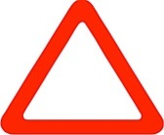 | 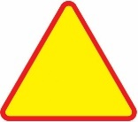
Addressed in chapter 1- see issue 10.
Addressed in chapter 1 – see issue 12.
Ab Danger warning signs
The Group noted that very few Contracting Parties use this sign.
A, 1 a “DANGEROUS BEND OR BENDS”
All signs examined appeared to convey the danger of “left bend” message.
A few countries use a strong curved (90 degree angle) bend and an arrowhead, not a curved pointed bend. The Group was divided as to whether it was worth considering matching the extent of the bend indicated on the sign to the local road conditions.
There was no agreement regarding whether the symbol used for C, 11 a should not also be used for A, 1 a.
Convention sign: | Examples from countries:
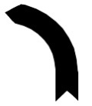 | 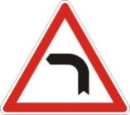 | 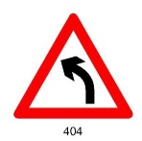 | 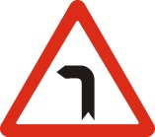 | 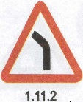
A, 1 b “DANGEROUS BEND OR BENDS”
All signs examined appeared to convey the danger of “right bend” message.
A few countries use a strong curved (90 degree angle) bend and an arrowhead, not a curved pointed bend. The Group was divided as to whether it was worth considering matching the extent of the bend indicated on the sign to the local road conditions.
There was no agreement regarding whether the symbol used for C, 11 b should not also be used for A, 1 b.
Convention sign: | Examples from countries:
 | 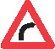 | 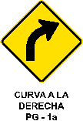 | 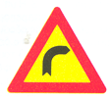
A, 1 c “DANGEROUS BEND OR BENDS”
No specific observations nor recommendations to Contracting Parties.
Convention sign: | Examples from countries:
 | 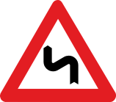 | 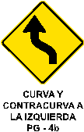 | 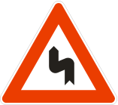
A, 1 d “DANGEROUS BEND OR BENDS”
No specific observations nor recommendations to Contracting Parties.
Convention sign: | Examples from countries:
 | 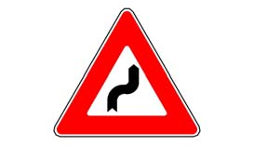 | 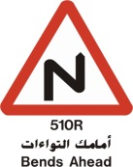 | 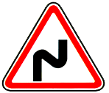
A, 2 a “DANGEROUS DESCENT”
A few countries use the image of a vehicle in addition to a percentage within the sign. A few countries use an arrow instead of a vehicle. Both approaches appear to contravene the Convention.
The Group did not agree on the most appropriate symbol or combination of symbols to indicate how dangerous the descent is and its direction (percentage, vehicle with or without a driver, arrow). However, the Group believed that indicating the direction of the descent was as important as indicating the degree of the descent.
Addressed in chapter 1 – see issue 12

Convention sign: | Examples from countries:
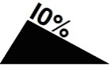 | 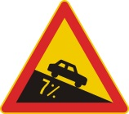 | 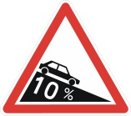 | 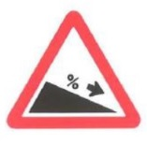
A, 2 b “DANGEROUS DESCENT”
No specific observations nor recommendations to Contracting Parties.
Addressed in chapter 1 – see issue 12
Convention sign: | Examples from countries:
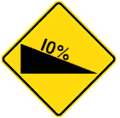 | No examples from countries
A, 2 c “DANGEROUS DESCENT”
The Group did not agree on the most appropriate symbol or combination of symbols to indicate how dangerous the descent is and its direction (percentage, vehicle with or without a driver, arrow). However, the Group believed that indicating the direction of the descent was as important as indicating the degree of the descent.
Convention sign: | Examples from countries:
 |  | 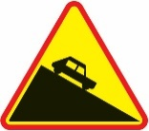 | 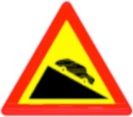
A, 2 d “DANGEROUS DESCENT”
No specific observations nor recommendations to Contracting Parties.
Convention sign: | Examples from countries:
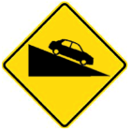 | 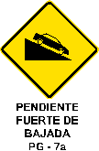
A, 3 a “STEEP ASCENT”
A few countries use the image of a vehicle in addition to a percentage within the sign. A few countries use an arrow instead of a vehicle. Both approaches appear to contravene the Convention.
The Group did not agree on the most appropriate symbol or combination of symbols to indicate how dangerous the ascent is and its direction (percentage, vehicle with or without a driver, arrow). However, the Group believed that indicating the direction of the ascent was as important as indicating the degree of the ascent.
Addressed in chapter 1 – see issue 12
Convention sign: | Examples from countries:
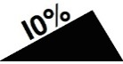 | 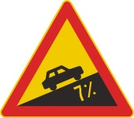 | 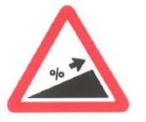
A, 3 b “STEEP ASCENT”
No specific observations nor recommendations to Contracting Parties.
Addressed in chapter 1 – see issue 12

Convention sign: | Examples from countries:
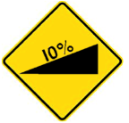 | No examples from countries
A, 3 c “STEEP ASCENT”
The Group did not agree on the most appropriate symbol or combination of symbols to indicate how dangerous the ascent is or its direction (percentage, vehicle with or without a driver, arrow). However, the Group believed that indicating the direction of the ascent was as important as indicating the degree of the ascent.
Convention sign: | Examples from countries:
A, 3 d “STEEP ASCENT”
No specific observations nor recommendations to Contracting Parties.
Convention sign: | Examples from countries:
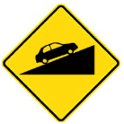 | 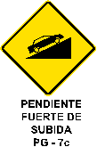
A, 4 a “CARRIAGEWAY NARROWS”
The Group noticed that some contracting parties include road marking on this sign. The Group believes this is not in conformity with the Convention.
Convention sign: | Examples from countries:
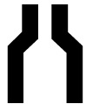 | 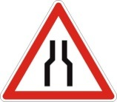 | 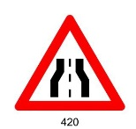 | 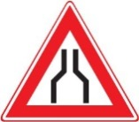
A, 4 b “CARRIAGEWAY NARROWS”
The Group noticed that some contracting parties include road marking on this sign. The Group believes this is not in conformity with the Convention.
Convention sign: | Examples from countries:
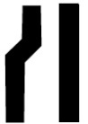 | 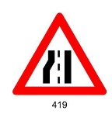 | 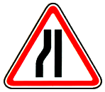 | 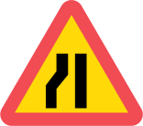
A, 5 “SWING BRIDGE”
The Group noted slight differences in the symbol of the bridge, the direction of the bridge opening (right side), the water underneath the bridge (waves replaced by solid half circles), and the use of two different colours on the same symbol (black and blue). Notwithstanding, the Group believed that the essential characteristics of the symbol have been retained.
Convention sign: | Examples from countries:
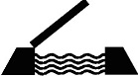 | 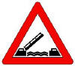 | 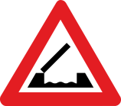 | 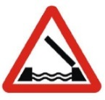 | 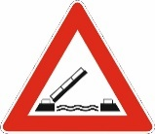
 | 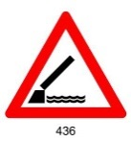 | 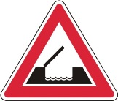 | 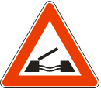 | 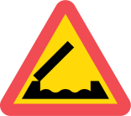
A, 6 “ROAD LEADS ON TO A QUAY OR RIVER BANK”
The Group noted that a few countries used two different colours on the same symbol (black and blue). Notwithstanding, the Group believed that the essential characteristics of the symbol have been retained.
Convention sign: | Examples from countries:
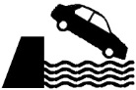 | 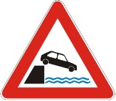 | 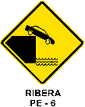 | 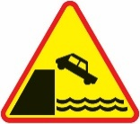
A, 7 a “UNEVEN ROAD”
The Group noticed that some contracting parties include three humps on the symbol. The Group believes this is not in conformity with the Convention.
Convention sign: | Examples from countries:
 | 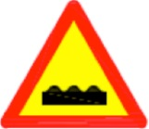 |  | 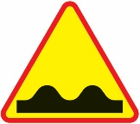
A, 7 b “UNEVEN ROAD”
The Group agreed that the definition of A, 7^{b} requires elaboration. The Group noticed that some contracting parties include three humps on the symbol. The Group believes this is not in conformity with the Convention.
Convention sign: | Examples from countries:
 | 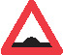
A, 7 c “UNEVEN ROAD”
The Group noticed that some contracting parties include three humps on the symbol. The Group believes this is not in conformity with the Convention.
Convention sign: | Examples from countries:
 |  | 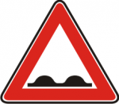 |  | 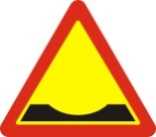
A, 8 “DANGEROUS SHOULDERS“
The Group noted slight differences in the symbols used and agreed that gravel should be clearly made part of the symbol.
Convention sign: | Examples from countries:
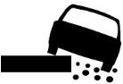 | 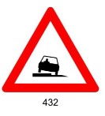 | 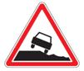 | 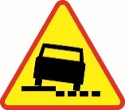
A, 9 “SLIPPERY ROAD”
The Group noted that most countries used a slightly different symbol and that one country had an upright vehicle. Notwithstanding, the Group believed that the essential characteristics of the symbol have been retained.
Convention sign: | Examples from countries:
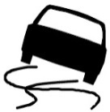 | 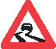 | 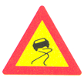 | 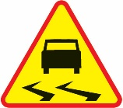
A, 10 a “LOOSE GRAVEL”
The Group noted that most countries used a slightly different symbol and that the loose gravel was not clear in some symbols. The Group agreed that the loose gravel should be clearly shown in the symbol and that for the countries which drive on the right hand side of the road, that the vehicle should be on the left hand side given that the danger will come from the left.
Convention sign: | Examples from countries:
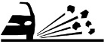 | 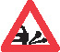 | 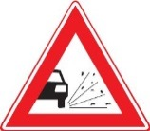 | 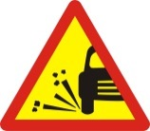
A, 10 b “LOOSE GRAVEL”
No specific observations nor recommendations to Contracting Parties.
Convention sign: | Examples from countries:
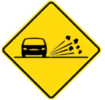 | 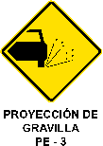
A, 11 a “FALLING ROCKS”
The Group noted that some countries included rocks on the carriageway which provide additional warning that fallen rocks are the main hazard. The Group agreed that having the rocks on the carriageway do not alter the essential characteristics of the symbol. The symbol as it presently is in the Convention should be retained.
Convention sign: | Examples from countries:
 | 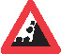 | 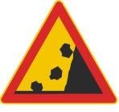 | 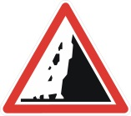 | 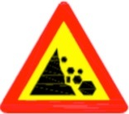
A, 11 b “FALLING ROCKS”
No specific observations nor recommendations to Contracting Parties.
Convention sign: | Examples from countries:
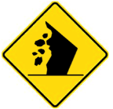
A, 12 a “PEDESTRIAN CROSSING”
The Group noted that many countries used a symbol of a person and a zebra crossing (stripes).
Addressed in chapter 1 – see issue 35
Contracting Parties should note the recommendation for this sign in section 1.2 of this document.

Convention sign: | Examples from countries:
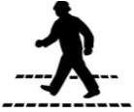 | 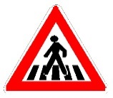 | 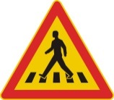 | 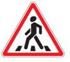 | 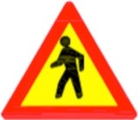
A, 12 b “PEDESTRIAN CROSSING”
No specific observations nor recommendations to Contracting Parties.
Addressed in chapter 1 – see issue 37
Contracting Parties should note the recommendation for this sign in section 1.2 of this document.
Convention sign: | Examples from countries:
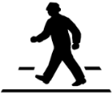 | 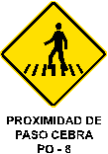 | 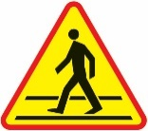
A, 13 “CHILDREN”
No specific observations nor recommendations to Contracting Parties.
Addressed in chapter 1 – see issue 37
Contracting Parties should note the recommendation for this sign in section 1.2 of this document.
Convention sign: | Examples from countries:
 | 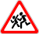 | 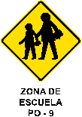 | 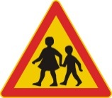 | 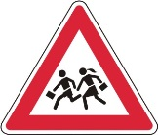
A, 14 “CYCLISTS ENTERING OR CROSSING”
1. The Group noted that some countries did not include a person as part of the symbol.
2. The Group also noted that there was a possibility that a symbol without a person sitting on the bicycle could be used. Addressed in chapter 1 – see issue 36.
3. The Group recommended that a Contracting Party should use this symbol consistently (i.e. with or without a cyclist such as in the C, 3 c and D, 4 symbols).
4. Contracting Parties should note the recommendation for this sign in section 1.2 of this document.

Convention sign: | Examples from countries:
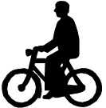 | 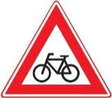 |  | 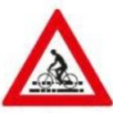 | 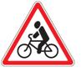
A, 15 a “DOMESTIC ANIMAL CROSSING”
No specific observations nor recommendations to Contracting Parties.
Convention sign: | Examples from countries:
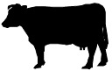 | 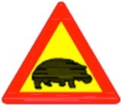 | 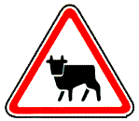 | 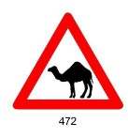 | 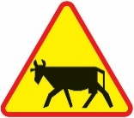
A, 15 b “WILD ANIMAL CROSSING”
No specific observations nor recommendations to Contracting Parties.
Convention sign: | Examples from countries:
 |  | 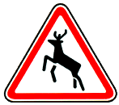 | 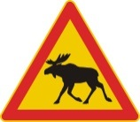 | 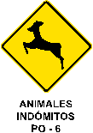
A, 16 “ROAD WORKS”
No specific observations nor recommendations to Contracting Parties.
Convention sign: | Examples from countries:
 | 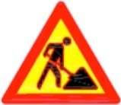 | 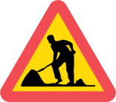 | 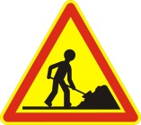 | 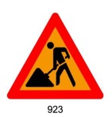
A, 17 a “LIGHT SIGNALS“
No specific observations nor recommendations to Contracting Parties.
Convention sign: | Examples from countries:
 | 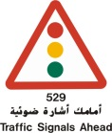 | 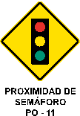 | 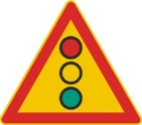
A, 17 b “LIGHT SIGNALS“
Addressed in chapter 1 – see issue 36
No specific observations nor recommendations to Contracting Parties.
Contracting Parties should note the recommendation for this sign in section 1.2 of this document.
Convention sign: | Examples from countries:
 | No examples from countries
A, 17^{c} “LIGHT SIGNALS“
Addressed in chapter 1 – see issue 36
No specific observations nor recommendations to Contracting Parties.
Contracting Parties should note the recommendation for this sign in section 1.2 of this document.
Convention sign: | Examples from countries:
 | 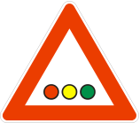 | 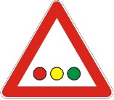 | 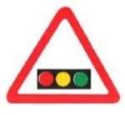
A, 18 a “INTERSECTION WHERE THE PRIORITY IS PRESCRIBED BY THE GENERAL PRIORITY RULE”
One country uses a “plus” symbol instead of the “X” shaped symbol but under the Convention, the “plus” symbol is to be used with the Ab model. The Group agreed that the current “X” shaped symbol should be the only symbol used with Aa model.
Convention sign: | Examples from countries:
 | 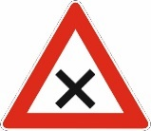 | 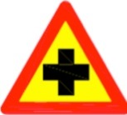 | 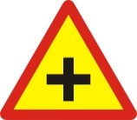
A, 18 b “INTERSECTION WHERE THE PRIORITY IS PRESCRIBED BY THE GENERAL PRIORITY RULE”
No comment.
Convention sign: | Examples from countries:
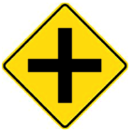 | 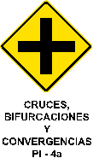
A, 18 c “INTERSECTION WHERE THE PRIORITY IS PRESCRIBED BY THE GENERAL PRIORITY RULE”
The Group stressed that all Contracting Parties must ensure that their general priority rule symbol should be indicated by the same width of all of the elements comprising the symbol.
Addressed in chapter 1 – see issue 14
Contracting Parties should note the recommendation for this sign in section 1.2 of this document.
Convention sign: | Examples from countries:
 | 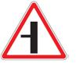 | 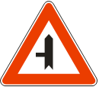 | 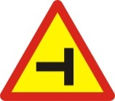
A, 18 d “INTERSECTION WHERE THE PRIORITY IS PRESCRIBED BY THE GENERAL PRIORITY RULE”
Addressed in chapter 1 – see issue 14 and 36
Contracting Parties should note the recommendation for this sign in section 1.2 of this document.
Convention sign: | Examples from countries:
 | 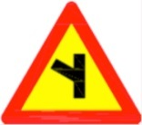 | 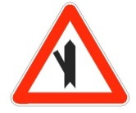 | 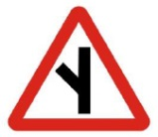
A, 18 e “INTERSECTION WHERE THE PRIORITY IS PRESCRIBED BY THE GENERAL PRIORITY RULE”
Addressed in chapter 1 – see issue 14 and 36
Contracting Parties should note the recommendation for this sign in section 1.2 of this document.
Convention sign: | Examples from countries:
 | 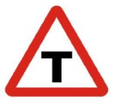 | 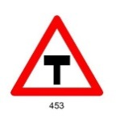 | 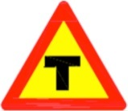
A, 18 f “INTERSECTION WHERE THE PRIORITY IS PRESCRIBED BY THE GENERAL PRIORITY RULE”
Addressed in chapter 1 – see issue 14 and 36
Contracting Parties should note the recommendation for this sign in section 1.2 of this document.
Convention sign: | Examples from countries:
 | 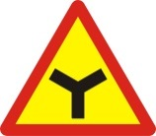 | 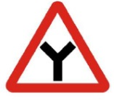 | 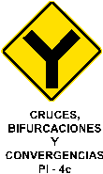
A, 18 g “INTERSECTION WHERE THE PRIORITY IS PRESCRIBED BY THE GENERAL PRIORITY RULE”
Addressed in chapter 1 – see issue 14 and 36
Contracting Parties should note the recommendation for this sign in section 1.2 of this document.
Convention sign: | Examples from countries:
 | 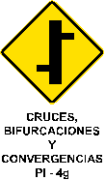 | 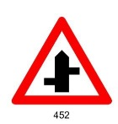 | 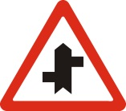
A, 19 a “INTERSECTION WITH A ROAD THE USERS OF WHICH MUST GIVE WAY”
Some countries do not use the arrow head or the “V” shape at the bottom. The Group recommended using the symbol in the Convention without altering it (that is, having the arrow head and the “V” shape at the bottom). The Group clarified that the arrow head and the “V” shape at the bottom, and the differences in the proportion of the line widths, are essential characteristics of the symbol.
Convention sign: | Examples from countries:
 |  | 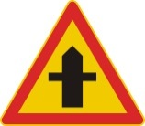 | 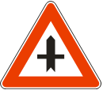
A, 19 b “INTERSECTION WITH A ROAD THE USERS OF WHICH MUST GIVE WAY”
Some countries do not use the arrow head or the “V” shape at the bottom. The Group recommended using the symbol in the Convention without altering it (that is, having the arrow head and the “V” shape at the bottom). The Group clarified that the arrow head and the “V” shape at the bottom, and the differences in the proportion of the line widths, are essential characteristics of the symbol.
Addressed in chapter 1 – see issue 14
Convention sign: | Examples from countries:
 |  | 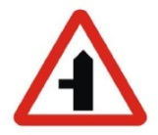 | 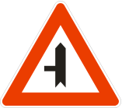
A, 19 c “INTERSECTION WITH A ROAD THE USERS OF WHICH MUST GIVE WAY”
Some countries do not use the arrow head or the “V” shape at the bottom. The Group recommended using the symbol in the Convention without altering it (that is, having the arrow head and the “V” shape at the bottom). The Group clarified that the arrow head and the “V” shape at the bottom, and the differences in the proportion of the line widths, are essential characteristics of the symbol.
Addressed in chapter 1 – see issue 14 and 36
Contracting Parties should note the recommendation for this sign in section 1.2 of this document.
Convention sign: | Examples from countries:
 |  | 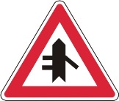 | 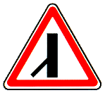
A, 20 “INTERSECTION WITH A ROAD TO WHOSE USERS DRIVERS MUST GIVE WAY”
The Group noted that only a very few countries use the sign A, 20 while the majority of countries use the sign B, 1 with additional panel H, 1. This second possibility is introduced with paragraph 6 Article 10 (first sentence). However, the Group noted that both the paragraph 6 as well as point 20 (a) of Section A of Annex 1 require that the same warning is implemented by different signs both being obligatory.
Addressed in chapter 1 – see issue 15 and 36
Contracting Parties should note the recommendation for this sign in section 1.2 of this document.
Convention sign: | Examples from countries:
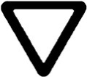 | 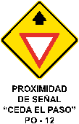
A, 21 a and A, 20 b “INTERSECTION WITH A ROAD TO WHOSE USERS DRIVERS MUST GIVE WAY”
The Group noted that only a very few countries or none use the sign A, 21 a and A, 21 b while the majority of countries use the sign B, 1 supplemented by an additional panel bearing the “STOP” inscription and the figure indicating the distance to the sign B, 2 a or B, 2 b. This second possibility is introduced with paragraph 6 Article 10 (second sentence). However, the Group noted that both the paragraph 6 as well as point 20 (b) and 20 (c) of Section A of Annex 1 require that the same warning is implemented by different signs both being obligatory.
Addressed in chapter 1 – see issue 15 and 36
Contracting Parties should note the recommendation for this sign in section 1.2 of this document.
Convention sign: | Examples from countries:
 | 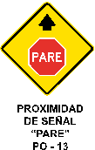 | 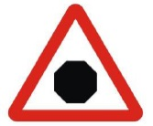
A, 22 “ROUNDABOUT”
Addressed in chapter 1 – see issue 37
No specific observations nor recommendations to Contracting Parties.
Convention sign: | Examples from countries:
A, 23 “TWO-WAY TRAFFIC”
Addressed in chapter 1 – see issue 37
No specific observations nor recommendations to Contracting Parties.
Convention sign: | Examples from countries:
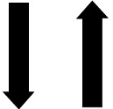 |  | 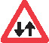 | 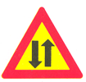
A, 24 TRAFFIC CONGESTION
The Group noted that many countries used slightly different symbols and in some cases, more than three vehicles were included in the symbol and the vehicles have red lights. Nevertheless, the Group believed that the essential characteristics of the symbol have been retained.
Convention sign: | Examples from countries:
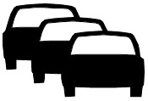 | 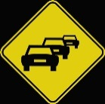 | 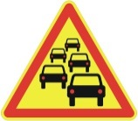 | 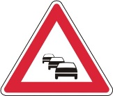 | 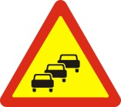
A, 25 “LEVEL CROSSINGS”
The Group noted that many countries used slightly different A, 25 symbols to indicate a gated level crossing except Nigeria which uses a symbol of a modern train. The Group considers that the train symbol is not in conformity with the Convention. The symbol of a train is to be used for the sign A, 26 a.
Addressed in chapter 1 – see issue 37
Contracting Parties should note the recommendation for this sign in section 1.2 of this document.
Convention sign: | Examples from countries:
 | 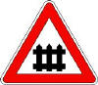 | 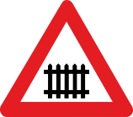 | 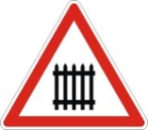 | 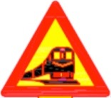
A, 26 a “OTHER LEVEL CROSSINGS”
The Group noted several countries use a modern symbol for the train (Bosnia and Herzegovina, Croatia, Iran, Luxembourg, Nigeria and Serbia). The Group considers this symbol not to be in conformity with the Convention. It does not adequately depict a train; might be confused with the bus or tram; is three dimensional; and shows two headlights instead of three (no road vehicle has three headlights while locomotives typically have three). In addition, the symbol used by Nigeria combines the symbol of a red/black coloured modern train and a stop sign. This combination is also not in conformity with the Convention.
The other countries use the symbol of a steam engine with some variations. The Group believes, they all retain the essential characteristics and therefore are in conformity with the Convention.
The Group believes that as long as the comprehension results of different symbols for the train are not available, the existing steam engine symbol should be retained.
Convention sign: | Examples from countries:
 | 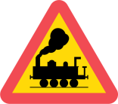 | 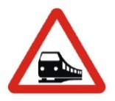 | 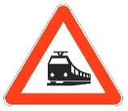 | 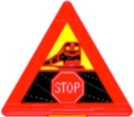
A, 26 b “OTHER LEVEL CROSSINGS”
No specific observations nor recommendations to Contracting Parties.
Convention sign: | Examples from countries:
 | 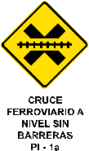
A, 27 “INTERSECTION WITH A TRAMWAY LINE”
The Group believes that an essential feature of the tramway symbol is the presence of a pantograph. It should be of a diamond shape which is not the case for Albania, Denmark, France, Italy, Republic of Moldova and Vietnam. Some countries place the pantograph in the middle which the Group considers to be in conformity with the Convention. Also, the symbol should not include the tramway tracks (as it is the case for Belgium, Croatia, France, Finland, Montenegro, Norway, Poland, Slovakia and Switzerland) to ensure that the tramway symbol is understood by itself.
Convention sign: | Examples from countries:
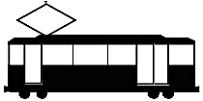 | 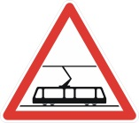 | 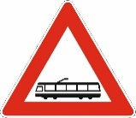 | 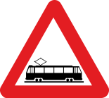 | 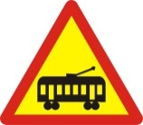

A, 28 a, A, 28 b, A, 28 c “SIGNS TO BE PLACED IN THE IMMEDIATE VICINITY OF LEVEL-CROSSINGS”
The Group noted that some countries use signs that do not appear to be in conformity with the Convention.
Addressed in chapter 1 – see issue 16
Convention sign: | Examples from countries:
 | 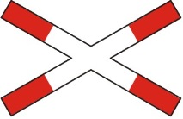 | 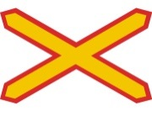 | 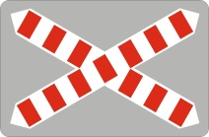 | 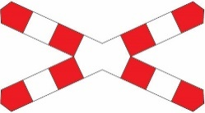

Convention sign: | Examples from countries:
 |  | 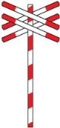

Convention sign: | Examples from countries:
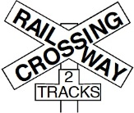 | 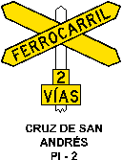
A, 29 a; A, 29 b and A, 29 c “ADDITIONAL SIGNS AT APPROACHES TO LEVEL-CROSSINGS OR SWING BRIDGES”
The Group noted that one country (Sweden) uses the panel that appears not to be in conformity with the Convention.
The Group recommended to reproduce the images of signs for both sides of the carriageway.
The Group believes, in terms of visibility, that the bars (one, two or three) be placed in the upper part of the panels (ref. to the sign from Finland) or preferably centred on the panels. The Group recommended including the preferred variant on the images reproduced in the Convention.
Addressed in chapter 1 – see issue 11 and 12
Convention sign: | Examples from countries:
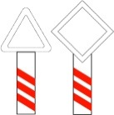 | 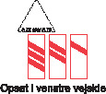 | 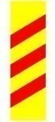
 | 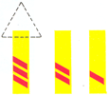
A, 30 “AIRFIELD”
The Group also noted that some countries have the airplane symbol in a downward direction. Nevertheless, the Group believed that the essential characteristics of the symbol have been retained.
Convention sign: | Examples from countries:
 | 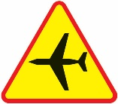 | 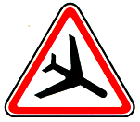 | 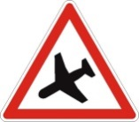
A, 31 “CROSS-WIND”
The Group noted that some countries use red colour for the symbol and recommended that the colour used be the same as in the Convention. For the other countries, the Group believed that the essential characteristics of the symbol have been retained.
Convention sign: | Examples from countries:
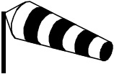 | 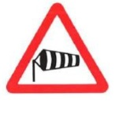 | 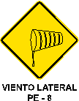 | 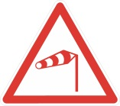
A, 32 “OTHER DANGERS”
The Group noted that some countries do not use an exclamation point and recommended that that country changes its symbol to be the same as in the Convention. For the other countries, the Group believed that the essential characteristics of the symbol have been retained.
Convention sign: | Examples from countries:
 | 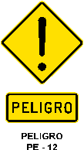 | 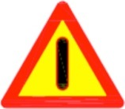 | 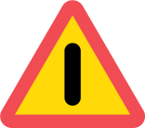
Observations and recommendations to Contracting Parties regarding B section signs
B, 1 “GIVE WAY”
The Group noted that some countries included the text “Give way” within the sign. The Group noted that, for the countries wishing to include the text “Give way”, there is the possibility that this could be done in an additional panel or within the sign itself (Article 8, paragraph 3). Addressed in in chapter 1 – see issue 11 and 12
Convention sign: | Examples from countries:
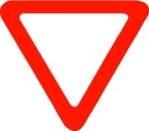 | 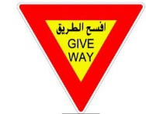 | 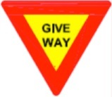 | 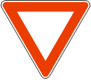
B, 2 a “STOP”
The Group recommended that, in relation to the signs used by the countries, the size of “Stop” should be in conformity with the size specified in the text of the Convention
Addressed in in chapter 1 – see issue 11 and 12.
Convention sign: | Examples from countries:
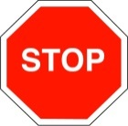 |  | 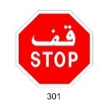
B, 2 b “STOP”
The Group noted that very few countries use this sign (refer to Part IV of the Convention).
Addressed in in chapter 1 – see issue 36
B, 3 “PRIORITY ROAD”
The Group noted that some countries do not use the black narrow strip for the yellow or orange square in the centre, and recommended that they do so.
Addressed in in chapter 1 – see issue 11, 12 and 36.
Convention sign: | Examples from countries:
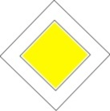 | 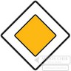 | 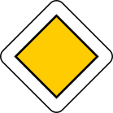
B, 4 “END OF PRIORITY”
The Group noted that some countries do not use the black narrow strip for the yellow or orange square in the centre, and recommended that they do so.
Addressed in in chapter 1 – see issue 11, 12 and 36.
Convention sign: | Examples from countries:
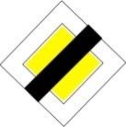 |  | 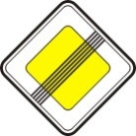
B, 5 “PRIORITY FOR ONCOMING TRAFFIC”
The Group noted that some countries do not use the arrows (i.e. length, width, positioning) as they appear in the Convention. Addressed in in chapter 1 – see issue 11, 12, 35 and 37
Contracting Parties should note the recommendation for this sign in section 1.2 of this document.
Convention sign: | Examples from countries:
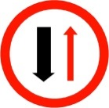 |  |  |  | 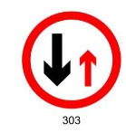
B, 6 “PRIORITY OVER ONCOMING TRAFFIC”
The Group noted that some countries do not use the arrows (i.e. length, width, positioning) as they appear in the Convention. Addressed in in chapter 1 – see issue 11, 12, 35 and 37
Contracting Parties should note the recommendation for this sign in section 1.2 of this document.
Convention sign: | Examples from countries:
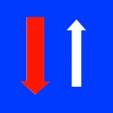 |  | 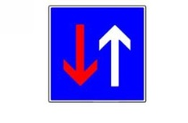 | 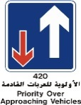 | 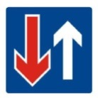
 |  |  | 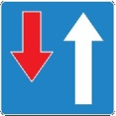 | 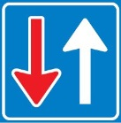
Observations and recommendations to Contracting Parties regarding C section signs
Addressed in chapter 1 – issues 11 and 12.
C, 1 a “NO ENTRY”
The Group noted that one country included the text “No Entry” within the sign. The Group noted that, for the countries wishing to include the text “No Entry”, there is the possibility that this could be done in an additional panel or within the sign itself (Article 8, paragraph 3).
Convention sign: | Examples from countries:
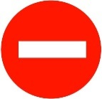 |  | 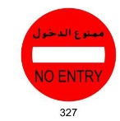
C, 1 b “NO ENTRY”
The Group noted that only one sign (C, 1 a or C, 1 b) could be used (Article 5, paragraph 2(a)).
Contracting Parties should note the recommendation for this sign in section 1.2 of this document.
Convention sign: | Examples from countries:
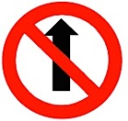 |  | 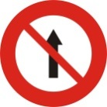 | 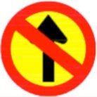
C, 2 “CLOSED TO ALL VEHICLES IN BOTH DIRECTIONS”
The Group noted some visual differences in the width of the border of the red circle, but believed that the essential characteristics of the symbol have been retained.
Convention sign: | Examples from countries:
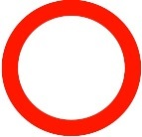 |  | 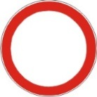
C, 3 a “NO ENTRY FOR ANY POWER DRIVEN VEHICLE EXCEPT TWO-WHEELED MOTOR CYCLES WITHOUT SIDE-CAR”
The Group noted some visual differences in the car symbol, but believed that the essential characteristics have been retained.
Addressed in chapter 1 – issue 17
Convention sign: | Examples from countries:
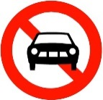 | 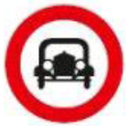 | 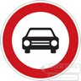 | 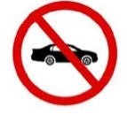 | 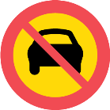
C, 3 b “NO ENTRY FOR MOTOR CYCLES”
The Group noted that there were many differences in the motor cycle symbol, including the presence or absence of a motor cycle driver, but believed that the essential characteristics of the symbol have been retained. The Group emphasized that it should be clear that the symbol is referring to a motorcycle. The Group is further considering whether or not the symbol depicted on this sign should be with or without driver.
Convention sign: | Examples from countries:
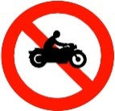 | 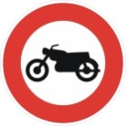 |  | 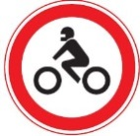 | 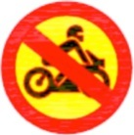
C, 3 c “NO ENTRY FOR CYCLES”
The Group noted that there were differences in the bicycle symbol, but believed that the essential characteristics of the symbol have been retained. The Group emphasized that it should be clear that the symbol is referring to a bicycle.
Convention sign: | Examples from countries:
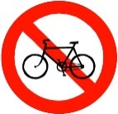 |  |  | 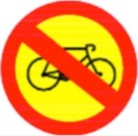 | 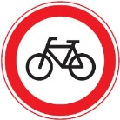
C, 3 d “NO ENTRY FOR MOPEDS”
The Group noted that there were differences in the moped symbol, but believed that the essential characteristics of the symbol have been retained. The Group emphasized that it should be clear that the symbol is referring to a moped.
Convention sign: | Examples from countries:
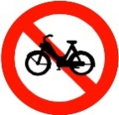 |  | 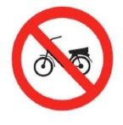 | 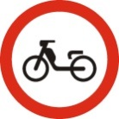
C, 3 e “NO ENTRY FOR GOODS VEHICLES”
The Group noted that there were differences in the goods vehicles symbol, but believed that the essential characteristics of the symbol have been retained.
Convention sign: | Examples from countries:
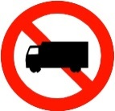 |  |  | 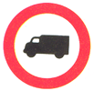 | 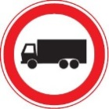
C, 3 f “NO ENTRY FOR ANY POWER DRIVEN VEHICLE DRAWING A TRAILER OTHER THAN A SEMI-TRAILER OR A SINGLE AXLE TRAILER”
1. The Group noted that some countries used a different symbol (entire goods vehicle with single axle trailer). This is considered as a change of the essential characteristics of the symbol. Some countries also use a symbol with two axles which the Group believed better reflects the meaning of this provision. Addressed in chapter 1 – issue 37
2. Contracting Parties should note the recommendation for this sign in section 1.2 of this document.
Convention sign: | Examples from countries:
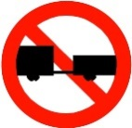 | 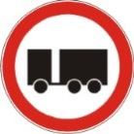 | 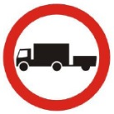
C, 3 g “NO ENTRY FOR ANY POWER DRIVEN VEHICLE DRAWING A TRAILER”
No specific observations nor recommendations to Contracting Parties.
Convention sign: | Examples from countries:
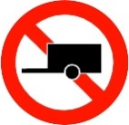 | 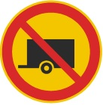
C, 3 h “NO ENTRY FOR VEHICLES CARRYING DANGEROUS GOODS FOR WHICH SPECIAL SIGN PLATING IS PRESCRIBED”
The Group noted that countries are using different colours (yellow, orange and red) for the symbols of the vehicles carrying dangerous goods. The Group recommended that the colour used should be orange (as per the symbol in the Convention). The Group was advised that only UNECE member States that have acceded to the 1968 Convention on Road Signs and Signals are able to accede to the 1971 European Agreement Supplementing the 1968 Convention. Addressed in chapter 1 – issue 2
Convention sign: | Examples from countries:
C, 3 i “NO ENTRY FOR PEDESTRIANS”
The Group noted that one country used a slightly different symbol (person standing). The Group believes that the symbol of a pedestrian has to reflect movement. Addressed in chapter 1 – issue 37
Convention sign: | Examples from countries:
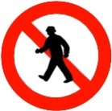 |  | 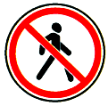 | 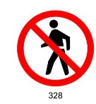 | 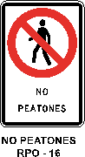
C, 3 j “NO ENTRY FOR ANIMAL-DRAWN VEHICLES”
The Group noted that some countries used a different symbol of the animal-drawn vehicles (entire animal and half of the vehicle being drawn), and considered this as a change of the essential characteristics of the symbol. The Group believed that the entire symbol as it appears in the Convention should be used.
Convention sign: | Examples from countries:
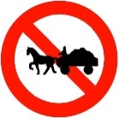 | 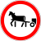 | 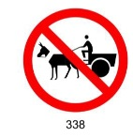 | 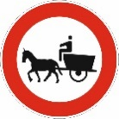 | 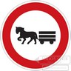
C, 3 k “NO ENTRY FOR HANDCARTS”
The Group noted that there were differences in the symbols, but believed that the essential characteristics of the symbol have been retained. Addressed in chapter 1 – issue 37
Convention sign: | Examples from countries:
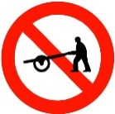 | 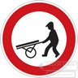 | 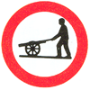 | 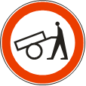
C, 3 l “NO ENTRY FOR POWER DRIVEN AGRICULTURAL VEHICLES”
The Group noted that there were differences in the symbols, but believed that the essential characteristics of the symbol have been retained.
Convention sign: | Examples from countries:
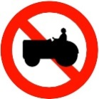 |  | 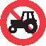 | 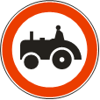
C, 3 m “NO ENTRY FOR VEHICLES CARRYING MORE THAN A CERTAIN QUANTITY OF EXPLOSIVES OR READILY INFLAMMABLE SUBSTANCES”
No observations made.
Convention sign:  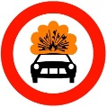 | Examples from countries:  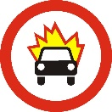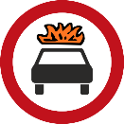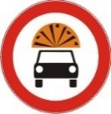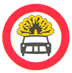
C, 3 N “NO ENTRY FOR VEHICLES CARRYING MORE THAN A CERTAIN QUANTITY OF SUBSTANCES LIABLE TO CAUSE WATER POLLUTION”
No observations made.
Convention sign:  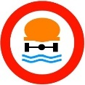 | Examples from countries:  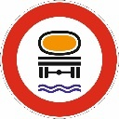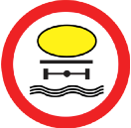
C, 4 a “NO ENTRY FOR POWER DRIVEN VEHICLES”
The Group believed that a horizontal bar was not in conformity with Section C.I, paragraph 2. Addressed in chapter 1 – issue 17.
Convention sign: | Examples from countries:
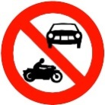 | 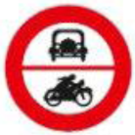 | 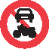 | 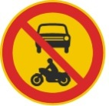
 | 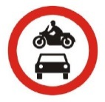 | 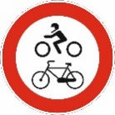 | 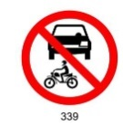
C, 4 b “NO ENTRY FOR POWER DRIVEN VEHICLES OR ANIMAL-DRAWN VEHICLES”
Addressed in chapter 1 – issue 17.
The Group believed that bars separating the symbols were not in conformity with Section C.I, paragraph 2.
Convention sign: | Examples from countries:
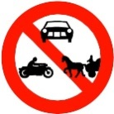 | 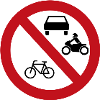 | 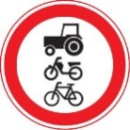 | 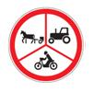 | 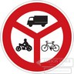
C, 5 “NO ENTRY FOR VEHICLES HAVING AN OVERALL WIDTH EXCEEDING … METRES”
The Group believed that the sign in the Convention is appropriate.
Addressed in chapter 1 – issue 35.
Convention sign: | Examples from countries:
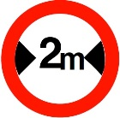 | 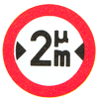 | 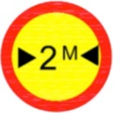 | 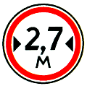
C, 6 “NO ENTRY FOR VEHICLES HAVING AN OVERALL HEIGHT EXCEEDING … METRES”
The Group believed that the sign in the Convention is appropriate.
Addressed in chapter 1 – issue 35.
Convention sign: | Examples from countries:
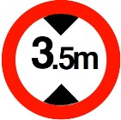 | 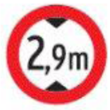 | 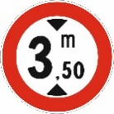 | 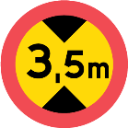
C, 7 “NO ENTRY FOR VEHICLES EXCEEDING … TONNES LADEN MASS”
The Group noted that one country used a sign with the image of a goods vehicle, and believe that this was a change of the essential characteristics of the symbol. The Group also noted that there was a difference in the casing of the symbol “T” (i.e. some countries use lower casing “t”) as well as its positioning within the sign, and also that some countries used commas and period marks. The Group believed that the symbol in the Convention should be modified from upper to lower casing (“t”) and that the positioning of the symbol “t” should appear where it currently appears in the Convention. Addressed in chapter 1 – issue 37.
The Group also believed, that where a comma or period mark is used, that the second digit should be two-thirds the size of the first digit, and that the lower casing “t” should appear immediately after the second digit and at the same level, and be proportionately visible. If a fraction is required, the Group believed that it should be to the nearest tenth (i.e. 3.5t, 7.8t). If it is an integer (i.e. 7.00t), it should appear without any zeros or period marks (i.e. 7t).
Addressed in chapter 1 – issue 35.
Convention sign: | Examples from countries:
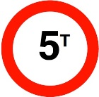 | 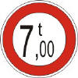 | 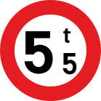 | 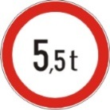 | 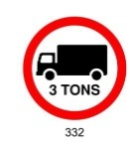
 | 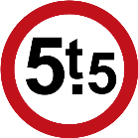 | 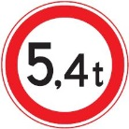 | 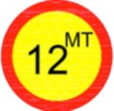 | 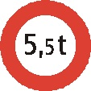
C, 8 “NO ENTRY FOR VEHICLES HAVING A MASS EXCEEDING … TONNES ON ONE AXLE”
The Group noted that there was a difference in the casing of the symbol “T” (i.e. some countries use lower casing “t”), its positioning within the sign, and also that some countries used commas and period marks. The Group also noted differences in the arrowheads and axles. The Group believed that the symbol in the Convention should be modified from upper to lower casing (“t”) and that the positioning of the symbol “t” should appear where it currently appears in the Convention. Addressed in chapter 1 – issue 37.
Finally, the Group believed, that where a comma or period mark is used, that the second digit should be two-thirds the size of the first digit, and that the lower casing “t” should appear immediately after the second digit and at the same level, and be proportionately visible. If a fraction is required, the Group believed that it should be to the nearest tenth (i.e. 3.5t, 7.8t). If it is an integer (i.e. 7.00t), it should appear without any zeros or period marks (i.e. 7t).
Convention sign: | Examples from countries:
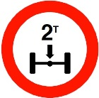 | 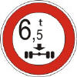
 | 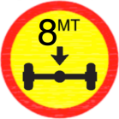 | 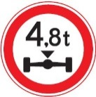 | 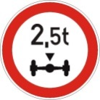 | 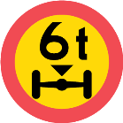
C, 9 “NO ENTRY FOR VEHICLES OR COMBINATIONS OF VEHICLES EXCEEDING … METRES IN LENGTH”
The Group noted that there was a difference in the casing of the symbol “m” (i.e. some countries use upper casing “M” where the Cyrillic alphabet is used) and that one country did not use the symbol of a truck. The Group believed that the symbol “m” should be placed after the number, and not below the number. Addressed in chapter 1 – issue 37.
Convention sign: | Examples from countries:
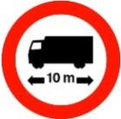 | 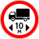 | 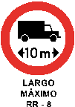 | 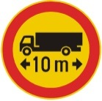 | 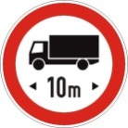
 | 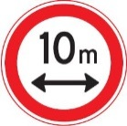 | 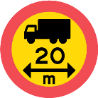 | 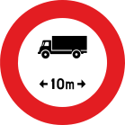
C, 10 “DRIVING OF VEHICLES LESS THAN METRES APART PROHIBITED”
Some countries (e.g. Finland, Sweden) place the symbol “m” under the number and they use an arrow.
One country (Croatia) uses a symbol for goods vehicle in addition to the symbol of a passenger vehicle. The Group believed this is not in conformity with the Convention. The application of this sign can be limited to the type of vehicle by the use of the relevant additional panel.
The Group believed that the symbol “m” should be placed after the number (not below the number).
Convention sign: | Examples from countries:
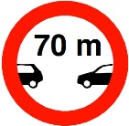 | 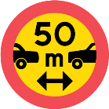 | 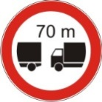 | 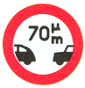
C, 11 a “NO LEFT TURN”
The Group considered that most countries use the sign in conformity with the Convention. Some countries (e.g. Finland) use the oblique bar that crosses from the upper left to the bottom right. The Group considered it not to be in conformity with the Convention.
Some countries (e.g. Chile) use an “arrow” symbol without any curvature.
Convention sign: | Examples from countries:
 | 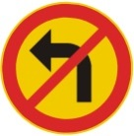 |  | 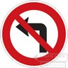
C, 11 b “NO RIGHT TURN”
The Group considered that most countries use the sign in conformity with the Convention. Some countries (e.g. Austria, Switzerland) use the oblique bar that crosses from the upper left to the bottom right. The Group considered it not to be in conformity with the Convention.
Some countries (e.g. Chile) use an “arrow” symbol without any curvature.

Convention sign: | Examples from countries:
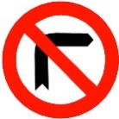 |  |  | 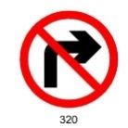
C, 12 “NO U-TURNS”
The Group considered that most countries use the sign in conformity with the Convention. Some countries (e.g. the Netherlands) do not use the oblique bar on the sign. The Group considered it not to be in conformity with the Convention.
Some countries (e.g. Ukraine) use a white outline around the red oblique bar.
Convention sign: | Examples from countries:
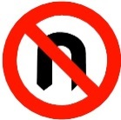 |  | 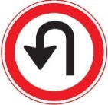
C, 13 aa “OVERTAKING PROHIBITED”
The Group noted that some countries (Austria, Czech Republic, Latvia, Slovakia, Sweden, Switzerland) included a line on the sign illustrating a pavement.
Convention sign: | Examples from countries:
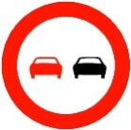 | 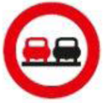 | 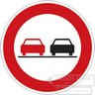
C, 13 ab “OVERTAKING PROHIBITED”
The Group noted that one country (Nigeria) put the vehicle symbols one below the other and not aligned horizontally. The Group also noted that one country (Kuwait) uses the oblique bar over only one of the vehicle symbols and not placed in the middle of the sign.
The Group recommended Nigeria to align both vehicle symbols and Kuwait not to use this sign, especially that Kuwait uses the C, 13^{aa} sign too.
Convention sign: | Examples from countries:
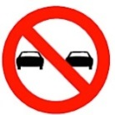 | 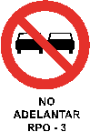 | 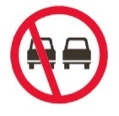 | 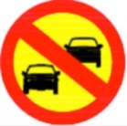
C, 13 ba “OVERTAKING BY GOODS VEHSILCES PROHIBITED”
The Group noted that some countries use symbols for the vehicles different than in the Convention. One country (Slovakia) uses a very narrow symbol for the truck vehicle. Some other countries (Bosnia and Herzegovina, Montenegro and Serbia) use a truck vehicle symbol that does not resemble a truck vehicle of the Convention. One country (Vietnam) puts a front image of the vehicle, which does not indicate the overtaking manoeuvre. One country (Uzbekistan) does not align the vehicle symbols horizontally. Again, some countries include a line on the sign illustrating a pavement.
The Group recommended that no line illustrating the pavement should be included in the sign. The Group also recommended that countries should pay more attention to the design details and ensure that the vehicle symbols resemble that of the Convention.
Convention sign: | Examples from countries:
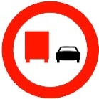 |  | 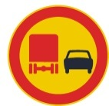 | 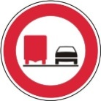 | 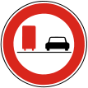
 |  |  | 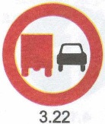 | 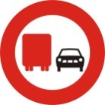
C, 13 bb “OVERTAKING BY GOODS VEHSILCES PROHIBITED”
The Group noted that one country (Kuwait) uses the oblique bar over the truck vehicle symbol and not placed in the middle of the sign.
The Group recommended Kuwait not to use this sign, especially that Kuwait uses the C, 13^{ba} sign too. As per Article 5, para 2 (a) of the Convention a Contracting Party should adopt only one of these signs.
Convention sign: | Examples from countries:
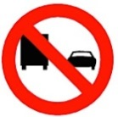 | 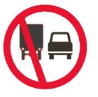
C, 14 “MAXIMUM SPEED LIMITED TO THE FIGURE INDICATED”
The Group noted some visual differences in the width of the border of the red circle and the size of the digits, but believed that the essential characteristics of the sign have been retained.
The Group also noted that one country (Guyana) uses the C, 14 sign placed on a rectangular panel with additional inscriptions. While this is permitted by the Convention (Article 8, para 3), the Group was of the opinion that the sign C, 14 should not be placed on panels with additional inscriptions.
Addressed in chapter 1 – issue 37.
Convention sign: | Examples from countries:
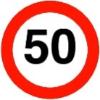 | 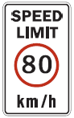 | 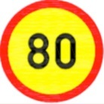 | 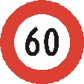
C, 15 “USE OF AUDIBLE WARNING DEVICES PROHIBITED”
The Group noted some visual differences in the symbol, but believed that the essential characteristics of the sign have been retained.
Some countries (Latvia and Ukraine) do not use the oblique bar on the sign, and one country (Kuwait) used the bar from right to left. The Group considered both acts not in conformity with the Convention.
Convention sign: | Examples from countries:
 | 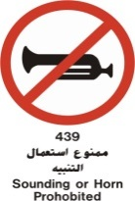 | 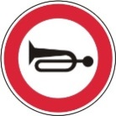 |  | 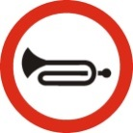
C, 16 “PASSING WITHOUT STOPPING PROHIBITED”
The Group noted some visual differences in the width of the border of the red circle, but believed that the essential characteristics of the sign have been retained.
The Group also noted that one country (Denmark) uses the inscription “Stop” on the sign, which should be removed as the meaning of the bar is “Stop”.
Two countries (Czech Republic and Slovakia) use a thin horizontal line instead of a black horizontal bar. The Group considered it not to be in conformity with the Convention.
Convention sign: | Examples from countries:
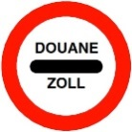 |  | 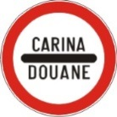 | 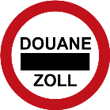
C, 17 a “END OF ALL LOCAL PROHIBITIONS IMPOSED ON MOVING VEHICLES”
The Group noted many visual differences in the width and the type of the black/dark grey band or grey parallel lines sloping downwards from right to left used by Contracting 2. Parties. The Group believed all Contracting Parties should use the black/dark grey band or a band consisting of black or grey parallel lines sloping downwards from right to left.
The Group believed that the Contracting Parties should give more attention to the angle of band/parallel lines to be as in the Convention.
Addressed in chapter 1 – issue 7 and 12.
Convention sign: | Examples from countries:
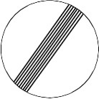 |  | 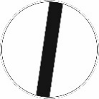 |  | 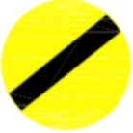
C, 17 b “END OF SPEED LIMIT”, C, 17 c “END OF PROHIBITION OF OVERTAKING”, C, 17 d “END OF PROHIBITION OF OVERTAKING FOR GOODS VEHICLES”
The Group believed that what has been said about the type, width and the angle of the black bar in sign C, 17 a applies to C, 17 b.
The Group noted many visual differences in the type of digits used by Contracting Parties, and recommended that all the digits/symbols should be light grey and not solid black or white. The Group recommended that the oblique bar consisting of parallel lines strikes through both digits. The solid bar can be interrupted over the digit.
The Group noted that one country (Vietnam) introduces a blue rim on the sign C, 17 b, which is not considered to be in conformity with the Convention.
Addressed in chapter 1 – issue 7 and 12.
Convention sign: | Examples from countries:
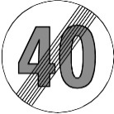 | 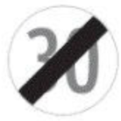 | 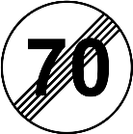 | 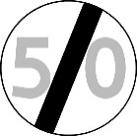 | 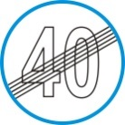
Convention sign: | Examples from countries:
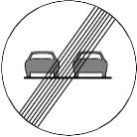 |  | 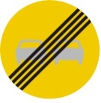 | 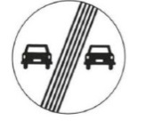 | 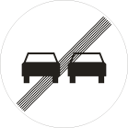
Convention sign: | Examples from countries:
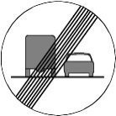 | 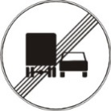 | 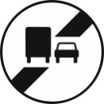
C, 18 “PARKING PROHIBITED”, C, 19 “STANDING AND PARKING PROHIBITED”
The Group noted some visual differences in the width of the border of the red circle (also in proportion to the width of the oblique bar), and differences in the shade of the blue colour as well as the use of white separation within the sign and a sign’s white external rim (essentially done to increase the discrimination between the colours used in the sign as well as the sign and its environment). The Group believed that the essential characteristics of the sign have been retained.
The Group noted that one country (Uzbekistan) separated the red oblique bar(s) from the red border of the sign.
Addressed in chapter 1 – issue 7, 12 and 19
Convention sign: | Examples from countries:
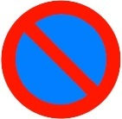 | 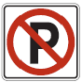 | 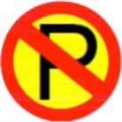 |  | 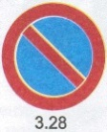
Convention sign: | Examples from countries:
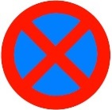 |  | 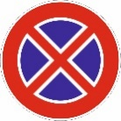

C, 20 a; C, 20 b “ALTERNATE PARKING”
1. The Group noted some visual differences in the width of the border of the red circle, in the length and width of the numerals I and II (symbol for odd days/ symbol for even days), in the shade of the blue colour as well as the use of white separation within the sign and a sign’s white external rim. The Group believed that the essential characteristics of the sign have been retained.
2. The Group noted that one country (Uzbekistan) separated the red oblique bar(s) from the red border of the sign.
3. The Group noted that countries not using the numerals I and II to indicate the period of parking alternation, do not use a hyphen (Belgium, France) between the numbers indicating dates of the month (e.g. “16 31” and “16.31”).
Convention sign: | Examples from countries:
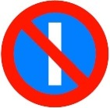 | 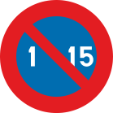 | 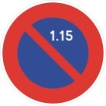 | 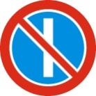 | 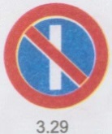
Convention sign: | Examples from countries:
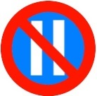 | 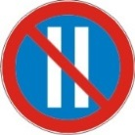 | 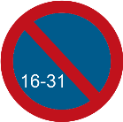 | 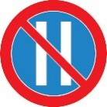 | 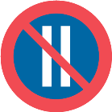
Observations and recommendations to Contracting Parties regarding D section signs
Addressed in chapter 1 – issue 22.
D, 1 a “DIRECTION TO BE FOLLOWED” (directions left, right, straight, etc.)
There are minor differences in shape of arrow heads, arrow tails, proportions of arrows within the sign and in the presence/absence of the white rim. However, the Group considered all signs to conform to the Convention. The Group recommended Contracting Parties to pay closer attention to the design details, in particular, to the shape of the arrow head (by making it wider to improve the legibility). Arrows used in the same category of signs should be of the same width. The tail of the arrow should not touch the edge of the sign.
In addition, for the sign arrow turning left/right, there are differences in the arrow’s curvatures. The Group considered this conforming to the Convention, however, it recommended Contracting Parties to ensure the arrow’s curvature is placed towards the centre of the sign.
Addressed in chapter 1 – issue 1.
Convention sign: | Examples from countries:
Convention sign: | Examples from countries:
 | 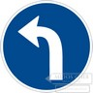 | 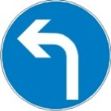
Convention sign: | Examples from countries:
 |  |  |  | 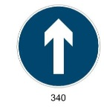
Convention sign: | Examples from countries:
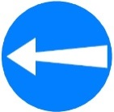
D, 2 “PASS THIS SIDE”
There are minor differences in shape of arrow heads, arrow tails, proportions of arrows within the sign and in the presence/absence of the white rim. However, the Group considered all signs to conform to the Convention. The Group recommended Contracting Parties to pay closer attention to the design details, in particular, to the shape of the arrow head (by making it wider to improve the legibility). The tail of the arrow should not touch the edge of the sign.
Convention sign: | Examples from countries:
 |  |  | 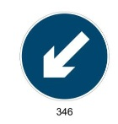
D, 3 “COMPULSORY ROUNDABOUT’
There are minor differences in shape of arrow heads, arrow tails, proportions of arrows within the sign and in the presence/absence of the white rim. However, the Group considered all signs to conform to the Convention.
Addressed in chapter 1 – issue 37.
Convention sign: | Examples from countries:
D, 4 “COMPULSORY CYCLE TRACK”
There are minor differences in symbol and in the presence/absence of the white rim. However, the Group considered all signs to conform to the Convention. Addressed in chapter 1 – issue 37.
Convention sign: | Examples from countries:
D, 5 “COMPULSORY FOOTPATH”
There are differences in symbol (two persons versus one person) and in the presence/absence of the white rim. The Group considered that having a one person symbol is not in conformity with the Convention.
Addressed in chapter 1 – issue 37.
Convention sign: | Examples from countries:
 |  | 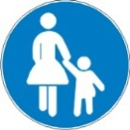 |  | 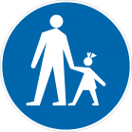
D, 6 “COMPULSORYTRACK FOR RIDERS ON HORSEBACK”
There are minor differences in symbol and in the presence/absence of the white rim. However, the Group considered all signs to conform to the Convention.
Convention sign: | Examples from countries:
D, 7 “COMPULSORY MINIMUM SPEED”
Addressed in chapter 1 – issue 37.
No specific observations nor recommendations to Contracting Parties.
Convention sign: | Examples from countries:
 | 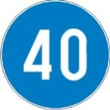 | 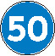 | 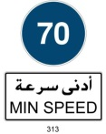
D, 8 “END OF COMPULSORY MINIMUM SPEED”
Addressed in chapter 1 – issue 37
The Group decided that too much space between the digits (i.e., Czech Republic) is not in conformity with the Convention. The red oblique bar should be in front of the number and not behind.
Addressed in chapter 1 – issue 7 and 12.
Convention sign: | Examples from countries:
 | 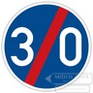 | 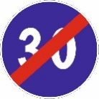 | 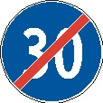
D, 9 “SHOW CHAINS COMPULSORY”
The Group noted differences in the illustration of the symbol but conforming with the Convention. The Group recommended several countries (Czech Republic, Montenegro and Serbia) to use wider black lines illustrating the chains on the tyre.
Convention sign: | Examples from countries:
D, 10 a, D, 10 b, D, 10, c “COMPULSORY DIRECTION FOR VEHICLES CARRYING DANGEROUS GOODS”
The Group noted that some countries are using different colours (yellow, orange and red) for the symbols of the vehicles carrying dangerous goods. The Group recommended that the colour used should be orange (as per the symbol in the Convention) with a black internal narrow strip. The symbol should show the rear part of the truck and be placed in the upper part of the sign.
The Group considered that countries using a different symbol of the vehicles carrying dangerous goods than an orange rear part of truck are not in conformity with the Convention.
Some countries placed the truck symbol and the direction sign in a reverse order (e.g. Albania), which the Group considered not to be in conformity with the Convention.
Some countries placed the wrong direction sign respectively to D, 10 a (e.g. Belgium, Bosnia and Herzegovina, Lithuania, Montenegro, Poland and Serbia), to D, 10 b (e.g. Belgium, Bosnia and Herzegovina, Italy, Poland and Sweden) and to D, 10 c (e.g. Hungary, Lithuania, Serbia and Sweden).
Addressed in chapter 1 – issue 2, 12 and 35.
The Group noted that Greece uses the E category sign with the C, 3 n symbol instead of the proper D, 10 sign and arrows instead of the proper D, 1 a signs, which is not in conformity with the Convention.
Contracting Parties should note the recommendation for this sign in section 1.2 of this document.
Convention sign: | Examples from countries:
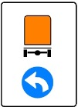 | 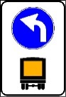 | 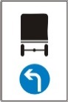 | 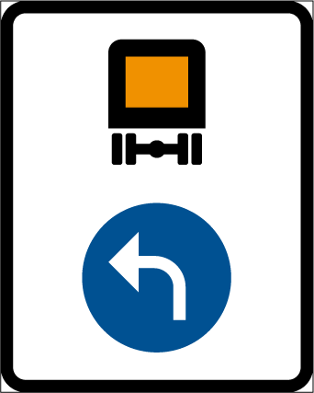
Convention sign: | Examples from countries:
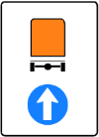 | 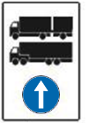 | 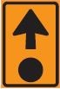 | 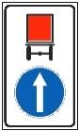 | 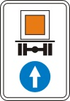
Convention sign: | Examples from countries:
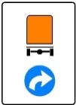 |  | 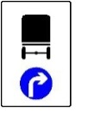 | 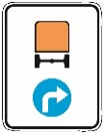 | 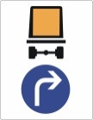
D, 11 a and D, 11 b
1. The Group recommended that the symbols of D, 4 and D, 5 should be exactly replicated in the D, 11 sign (e.g. the direction of the bicycle symbol). The actual format of the symbols will be determined at the future session.
2. The Group noted a white horizontal line in the D, 11 b sign separating symbols (e.g. Poland). The Group noted that when there is a separation of the path or track for different road users (by physical means or road markings), the sign D, 11 a should place the symbols side by side and separate them by a vertical line through the centre of the sign. If there is no separation of the path or track (by physical means or road markings), the symbols should be placed one above the other without any lines.
3. The Group agreed that using a white horizontal line is not in conformity with the Convention.
Convention sign: | Examples from countries:
 |  | 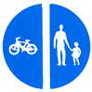 | 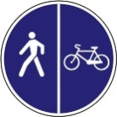
Convention sign: | Examples from countries:
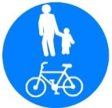 | 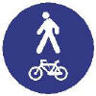 |  | 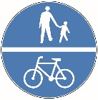 | 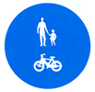
Observations and recommendations to Contracting Parties regarding E section signs
The Group noted that many countries use a white rim to enhance the sign’s conspicuity.
Addressed in chapter 1 – issue 12 and 19.
E, 1 a “COMPULSORY MINIMUM SPEED APPLYING TO DIFFERENT LANES”
1. Azerbaijan, Hungary, Montenegro, Moldova, Russian Federation, Ukraine and Uzbekistan wrongly use examples for E, 1 b instead of E, 1 a.
2. Many countries use road markings (broken line) on this sign. The Group recommended the symbols on this sign not to include road markings ie., broken lines, as the arrows indicate the “lanes”.
3. The Group recommended that for the E, 1 a sign the sign D, 7 is used with a white rim.
Convention sign: | Examples from countries:
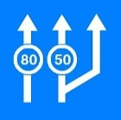 | 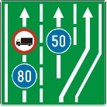 | 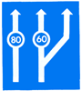 | 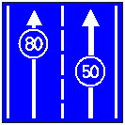 | 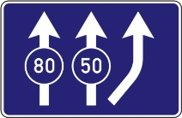
E, 1 b “COMPULSORY MINIMUM SPEED APPLYING TO ONE LANE”
Albania, Croatia and Greece wrongly used examples for E, 1 a instead of E, 1 b.
Many countries use road markings (broken line) on this sign. The Group recommended the symbols on this sign not to include road markings ie., broken lines as the arrows indicate the “lanes”.
The Group recommended that for the E, 1 b sign the sign D, 7 is used with a white rim.
Convention sign: | Examples from countries:
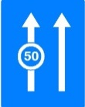 | 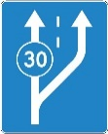 | 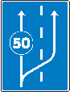
E, 1 c “SPEED LIMITS APPLYING TO DIFFERENT LANES”
Azerbaijan used a wrong example for E, 1 c sign (truck entry prohibition sign instead of speed limit sign).
The Group recommended that the E, 1 c sign is improved by placing the sign C, 14 on the arrows and adding a white rim.
Convention sign: | Examples from countries:
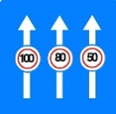 | 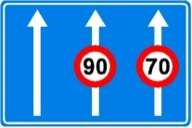 | 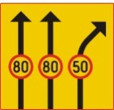 | 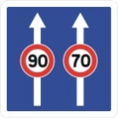 | 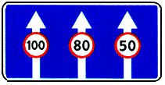
E, 2 a “SIGNS INDICATING LANES RESERVED FOR BUSES”
Addressed in chapter 1 – issue 23.
Several countries (Azerbaijan, Belgium, Croatia, Latvia, Luxembourg, Montenegro and Ukraine) use examples for E, 2a that do not correspond to the examples of the Convention.
Many countries use road markings (broken or continuous line) on this sign. The Group recommended the symbols on this sign not to include road markings as the arrows indicate the “lanes”.
Contracting Parties should note the recommendation for this sign in section 1.2 of this document.
Convention sign: | Examples from countries:
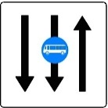 | 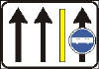 | 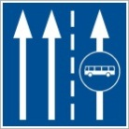 | 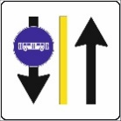 | 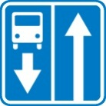
E, 2 b “SIGNS INDICATING LANES RESERVED FOR BUSES”
Addressed in chapter 1 – issue 22.
Several countries (Belgium, Croatia, Finland, Latvia, Montenegro, Poland and Ukraine) use examples for E, 2 b that do not correspond to the examples of the Convention.
Many countries use road markings (broken or continuous line) on this sign. The Group recommended the symbols on this sign not to include road markings as the arrows indicate the “lanes”.
Addressed in chapter 1 – issue 23.
Contracting Parties should note the recommendation for this sign in section 1.2 of this document.
Convention sign: | Examples from countries:
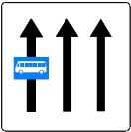 | 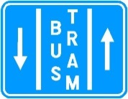 | 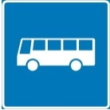 | 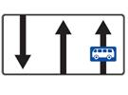 | 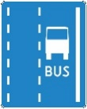
E, 3 a “ONE WAY”
There are minor differences in shape of arrow heads, arrow tails, proportions of arrows within the sign. The Group recommended Contracting Parties to pay closer attention to the design details, in particular, to the shape of the arrow head (by making it wider to improve the legibility). The tail of the arrow should not touch the edge of the sign.
Some countries (e.g. Sweden) use rectangular shape for this sign.
Addressed in chapter 1 – issue 37.
Convention sign: | Examples from countries:
E, 3 b “ONE WAY”
There are minor differences in shape of arrow heads, arrow tails, proportions of arrows within the sign. The Group recommended Contracting Parties to pay closer attention to the design details, in particular, to the shape of the arrow head (by making it wider to improve the legibility). The tail of the arrow should not touch the edge of the sign.
Addressed in chapter 1 – issue 37.
Convention sign: | Examples from countries:
 |  |  | 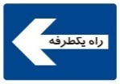
E, 4 “PRESELECTION”
Addressed in chapter 1 – issue 20 and 37.
No specific observations nor recommendations to Contracting Parties.
Convention sign: | Examples from countries:
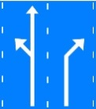 | 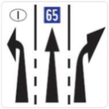 | 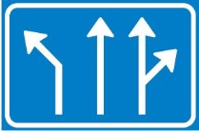 | 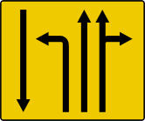 | 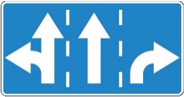
E, 5 a “MOTORWAY”
All the signs are in conformity with the Convention.
The Group recommended Contracting Parties to pay closer attention to the design details. In particular, the symbol should not touch the edge of the sign (to improve the legibility).
Addressed in chapter 1 – issue 12.
Convention sign: | Examples from countries:
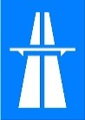 |  | 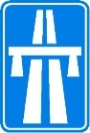 |  | 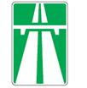
E, 5 b “END OF MOTORWAY”
Kuwait’s sign is crossed by an oblique bar running from the upper left edge to the lower right edge. The Group noted that the Convention does not specify the positioning of the oblique bar for the sign E, 5 b. However, for all the other end of regulation signs of the E section, the oblique bar crosses from the right upper edge to the lower left edge.
The sign E, 5 b of the Netherlands includes a red oblique bar with a white outline.
Addressed in chapter 1 – issue 24.
Convention sign: | Examples from countries:
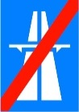 | 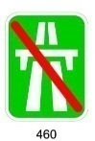 | 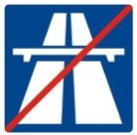 |  | 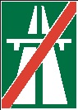
E, 6 a “ROAD FOR MOTOR VEHICLES”
The Group noted that in some cases (Latvia) the car symbol is not placed centrally on the sign. Some countries (Belgium, the Netherlands) use a white rim. All the signs are considered in conformity with the Convention.
Addressed in chapter 1 – issue 12.
Convention sign: | Examples from countries:
 | 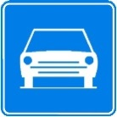 | 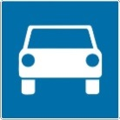 |  | 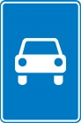
E, 6 b “END OF ROAD FOR MOTOR VEHICLES”
The Group noted that in some cases (Latvia) the car symbol is not placed centrally on the sign. Some countries (Belgium, the Netherlands) use a white rim. All the signs are considered in conformity with the Convention.
Addressed in chapter 1 – issue 12 and 24.
Convention sign: | Examples from countries:
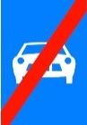 | 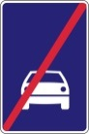 | 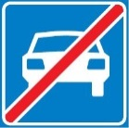 | 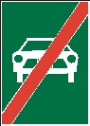
E, 7 a; E, 7 b; E, 7 c; E, 7 d and E, 8 a; E, 8 b; E, 8 c; E, 8 d “SIGNS INDICATING THE BEGINNING AND THE END OF A BUILT-UP AREA” (general remark)
The Group discussed at length the relationship between E, 7 and E, 8 signs and the place identification signs (as defined in Article 18). Some countries (e.g. Finland, the Russian Federation, Sweden) informed the Group that they use a sign resembling the E, 7 a or E, 7 d signs (as reproduced in Annex 3) as “place identification signs”. The Group agreed that the use of a sign resembling the E, 7 a or E, 7 d as place identification signs contradicts Article 18. However, the Group believed that place identification signs could not be made to differ conspicuously from the E, 7 a or E, 7 d signs (as required by Article 18) unless sign indicating built-up area would need to bear a silhouette of a built-up area.
The Group further noted the differences in the signs.
Addressed in chapter 1 – issue 11, 12 and 36.
Convention sign: | Examples from countries:
 | 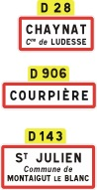 | 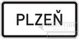 | 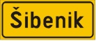
Convention sign: | Examples from countries:
 |  | 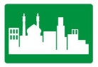
Convention sign: | Examples from countries:
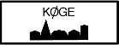 | 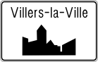 |  | 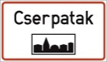
Convention sign: | Examples from countries:
 |  |  | 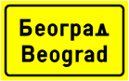 | 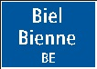
Addressed in chapter 1 – issue 7, 10, 12, 24 and 34.
E, 9 a and E, 9 b “SIGNS HAVING ZONAL VALIDITY”
The Group noted that all the signs appear to be in the conformity with the Convention, except for one country (Austria) that altered the inscription “Zone” on the sign E, 9 b.
Convention sign: | Examples from countries:
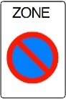 | 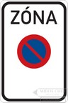 | 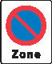 | 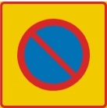 | 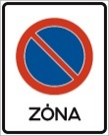
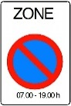 | 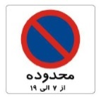 | 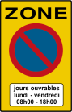 | 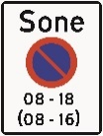 | 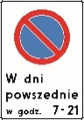
E, 9 c “SIGNS HAVING ZONAL VALIDITY”
1. The Group noted that all the signs appear to be in the conformity with the Convention.
Convention sign: | Examples from countries:
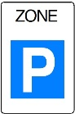 | 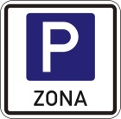 | 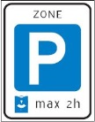 | 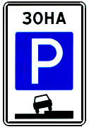 | 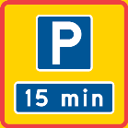
E, 9 d “SIGNS HAVING ZONAL VALIDITY”
2. The Group noted that all the signs appear to be in the conformity with the Convention.
Convention sign: | Examples from countries:
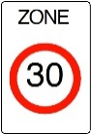 | 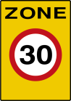 | 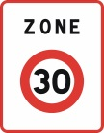 | 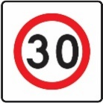 | 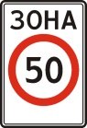
E, 10 a “SIGNS HAVING ZONAL VALIDITY”
The Group noted that some countries (Bosnia and Herzegovina, Croatia, Iran, Montenegro and Ukraine) do not use the color grey on a rectangular panel, which is considered not to be in conformity with the Convention.
Convention sign: | Examples from countries:
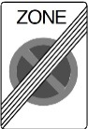 | 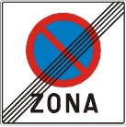
E, 10 b “SIGNS HAVING ZONAL VALIDITY”
The Group noted that some countries (Croatia, Iran and Montenegro) do not use the color grey on a rectangular panel, which is considered not to be in conformity with the Convention.
Convention sign: | Examples from countries:
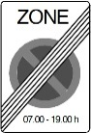 | 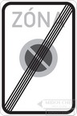 | 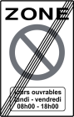 | 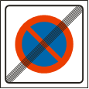 | 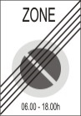
E, 10 c “SIGNS HAVING ZONAL VALIDITY”
The Group noted that some countries (Greece and Ukraine) do not use the color grey on a rectangular panel, one country (Poland) use a red instead of grey diagonal band/bar.
Addressed in chapter 1 – issue 37.
Convention sign: | Examples from countries:
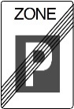 | 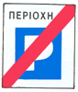 |  | 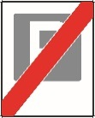 | 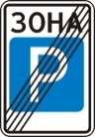
E, 10 d “SIGNS HAVING ZONAL VALIDITY”
The Group noted that some countries (Bosnia and Herzegovina, Croatia, Iran and Montenegro) do not use the color grey on a rectangular panel. One country (France) uses inscription “End of the zone” instead of “Zone”. One country (Italy) does not use the color grey while the band/bar does not cross the whole E, 10 d sign. One country (Ukraine) does not use the band/bar to cross the whole E, 10 d sign. All these are considered not to be in conformity with the Convention.
Convention sign: | Examples from countries:
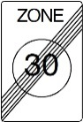 | 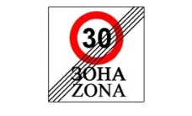 | 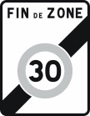 | 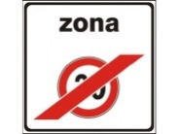 | 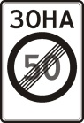
E, 11 a “TUNNEL” and E, 11 b “END OF TUNNEL”
The Group noted that countries use different design variation for E, 11 a and E, 11 b signs. The Group believed that this is due to the fact that the reproduction (image) of these signs does not follow the description of the general characteristics for E section signs. Some countries (Chile, Montenegro, Republic of Moldova, Ukraine) use the tunnel symbol on the warning A section sign.
Addressed in chapter 1 – issue 11, 12and 24.
Convention sign: | Examples from countries:
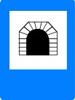 | 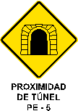 |  |  | 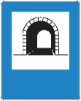
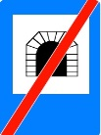 | 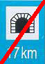 | 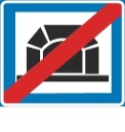 | 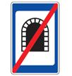
E, 12 a; E, 12 b; E, 12 c “PEDESTRIAN CROSSING”
The Group noted that majority of countries use a symbol of a person and a zebra crossing (stripes) which is not included in the Convention [suggested change]. A few countries (Austria, Belgium, Greece, Kuwait, Vietnam) use the A, 12 a symbol.
Addressed in chapter 1 – issue 11, 12, 36 and 37
Contracting Parties should note the recommendation for this sign in section 1.2 of this document.
Convention sign: | Examples from countries:
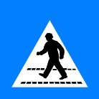 | 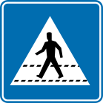 | 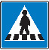 | 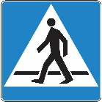
Convention sign: | Examples from countries:
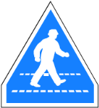 | n.a.
Convention sign: | Examples from countries:
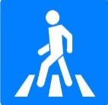 | 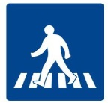
E, 13 a “HOSPITAL”
The Group noted that one country (Iran) uses several colours (blue and white) for the background of the sign, also uses different colour (black) for letter "H" (in comparison with illustrated white colour in the Convention).
The Group also noted that some countries (Austria, Bosnia and Herzegovina, Croatia, Montenegro, Serbia) use additional word in national language meaning "Hospital".
Convention sign: | Examples from countries:
E, 13 b “HOSPITAL”
Addressed in chapter 1 – issue 37
One country (Nigeria) uses a green ground on the E, 13 b sign, which is not in conformity with the Convention.
Convention sign: | Examples from countries:
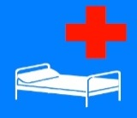 |  | 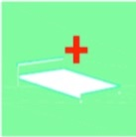 | 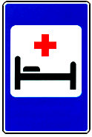
E, 14 a “PARKING”
All countries use the same design of sign in accordance with the Convention. There are very slight difference of symbol and the tone of blue background used in the Convention. One country (Nigeria) uses the dark green colour on the sign as ground, which is considered not to be in conformity with the Convention [added].
The Group recommended that the use of letter P to denote parking is a preferred option (and required in the Contracting Parties to the European Agreement). However, the Group recognized the extensive use of letter E on other continents.
Convention sign: | Examples from countries:
 |  |  | 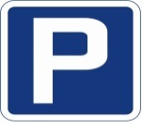
E, 14 b; E, 14 c “PARKING”
The Group noted that majority of countries do not follow the example of the sign E, 14^{b} and E, 14 c but they use a sign of a different design.
The Group believed that using the “+ sign” on the E, 14 b and E, 14 c sign is required by the Convention, which is not the case in several countries (Iran, Montenegro, Serbia). When additional panels are used in combination with the E, 14 a sign then the “+ sign” together with symbol or, if not possible, name of the type of transport is to be placed on the panel.
Addressed in chapter 1 – issue 12 and 35
Contracting Parties should note the recommendation for this sign in section 1.2 of this document.
Convention sign: | Examples from countries:
 | 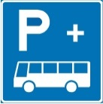 | 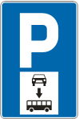
Convention sign: | Examples from countries:
 | 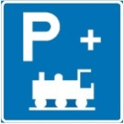 | 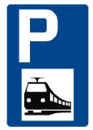 | 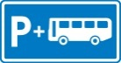
E, 15 “BUS STOP”, E, 16 “TRAMWAY STOP”
The Group noted that countries use different design variation for E, 15 and E, 16 signs. The Group believed that this is due to the fact that the reproduction (image) of these signs does not follow the description of the general characteristics for E section signs.
Addressed in chapter 1 – issue 25
Contracting Parties should note the recommendation for this sign in section 1.2 of this document.
Convention sign: | Examples from countries:
 | 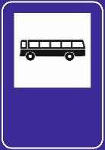 |  | 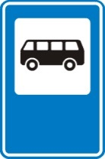
Convention sign: | Examples from countries:
 |  | 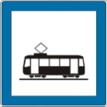 | 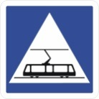
 | 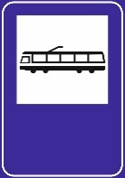 | 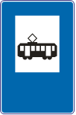 | 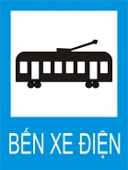
E, 17 a, E, 17 b “RESIDENTIAL AREA and END OF RESIDENTIAL AREA”
The Group believes that the essential features of this sign are: symbols of a house, pavement (sidewalk), adult, child, ball and passenger car. The Group noted that a number of countries (Albania, Italy, the Russian Federation, Sweden and Ukraine) altered the sign, either by including additional features (e.g. tree) or by omitting the essential features. The Group considers these countries not to be in conformity with the European Agreement.
Addressed in chapter 1 – issue 2, 12 and 24.
Contracting Parties should note the recommendation for this sign in section 1.2 of this document.
Convention sign: | Examples from countries:
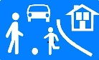 |  | 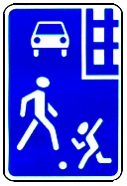 | 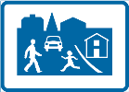
Convention sign: | Examples from countries:
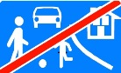 | 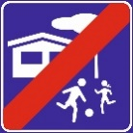 | 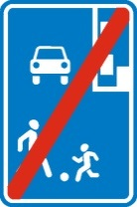 | 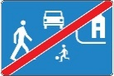
E, 18 a “STOPPING PLACE IN CASE OF EMERGENCY OR DANGER”
The Group noted that some countries (Croatia and Norway) included the inscription S.O.S in the sign. Placing the S.O.S inscription the Group considers to be in conformity with the Convention. Placing the inscription within a red square on the sign (Croatia) is however considered not to be in Conformity with the Convention.
The Group also noted that one country (Austria) used a sign with an inscription of a distance to the stopping place, which is considered not to be in conformity with the Convention.
Addressed in chapter 1 – issue 7 and 36
Contracting Parties should note the recommendation for this sign in section 1.2 of this document.
Convention sign: | Examples from countries:
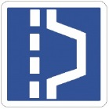 | 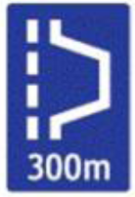 | 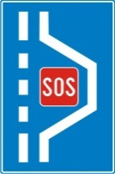 | 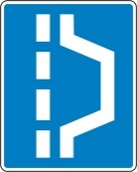 | 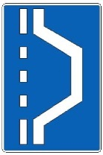
E, 18 b “STOPPING PLACE IN CASE OF EMERGENCY OR DANGER”
The Group noted that some countries (Belgium, Denmark, Finland, Netherlands, Portugal, Sweden and Switzerland) included the inscription S.O.S in the sign, which the Group considers to be in conformity with the Convention. The sign from Serbia contains the inscription S.O.S on the red square, which the Group considers not to be in conformity with the Convention.
The Group also noted that the sign from Germany has a different design, which appears to be a combination of E, 18 a and E, 18 b designs, which is considered not to be in conformity with the Convention.
Convention sign: | Examples from countries:
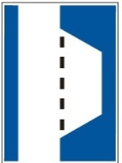 | 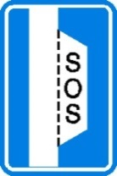 | 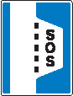 | 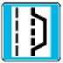 | 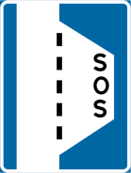
Observations and recommendations to Contracting Parties regarding F section signs
Addressed in chapter 1 – issue 11 and 12.
The Group noted that Italy uses the F category signs of blue and green background depending on the type of road. The Group believed that when a background colour (green or blue) is adopted, that that colour should continue to be used for the same sign.
Addressed in chapter 1 – issue 11 and 12.
F, 1 a, b, c “FIRST AID STATION”
The Group noted that one country (Slovakia) used another symbol than those specified by the Convention’s examples. The sign of another country (Chile) is not in conformity with the Convention due to the definition used.
Addressed in chapter 1 – issue 36.
Contracting Parties should note the recommendation for this sign in section 1.2 of this document.
Convention sign: | Examples from countries:
 | 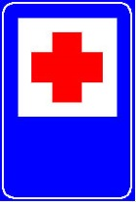
F, 2 “BREAKDOWN SERVICE”
1. The Group noted that some countries (Chile, Iran and Nigeria) used a symbol other than that specified by the Convention. The Group agreed that those symbols reflect the essential characteristics of the sign.
2. In addition, Chile used the symbol with a blue background without a white or yellow rectangle on which the symbol should be displayed. The Group believed that this was not in conformity with the Convention and that the white/yellow rectangle should be used.
Convention sign: | Examples from countries:
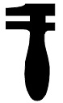

F, 3 “TELEPHONE”
The Group noted that Chile used the symbol with a blue background without a white or yellow rectangle on which the symbol should be displayed. The Group believed that this was not in conformity with the Convention and that the white/yellow rectangle should be used.
Convention sign: | Examples from countries:
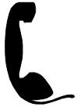 |  | 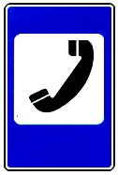 |  | 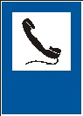
F, 4 “FILLING STATION”
Addressed in chapter 1 – issue 37.
2. The Group noted that Poland used the symbol (one filling station in black and another in green) and believed that using multiple colours was not in conformity with the Convention.
3. The Group also noted that Chile used the symbol with both blue and green backgrounds. The Group believed that this was also not in conformity with the Convention and that it should adopt one colour (blue or green) for the background, and that the white/yellow rectangle should be used.
Convention sign: | Examples from countries:
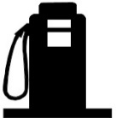 |  | 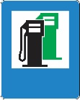
F, 5 “HOTEL or MOTEL”
The Group noted that some countries used a symbol other than that specified by the Convention. The Group also noted that Switzerland used an additional symbol (restaurant). The Group agreed that those symbols reflect the essential characteristics of the sign.
Convention sign: | Examples from countries:
 | 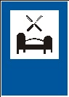 |  | 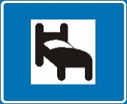 | 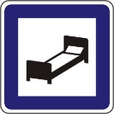
F, 6 “RESTAURANT”
The Group noted that some countries used a symbol other than that specified by the Convention. Nigeria used a plate and utensils, which the Group believed not to be in conformity. In addition, the Republic of Moldova, Russian Federation, Ukraine and Uzbekistan used a fork and knife (parallel, not crossed). The Group believed that those symbols reflected the essential characteristics of the sign.
Convention sign: | Examples from countries:
 |  | 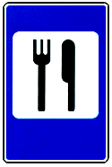 | 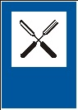
F, 7 “REFRESHMENTS OR CAFETERIA”
The Group noted that in a number of cases (e.g. Albania, Ukraine) the symbol differs slightly from the one in the Convention but the essential characteristics were retained.
Convention sign: | Examples from countries:
F, 8 “PICNIC SITE”
Some countries use tree symbols from their region (e.g. Kuwait) which the Group considered was in conformity with the Convention.
Several countries use signs with a brown background (Albania, Chile and Italy), which are not in conformity with the Convention. The Group believed that a blue or green background should be used. The Group noted that the sign used by Nigeria (with the text “rest area”) was not in conformity with the Convention. The Group also noted that the signs from Chile and Nigeria do not have the white or yellow rectangle on which the symbol should be displayed.
Addressed in chapter 1 – issue 12 and 37.
Convention sign: | Examples from countries:
 | 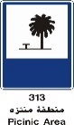 | 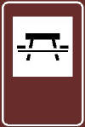 |  | 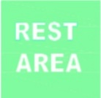
F, 9 “STARTING POINT FOR WALKS”
No specific observations nor recommendations to Contracting Parties.
Addressed in chapter 1 – issue 36
Contracting Parties should note the recommendation for this sign in section 1.2 of this document.
Convention sign:
F, 10 “CAMPING SITE”
The Group noted that in a number of cases the symbol differs slightly from the one in the Convention but the essential characteristics were retained. The Group also noted that the sign from Chile does not have the white or yellow rectangle on which the symbol should be displayed. The Group believed that this was not in conformity with the Convention and that the white/yellow rectangle should be used.
Convention sign: | Examples from countries:
 |  | 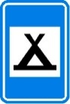 | 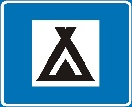 | 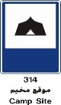
F, 11 “CARAVAN SITE”
The Group noted that in a number of cases the symbol differs slightly from the one in the Convention but the essential characteristics were retained. The Group also noted that Norway uses the symbol of a motor home (motorised caravan) rather than a caravan, which it considered to be not in conformity with the Convention. The Group believed that the symbol of the caravan used by Ukraine has different characteristics from the symbol in the Convention, and hence is not in conformity. The Group requested that the signs used by Denmark (camping site) be placed under F, 10 only, and the signs used by Nigeria (with the text “motor park”) and Norway be moved to the non-Convention signs.
Convention sign: | Examples from countries:
 |  |  |  | 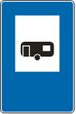
F, 12 “CAMPING AND CARAVAN SITE”
The Group noted that Albania, Italy and Kuwait used brown background, which is not in conformity with the Convention. The Group believed that the symbol of the caravan used by Ukraine has different characteristics from the symbol in the Convention, and hence is not in conformity.
Addressed in chapter 1 – issue 36.
Convention sign: | Examples from countries:
 | 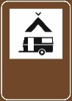 |  |  | 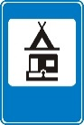
F, 13 “YOUTH HOSTEL”
The Group noted that Albania, Italy and Kuwait used brown background, which is not in conformity with the Convention.
Convention sign: | Examples from countries:
F, 14 “RADIO STATIONS GIVING TRAFFIC INFORMATION”
The Group noted that a number of countries (France, Italy, Lithuania, Romania, Russian Federation) did not have their signs in conformity with the European Agreement. These included, for example omitting the inscription of the radio frequency on the white rectangle, having the inscription “radio” in the national language only, or having the inscription “radio” on the blue background.
The Group recommended to amend point 23 of the Annex of the European Agreement as follows to ensure consistency with the Convention: “Inscription on blue or green ground: Indication of the frequency…”, (that the words “or green” be inserted). Addressed in chapter 1 – issue 3 and 19.
Contracting Parties should note the recommendation for this sign in section 1.2 of this document.
Convention sign: | Examples from countries:
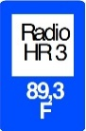 |  | 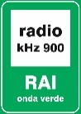 | 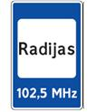 | 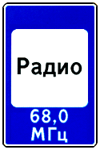
F, 15 “PUBLIC LAVATORY”
The Group noted that a number of countries used male and female symbols (Albania and France) instead of the inscription “WC”. Sweden had a unique symbol for this sign using it for lavatories for people with reduced mobility. The Group considered that these were not in conformity with the European Agreement.
Contracting Parties should note the recommendation for this sign in section 1.2 of this document.
Convention sign: | Examples from countries:
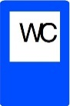
F, 16 “BEACH OR SWIMMING POOL”
The Group recommended that the sign be removed from the European Agreement. Addressed in chapter 1 – issue 36
No specific observations nor recommendations to Contracting Parties.
Contracting Parties should note the recommendation for this sign in section 1.2 of this document.
Convention sign:
F, 17 “EMERGENCY TELEPHONE”
1. The Group noted that the symbols used by many countries do not reflect the symbol as it appears in the Convention, and recommended that the countries ensure that their symbols are in conformity with the Convention, in particular ensuring that the symbol (the inscription “SOS” and the telephone image) appears in one colour (red or black/dark blue).
2. The Group also noted that some countries inserted the wrong sign (Croatia, Italy) in RSMS and that some countries used the symbol only on an additional panel (Denmark, Iran, Poland). In addition, Denmark used a white symbol (rather than black or red).
Convention sign: | Examples from countries:
 | 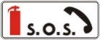 | 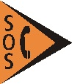

F, 18 “EXTINGUISHER”
The Group noted that the symbols used by some countries (Bosnia and Herzegovina, Croatia, Montenegro, Norway, Slovakia, Switzerland) differed in varying degrees from the symbol as it appears in the Convention and recommended that the countries ensure that their symbols more closely resemble the symbol in the Convention.
The Group also noted that some countries inserted the wrong sign (France, Italy) in RSMS and also that some countries used the symbol only on an additional panel (Denmark, Poland). In addition, Denmark used a white symbol (rather than red).
Convention sign: | Examples from countries:
 |  |  | 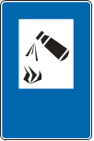
Observations and recommendations to Contracting Parties regarding G section signs
Addressed in chapter 1 – issue 9, 11, 12 and 26
G, 1 a, G, 1 b and G, 1 c Advance direction signs
No specific observations nor recommendations to Contracting Parties.
Addressed in chapter 1 – issue 12 and 28
Contracting Parties should note the recommendation for this sign in section 1.2 of this document.
G, 2a and G, 2b “NO THROUGH ROAD” (advance direction signs)
1. The Group also noted that the G, 2a Slovakian sign had a white border, instead of a rim, around the red bar. The Group further noted that the G, 2a sign from the Netherlands contained an arrow. The Group considered these signs not to be in conformity with the Convention.
2. The Group noted that, in the G, 2a signs of some countries (Azerbaijan, Greece, Lithuania, Republic of Moldova, Russian Federation, Ukraine, Uzbekistan and Viet Nam), and in the G, 2b sign of Greece, there was no visible space between the symbol and the edge of the sign. The Group believed that this was not a good practice for sign legibility.
Addressed in chapter 1 – issue 12
3. Contracting Parties should note the recommendation for this sign in section 1.2 of this document.
Convention sign: | Examples from countries:
 |  | 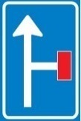

G, 3 “ROUTE TO BE FOLLOWED IN ORDER TO TURN LEFT” (advance direction sign)
No specific observations nor recommendations to Contracting Parties.
Signs G, 4 a through G, 9 b
No specific observations nor recommendations to Contracting Parties.
Addressed in chapter 1 – issue 12 and 29
Addressed in chapter 1 – issue 4, 11 and 12
Contracting Parties should note the recommendation for this sign in section 1.2 of this document.
G, 10 Confirmatory sign
No specific observations nor recommendations to Contracting Parties.
Addressed in in chapter 1 – issue 11 and 12
Contracting Parties should note the recommendation for this sign in section 1.2 of this document.
G, 11a, 11b, 11c, 12a and 12b Signs indicating the number and direction of traffic lanes
1. The Group noted that some countries used different colours for the ground and symbol (i.e. blue/green ground and white symbol) in addition to the white ground and black symbol for the Convention sign. In this regard, the Group noted that the Convention did not specify what colours are permitted for this sign. However, it did note that the Convention specified that the use of orange symbols may be used for temporary indication signs. Addressed in in chapter 1 – issue 36
Addressed in chapter 1 – issue 11, 12 and 31.
G, 13 “NO THROUGH ROAD” indication sign
1. The Group also noted that a number of countries did not have the white part of the symbol going to the bottom edge of the sign.
2. The Group also noted that a white narrow strip around the red bar was mandatory for Contracting Parties to the 1971 European Agreement. In this regard, a few countries were not in conformity.
Addressed in chapter 1 – issue 31 and 37
Convention sign: | Examples from countries:
 | 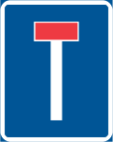 |  | 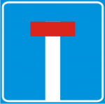 | 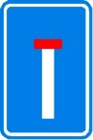

G, 14 “GENERAL SPEED LIMITS”
The Group noted that some countries had more than three squares in their signs and included a lot of information on their signs. The Group cautioned against information overload. The Group was of the view, that depending on the local language (i.e. reading from left to right, or right to left), that the symbol could appear to the left or right of the speed limit as appropriate for ease of comprehension.
Addressed in chapter 1 – issue 6
The Group also recommended that in relation to the sign in general, a speed limit should not be displayed without a corresponding applicable symbol, and vice versa.
Convention sign: | Examples from countries:
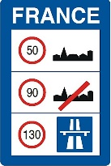 | 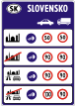 | 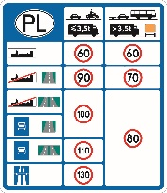 | 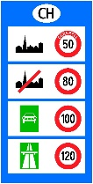 | 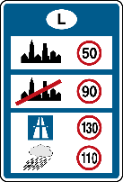
G, 15 “ROAD OPEN OR CLOSED”
The Group noted that the signs reviewed inserted in the RSMS were mostly in conformity with the Convention, though a number of countries included danger warning signs in Panel 3.
Addressed in chapter 1 – issue 7
Convention sign: | Examples from countries:
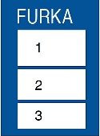 | 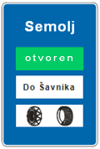 | 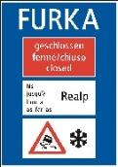 | 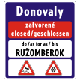
G, 16 “CHAINS OR SNOW TYRES RECOMMENDED”
No specific observations nor recommendations to Contracting Parties.
Contracting Parties should note the recommendation for this sign in section 1.2 of this document.
G, 17 “ADVISORY SPEED”
The Group noted that most countries used a dark ground and white or light inscriptions, or a white or light ground with black inscriptions.
The Group recommended that a blue ground and white inscriptions be used for this sign.
Convention sign: | Examples from countries:
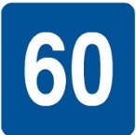 | 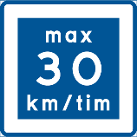 | 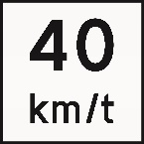 | 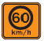 | 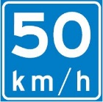
G, 18 “ADVISED ITINERARY FOR HEAVY VEHICLES”
The Group noted that for the countries which used this sign, most used a blue ground with a white symbol, but a few used a white ground with a black symbol. Additionally, some countries included arrows within the sign, or used an arrow shaped sign.
The Group recommended that a blue ground and white symbol be used for this sign.
G, 19 “ESCAPE LANE”
The Group recommended that a blue ground and white with red symbol be used for this sign.
Addressed in chapter 1 – issue 6 and 30.
G, 20 “PEDESTRIAN OVERPASS” and G, 21 “PEDESTRIAN UNDERPASS”
The Group recommended that a blue ground and white symbol be used for these signs. Addressed in chapter 1 – issue 12.
G, 22 “EXIT FROM A MOTORWAY”
The Group recommended that a blue and green ground and white stripes be used for this sign.
Addressed in chapter 1 – issue 27 and 35
G, 23-G.24 c “EMERGENCY EXITS”
No specific observations nor recommendations to Contracting Parties.
Observations and recommendations to Contracting Parties regarding H section signs
Addressed in chapter 1 – issue 32.
H, 1 Distance from the sign to the beginning of the dangerous section of road or zone
Addressed in chapter 1 – issue 12.
Convention sign: | Examples from countries:
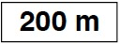 | 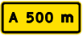 |  | 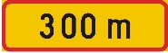 | 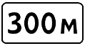
H, 2 Length of the dangerous section of road or zone
1. The Group also noted that some countries did not include the two arrows in their signs. The Group believed that these were not in conformity with the Convention, and that the two arrows must be included. The Group also noted that Chile’s sign which included the inscription “PROXIMOS” was not in conformity with the Convention.
Addressed in chapter 1 – issue 37.
Convention sign: | Examples from countries:
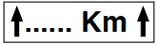 | 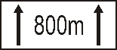 |  | 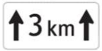
Addressed in chapter 1 – issue 33
H, 3 a Start of parking prohibition
Addressed in chapter 1 – issue 33
No specific observations nor recommendations to Contracting Parties.
Convention sign: | Examples from countries:
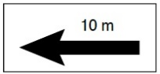 | 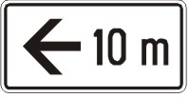 | 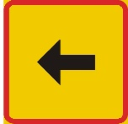 |  | 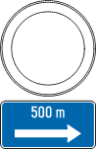
H, 3 b Directions of parking prohibitions
The Group noted that most countries use one arrow with two arrowheads (as per the Convention), but that some countries use two arrows (each with arrowheads). The Group considered that the latter was in conformity with the Convention. The Group also noted that some countries (Lithuania, Austria) used one arrow with two arrowheads, with a unit of measurement appearing on the top of the arrow in the middle.
The Group believed that it was important to place the sign carefully so that the direction/s of the parking prohibition is/are accurate.
H, 3 c End of parking prohibition
No specific observations nor recommendations to Contracting Parties.
Convention sign: | Examples from countries:
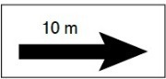 | 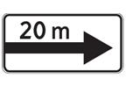 | 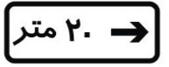 |  | 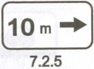
H, 5 and H, 6 Symbols of road users
No specific observations nor recommendations to Contracting Parties.
Addressed in chapter 1 – issue 33.
H, 7 Person with disabilities
No specific observations nor recommendations to Contracting Parties.
Addressed in chapter 1 – issue 33.
H, 8 Diagram of intersection
No specific observations nor recommendations to Contracting Parties.
Addressed in chapter 1 – issue 33.
H, 9 Snow or ice
No specific observations nor recommendations to Contracting Parties.
Addressed in chapter 1 – issue 33.

The sign-by-sign assessment only concerns signs of Contracting Parties that have been made available in time for specific sessions at which specific the signs had been analysed.

