|  |  |  |  |
| --- | --- | --- | --- |
|  | United Nations | ECE/TRANS/WP.15/AC.1/2020/9 | |
| _unlogo | **Economic and Social Council** | | Distr.: General  17 December 2019  Original: English |

**Economic Commission for Europe**

Inland Transport Committee

**Working Party on the Transport of Dangerous Goods**

**Joint Meeting of the RID Committee of Experts and the  
Working Party on the Transport of Dangerous Goods**

Bern, 16–20 March 2020

Item 7 of the provisional agenda

**Accidents and risk management**

Test periods for battery vehicles filled in accordance with packing instruction P200

Transmitted by the European Industrial Gases Association (EIGA)[[1]](#footnote-2)\*, [[2]](#footnote-3)\*\*

Introduction

1. The 2015 edition of RID/ADR was amended to permit certain gases of P200 to have their test periods extended from ten to fifteen years. This was aimed for individual cylinders and also cylinders mounted in bundles of cylinders.

2. Extensive work was carried out by an informal intersessional working group of the Joint Meeting to arrive at the final proposal, see ECE/TRANS/WP.15/AC.1/2013/42 and supporting informal documents.

3. At the time of the proposal in ECE/TRANS/WP.15/AC.1/2013/42 it was decided not to extend the work to cover the elements in battery vehicles until experience had been gained with single cylinders and bundles of cylinders.

4. Since the 2015 edition of RID/ADR has come into effect the extended test regime for both single cylinders and bundles of cylinders has been adopted in many countries. EIGA has not received any reports of cylinders or bundles of cylinders being rejected after the extension to a fifteen-year test interval has been introduced.

5. Based on this positive feedback EIGA proposes that the fifteen-year test interval is extended to include battery vehicles constructed with either seamless steel cylinders or seamless steel tubes containing carrying either UN 1046 HELIUM, COMPRESSED and UN 1049, HYDROGEN, COMPRESSED,

Overview of Battery Vehicles

6. A battery vehicle is defined as:

*"Battery-vehicle"* means a vehicle containing elements which are linked to each other by a manifold and permanently fixed to this vehicle. The following elements are considered to be elements of a battery-vehicle: cylinders, tubes, bundles of cylinders (also known as frames), pressure drums as well as tanks destined for the carriage of gases as defined in 2.2.2.1.1 with a capacity of more than 450 litres;

7. Battery vehicles are a well-established means of carrying large volumes of certain compressed gases that are generally not as convenient to be transported as a refrigerated liquefied gas. Typically, the gases transported in battery vehicles are UN 1046 HELIUM, COMPRESSED and UN 1049, HYDROGEN, COMPRESSED. The main reason UN 1046 and UN 1049 are carried as a compressed gas is that their liquefaction temperature is very close to absolute zero and thus requires special equipment to handle these very low temperatures.

8. Examples of battery vehicles are shown in Appendix 1. Battery vehicles can typically contain 400 cylinders or 10 tubes. The method of construction is that the elements, cylinders or tubes, are secured to the chassis of the trailer and the elements connected by manifold piping. Depending on the configuration there could be individual valves on each element, or valves to isolate a bank of cylinders or tubes.

9. The mode of operation of a battery vehicle is that they are filled at a limited number of dedicated specialist filling centres, driven to the point of use and connected to a process and remain in-situ until the product has been used. There is always a residual pressure left in the battery vehicle due to a number of factors, one is that the process a battery vehicle is connected to requires a pressure greater than atmospheric pressure, and by maintaining a positive pressure so that product purity is ensured. Battery vehicles usually do not have residual pressure valves as these can impede the flow in case of high volume applications, but if there is a risk of contamination from a customer process safeguards will be put in place on the installation to which the battery vehicle is connected to. It should be noted that under 1.4.3.7.1 (d) (ii) of the RID/ADR there is a requirement for the unloader “Immediately following the unloading of the tank, vehicle or container; Ensure the closure of valves and inspection openings.” This is an additional safeguard to ensure a residual pressure. Battery vehicles almost always remain in one product service.

**Principles**

10. The principles for extending the retest period from ten to fifteen years is based upon those that were used for individual cylinders and bundles of cylinder. These are summarised in the following section.

11. The proposed increase in periodicity only applies to UN 1046 HELIUM, COMPRESSED and UN 1049, HYDROGEN, COMPRESSED. These gases have been selected due to the following:

a) The vast majority of products transported in battery vehicles are either UN 1046 or UN 1049.

b) The applications that require UN 1046 and UN 1049 are almost always of very high purity, well in excess of the requirements of 2.4 of paragraph 13 of P200. The applications include electronics component production, medical and food processing. Consequently, analysis of the contents of the battery vehicle prior to filling is usually carried out to ensure product purity.

12. Facilities that fill battery vehicles will apply a documented and certified quality system which will be monitored by the competent authority. Filling shall only be carried out by these approved facilities.

13. For all battery vehicles operating under a fifteen-year inspection regime the battery vehicle will be checked before filling for a positive pressure.

14. The owner of battery vehicles that are eligible for a fifteen-year inspection regime shall establish procedures to ensure that cylinders are only filled in approved filling centres.

15. Battery vehicles constructed with composite elements are excluded from this proposal.

Pre-Fill Inspection and Monitoring of Battery Vehicles

16. Battery vehicles are subject to pre-fill inspections as prescribed in EN 13385:

*Transportable gas cylinders — Battery vehicles for permanent and liquefied gases (excluding acetylene) — Inspection at time of filling.* Key elements of this standard include:

1. Ensuring the battery vehicle is free from damage;
2. Restraining systems are secure;
3. Visible surfaces are free of any signs of cuts, gouges, fire damage and any other defects that could affect the integrity of the battery vehicle;
4. Valves function correctly;
5. Battery vehicle is appropriately marked and labelled.
6. Free of internal contamination

These checks are in addition to the inspections required for the automotive components.

17. Due to the nature of battery vehicles, their location is always known, that is either being loaded, in transit or being unloaded.

**Risk Analysis Consideration**

18. EIGA members have considered if there are increased risks in extending the test interval from ten to fifteen years for battery vehicles and their conclusions are that subject to the pre-fill inspection being carried out there is no increased risk.

19. The reason for this conclusion is that the following requirements will be carried out under an approved quality system:

(a) The prefill check on the external condition of the battery vehicle remains a critical part of the overall filling process to ensure the safety of the battery vehicle.

(i) This is important as battery vehicles are filled a number of times between the periodic inspections.

(ii) The majority of damage to battery vehicles is from external influences.

(iii) The most hazardous part of a battery vehicles life is during filling, when it is subjected to the highest stress due to internal pressure.

(b) The presence of a positive pressure is checked prior to every fill thereby ensuring that outside contamination will not have entered into the battery vehicle during customer use.

(c) The above points will be reinforced by only allowing the filling of battery vehicles at filling locations that have been approved to fill battery vehicles with the extended test interval.

20. As mentioned above in 11. (b) the purity requirements for the products are very stringent.

**Methodology of how to extend 10 to 15 years**

21. As battery vehicles are subject to detailed inspections including the requirements of EN 13385 and monitored for the residual product and gas quality and as there are quality systems in place the test intervals may be extended. Based on this, it would appear to be appropriate to implement the extended test interval may be extended for battery vehicles from the date of the last periodic inspection, if the requirements for the extended period have already been met since then. In this case it should not be necessary to wait for the next periodic inspection; the next inspection is due 15 years after the last inspection, even if it was done prior to the new regulation.

Safety

22. No safety issues are foreseen as the battery vehicles will continue to be subject to the prefill inspection requirements as mentioned in EN 13385.

Enforceability

23. Enforceability is not considered to present any obstacles due to the close monitoring of battery vehicles during loading, unloading and carriage.

Proposal for changes to 4.1.4.1

In this proposal new text is shown underlined and deleted text is shown with a ~~strikethrough~~.

All the proposed changes relate to packing instruction P200 of chapter 4.1.4.1.

Add to para (10):

vb: For battery vehicles constructed with elements that are either seamless steel cylinders or seamless steel tubes the test interval between periodic tests may be extended to 15 years if the provisions of paragraph (13) of this packing instruction are applied.

Add into (11) EN 13385 after the row containing ISO 11755

|  |  |  |
| --- | --- | --- |
| **Applicable requirements** | **Reference** | **Title of document** |
| (7) (a) | EN 13385:2002 | Transportable gas cylinders – Battery vehicles for permanent and liquefied gases (excluding acetylene) – Inspection at the time of filling |

(13) In the first sentence replace “cylinders and bundles of such cylinders may be granted in accordance with special packing provisions ua or va ” by “cylinders, bundles of cylinders and battery vehicles constructed of seamless steel cylinders or seamless steel tubes may be granted in accordance with special packing provisions ua, ~~or~~ va or vb”.

(13) 1.2 In the first sentence replace “the cylinders or bundles of cylinders” by “the cylinders, bundles of cylinders, or battery vehicles”.

(13) 1.3 In the first sentence replace “Cylinders manufactured since 1 January1999” by “Cylinders and tubes manufactured since 1 January 1999 “.

(13) 1.3 Insert EN ISO 11120; or after EN 7866.

(13) 1.3 In the second sentence replace “Other cylinders manufactured before 1 January 2009” by “Other cylinders and tubes manufactured before 1 January 2009”.

(13) 1.3 In the Note add to the first sentence “*This provision is considered to be fulfilled if the cylinder or tube has been reassessed*…”.

(13) 1.3 In the final sentence replace “Cylinders and bundles of cylinders” by “Cylinders, bundles of cylinders and tubes”.

In (13) 1.4 In the first sentence replace “Bundles of cylinders shall be constructed such that contact between cylinders along the longitudinal axis” by ”Bundles of cylinders and battery vehicles shall be constructed such that contact between cylinders or tubes along the longitudinal axis”.

(13) 1.4 At the end of the second sentence replace “to the cylinders” by “to the cylinders or tubes.”.

(13) 1.5 In the first sentence replace “that the cylinders comply with” by “that the cylinders and tubes comply with”.

(13) 1.6 In the second sentence replace “periodic inspection of the cylinders or bundles of cylinders” by “periodic inspection of the cylinders, bundles of cylinders or battery vehicles.”

(13) 1.6 In the last sentence replace “as long as the cylinders are authorised” by “as long as the cylinders or tubes are authorised”.

(13) 1.6 NOTE In the first sentence replace “A *group of cylinders is defined by the production dates of identical cylinders for a period*” by “*A group of cylinders or tubes is defined by the production dates of identical cylinders or tubes for a period,”.*

(13) 2.1 In the first sentence replace “Cylinders or bundles of cylinders having been granted” by “Cylinders, bundles of cylinders or battery vehicles having been granted” and “EN ISO 24431:2016 , EN 13365:2002 as applicable” by “EN ISO 24431:2016 , EN 13365:2002 or EN 13385:2002 as applicable”.

(13) 2.1 In the final sentence replace “the filling process for cylinders, bundles of cylinders and valves.” by “the filling process for cylinders, bundles of cylinders, battery vehicles and valves.”.

(13) 2.4 In the first sentence replace “shall be filled into cylinders or bundles of cylinders.” by “shall be filled into cylinders, ~~or~~ bundles of cylinders or battery vehicles.”.

Insert new 2.5

2.5 Battery vehicles having been granted a 15-year interval for periodic inspection shall be checked prior to every fill in accordance with a documented procedure which shall at least include the following:

* A check for residual pressure;
* If residual pressure is present, the battery vehicle may be filled;
* If the check shows that the battery vehicle does not have residual pressure the internal condition of the elements of the battery vehicle shall be checked for contamination:
  + If no contamination is detected, the battery vehicle may be filled;

If contamination is detected, a corrective action shall be carried out.

(13) 2.5 Replace “the requirements of 2.1 to 2.4” by “the requirements of 2.1 to ~~2.4~~ 2.5 “

Renumber 2.5 as 2.6 and 2.6 as 2.7

(13) 3.1 Replace “Cylinders and bundles of cylinder already in use” by “Cylinders, bundles of cylinders and battery vehicles already in use,”.

(13) 3.1 Introduce a new sentence at the end of 3.1; “For battery vehicles there shall be evidence that the residual pressure has been maintained in all the elements at all times.”.

(13) 3.2 In the first sentence replace “If a cylinder with a 15 year interval” by “If a cylinder or tube with a 15 year interval” and “if other cylinders (e.g. of the same type or group)” by “if other cylinders or tubes (e.g. of the same type or group).

(13) 3.3 In the first sentence replace “6.2.4 have been detected, the cylinder shall be withdrawn” by “6.2.4 have been detected, the cylinder or tube shall be”.

Add in a new 3.5 “Valves fitted to battery vehicles having been granted a 15-year interval for periodic inspection may continue to be used until the next periodic inspection.”.

(13) 4. In the first sentence replace “Cylinders and bundles of cylinder having been granted” by

“Cylinders, ~~and~~ bundles of cylinders and elements of battery vehicles having been granted”

(13) 4 Add in a new second sentence “For battery vehicles “P15Y” shall additionally be marked on the metal plate of the battery vehicle required in 6.8.3.5.10.”

(13) 4 In the final sentence replace “if the cylinder or bundle of cylinders is no longer” by “if the cylinder, ~~or~~ bundle of cylinders or battery vehicle is no longer”.

Amend Table 1: Compressed gases of PACKING INSTRUCTION P200 add in “vb” under Special Packing Provisions for UN 1046 HELIUM, COMPRESSED and UN 1049 HYDROGEN, COMPRESSED.

Appendix 1 Examples of Battery Vehicles

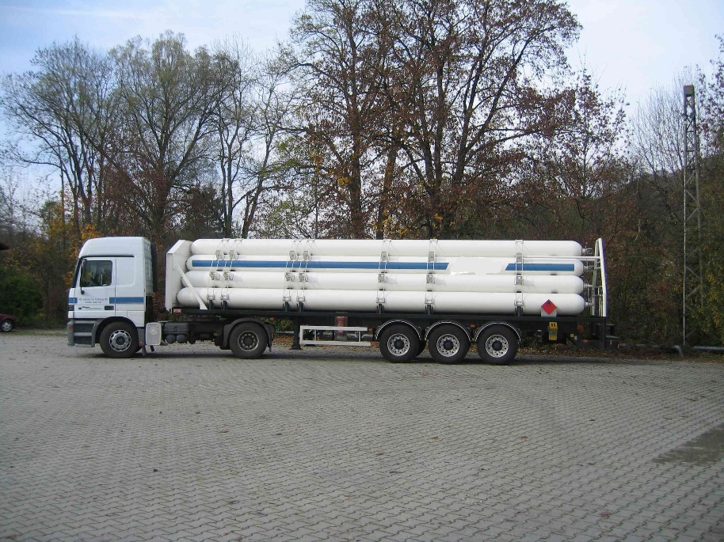

Battery vehicle constructed with seamless steel tubes

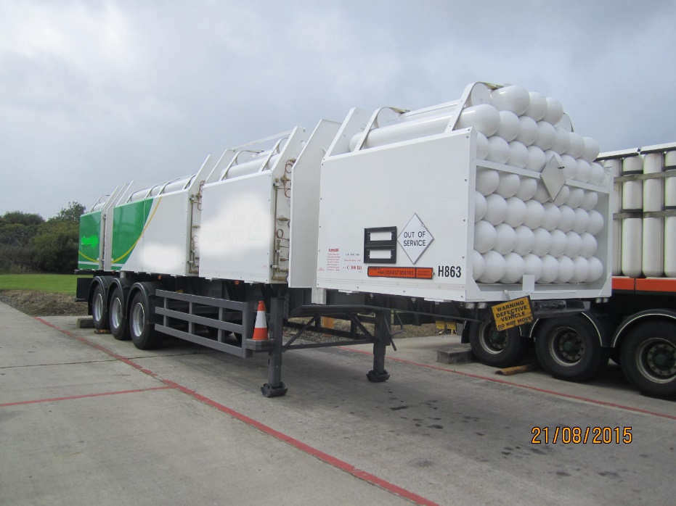

Battery vehicle constructed with seamless steel cylinders

1. \* In accordance with the programme of work of the Inland Transport Committee for 2018-2019, (ECE/TRANS/WP.15/237, annex V, (9.2)). [↑](#footnote-ref-2)
2. \*\* Circulated by the Intergovernmental Organisation for International Carriage by Rail (OTIF) under the symbol OTIF/RID/RC/2020/9. [↑](#footnote-ref-3)