|  |  |  |  |
| --- | --- | --- | --- |
|  | United Nations | ECE/TRANS/WP.15/AC.1/2020/29 | |
| _unlogo | **Economic and Social Council** | | Distr.: General  3 January 2020  English  Original: French |

**Economic Commission for Europe**

Inland Transport Committee

**Working Party on the Transport of Dangerous Goods**

**Joint Meeting of the RID Committee of Experts and the  
Working Party on the Transport of Dangerous Goods**

Bern, 16–20 March 2020

Item 5 (b) of the provisional agenda

**Proposals for amendments to RID/ADR/ADN:**

**new proposals**

Carriage of battery-powered vehicles

Transmitted by the Government of Switzerland[[1]](#footnote-1)\*,[[2]](#footnote-2)\*\*

|  |
| --- |
| *Summary* |
| **Executive summary**: ADR regulations for the transport of defective or damaged lithium batteries installed on vehicles powered by electric motors should be clarified. |
| **Action to be taken**: Introduce texts describing the conditions of transport. |
| **Related** **documents**: ECE/TRANS/WP.15/2019/21 from the 107th session of WP.15 and ECE/TRANS/WP.15/248, paras. 85 and 86. |
|  |

Introduction

1. ADR regulations for the transport of defective or damaged lithium batteries installed on vehicles powered by electric motors are not clear. The rules for the transport of vehicles with damaged lithium batteries are also not clearly established.

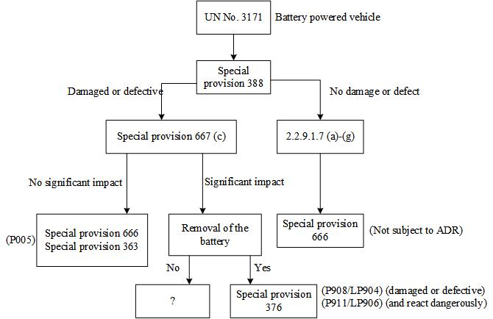

2. The danger is recognized, but there are no regulations on transport or packaging for damaged electric vehicles. Damaged or defective lithium batteries can heat up and start to burn. It does not matter whether the batteries are still installed on the electric vehicle or not. Precautions must be taken and any such situation brought under control as quickly as possible.

3. To make the carriage of potentially dangerous batteries installed on electric vehicles as safe as that of disassembled lithium batteries, we propose the following solution.

4. This could involve a standard 20-foot container with an integrated fire alarm and aerosol fire extinguishing system and straps to attach the load. The fire alarm and extinguishing system is activated once the electric vehicle is loaded. It monitors the vehicle or the lithium battery. It sets off an alarm and automatically extinguishes any fire. Overpressure in the container is reduced via a pressure relief valve, such that the container remains intact. The extinguishing aerosol remains active in the container for at least 30 minutes, thus preventing continued combustion or reignition.

5. The advantage of using an extinguishing aerosol is that no water is used and so the transport can be continued until a safe storage area is reached.

6. It also enables crucial time to be gained because fires are extinguished immediately upon detection and active protection is ensured for at least 30 minutes, thus giving the firefighters valuable time to intervene, if necessary.

7. Unlike vehicles assigned to UN No. 3166, vehicles assigned to UN No. 3171 that contain damaged or defective lithium batteries are not adequately covered by the regulations. The only requirements set for them are those of the second paragraph of special provision 667 (b) (ii), which refers to special provision 667 (b) (i) in the event that it is not possible to safely remove the cell or battery or it is not possible to verify the status of the cell or battery. Special provision 667 (b) (i) indicates that the transport operation may be performed in accordance with special provisions 363 or 666. Special provision 666 specifies that it applies to the vehicles defined in special provision 388. Special provision 388 specifies that lithium batteries “shall meet the provisions of 2.2.9.1.7, except as otherwise provided for in special provision 667”. The first sentence of special provision 667 (b) specifies that: “The provisions of 2.2.9.1.7 do not apply to lithium cells or batteries in damaged or defective vehicles, engine, machinery or article.” Therefore, if the batteries cannot be removed from an electric vehicle for safety reasons, the vehicle may be carried only in accordance with special provision 666, which does not set any conditions for electric propulsion.

8. It seems to us that the minimum conditions for the safe carriage of damaged electric vehicles could be set out in the regulations for users. For this reason, we believe that some provisions on the carriage of vehicles containing defective or damaged electric vehicles containing lithium batteries should be added to the regulations.

9. To this end, we would like to know whether other delegations are interested in providing more detailed specifications for such containers in the regulations.

10. We present below a draft of provisions that could be introduced to RID-ADR-ADN to define the containers intended for use in the recovery of electric vehicles. An example of the equipment can be found in the annex. It takes the form of an aerosol extinguishing medium that seems to have less impact on the environment than other extinguishing media that use water, which involve environmentally costly water treatment processes.

Proposal

11. For the entries for UN Nos. 3171, 3480 and 3481, add “BK1 BK2” in Column (10), AP11 in Column (17) and CVXY in Column (18) of Table A in Chapter 3.2.

12. Amend the second paragraph of special provision 667 (b) (ii) as follows:

“However if it is not possible to safely remove the cell or battery or it is not possible to verify the status of the cell or battery, the vehicle, engine, machinery or article may be towed or carried **in containers that meet the requirements of 6.11.6, 7.3.2.9, AP11 in 7.3.3.2.7 and CW/CVXY in 7.5.11** ~~as specified in (i)~~;”

13. Then add the following new section to Chapter 6.11:

“**6.11.6 Container for batteries and for a single vehicle or a single piece of equipment containing batteries**

6.11.6.1 To permit the safe handling and disposal of batteries contained in battery-powered equipment or vehicles of the entry for UN No. 3171 or damaged or defective cells and batteries of UN Nos. 3480 and 3481 that are liable to rapidly disassemble, dangerously react, produce a flame or a dangerous evolution of heat or a dangerous emission of toxic, corrosive or flammable gases or vapours under normal conditions of carriage, the transport operation shall be performed in a salvage container, the design of which may include equipment such as a fire alarm and an aerosol extinguishing system.

6.11.6.2 The general requirements for design and construction shall be deemed to be met if the container is an ISO 20-foot container conforming to ISO 668.

6.11.6.3 The container shall be capable of meeting the following additional performance requirements in case of rapid disassembly, dangerous reaction, production of a flame or a dangerous evolution of heat or a dangerous emission of toxic, corrosive or flammable gases or vapours of the battery:

(a) It shall be equipped with a fire alarm and an aerosol extinguishing system;

(b) The outside surface temperature of the container shall not have a temperature of more than 100°C. A momentary spike in temperature up to 200°C is acceptable;

(c) No flame shall occur outside the container;

(d) No projectiles shall exit the container;

(e) The structural integrity of the container shall be maintained.

6.11.6.4 Batteries or vehicles carried in the container shall be secured in accordance with standard cargo security guidelines in order to ensure their safe carriage.

**6.11.6.5** **Marking**

The marking of containers according to 6.11.6 complies with the marking provisions of 6.11.3.4.”

14. Add the following new paragraph to 7.3.2.9:

“7.3.2.9.2 For battery-powered equipment or vehicles of the entry for UN No. 3171 and damaged or defective cells and batteries of UN Nos. 3480 and 3481 that are liable to rapidly disassemble, dangerously react, produce a flame or a dangerous evolution of heat or a dangerous emission of toxic, corrosive or flammable gases or vapours under normal conditions of carriage, only closed bulk containers (code BK2) [consistent with 6.11.6]/[that meet the following additional requirements:

(a) The outside surface temperature of the container shall not have a temperature of more than 100°C. A momentary spike in temperature up to 200°C is acceptable;

(b) No flame shall occur outside the container;

(c) No projectiles shall exit the container;

(d) The structural integrity of the container shall be maintained.]

may be used.”

15. Add the following provision AP11 to 7.3.3.2.7:

“AP11 The vehicles and containers shall be leakproof and have a means of retaining any liquid that might escape during carriage.”

16. Add the following additional provision CW/CVXY to 7.5.11:

“CW/CVXY Batteries or vehicles shall be so stowed in the vehicle or container that they cannot overturn or fall.”

Annex

[English only]

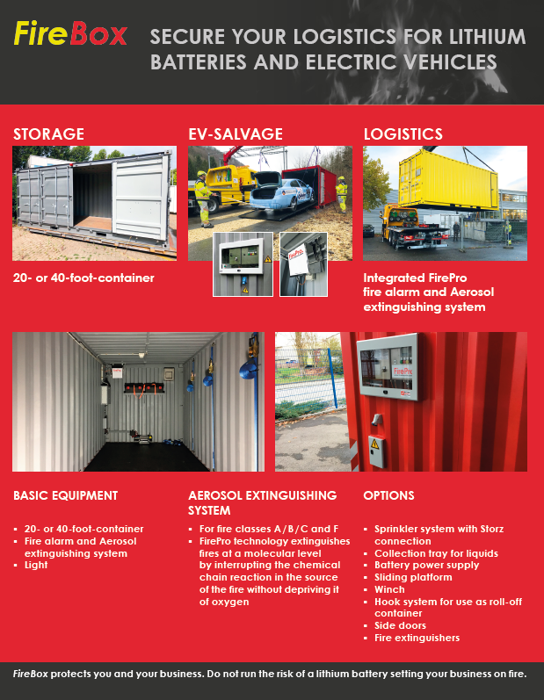

1. \* Subprogramme 2 of the programme budget for 2020 (A/74/6 (Sect. 20) and supplementary information). [↑](#footnote-ref-1)
2. \*\* Circulated by the Intergovernmental Organisation for International Carriage by Rail (OTIF) under the symbol OTIF/RID/RC/2020/29. [↑](#footnote-ref-2)