|  |  |  |  |
| --- | --- | --- | --- |
|  | United Nations | ECE/TRANS/WP.15/AC.1/2020/26 | |
| _unlogo | **Economic and Social Council** | | Distr.: General  6 January 2020  Original: English |

**Economic Commission for Europe**

Inland Transport Committee

**Working Party on the Transport of Dangerous Goods**

**Joint Meeting of the RID Committee of Experts and the  
Working Party on the Transport of Dangerous Goods**

Bern, 16-20 March 2020

Item 5 (b) of the provisional agenda

**Proposals for amendments to RID/ADR/ADN:**

**new proposals**

Proposal of amendment to 4.3.3.3.2 of RID/ADR

Transmitted by the Government of Poland**[[1]](#footnote-2)\*, [[2]](#footnote-3)\*\***

Introduction

1. This proposal aims to amend 4.3.3.3.2 (see also “INF.10 (Netherlands) Interpretation of the purpose and visibility of the markings required by 6.8.2.5.2 and 6.8.3.5.6” [March 2018]) according to the provisions:

**4.3.3.3.2:**

“When tanks, battery­vehicles or MEGCs are handed over for carriage, only the particulars specified in **6.8.3.5.6** applicable to the gas loaded or just discharged shall be visible; all particulars concerning other gases shall be covered up.”

**6.8.3.5.6:**

“In addition to the particulars prescribed in 6.8.2.5.2, the following shall be inscribed on the tank-vehicle (on the tank itself or on plates):

(c) where the tank is a multipurpose tank:

- the proper shipping name of the gas and, for gases classified under an n.o.s. entry, the technical name16 of all gases to whose carriage the tank is assigned with an indication of the maximum permissible load mass in kg for each of them;”

*(this provision also applies to ADN (4.1.2))*

2. The provision of 4.3.3.3.2 is contradictory to 6.8.3.5.6. In its current wording, it has served as a pretext to impose penalties on the carriers that fail to cover up the particulars. Such cover-up is associated with interference in the nameplate (see annex), which is prohibited. The argument that these particulars are vital for the rescue service is irrelevant. In the case of a fire, there is little chance to read the particulars provided on the plate. The rescue services will focus on transport documents and orange-coloured plate that shall bear the name of carried gas.

3. 4.3.3.3.2 applies to tank vehicles, tank wagons, battery-vehicles and battery-wagons, removable tanks, tank containers and MEGCs. It shall not apply to portable tanks and UN MEGCs. The provisions of part 4.2 of ADR/RID include the applicable references to part 6.7 and plate content – which require specification of names of all gases to be carried by a dedicated tank.

4. The provision of 4.3.3.3.2 has been applied in non-amended wording since 1981.

Proposal

5. The provision of 4.3.3.3.2 of RID/ADR should be deleted.

Justification

6. This amendment harmonizes the requirements for carriage and introduce greater transparency of regulations.

Difficulties

7. No difficulties with the application of the amendment are expected.

Annex

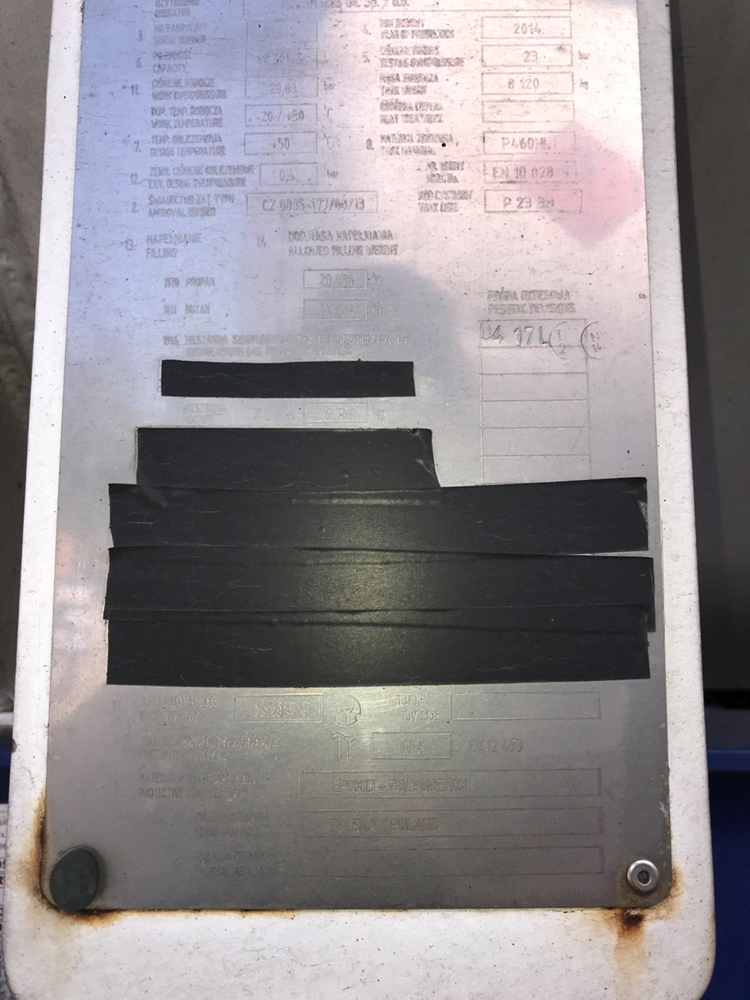

1. \* 2020 (A/74/6 (Sect.20) and Supplementary, Subprogramme 2). [↑](#footnote-ref-2)
2. \*\* Circulated by the Intergovernmental Organisation for International Carriage by Rail (OTIF) under the symbol OTIF/RID/RC/2020/26. [↑](#footnote-ref-3)