Economic Commission for Europe
Inland Transport Committee
Working Party on the Transport of Dangerous Goods
Joint Meeting of the RID Committee of Experts and the
Working Party on the Transport of Dangerous Goods 4 September 2020
Bern, 10-11 September 2020 and Geneva, 14–18 September 2020
Item 3 of the provisional agenda
Standards
Explanation to the amendment on the requirements of standard EN ISO 18119
Related to document ECE/TRANS/WP.15/AC.1/2020/63
Transmitted by the European Industrial Gases Association (EIGA)
Justification for deleting the note in 6.2.4.2
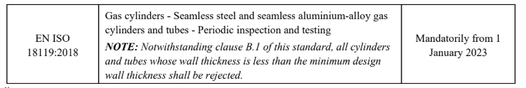
1. Ultrasonic testing of cylinders is a modern and efficient method for retesting gas cylinders.
2. This method is more reliable than the internal + external+visual + hydro inspection (EVH).
3. In particular, ADR allows ultrasonic examination (UT) to replace the internal visual inspection “verification of the minimum wall thickness” (not required that this thickness be > than the minimum design).
6.2.1.6.1(b): “Check of the internal conditions of the pressure receptacle (e.g. internal inspection, verification of minimum wall thickness);”
6.2.1.6.1 NOTE 3: “The hydraulic pressure test may be replaced by ultrasonic examination carried out in accordance with ISO 10461:2005+A1:2006 for seamless aluminium alloy gas cylinders and in accordance with ISO 6406:2005 for seamless steel gas cylinders.”
4. ISO 6406 referred to in ADR already allows thicknesses less than the minimum design (in Table B.2 footnote c)):
“c If corrosion has reached limits of depth or extent, the remaining wall thickness should be checked with an ultrasonic device. The wall thickness may be less than the minimum guaranteed wall thickness, e.g. small (depth and extent) isolated pits (see Figure B.5), where authorized by the relevant regulations taking into consideration the severity of the defect and safety factors.”
5. UT allows to detect much more cylinder imperfections than EVH.
6. Extensive testing and examination have been performed to determine acceptance/ rejection criteria (ISO/TR 22694).
7. ISO 18119 is referred to in UN Model Regulations without the Note of 6.2.4.2 of the ADR:
8. US DOT recognizes ISO 18119 and has allowed on the same conditions to accept thickness below the minimum design since already many years.
9. CONCLUSION: Removing this Note will not have any impact on the safety on the cylinders.

