UN/SCETDG/57/INF.59

Committee of Experts on the Transport of Dangerous Goods
and on the Globally Harmonized System of Classification
and Labelling of Chemicals 3 December 2020
Sub-Committee of Experts on the Transport of Dangerous Goods
Fifty-seventh session

Geneva, 30 November-8 December 2020
Item 6 (b) of the provisional agenda
Miscellaneous proposals for amendments to the Model Regulations
on the Transport of Dangerous Goods: packagings
Scope of 4G packaging and the translation of the Chinese version
Transmitted by the expert from China
Introduction
- We thank all the delegations who have commented for the working document ST/SG/AC.10/C.3/2020/35. We don't have the intention to amend the model regulations in the languages besides Chinese version. This working document is a result of problems encountered during actual transport in China. Our intention in this informal document is to give further examples of the packing material we were trying to describe in ST/SG/AC.10/C.3/2020/35, so that the Sub-Committee can have a better understanding on the problem we are facing now.
2. In the Model Regulations, the letter “G” indicates the packaging material “Fibreboard” and “4G” represents “Fibreboard box”. However, there is no definition of the term “fibreboard” in the Model Regulations.
3. In Chinese National Standards, “fibreboard” is a kind of material as shown in Fig.1. They are made from the raw materials of wood or other vegetation. These raw materials are prepared into fibres first, and then with adhesive applied, pressed under heating into plates with a thickness of not less than 1.5mm and a nominal density of ≥0.65g/cm³. Only these plates are known as fibreboard in Chinese National Standard. So, in domestic transport in China, only boxes made of this kind of material can be regarded as “fibreboard box”.
4. However, in international transport practice, we find that a number of dangerous goods from other countries are packed in boxes shown in Fig.2, and these boxes are marked as 4G. These packing boxes are in accordance with the Chinese National Standard for “corrugated fibreboard box”, which is totally different from “fibreboard box” in Chinese Standards. This makes us confused on what exactly “4G” in the Model Regulations indicates.
Figure 1: fibreboard defined in Chinese National Standard

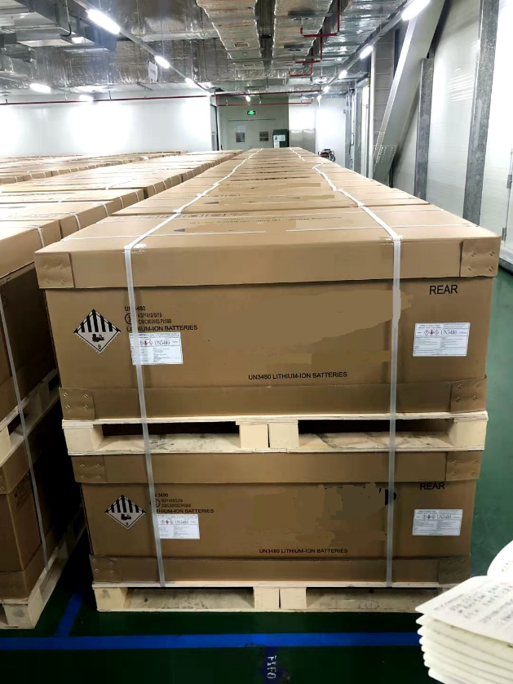
Figure 2: Boxes compliant to Chinese National Standard for “corrugated fibreboard box”
Proposal
5. The experts from China invite sub-committee to discuss the following issues:
6. We would like to ask the sub-committee
(a) To clarify if “corrugated fibreboard box” is included in 4G in Model Regulations
(b) If the answer to a) is “yes”, to clarify if there are types of boxes, other than corrugated fibreboard box, included in 4G. (Are non- corrugated fibreboard box 4G? Are boxes made of material shown in Fig.1 4G?).
7. And, if the Sub-Committee confirm that 4G is only for corrugated fibreboard box, we hope the Secretariat can assist us to revise the translation of “fibreboard” in Chinese Version Model Regulations.

