UN/SCETDG/57/INF.54

Committee of Experts on the Transport of Dangerous Goods
and on the Globally Harmonized System of Classification
and Labelling of Chemicals 28 November 2020
Sub-Committee of Experts on the Transport of Dangerous Goods
Fifty-seventh session

Geneva, 30 November-8 December 2020
Item 3 of the provisional agenda
Listing, classification and packing
Transport of transformers with gas cylinders
Transmitted by the expert from the United Kingdom
1. Further information to accompany formal paper ST/SG/AC.10/C.3/2020/49 as indicated in paragraph 7 of that paper.
2. Although there was an illustration of a transformer in the original paper introduced by the expert from Germany at the fifty-sixth meeting it was a relatively small one and not necessarily very typical of these items.
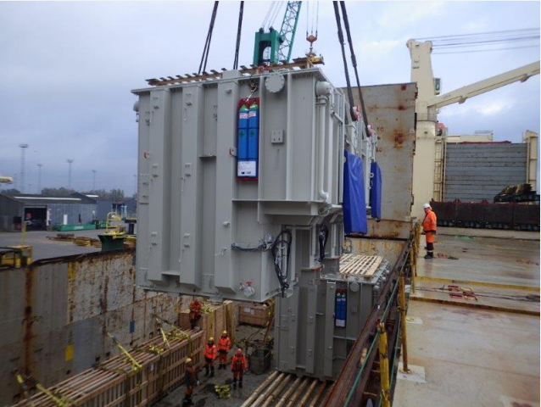
3. In this illustration the gas cylinders can be clearly seen. They have class 2 labels and the pipework feeding into the top of the transformer can just be seen. In this situation and in the two following illustrations the total release of all the gas would not cause an asphyxiation hazard. Turning these into dangerous goods for transport has the potential to create both commercial and logistic issues.
4. It is also important to appreciate that although the cylinder valves are open during transport there isn’t a continuous flow of gas. The system is pressurised to the required level and only vents gas when heating takes place causing the oil to expand. On cooling the oil contracts and new gas is drawn in to ensure no moisture is sucked into the equipment.
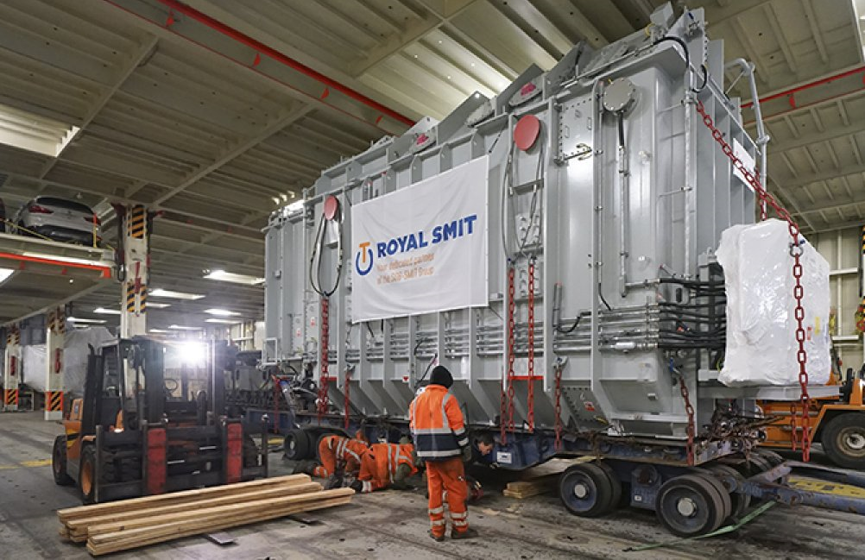
A transformer on the car deck of a ro-ro ferry.
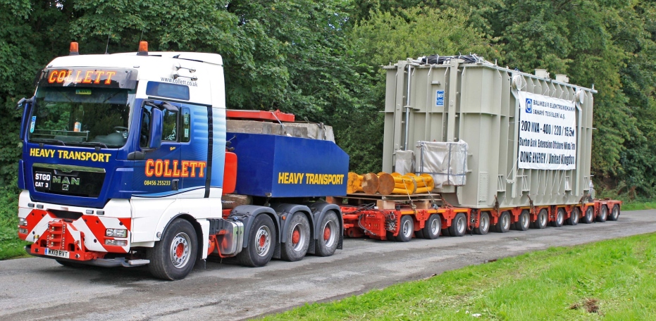
A transformer prepared for road transport.

