UN/SCETDG/57/INF.53

Committee of Experts on the Transport of Dangerous Goods
and on the Globally Harmonized System of Classification
and Labelling of Chemicals 27 November 2020
Sub-Committee of Experts on the Transport of Dangerous Goods
Fifty-seventh session

Geneva, 30 November - 8 December 2020
Item 3 of the provisional agenda
Listing, classification and packing
Information on document ST/SG/AC.10/C.3/2020/18 “Modifications concerning Salvage Pressure Receptacles”
Transmitted by the expert from Germany
Introduction
- On 6 April 2020, Germany submitted document ST/SG/AC.10/C.3/2020/18 “Modifications concerning Salvage Pressure Receptacles”, which proposed the introduction of a pV-limit for pressure receptacles.
- Germany thanks all participants for the valuable comments and contribution. For tracing convenience comments and information are collected in this document.
Comments and answers
3. Comment: We would like to know more about the technical reasons for choosing the 1.5 million bar litres limit.
Answer: The explanations of the necessity for such a pV-limit on the one hand and the value of 1.5 Mio bar litres on the other hand are relatively complex issues. An important part is the explanation, why we need such a limit at all. The special aspect of being prepared with respect to salvage pressure receptacles is explained in ST/SG/AC.10/C.3/2020/1. Further aspects and the argument for the figure of 1.5 Mio bar litres is provided in a paper presented at the ICHS 2019 in Adelaide (International Conference on Hydrogen Safety; see https://hysafe.info/iahysafe/wp-content/uploads/2019_papers/104.pdf). Relevant are the chapters 2, 3 and 4. A version shorted for chapters not being valid in this context has been prepared but unfortunately cannot be provided within this tool.
The aspect that is not reflected in this paper is the rational for the values in the FR-pV-diagram that is used there. This is described in a paper that is not publicly available. But we are open to distribute this paper as well as the already mentioned excerpt of the ICHS-paper to interested delegates via e-Mail.
4. Comment: We would like some further explanations why the definition for “Pressure receptacle” should contain the proposed limit for a test pressure volume product for the salvage pressure receptacle. In our view that limitation would perhaps be more suitable to insert in the definition for the "Salvage pressure receptacle". For other types of pressure receptacles, e.g. for pressure drum and cylinder, the capacity limits are expressed in their specific definitions, not in the general definition “pressure receptacle”.
Answer: Based on the functionality of a salvage pressure receptacle we think that such a salvage containment should be acceptable and manageable for all kinds of pressure receptacle, which makes a difference to tanks. For achieving this (safety) goal we are requested to limit the framework of possible pV-products of pressure receptacles. With respect to this it is counterproductive to limit the salvage pressure receptacles without knowing the limits of the pressure receptacles to be stored in if necessary.
Currently, we do not have a limitation of the gas capacity for compressed gases in any of the pressure receptacles. Therefore, it is possible to increase the stored amount of gas and energy by increasing the pressure of a pressure receptacle, which is currently limited by its water capacity, only. That an open end of the total amount of gas indicated by pV of pressure receptacles is not manageable due to increasing consequence is the second argument for limiting pressure receptacles itself and not their salvage containment.
5. Comment: However, Germany introduces a new kind of limit here: the pressure volume product (pV). It is not clear to us why a new type of limit is necessary and what this means for other limits. The implications of this new limit are not clear. We would like to see more background information and more explanation on why this new limit should be introduced in the Model Regulations and why this is better than the old limit.
Answer: The pV-product is already in use for several issues (e.g. SP 283, SP 653 and 6.2.6.1.5) and it was an essential aspect in the ADR before restructuring (marginals). Marginal 2214 and 2215 provided different levels of certification requirements dependent on the pV product of the pressure receptacles.
The idea is not to substitute the volume as a criterion for the definition of pressure receptacles. The addition to the water capacity V the pV-product creates a limitation to the total amount of gas and therefore of the physically and indirectly even to the chemically stored energy in a pressure receptacle. Since V is limited, this means a simultaneous limitation of the pressure p, which increases when the maximum permitted volume V is not used. With respect to worst case scenario we want to add a limitation of the maximum permissible energy to be stored in one unit.
For an explanation of the arguments we like to reference to paragraph 3.
6. Comment: The definition of pressure receptacle was just recently accepted, and several consequential amendments will be needed to modify other sections of the UN Model Regulations; and a better justification and possible real-world examples are needed for such a drastic increase in the water capacity of a placed pressure receptacle from 1 000 litres to 3 000 litres.
Answer: On the first view no impact on other sections could be detected. Since the salvage pressure receptacles should be intended for safety reasons mainly in emergency case there is the general request to enable the approval of salvage pressure receptacle for all available pressure receptacles. Therefore, especially for compressed gases it is not clear why to limit the capacity of salvage pressure receptacles instead of limiting pV-product of the pressure receptacle(s) to be stored in.
7. Comment: We do not believe that discussions in ISO on the proposed limit of 1.5 million bar litres has reached a consensus or a conclusion. In the absence of an ISO consensus the UK would like to see the evidence that Germany has on the safety of this limit in order to be able to consider the proposal further.
Answer: For a deeper understanding of the provided limited please see the reference provided in paragraph 3.
Yes, there are two projects considering a pV-limit at ISO level. Discussion is still circling around and not finalised yet. But CEN has already fixed their pV limit for the EN 17339 on the level presented here.
Germany raised this issue to this committee of experts based on two different aspects.
On one hand the background of the pV-discussion at CEN and ISO had been launched by Germany and is exclusively safety oriented. Safety aspects are the domain of regulatory bodies, which made us thinking this basic approach for a limitation due to safety reasons should be discussed here. Such a decision would help to finalise the individual discussions in the standardisation projects and would care for a unitary figure.
On the other hand, the main problem of salvage pressure receptacles is the open end of the pV-product as key issue for choosing the right salvage receptacle. This can be solved by definitions, which is the duty of regulators to whom ISO is invited for giving advisement.
Up to now no one has provided a rational for different data (i.e. lower consequence or high pV) on the basis of an analysis of the maximum consequence possibly caused by pressure receptacles. With respect to the Swizz document referenced in the scientific paper from ICHS 2019 about 40…45 fatalities (as border to catastrophic consequences) must be seen as an absolute limit for the maximum possible consequence of worst-case scenarios. All the measures to be taken in case of catastrophic incidents like they are treated in worst-case scenarios for some stationary plants cannot be managed during transport.
8. Comment: We ask for consistency whether the proposal should be considered in SI units.
Answer: We are in principle open to follow it. For reasons of practical experience and traceability we have based our proposal on the units provided in the permanent marking of pressure receptacles: bar and litre.
9. Comment: We prefer to consider this proposal after the publication of ISO 11515.

Answer: Please compare with paragraph 7.

Adding a limit value of the test pressure times water capacity is consensus in the working group 32 of the Technical Committee ISO/TC 58/SC 3 for the ISO 11515. A value of 1.5 million bar litres is proposed. The standard limits independently the volume to 3000 l and the test pressure to 1600 bar. Without limiting the combination of pressure and volume, a value of 4.8 million bar litres could be reached.
The consequence of a pressure receptacle burst is driven by the over pressure wave. The overpressure decreases with larger distance. The value of the overpressure indicates different consequences:
overpressure | Consequence
0.01 bar | human: blow over of persons
0.03 bar | environment: damage of 50 % of glass window
0.07 bar | human: injuries by glass window damage
0.16 bar | human: damage of eardrum
0.2 bar | human: serious injuries are common and fatalities may occur  environment: damage of steel frame structures; damage of 50 % of brick-made houses
0.35 bar | human: injuries are universal and fatalities are widespread  environment: extensive damage of buildings
0.5 bar | environment: collapse of 20 to 30 cm thick brick-made walls
0.7 bar | human: most people are killed  environment: extensive damage of buildings
1.4 – 2 bar | human: 99% fatalities
The blow over of persons and damages of some glass windows are used to approximate the number of possibly injured persons, and for fatalities the lower limit is used. Knowing that there is a variation in model approximation of blast waves, guiding values are illustrated for different gases in the following figure. The influence of gas properties is significant. Here the common calculation of an TNT-equivalent has not been used. It overestimates the consequences.
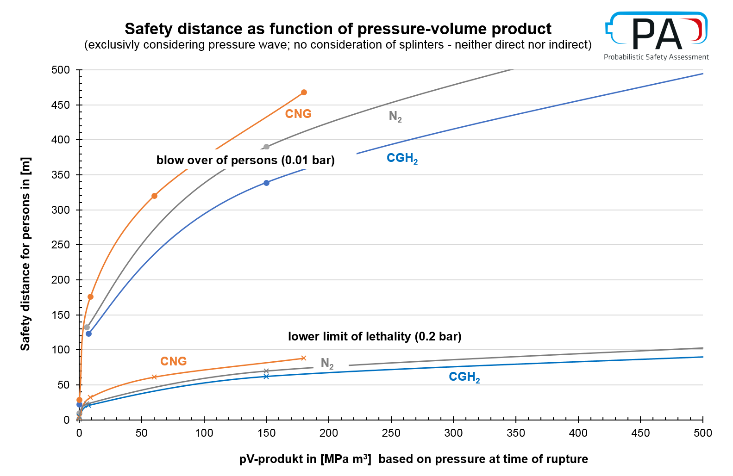
The consequence of a worst-case scenario and therefore the criteria to call it a catastrophe depends largely on the population density and its lethality due to pressure waves. Higher pressure volume products result in higher overpressures and a larger risk area. The higher overpressures cause a higher lethality in the near field of the accident. As secondary consequences, e.g. splinters from the pressure receptacle itself or from impacted buildings, are not part in this analysis of fatalities. Those fatality lines are lower boundaries. The upper boundary is the total number of people inside the risk area. Both is shown in the figure below. The spread (big arrow) indicates the possible size of the catastrophe for the proposed 1.5 Mio bar litre. A population density of 4000 people/km² is chosen for the following figure. This density represents the average density in Berlin, which stands for a big city with a lot of forest and water areas. Most cities will have a (much) high population density with an adequate higher consequence.
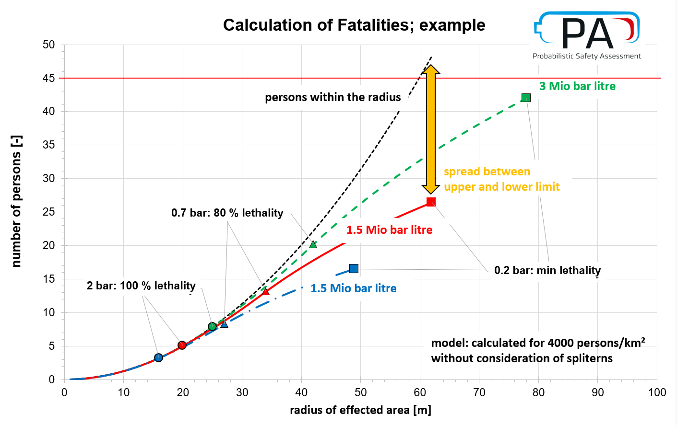
In conclusion, for average gas properties and an average city population density a value of 1.5 million bar litre for the product of test pressure times water capacity is appropriate to limit the size of consequences in terms of fatalities to 45 in general. As some gases may cause worse consequences, an additional limit for those gases will be proposed to amend packing instruction P200.
Summary
- We are convinced that the introduction of a pV-limit is a necessary topic to be decided here and not individually in standardisation projects.
- We think that this limit should be introduced in the definition and should be based on the analysis for a gas with relatively low consequence like hydrogen.
- If necessary, the pV-limit may by reduced further to lower figures for individual gases in the tables in P 200 where a gas show a high consequence than hydrogen at a given pV-product (e.g. methane/CNG or nitrogen).
- We are open to discuss the figure of the acceptable pV-limit on the basis of consequence analysis and welcome each contribution to this discussion.

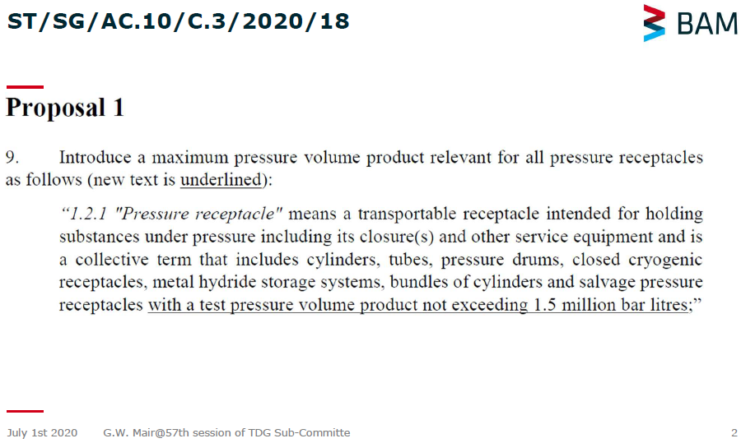
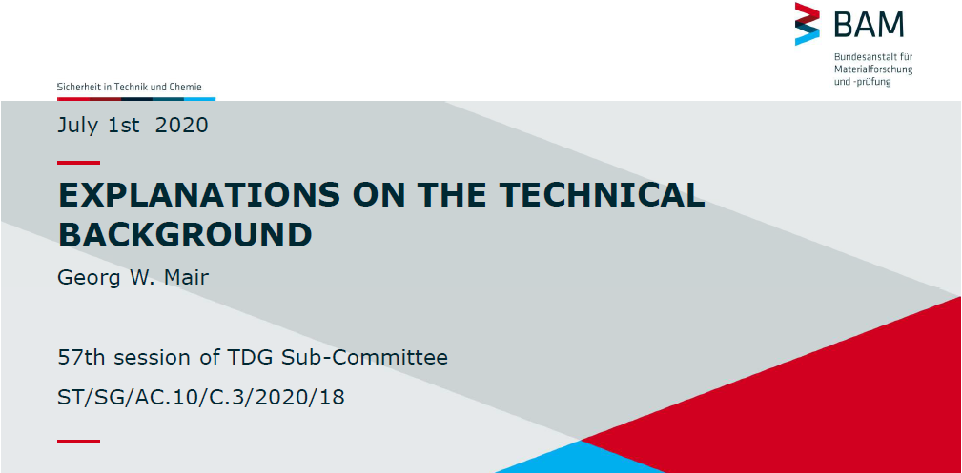
Slides provided in the online session during the 57th session of TDG Sub-Committee for explanations on the technical background

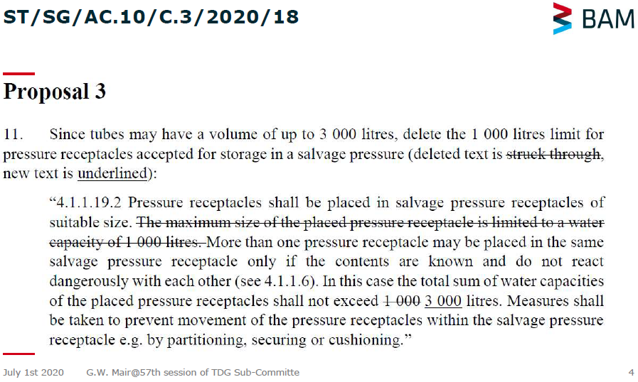
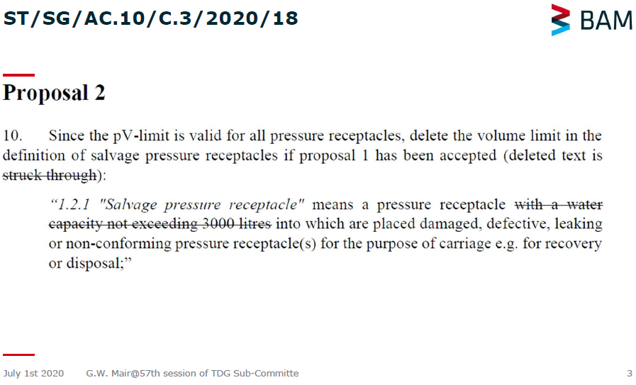
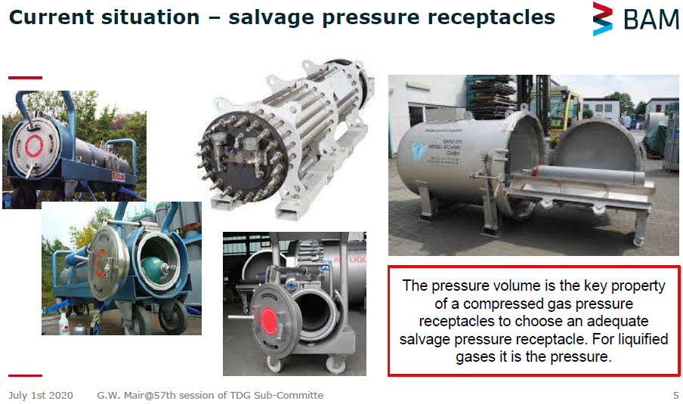

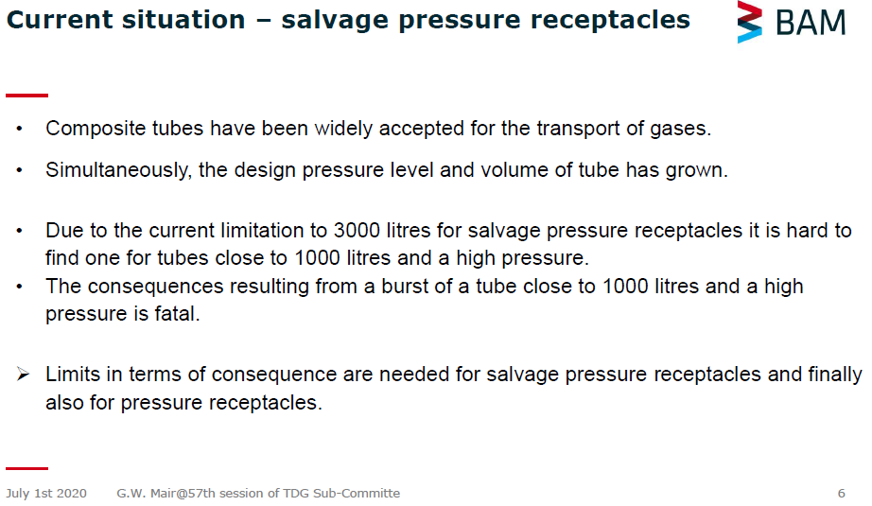
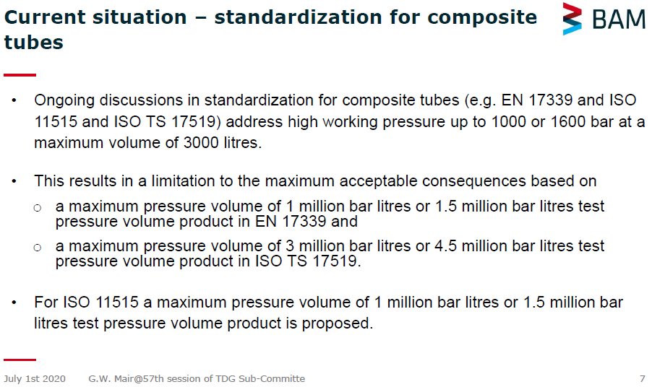
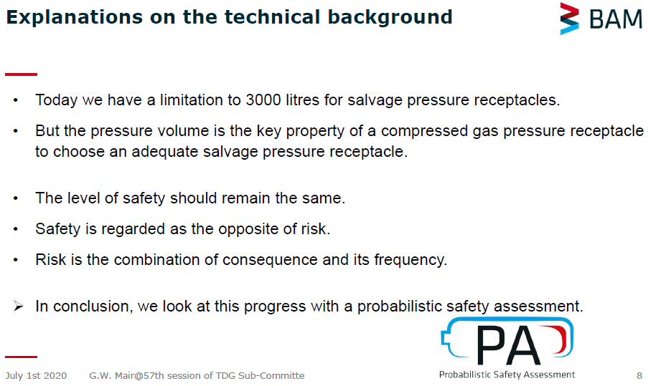
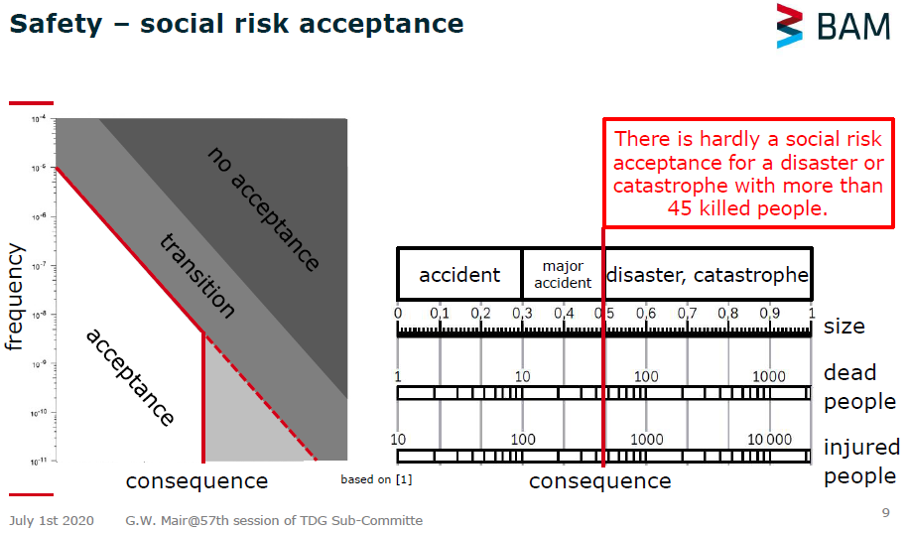
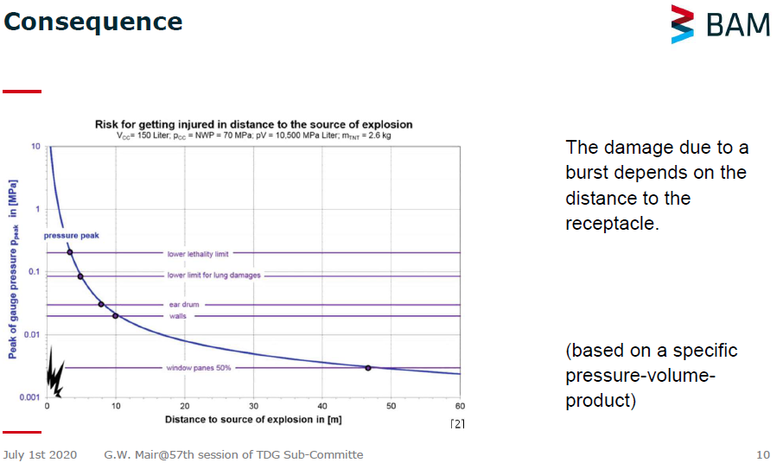
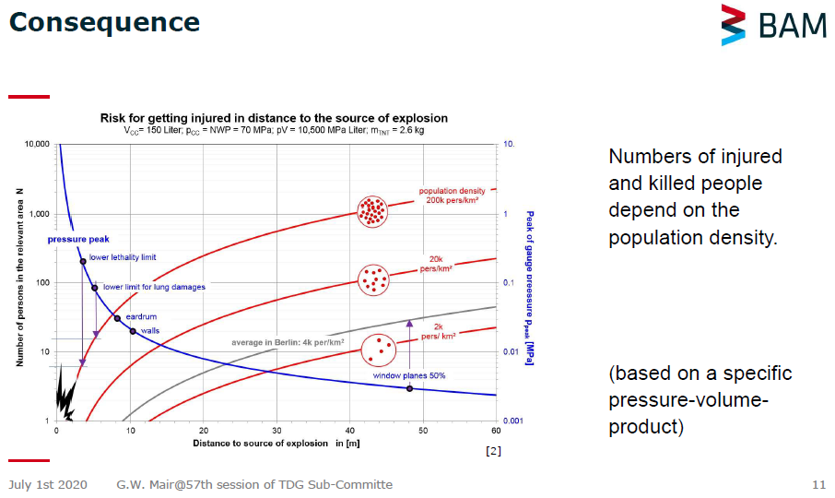
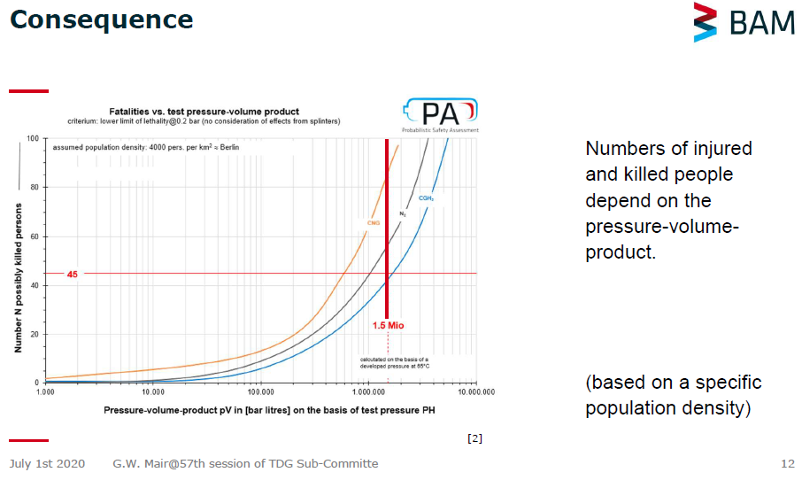
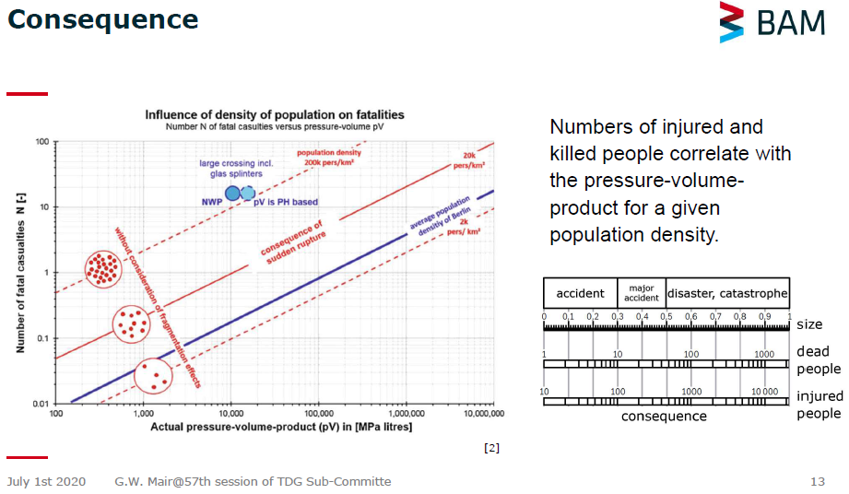
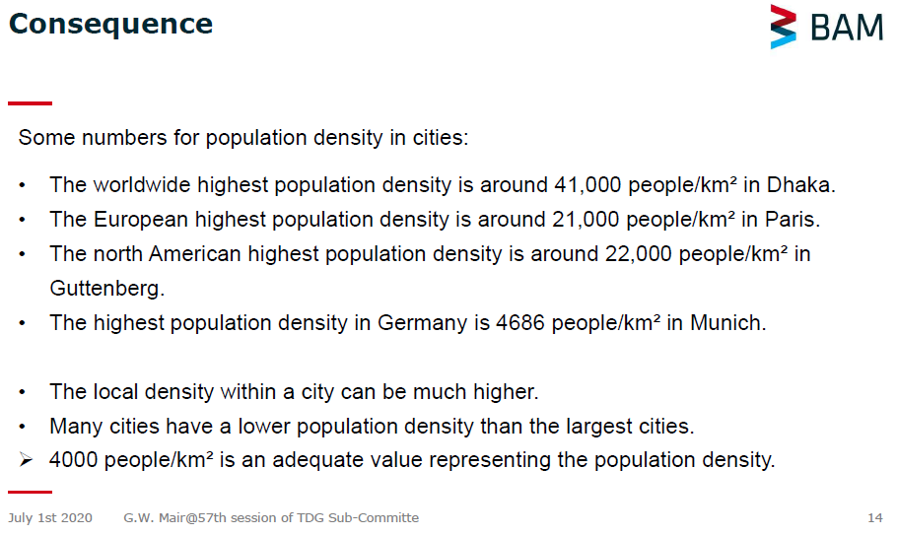
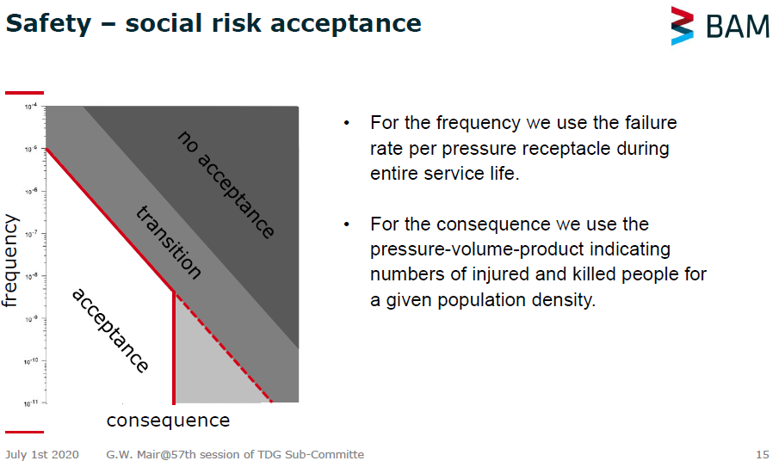
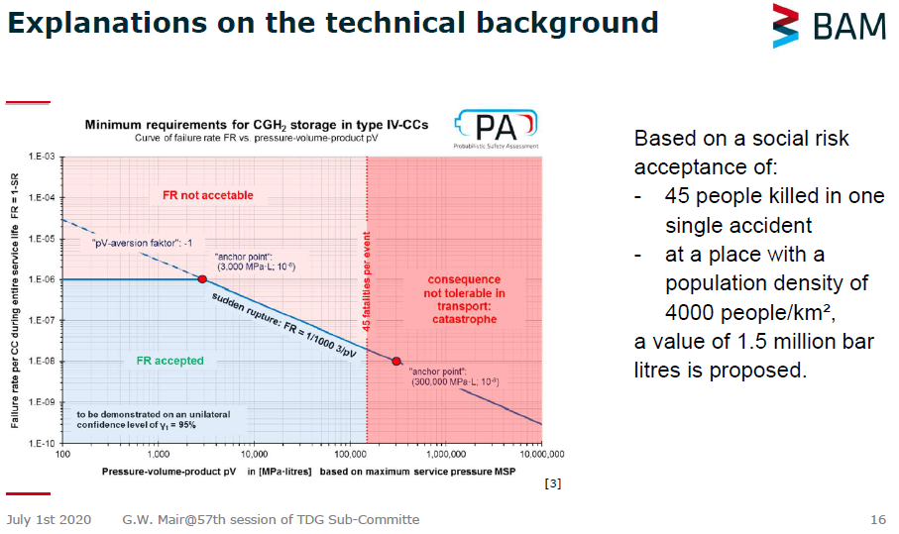
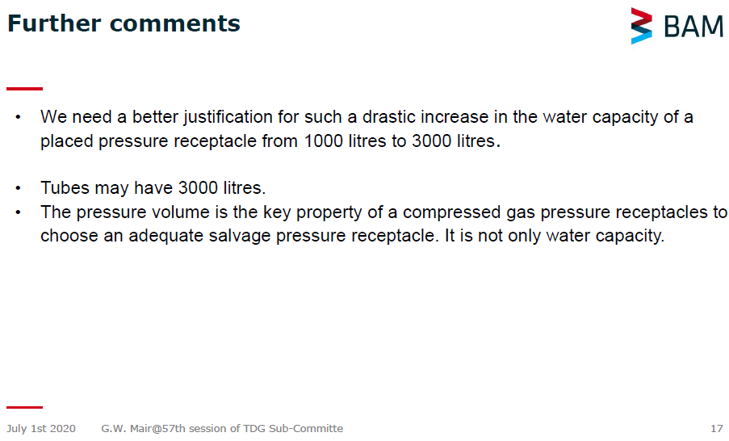
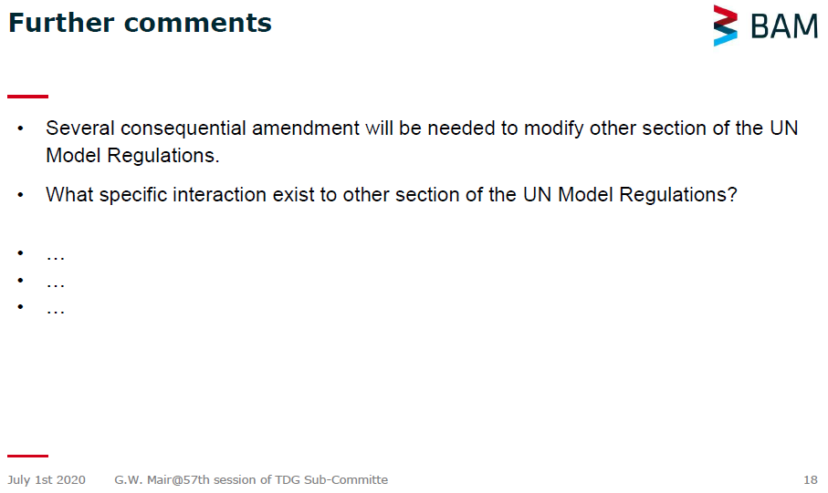

Further information
The PV product 1.5 million bar*litre is determined based on the consideration of assumed population density. The damage radius of explosion of pressure vessels depends on the explosion energy which is linearly related to the PV product; the damage, for example the number of “killed person” by shock wave depends on the number of persons within the radius of shock wave. Parentally, different population densities will result different severity of consequence.
The other factor which could influence the limitation of 1.5 million bar*litre is the safety measures for the gas transportation. For example, to define the transport route and the time to reduce the number of the population within the area.

