UN/SCETDG/57/INF.9

Committee of Experts on the Transport of Dangerous Goods
and on the Globally Harmonized System of Classification
and Labelling of Chemicals 12 June 2020
Sub-Committee of Experts on the Transport of Dangerous Goods
Fifty-seventh session

Geneva, 29 June-8 July 2020
Item 4 (e) of the provisional agenda
Electric storage systems: sodium-ion batteries
Supporting information about ST/SG/AC.10/C.3/2020/45: Sodium-ion batteries – Creation of a dedicated UN number and related special provisions
Transmitted by the experts from France and the United Kingdom
Summary
- To complete doc ST/SG/AC.10/C.3/2020/45, this document provides abusive tests results run on two different chemistries and formats of Na-ion batteries (18650 and pouch cell). Those tests have not the ambition to cover all type of Na-ion batteries but give a tendency.
- Tests results on fully charged batteries show that in some abuse scenario and for some chemistries, even well-designed Na-ion batteries are liable to produce a hazardous reaction (heat emission for example). This behavior justifies the necessity to perform a testing scheme, similar to UN38.3 before authorizing the battery for transport. In particular this aims at avoiding badly designed batteries that could create safety issues during transport.
- Results also shows that the tested Na-ion batteries seems to be less hazardous than ordinary Li-ion batteries and justify the simplification of required tests.
- Tests results on discharged batteries support the proposal 4 for transport of shorted sodium-ion batteries.
Test results on fully charged cells
Presented tests were not intended to be conform to UN38.3 procedures. Tests are run on fully charged cells. Two cell formats are tested, each one is based on a different chemistry and technology of Na-ion batteries. Other formats, chemistry, technology or design of cell might result on different test outcomes.

- Altitude simulation:
No reaction is observed for 18650 cells
- 18650 cells, chemistry B
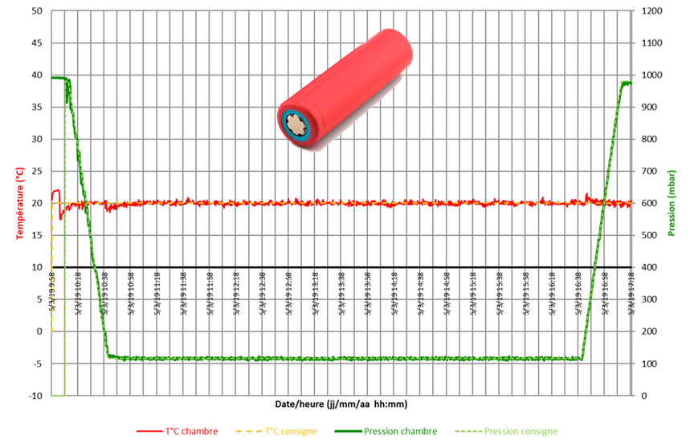
Figure 1 : Altitude simulation test result for fully charged 18650 cells
- External short circuit:
In both case a significant increase in temperature is observed. Performing a short circuit test as preconized in UN38.3 is necessary to ensure safety during transport. As a reminder, limit temperature in UN38.3 for Li-ion batteries is is fixed at 170°C, starting at 57°C ambient temperature.
- Pouch cell, chemistry A:
R short circuit: 0,6 mΩ Tamb: 20°C Tmax reached: 96°C Swelling of the cell is observed
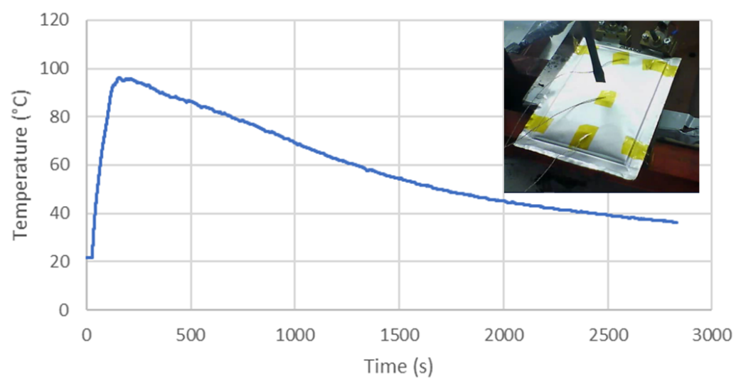
Figure 2 : External short circuit test of a fully charged pouch cell

- 18650 cells, chemistry B
R short circuit: 3,7 mΩ Tamb: 22°C Tmax reached: 131°C
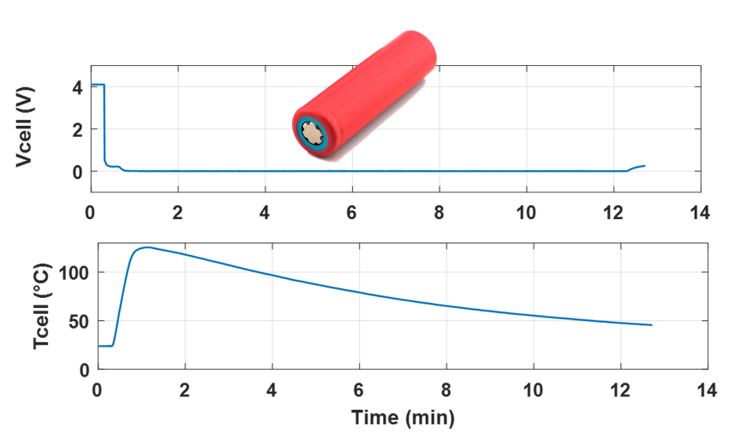
Figure 3 : External short-circuit test result for a fully charged cell
- Crush:
For the pouch cell format with chemistry A, no reaction (steady temperature and steady voltage) is observed.
For the 18650 cells and chemistry B a limited increase in temperature (50°C) is observed.
- Pouch cell, chemistry A:
Crush speed: 0,0033 cm/s
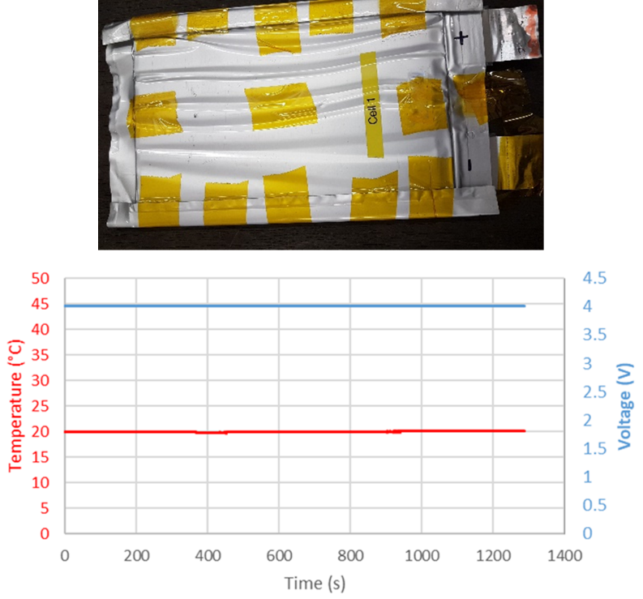
Figure 4 : crush test of a fully charged pouch cell

- 18650 cells, chemistry B
Crush speed: 15 cm/s
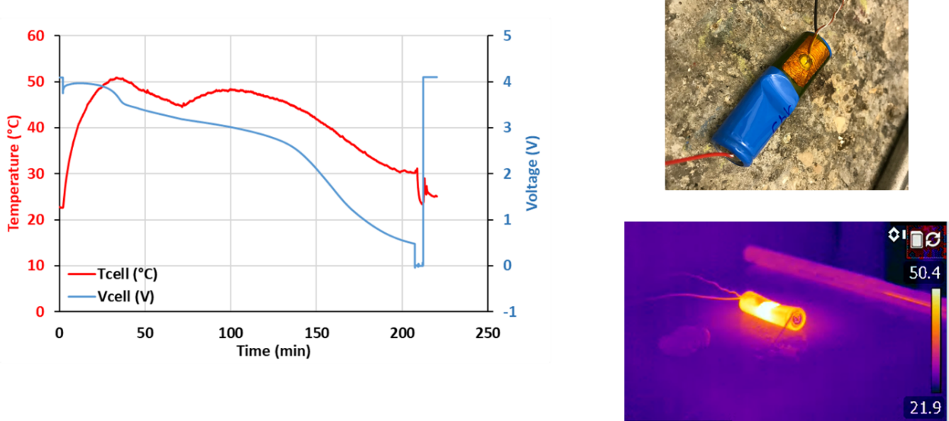
Figure 5: Crush test result for a fully charged 18650 cell
- Nail penetration (internal short circuit simulation):
For the pouch cell format and chemistry A, a limited increase in temperature (40°C) is observed. The voltage remains stable.
For the 18650 cells an important increase in temperature (130°C) is observed. The voltage drops to 0 V.
- Pouch cell, chemistry A:
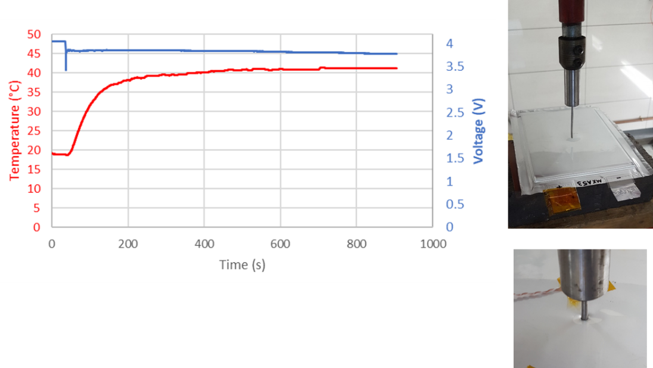
Figure 6 : Nail penetration test of a fully charged pouch cell

- 18650 cells, chemistry B
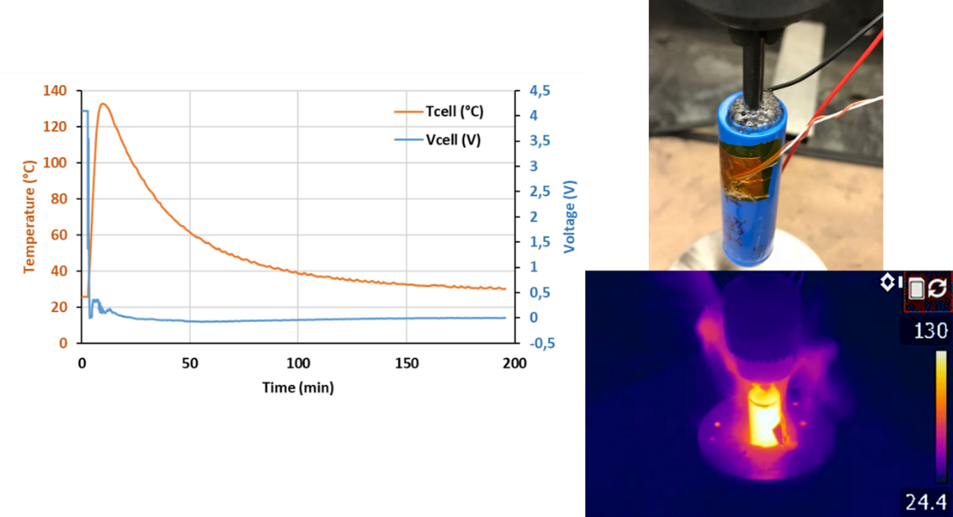
Figure 7: Nail penetration test result for a fully charged 18650 cell
Test results on fully discharged cells
Presented tests were not intended to be conform to UN38.3 procedures. Tests are run on fully discharged cells (similar behavior than a short-circuited cells). Only the 18650 format (chemistry B) was tested at fully discharged state.
- External short circuit:
Contrary to the fully charged cells, no temperature elevation is observed.
- 18650 cells, chemistry B
R short circuit: 3,7 mΩ Tamb: 22°C
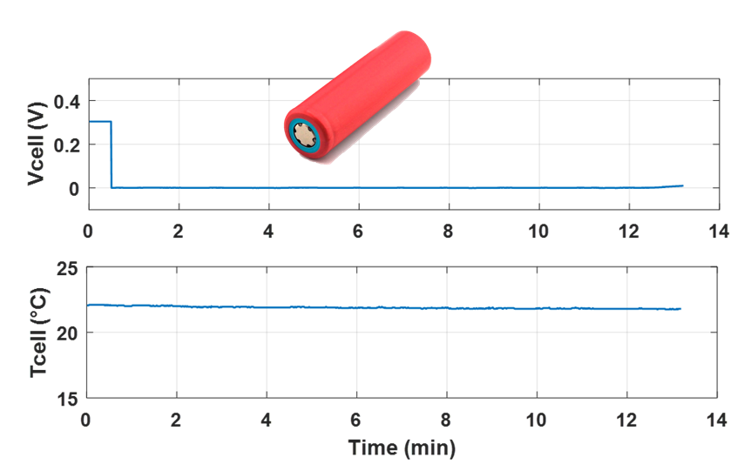
Figure 8 : External short-circuit test result for a fully discharged cell

- Crush:
Contrary to the fully charged cells, no temperature elevation is observed.
- 18650 cells, chemistry B
Crush speed: 15 cm/s
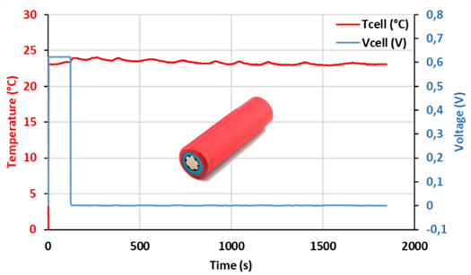
Figure 9: Crush test result for a fully discharged 18650 cell
- Nail penetration (internal short circuit simulation):
Contrary to the fully charged cells, no temperature elevation is observed.
- 18650 cells, chemistry B
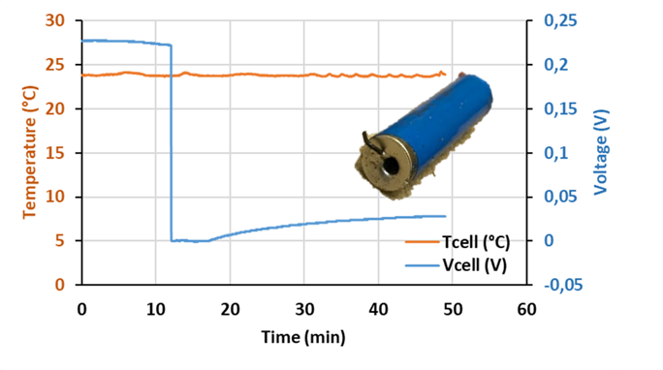
Figure 10: Nail penetration test result for a fully discharged 18650 cell
____________________

