|  |  |  |  |
| --- | --- | --- | --- |
|  | United Nations | ST/SG/AC.10/C.3/2020/72 | |
| _unlogo | **Secretariat** | | Distr.: General  7 September 2020  Original: English |

**Committee of Experts on the Transport of Dangerous Goods  
and on the Globally Harmonized System of Classification  
and Labelling of Chemicals**

**Sub-Committee of Experts on the Transport of Dangerous Goods**

**Fifty-seventh session**

Geneva, 30 November-8 December 2020

Item 3 of the provisional agenda

**Listing, classification and packing**

Classification of UN 1891 ETHYL BROMIDE

Transmitted by the expert from Belgium[[1]](#footnote-2)

Introduction

1. During the fifty-sixth session, Belgium presented informal document INF.11 (fifty-sixth session) in which it was explained that there are scientific data indicating that UN 1891 ETHYL BROMIDE is currently not classified according to the dangers it holds.

2. More specifically, different data sources show that its flash point (-20 °C) and its boiling point (38 °C) clearly meet the criteria for inclusion in class 3, PGII (i.e. flash point < 23 °C and boiling point > 35 °C, see 2.3.2.6.). Furthermore, as also explained in informal document INF.11 (fifty-sixth session), when taking into account the current classification of UN 1891 as a division 6.1, PGII substance, it seems that UN 1891 should rather be classified as a class 3, PGII substance with division 6.1 as a subsidiary hazard, when applying the precedence of hazard principles given in 2.0.3.3.

3. As already pointed out in informal document INF.11 (fifty-sixth session), the European CLP-regulation also indicates that the primary hazard of this substance is flammability rather than toxicity, because it is categorized as a category 2 flammable liquid, while classifying as category 4 for both acute oral toxicity and acute toxicity by inhalation.

4. Besides showing that the primary hazard should be flammability rather than toxicity, the scientific data obtained raise doubts whether UN 1891 actually meets the criteria for inclusion into division 6.1 according to the principles of classification in the UN Model Regulations. The obtained value for the LD50 for oral toxicity (1350 mg/kg) is clearly above the upper limit for inclusion into division 6.1 by oral toxicity (300 mg/kg, see 2.6.2.2.4.1). Additionally, none of the obtained data sources indicate that UN 1891 is toxic through the dermal route.

5. However, after reanalysing the obtained data for toxicity by inhalation, doubt still exists whether one can conclude that ethyl bromide does or does not meet the criteria for toxicity by inhalation of vapours given in 2.6.2.2.4.3 of the Model Regulations. Nevertheless, the classification according to the CLP-regulation (i.e. category 4 for acute toxicity by inhalation) suggests that UN 1891 ETHYL BROMIDE should indeed not be classified as toxic by inhalation according to the Model Regulations because table A1.18 of the Annex 1 to the GHS indicates that category 4 for acute toxicity does not require classification as a division 6.1 substance according to the Model Regulations.

6. When informal document INF.11 (fifty-sixth session) was discussed, the Sub-Committee agreed that the classification should be reconsidered and, with some reservation, support was expressed to reclassify UN 1891 ETHYL BROMIDE as a class 3, packing group II substance. For the classification as a division 6.1 substance, a need for more data and a need to know the rationale or data supporting the original classification as a division 6.1 substance was expressed (see ST/SG/AC.10/C.3/112, para. 39).

7. Considering the flammability, some data sources mention that the value of -20 °C for the flash point was obtained using the closed cup method, as such being in line with the requirements of table 2.3.2.6 of the Model Regulations. Additionally, in 2009, during the twenty-second session of the International Civil Aviation Organization (ICAO) Dangerous Goods Panel, Working Paper 44 on the classification of UN 1891 ETHYL BROMIDE was discussed (informal document INF.21), providing additional evidence that UN 1891 indeed meets the criteria to be classified as a class 3, packing group II substance. However, it was noted in the report of the ICAO Dangerous Goods Panel, that this proposal was withdrawn because it needed to be considered by the UN Sub-Committee (see 2.3.4.1 of that report).

8. A quest was undertaken by the secretariat and the library services of the UN and it seems that ethyl bromide was initially included in the “UN list of dangerous goods” by the “Committee of experts for further work on the transport of dangerous goods” at its second session in 1961. This was based on its appearance on a list transmitted by the International Air Transport Association (IATA) as an “Other restricted article” which meant it was considered as a hazardous item for transport in some cases. A rationale why this substance was subsequentially classified as a class 6.1 substance was not provided (informal document INF.22).

9. Even though research was undertaken, no further data supporting or undisputedly disproving the classification of UN 1891 ETHYL BROMIDE as a substance meeting the criteria of 2.6.2.2.4.3 for toxicity by inhalation was retrieved at the time being. In the case such data are to be obtained before the next session, they will be provided in the form of an informal document.

Consequences of reclassifying UN 1891 as a class 3, PGII substance

10. To have a clearer understanding of what the consequences would be of deciding whether or not to reclassify UN 1891 for the reasons provided above, it seemed interesting to analyse the changes in the Dangerous Goods List that would occur as a consequence of this reclassification. For reasons of easy comparison, the current entry for UN 1891 in the Model Regulations is given in Figure 1.

**Figure 1:** Current entry for UN 1891 in the Dangerous Goods List

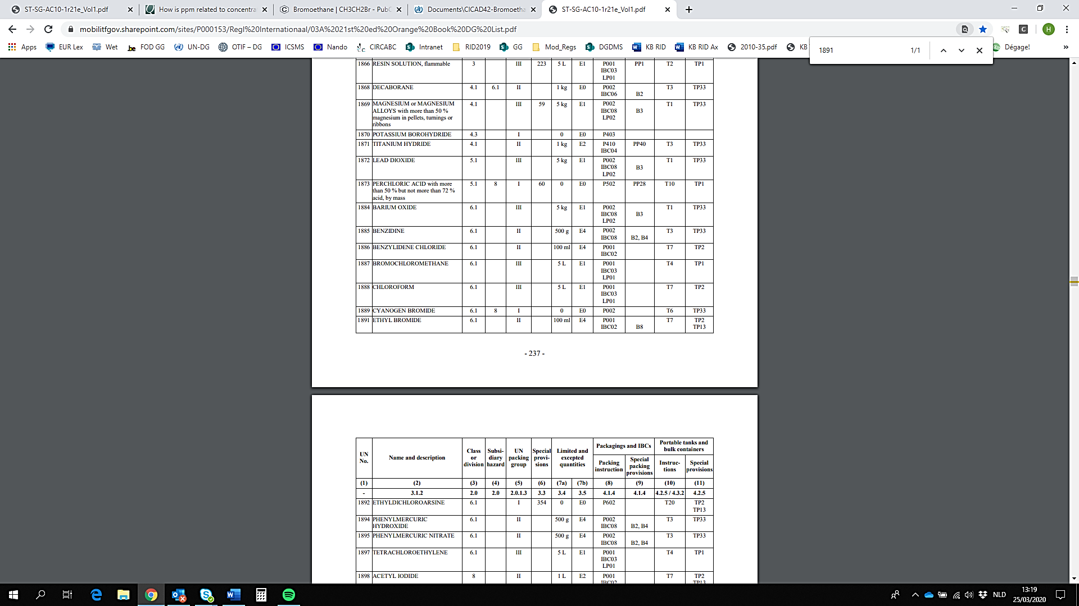

Excepted Quantity (EQ) and Limited Quantity (LQ)

11. Based on its current classification as a division 6.1 PGII substance, UN 1891 has 100 ml assigned as the upper limit for LQ and E4 assigned for EQ. To be in line with the Guiding Principles for a Class 3, PGII substance an upper limit of 1 litre should be assigned for LQ and E2 for EQ.

Packing instruction P001

12. UN 1891 is currently assigned P001, a general packing instruction for liquids which is used as packing instruction for liquids from different Dangerous Goods classes and is already assigned to many other class 3 substances. As such reclassification of UN 1891 as a class 3, PGII substance does not seem to necessitate any change to the assignment of P001 to UN 1891 in the Dangerous Goods List.

IBC packing instruction IBC02

13. Given its current classification as a liquid division 6.1 substance and in line with Chapter 4.2 of the Guiding Principles, that mentions IBC02 should be assigned to a division 6.1, packing group II liquid, UN 1891 currently has IBC02 assigned to it. Nevertheless, assignment of IBC02 to a class 3 PGII substance is also in line with Chapter 4.2 of the Guiding Principles. As such, changing the classification of UN 1891 to a class 3 PGII substance would not require changing the assignment of IBC02 in the Dangerous Goods List.

IBC special packing provision B8

14. IBC special packing provision B8 is currently assigned to UN 1891 and reads: “The pure form of this substance shall not be transported in IBCs since it is known to have a vapour pressure of more than 110 kPa at 50 °C or 130 kPa at 55 °C.” Reclassifying this substance as a class 3 PGII substance does of course not change its physical properties and as such, it seems logical to keep B8 assigned to UN 1891.

Portable tank instruction T7

15. In line with the guidance given by the Guiding Principles, UN 1891 has currently been assigned portable tank instruction T7. When reclassifying as a class 3 PGII substance and taking into account the guidance given in the Guiding Principles, the proper choice of the portable tank instruction depends on whether or not it is decided to keep into account the current classification as a toxic substance or not. If division 6.1 is kept as a subsidiary hazard, portable tank instruction T7 should be kept assigned. In the case, it is decided not to keep division 6.1 as a subsidiary hazard, portable tank instruction T4 should be assigned to UN 1891.

Portable tanks special provisions TP2 and TP13

16. Portable tank special provisions TP2 and TP13 are currently assigned to UN 1891. TP2 requires that the degree of filling prescribed in 4.2.1.9.3 shall not be exceeded. It is noted in the Guiding Principles that it is assigned to substances with a vapour pressure greater than 175 kPa at 65 °C and also to substances of division 6.1 or Class 8 in PGI or PGII. Currently data on the vapour pressure greater at 65 °C are lacking, so it is not clear whether the assignment of TP2 depends on the classification of UN 1891 as a division 6.1, PGII substance or not.

17. TP13 prescribes that a breathing apparatus shall be provided when this substance is transported, and it is noted in the guiding principles that it should be applied to substances which are toxic by inhalation. As such, assignment of TP13 would be dependent on the decision to keep 6.1 assigned to TP13 based on its toxicity by inhalation.

Proposal

18. Amend the entry for UN 1891 in the Dangerous Goods list as follows (deleted text ~~stricken through~~, new text underlined.

|  |  |  |  |  |  |  |  |  |  |  |  |
| --- | --- | --- | --- | --- | --- | --- | --- | --- | --- | --- | --- |
| **UN No.** | **Name and description** | **Class or division** | **Subsidiary hazard** | **UN packing group** | **Special Provisions** | **Limited and excepted quantities** | | **Packagings and IBCs** | | **Portable tanks and bulk containers** | |
| **Packing instruction** | **Special packing provision** | **Instructions** | **Special provisions** |
| **(1)** | **(2)** | **(3)** | **(4)** | **(5)** | **(6)** | **(7)** | **(8)** | **(9)** | **(10)** | **(11)** | **(12)** |
| 1891 | ETHYL BROMIDE | ~~6.1~~ 3 | 6.1 | II |  | ~~100 ml~~  1 L | ~~E4~~  E2 | P001  IBC02 | B8 | T7 | TP2  TP13 |

Justification

19. Given the arguments and data provided about the classification of UN1891 as a class 3, PGII substance according to the criteria in 2.3.2.6, it seems justified to reclassify this substance accordingly.

20. The current data on the toxicity by inhalation of UN 1891 do not allow to clearly and undoubtedly decide whether UN 1891 should be classified as a toxic substance or not. Even though no rationale could be provided why this substance was originally classified as a division 6.1, PGII substance, it seems appropriate to keep into account its current classification as a division 6.1, PGII substance and thus assign 6.1 as a subsidiary hazard.

21. Keeping the current classification into consideration also provides a rationale for why the transport conditions that are currently assigned and proven to be safe, are kept, which is especially true in case of the transport in portable tanks. For transport under the LQ and EQ regimes, the proposed changes, which are in line with the Guiding Principles, lead to a relaxation and thus still allow and do not hamper the way this substance can currently be transported.

22. This proposal improves safety by clearly communicating the actual dangers and risks that this substance presents while, at the same time, keeping the current transport conditions (which have shown to be safe for many years) as much as reasonably possible.

Annex

Scientific data on UN 1891

Table 1: Flashpoint and boiling point, LD50 and LC50

|  |  |  |  |  |
| --- | --- | --- | --- | --- |
| Property    Source | Flashpoint (°C) | Boiling point (°C) | Oral toxicity LD50 (mg/kg) | Inhalation toxicity LC50 |
| BIG Kaleidos Database1 | -20 | 38 | / | / |
| Pubmed Database2 | -20 | 38 | 1350 (rat) | 26980 mg/kg (rat)  16230 mg/kg (mouse) |
| Concise International Chemical Assessment Document 42 (WHO)3, 4 | -20 | 38.4 | 1350 (rat) | 21200 mg/m³ = 4681 ppm (rat, 4h)  12300 mg/m³ = 2723 ppm  (mouse, 4h) |
| MSDS Bromoethane5 | -23 | 37 - 40°C | 1350 (rat) | 20.9 mg/l (rat, 4h)  26980 ppm (rat, 1h) |

Table 2: Volatility and vapor pressure

|  |  |
| --- | --- |
| Source | Value |
| MSDS Bromoethane5 | Volatility: 400 mm Hg |
| ILO international chemical safety card6 | Vapor pressure at 20°C: 51 kPa |

Sources

1: <https://www.big.be/en-us/Products/Kaleidos>

2: <https://pubchem.ncbi.nlm.nih.gov/compound/Bromoethane#section=Acute-Effects>

3: <https://www.who.int/ipcs/publications/cicad/en/cicad42.pdf?ua=1>, Data LC50: see source 4

4: Only for LC50:In the document for LC50 rat: see table 5; LC50mice: see table 16. <https://ntp.niehs.nih.gov/ntp/htdocs/lt_rpts/tr363.pdf?utm_source=direct&utm_medium=prod&utm_campaign=ntpgolinks&utm_term=tr363>

5: <https://www.fishersci.com/store/msds?partNumber=AC154215000&productDescription=BROMOETHANE+98%25+500ML&vendorId=VN00032119&countryCode=US&language=en>

6: <http://www.ilo.org/dyn/icsc/showcard.display?p_version=2&p_card_id=1378>

1. 2020 (A/74/6 (Sect.20)) and Supplementary, Subprogramme 2.) [↑](#footnote-ref-2)