|  |  |  |  |
| --- | --- | --- | --- |
|  | United Nations | ST/SG/AC.10/C.3/2020/24/Rev.1 | |
| _unlogo | **Secretariat** | | Distr.: General  7 September 2020  Original: English |

**Committee of Experts on the Transport of Dangerous Goods  
and on the Globally Harmonized System of Classification  
and Labelling of Chemicals**

**Sub-Committee of Experts on the Transport of Dangerous Goods**

**Fifty-seventh session**

Geneva, 30 November-8 December 2020  
Item 3 of the provisional agenda

**Listing, classification and packing**

Amendments to P621

Transmitted by the expert from Belgium[[1]](#footnote-2)

Revision

Introduction

1. Packing instruction P621 applies to UN 3291 CLINICAL WASTE, UNSPECIFIED, N.O.S or (BIO)MEDICAL WASTE, N.O.S or REGULATED MEDICAL WASTE, N.O.S. This packing instruction authorizes the use of packagings conforming to the packing group II performance level for solids provided there is sufficient absorbent material to absorb the entire amount of liquid present and the packaging is capable of retaining liquids.

2. Most of the medical waste packagings have openings with a diameter exceeding 7 cm and are therefore, by definition, of the removable head type e.g. 3H2. Some smaller medical waste packagings, such as little needle containers, may however have openings with a diameter not exceeding 7 cm (see Picture 1). They are, by definition, of the non-removable head type e.g. 3H1.

3. Bearing in mind that the construction and testing requirements of non-removable head type packagings are at least equivalent to the construction and testing requirements of the removable head type packagings, it is assumed that the non-removable head type packagings offer at least an equivalent safety level for the transport of UN 3291.

4. Currently, packing instruction P621 (2) only allows the use of packagings with a non-removable head for packages containing larger quantities of liquid. It is proposed to allow the non-removable head type packagings also in packing instruction P621 (1).

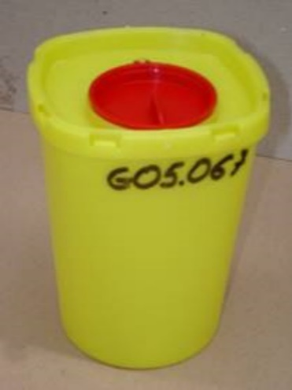 [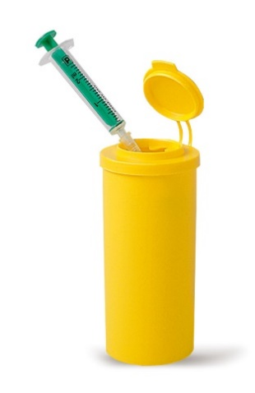](https://www.google.be/url?sa=i&url=https%3A%2F%2Fwww.carlroth.com%2Fcom%2Fen%2Fwaste-disposal-containers%2Fneedle-collector-kontamed-chen%2Fp%2Fha52.1&psig=AOvVaw2tzde824ylWyDFgAwZIAl9&ust=1585824837067000&source=images&cd=vfe&ved=0CAIQjRxqFwoTCIDsrIeIx-gCFQAAAAAdAAAAABAD)

Picture 1: Little needle containers having an opening with a diameter not exceeding 7 cm.

Proposal

5. Add the non-removable head type packagings as shown in P621 below (new text underlined):

|  |  |  |
| --- | --- | --- |
| **P621** | **PACKING INSTRUCTION** | **P621** |
| This instruction applies to UN No. 3291. | | |
| The following packagings are authorized provided that the general provisions of 4.1.1 except 4.1.1.15 and 4.1.3 are met:  (1) Provided that there is sufficient absorbent material to absorb the entire amount of liquid present and the packaging is capable of retaining liquids:  Drums (1A1, 1A2, 1B1, 1B2, 1N1, 1N2, 1H1, 1H2, 1D, 1G);  Boxes (4A, 4B, 4N, 4C1, 4C2, 4D, 4F, 4G, 4H1, 4H2);  Jerricans (3A1, 3A2, 3B1, 3B2, 3H1, 3H2).  Packagings shall conform to the packing group II performance level for solids.  (2) For packages containing larger quantities of liquid:  Drums (1A1, 1A2, 1B1, 1B2, 1N1, 1N2, 1H1, 1H2, 1D, 1G);  Jerricans (3A1, 3A2, 3B1, 3B2, 3H1, 3H2);  Composites (6HA1, 6HB1, 6HG1, 6HH1, 6HD1, 6HA2, 6HB2, 6HC, 6HD2, 6HG2, 6HH2, 6PA1, 6PB1, 6PG1, 6PD1, 6PH1, 6PH2, 6PA2, 6PB2, 6PC, 6PG2 or 6PD2).  Packagings shall conform to the packing group II performance level for liquids. | | |
| **Additional requirement:**  Packagings intended to contain sharp objects such as broken glass and needles shall be resistant to puncture and retain liquids under the performance test conditions in Chapter 6.1. | | |

1. 2020 (A/74/6 (Sect.20) and Supplementary, Subprogramme 2) [↑](#footnote-ref-2)