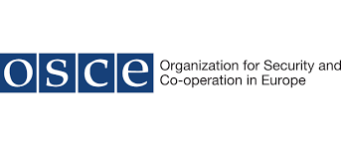

International workshop on “Strengthening security and inter-operability along Euro-Asian inland transport corridors”

12-13 December 2019, Tbilisi, Georgia

REGISTRATION FORM

Please return this form to: aneta.krzemien@osce.org and maria.mostovets@un.org, no later than by 20 November 2019.

- COUNTRY (for OSCE participating States/Partners for Co-operation/ UNECE Member States):
- NAME OF ORGANIZATION (for representatives of an IO or NGO):

3. Category  (Please indicate the category you register in) | International Organization Government Official:  Non-Governmental Organization Ministry of Transport  Academic Community Ministry of Interior  Ministry of Foreign Affairs  Other:
4. Title | Mr. Ms. :
5. Name | First Name:  Family/Last Name:
6. Position/Title

7. Department

8. E-mail

9. Phone: (incl. country code)  Mobile: |  | Fax:
10. Written Contribution/Title | Yes No
11. TRAVEL INFORMATION (if applicable) please indicate below your precise travel schedule
Arrival to Tbilisi | Date: Time: Flight Number:
Departure from Tbilisi | Date: Time: Flight Number:
Hotel in Tbilisi
(Name, address, phone)

