Submitted by the experts from CLEPA and OICA Informal document GRVA-02-24
2nd GRVA, 31 January - 1 February 2019
Agenda item 5(d)

Proposal for a draft Supplement to the 03 series of amendments
to UN Regulation No. 79

Submitted by the experts from the International Organization of Motor Vehicle Manufacturers and European Association of Automotive Suppliers**
The text reproduced below was prepared by the experts from the International Organization of Motor Vehicle Manufacturers (OICA) and European Association of Automotive Suppliers (CLEPA). It contains a proposal for amendments to the requirements for Automatically Commanded Steering Functions (ACSF) of Category C, which has been adopted by WP.29 in March 2018. This text proposes specific provisions for the use of a lane change function with a so-called two-step Human Machine Interface (HMI). The original proposal has been amended, taking into account the comments received from contracting parties at the 1st session of GRVA (September 2018). The modifications to the existing text of the Regulation (in ECE/TRANS/WP29/2018/35) are marked in bold for new, and strikethrough for deleted characters.

- Background
This amendment proposal is superseding documents GRVA/2018/2 and GRVA-01-22

- Proposal

Paragraph 5.6.4.6.4., amend to read:
"5.6.4.6.4. The lateral movement of the vehicle towards the intended lane shall not start earlier than 1 1.0 second after the start of the lane change procedure. Additionally, the lateral movement to approach the lane marking and the lateral movement necessary to complete the lane change manoeuvre shall be completed as one continuous movement.
The lane change manoeuvre shall not be initiated before a period of 3.0 seconds and not later than 5.0 seconds after the deliberate action of the driver described in paragraph 5.6.4.6.2. above.
The lane change manoeuvre shall be initiated either automatically or by a second deliberate action of the driver.

5.6.4.6.4.1 Automatic initiation of the lane change manoeuvre
In case of an automatic initiation the lane change manoeuvre shall commence between 3.0 seconds and 5.0 seconds after the manual activation of the procedure as described in paragraph 5.6.4.6.2. and shown in the Figure below.

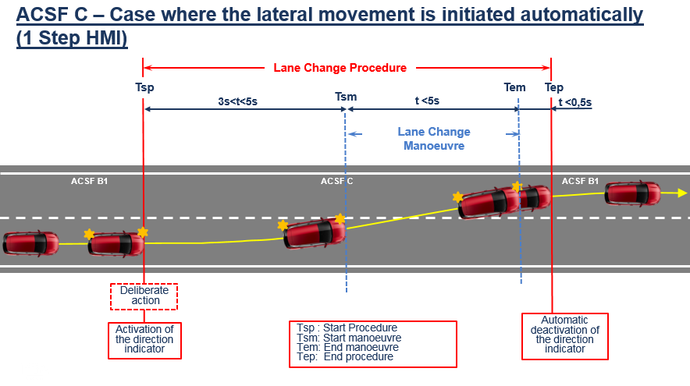

5.6.4.6.4.2. Initiation of the lane change manoeuvre by a second deliberate action
In case of an initiation by a second deliberate action the lane change manoeuvre shall commence between 3.0 and 7.0 seconds after the manual activation of the procedure as described in paragraph 5.6.4.6.2.
Additionally, the lane change manoeuvre shall commence at the latest 3.0 seconds after the second deliberate action as shown in the Figure below.

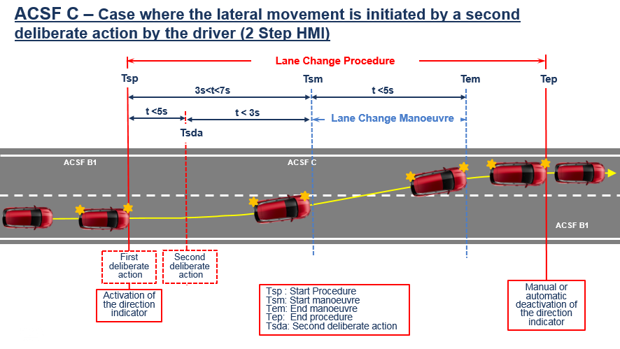
The control to operate the second deliberate action shall be located in the steering control area."

Paragraph 5.6.4.6.7., amend to read:
"5.6.4.6.7. The direction indicator shall remain active throughout the whole period of the lane change manoeuvre and shall be automatically deactivated by the system no later than 0.5 seconds after the resumption of ACSF of Category B1 lane keeping function as described in paragraph 5.6.4.6.6 above. Automatic deactivation by the system of the direction indicator is required only if the lane change manoeuvre is initiated automatically."

Paragraph 5.6.4.6.8.1., amend to read:
"5.6.4.6.8.1. The lane change procedure shall be suppressed automatically by the system when at least one of the following situations occurs before the lane change manoeuvre has started:
(a) The system detects a critical situation (as defined in paragraph 5.6.4.7),
(b) The system is overridden or switched off by the driver,
(c) The system reaches its boundaries (e.g., lane markings are no longer detected),
(d) The system has detected that the driver is not holding the steering control at the start of the lane change manoeuvre,
(e) The direction indicator lamps are manually deactivated by the driver,
(f) The lane change manoeuvre has not commenced within 5.0 seconds following the deliberate action of the driver described in paragraph 5.6.4.6.2.; Following the deliberate action of the driver to start the procedure described in paragraph 5.6.4.6.2., the lane change manoeuvre has not commenced:
(1) At the latest after 5.0 seconds, in the case of an automatic initiation,
(2) At the latest after 7.0 seconds, in the case of an initiation by a second deliberate action,
(3) At the latest after 3.0 seconds after the second deliberate action, in the case of an initiation by a second deliberate action,
whatever is appropriate
(g) The system, with an initiation of the lane change manoeuvre by a second deliberate action, has not detected the second deliberate action at the latest 5.0 seconds after the start of the lane change procedure.
(ge) The lateral movement described in paragraph 5.6.4.6.4. is not continuous."

Annex 8,
Paragraph 3.5.1.2., amend to read:
"3.5.1.2. The requirements of the test are fulfilled if:
(a) The lateral movement towards the marking does not start earlier than 1 second after the lane change procedure was initiated,
(b) The lateral movement to approach the lane marking and the lateral movement necessary to complete the lane change manoeuvre are completed as one continuous movement,
(c) The recorded lateral acceleration does not exceed 1m/s²,
(d) The moving average over half a second of the lateral jerk does not exceed 5 m/s³,
(e) The measured time between the start of the lane change procedure and the start of the lane change manoeuvre is not less than 3.0 s and not more than:
(i) 5.0 seconds in the case of an automatic initiation,
(ii) 7.0 seconds in the case of an initiation by a second deliberate action
whatever is appropriate.
(f) For systems with an initiation of the lane change manoeuvre by a second deliberate action,
- the measured time between the start of the lane change procedure and the second deliberate action is not more than 5.0 seconds, and
- the measured time between the second deliberate action and the start of the lane change manoeuvre is not more than [3.0] seconds.
(f g) The system provides an information to the driver to indicate that the lane change procedure is on-going,
(g h) The lane change manoeuvre is completed in less than 5 s for M₁, N₁ vehicle categories and less than 10 s for M₂, M₃, N₂, N₃ vehicle categories,
(h i) ACSF of Category B1 automatically resumes after the lane change procedure is completed, and
(i j) The direction indicator is deactivated not before the end of the lane change manoeuvre and no later than 0.5 seconds after B1 has resumed, in case the lateral movement is initiated automatically."

Paragraph 3.5.4.1., amend to read:
"3.5.4.1. The test vehicle shall be driven in a lane of a straight test track, which has at least two lanes in the same direction of travel, with road markings on each side of the lanes.
The vehicle speed shall be: V_{smin} + 10km/h.
The ACSF of Category C shall be activated (standby mode) and another vehicle shall approach from the rear in order to enable the system as specified in paragraph 5.6.4.8.3. above.
The approaching vehicle shall then pass the vehicle under test entirely.
A Lane Change Procedure shall then be initiated by the driver.
The test shall be repeated for each of the following conditions, which shall occur before the lane change manoeuvre has started:
(a) The system is overridden by the driver;
(b) The system is switched off by the driver;
(c) The vehicle speed is reduced to: V_{smin}-10 km/h;
(d) The driver has removed his hands from the steering control and the hands-off warning has been initiated;
(e) The direction indicator lamps are manually deactivated by the driver;
(f) The lane change manoeuvre has not commenced within 5.0 s following the initiation of the lane change procedure. (e.g., another vehicle is driving in the adjacent lane in a critical situation as described in 5.6.4.7.) or 7.0 seconds if initiated by a second deliberate action.
(g) The second deliberate action for an appropriate system is performed later than 5.0 seconds after the initiation of the lane change procedure."

Paragraph 3.5.7.1.1., amend to read:
"3.5.7.1.1. Following a new engine start /run cycle performed by the driver, the test vehicle shall be driven in a lane of a straight test track, which has at least two lanes in the same direction of travel, with road markings on each side of the lanes.
The ACSF of Category C shall not be activated (off mode) and another vehicle shall approach from the rear and the approaching vehicle shall pass the vehicle entirely.
The direction indicator used to initiate a lane change procedure shall be activated by the driver for a period greater than 5 seconds.
A lane change procedure and manoeuvre shall then be initiated by the driver with the appropriate deliberate action(s)."
Paragraph 3.5.7.2.1., amend to read:
"3.5.7.2.1. Following a new engine start / run cycle performed by the driver, the test vehicle shall be driven in a lane of a straight test track, which has at least two lanes in the same direction of travel, with road markings on each side of the lanes.
The ACSF of Category C shall be manually activated (standby mode).
A lane change procedure and manoeuvre shall then be initiated by the driver with the appropriate deliberate action(s)."
Paragraph 3.5.7.3.1., amend to read:
"3.5.7.3.1. Following the completion of the test phase 2, another vehicle shall approach from the rear on the adjacent lane in order to enable the system as specified in paragraph 5.6.4.8.3.
The approaching vehicle shall be a type approved high volume series production vehicle.
The distance between the rear end of the test vehicle and the front end of the approaching vehicle shall be measured (e.g. with a differential GPS), and the value when the system detects the approaching vehicle be recorded.
After the rear coming vehicle has entirely passed the vehicle under test, a lane change procedure and manoeuvre shall be initiated by the driver with the appropriate deliberate action(s)."

- Justification
A. Introduction
1. This proposal does not at all change the current requirements for ACSF of Category C (ACSF-C) with the one-step HMI.
2. The proposal inserts provisions for ACSF-C with a two-step HMI, while keeping unchanged the main performance of the system e.g. rear sensor range, critical situations, minimum distance and minimum operating speed, etc.
B. Proposal
Paragraph 5.6.4.6.4.
3. For the lane change function with one-step HMI, the lane change manoeuvre shall be initiated between the third and the fifth second after the initiation of the lane change procedure.
4. The lane change function with two-step HMI is a quite natural HMI, close to manual lane change: the driver has full control on the timing of the two steps of a lane change, i.e. initiating the lane change procedure, then initiating the lateral movement, by two deliberate actions.
5. This permits an increase in the maximum time between the Lane Change Procedure and the Lane Change Manoeuvre.
6. So, it is proposed to initiate the lateral movement of the vehicle after the second deliberate action.
7. This second action shall be performed at the latest 5 seconds after the start of the lane change procedure. The lane change manoeuvre shall commence latest 3 seconds after the second deliberate action and latest seven seconds after the initiation of the lane change procedure.
Framing the start of the manoeuvre in this way addresses the concerns raised by ROK and NL during GRVA-01. A second deliberate action performed right after the procedure start will not delay the starting time of the manoeuvre.
Any second deliberate action later than 5.0 seconds after the manual activation of the procedure will not initiate a manoeuvre as the whole procedure is suppressed latest after 5 seconds as per paragraph 5.6.4.6.8.1 f).
8. The time between the second deliberate action and the start of the lane change manoeuvre is limited to maximum 3.0 seconds what leads to a similar manoeuvring sequence compared with an automatic activation
Paragraph 5.6.4.6.7.
9. In case of an HMI where a complete engagement of the direction indicator lever is used as a second deliberate action its manual deactivation is exactly what the driver is used to do after performing a conventional lane change.
Paragraph 5.6.4.6.8.1.
10. This paragraph describes the conditions that lead to an automatic suppression of the lane change procedure. For the lane change with two-step HMI, the lane change manoeuvre shall commence latest after seven seconds. Otherwise, the lane change procedure shall be suppressed and the ACSF of Category B1 shall resume.
Annex 8:
11. The testing procedure is then adapted according to the above requirements.

