|  |  |  |  |
| --- | --- | --- | --- |
|  | United Nations | ECE/TRANS/WP.29/GRSP/2019/28 | |
| _unlogo | **Economic and Social Council** | | Distr.: General  26 September 2019  Original: English |

**Economic Commission for Europe**

Inland Transport Committee

**World Forum for Harmonization of Vehicle Regulations**

**Working Party on Passive Safety**

**Sixty-sixth session**

Geneva, 10-13 December 2019

Item 13 of the provisional agenda

**UN Regulation No. 44 (Child Restraint Systems)**

**Proposal for Supplement 18 to the 04 series of amendments to UN Regulation No. 44 (Child Restraint Systems)**

**Submitted by the expert from the European Commission** [[1]](#footnote-2)\*

The text reproduced below was prepared by the expert from the European Commission to introduce an amendment to UN Regulation No. 44 (Child Restraint System (CRS)). The modifications to the existing text of the UN Regulation are marked in bold for new or strikethrough for deleted characters.

I. Proposal

*Insert a new paragraph 1.2.*, to read:

"**1.2. This Regulation explicitly forbids child restraint systems in the form of belt guides and other sitting devices that are dangerous and can harm children in the event of a vehicle collision, irrespective of any test results obtained in accordance with paragraph 8.**

**In particular, it concerns belt guides and sitting devices meant for children of a mass from 15 kg to 36 kg that connect to or attach onto the lap belt portion as well as the torso belt portion of a 3-point adult safety belt system with the aim to alter the adult safety belt routing by for example pulling down the torso belt portion or squeezing together the torso belt portion and lap belt portion. Examples of such non-compliant devices are shown below.**

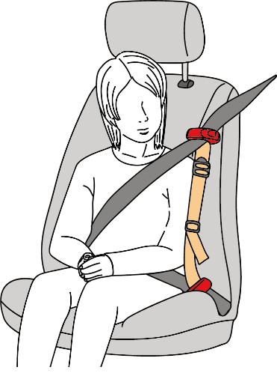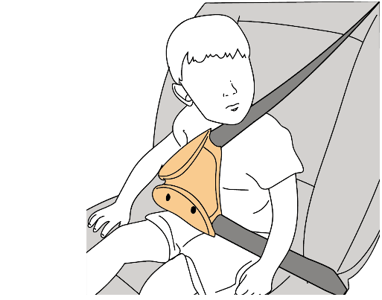

**It also concerns sitting devices that are unusable by a child unless they are properly inflated or other compact sitting devices that attempt to guide the lap belt portion by keeping it down or forward, just above the seat cushion, rather than to significantly elevate the child in relation to the vehicle’s normal seating position and the corresponding adult safety belt effective lower anchorages.**"

*Amend paragraph 17.15.*, to read:

"17.15. **As** from the **official** date of entry into force of Supplement ~~4~~ **18** to the 04 series of Amendments of this Regulation, ~~by way of derogation to the obligations of~~ Contracting Parties **applying this Regulation** ~~during the transitional period set out in paragraph 17.14. and based on the declaration made by the European Community at the time of its accession to the 1958 Agreement (Depositary Notification C.N.60.1998.TREATIES-28), member states of the European Community~~ may prohibit the placing on the market of **non-compliant devices** **and** child restraint systems which do not meet the requirements of ~~Supplement 4 to~~ the 04 series of Amendments of this Regulation."

II. Justification

1. Supplement 11 to the 04 series of amendments tried to rectify the issue of approving dangerous belt guides by clarifying that a “guide strap” is part of a CRS and cannot be separately approved as a CRS.

2. However, the above has not been able to withhold several economic operators from attempting and succeeding in obtaining a type-approval for similar product types fitting the description, as well as other inappropriate sitting devices.

3. It is clear that the acceptance of such belt guides and sitting devices has been a matter of incorrect interpretation of the regulatory text.

4. Numerous Contracting Parties and other stakeholders have already expressed their deep concern about these devices and the absence of safety for children that are transported in vehicles using such devices. However, they find it nearly impossible to address or refuse products that have been incorrectly approved.

5. The severe safety risks were already identified in the Working Party of Passive Safety (GRSP) documents GRSP-50-09, GRSP-50-25 and GRSP-50-34.

6. This proposal aims to make it absolutely clear which kind of belt guides and sitting devices shall not be allowed by means of a clarification in the scope of the regulation.

7. This proposal also addresses an out-of-date transitional provision linked specifically to the previous and no longer applicable "European Community" as Contracting Party.

1. \* In accordance with the programme of work of the Inland Transport Committee for 2018–2019 (ECE/TRANS/274, para. 123 and ECE/TRANS/2018/21/Add.1, Cluster 3.1), the World Forum will develop, harmonize and update UN regulations to enhance the performance of vehicles. The present document is submitted in conformity with that mandate. [↑](#footnote-ref-2)