|  |  |  |  |
| --- | --- | --- | --- |
|  | United Nations | ECE/TRANS/WP.29/GRSG/2019/11 | |
| _unlogo | **Economic and Social Council** | | Distr.: General  11 January 2019  Original: English |

**Economic Commission for Europe**

Inland Transport Committee

**World Forum for Harmonization of Vehicle Regulations**

**Working Party on General Safety Provisions**

**116th session**

Geneva, 1–5 April 2019

Item 3 of the provisional agenda

**UN Regulation No. 26 (External projection for passenger cars)**

Proposal for Supplement 4 to the 03 series of amendments to UN Regulation No. 26 (External projection for passenger cars)

Submitted by the expert from France[[1]](#footnote-2)\*

The text reproduced below was prepared by the expert from France to clarify requirements in UN Regulation No. 26 on windscreen wipers. It is based on documents ECE/TRANS/WP.29/GRSG/2018/17, GRSG-115-08 and GRSG-115-32 that were presented at the 115th session of the Working Party on General Safety Provisions (GRSG) (see report ECE/TRANS/WP.29/GRSG/94, para. 12). The modifications to the current text of UN Regulation No. 26 are marked in bold characters for new and strikethrough for deleted characters.

**I. Proposal**

*Paragraphs 6.4. to 6.4.2.,* amend to read:

"6.4. Windscreen wipers

6.4.1. The windscreen wiper fittings shall be such that the wiper shaft **(number 1 in Figure 0)** is furnished with a protective casing **(number 1.1 in Figure 0)** which has a radius of curvature meeting the requirements of paragraph [5.4.](https://raceonline.utac.com/fr/document/show/document_id/4022#A0_S5_4_) above and an end surface area of not less than 150 mm². **The holder (head, main and/or other parts, i.e. numbers 2, 2.1 and 2.2 in Figure 0) are designed with a radius of curvature meeting the requirements of paragraph 5.4. above.** In the case of rounded covers, these shall have a minimum projected area of 150 mm² when measured not more than 6.5 mm from the point projecting furthest. These requirements shall also be met by rear window wipers and headlamp wipers.

6.4.2. Paragraph [5.4.](https://raceonline.utac.com/fr/document/show/document_id/4022#A0_S5_4_) shall not apply to the wiper blades **(number 4 in Figure 0),** ~~or to any~~ **to** supporting members **(number 3 in Figure 0) or to the functional hinge between the holder head and the holder**. However, these units shall be so made as to have no sharp angles or pointed or cutting parts.

**Figure 0**

**Example of parts distribution**

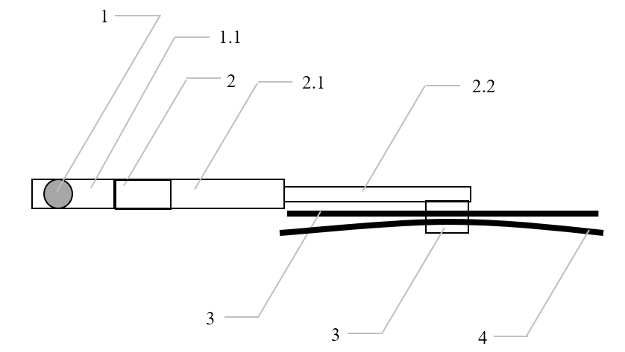

**1 – Wiper shaft**

**1.1 – Protective casing**

**2 – Holder head**

**2.1 – Main holder**

**2.2 – Second holder**

**3 – Supporting members**

**4 – Wiper blades** "

II. Justification

In order to avoid any misunderstanding of which requirements apply to which part of the windscreen wiper, a simple generic drawing presenting the concerned areas seems to be the best way for a coherent application. Geometrical requirements are only applicable on contactable parts (sphere protocol).

1. \* In accordance with the programme of work of the Inland Transport Committee for 2018–2019 (ECE/TRANS/274, para. 123 and ECE/TRANS/2018/21/Add.1, Cluster 3.1), the World Forum will develop, harmonize and update UN regulations to enhance the performance of vehicles. The present document is submitted in conformity with that mandate. [↑](#footnote-ref-2)