Proposal for improvement of ECE/TRANS/WP.29/GRE/2019/3 (draft new [07] series of amendments to UN Regulation No. 48 (Installation of lighting and light-signalling devices))
The text reproduced below was prepared by expert from Poland, on the basis of document ECE/TRANS/WP.29/GRE/2019/3, with the purpose to improve the proposed range for aiming/levelling to make it performance based and to guarantee minimum road illumination distance of 50m and the same maximum glare conditions for beyond 25m independently on mounting height of headlamp.
The modifications to the text of the ECE/TRANS/WP.29/ GRE/2019/3 are marked in red and bold for new or strikethrough for deleted characters.

I. Proposal
Paragraph 4.2., amend to read:
4.2. An approval number shall be assigned to each type approved. Its first two digits (at present [07], corresponding to the [07] series of amendments) shall indicate the series of amendments incorporating the most recent major technical amendments made to the Regulation at the time of issue of the approval. The same Contracting Party shall not assign this number to another vehicle type or to the same vehicle type submitted with equipment not specified in the list referred to in paragraph 3.2.2. above, subject to the provisions of paragraph 7. of this Regulation.
Paragraph 6.2.6. and related sub-paragraphs, amend to read:
6.2.6. Orientation.
Towards the front.
6.2.6.1. Vertical orientation
6.2.6.1.1. The initial downward inclination of the cut-off of the dipped-beam to be set in the unladen vehicle state with one person in the driver's seat shall be specified within an accuracy of 0.1 per cent by the manufacturer and indicated in a clearly legible and indelible manner on each vehicle close to either headlamp or the manufacturer's plate by the symbol shown in Annex 7.
The value of this indicated downward inclination shall be defined in accordance with by the vehicle manufacturer in the range prescribed in paragraph 6.2.6.1.2. in relation to the dipped-beam headlamp mounting height.
[Different values of initial downward vertical orientation for different variants/versions of the same vehicle type can be defined, provided that only the pertinent value is indicated on each variant/version.]
6.2.6.1.2. Depending on the mounting height in metres (h) of the lower edge of the apparent surface in the direction of the reference axis of the dipped-beam headlamp, measured on the unladen vehicles, the vertical inclination of the cut-off of the dipped beam, starting from the initial inclination value set by the vehicle manufacturer as prescribed in paragraph 6.2.6.1.1. above, shall under all the static conditions of Annex 5, remain between the following limits, under all the stating loading conditions of Annex 5:
for 0.5 m < h < 0.95 m, between:
-0.2 % and -1.8 %;
the highest vertical inclination limit is -0.2 %

for 0.95 m < h < 1.2 m, between:
the minimum highest vertical inclination limit increasing linearly, in relation to the dipped-beam headlamp mounting height,
from - 0.2 % to -2.4 - 0.8[5] %
and
for 0. 5 m < h < 1.5 m
the maximum lowest vertical inclination limit increasing linearly, in relation to the dipped-beam headlamp mounting height,
from - 1.08 % to - 2.4[5] -3.0 %;
[In the case of vehicle which maximum speed is restricted by design to 50km/h
category N₃G (off-road) vehicles: , where the headlamps exceed a height of 1,200 mm the limits for the vertical inclination of the cut-off shall be between: -1.5 per cent and -3.5 per cent
for 0.5 1.2 m < h < 1. 5 m, between:
the minimum lowest vertical inclination limit increasing linearly, in relation to the dipped-beam headlamp mounting height,
from -1.7 0.8[5] % to - 1.5 5.0 % ]
and
the maximum vertical inclination limit increasing linearly, in relation to the dipped-beam headlamp mounting height, from
- 2.4[5] % to - 3.1 %.]

The above limits and the initial aiming values are summarized in the diagram below.

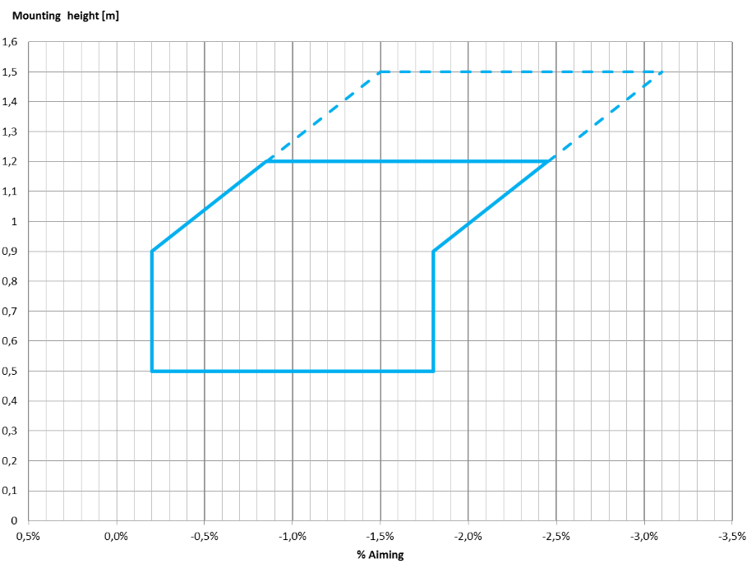

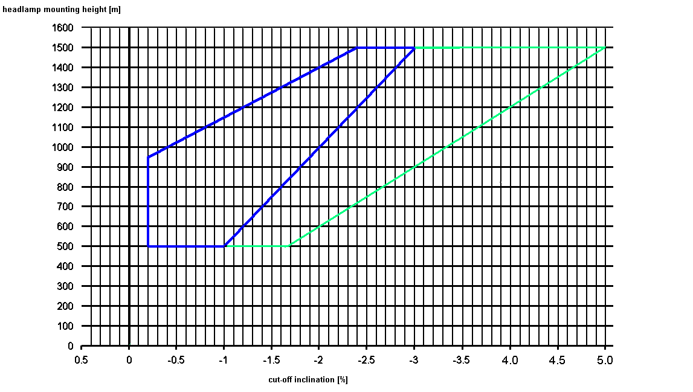

6.2.6.2. Headlamp levelling device
6.2.6.2.1. In the case where a headlamp levelling device is necessary to satisfy the requirements of paragraphs 6.2.6.1.1. and 6.2.6.1.2., the device shall be automatic.
6.2.6.2.2. However, devices which are adjusted manually, either continuously or non-continuously, shall be permitted, provided [that] they have a stop position at which the lamps can be returned to the initial inclination defined in paragraph 6.2.6.1.1. by means of the usual adjusting screws or similar means.
These manually adjustable devices shall be from the driver's seat.
Continually adjustable devices shall have reference marks indicating the loading conditions that require adjustment of the dipped-beam.
The number of positions on devices which are not continuously adjustable shall be such as to ensure compliance with the range of values prescribed in paragraph 6.2.6.1.2. in all the loading conditions defined in Annex 5.
For these devices also, the loading conditions of Annex 5 that require adjustment of the dipped-beam shall be clearly marked near the control of the device (Annex 8).
6.2.6.2.3. In the event of a failure of devices described prescribed in paragraphs 6.2.6.2.1. and 6.2.6.2.2., the dipped-beam shall not assume a position in which the dip vertical orientation is less downward than it was at the time when the failure of the device occurred.
6.2.6.3. Measuring procedure
6.2.6.3.1. After adjustment of the initial downward vertical inclination, the vertical inclination of the dipped-beam, expressed in per cent, shall be measured in static conditions under all the loading conditions defined in Annex 5.
6.2.6.3.2. The measurement of the variation of dipped-beam downward vertical inclination as a function of load shall be carried out in accordance with the test procedure set out in Annex 6.
Paragraph 6.2.9., amend to read:
6.2.9. Other requirements
The requirements of paragraph 5.5.2. shall not apply to dipped-beam headlamps.
[Dipped-beam headlamps with a light source or LED module(s) producing the principal dipped-beam and having a total objective luminous flux which exceeds 2,000 lumen shall only be installed in conjunction with the installation of headlamp cleaning device(s) according to Regulation No. 45.¹³]
With respect to vertical inclination the provisions of paragraph 6.2.6.2.2. above shall not be applied for dipped-beam headlamps with a light source or LED module(s) producing the principal dipped beam and having an objective luminous flux which exceeds 2,000 lumens.
[In the case of filament lamps for which more than one test voltage is specified, the objective luminous flux which produces the principal dipped-beam, as indicated in the communication form for the type approval of the device, is applied.
In the case of dipped-beam headlamps equipped with an approved light source, the applicable objective luminous flux is the value at the relevant test voltage as given in the relevant data sheet in the Regulation, according to which the applied light source was approved, without taking into account the tolerances to the objective luminous flux specified on this datasheet.]
Only dipped-beam headlamps according to Regulation Nos. 98 or 112 may be used to produce bend lighting.
If bend lighting is produced by a horizontal movement of the whole beam or the kink of the elbow of the cut-off, it shall be activated only if the vehicle is in forward motion; this shall not apply if bend lighting is produced for a right turn in right hand traffic (left turn in left hand traffic).
Paragraph 6.22.6.1. and related sub-paragraphs, amend to read:
6.22.6.1. Vertical orientation:
6.22.6.1.1. The initial downward inclination of the cut-off of the basic passing dipped-beam to be set in the unladen vehicle state with one person in the driver's seat shall be specified within an precision accuracy of 0.1 per cent by the manufacturer and indicated in a clearly legible and indelible manner on each vehicle, close to either the front lighting system or the manufacturer's plate, by the symbol shown in Annex 7.
Where differing initial downward inclination are specified by the manufacturer for different lighting units that provide or contribute to the cut-off of the basic passing dipped-beam, these values of downward inclination shall be specified within an precision accuracy of 0.1 per cent by the manufacturer and indicated in a clearly legible and indelible manner on each vehicle, close to either the relevant lighting units or on the manufacturer's plate, by the symbol shown in Annex 7 in such a way that all the lighting units concerned can be unambiguously identified.
The value(s) of this (these) indicated vertical orientation(s) shall be defined by the vehicle manufacturer in the range prescribed in paragraph 6.2.6.1.2. in relation to the mounting height of the lighting units that provide or contribute to the cut-off of the basic dipped-beam.
[Different values of initial downward vertical orientation for different variants/versions of the same vehicle type can be defined, provided that only the pertinent value is indicated on each variant/version.]
6.22.6.1.2. The downward inclination of the horizontal part of the "cut-off" of the basic passing dipped-beam shall remain between the limits indicated in paragraph 6.2.6.1.2. of this Regulation under all the static loading conditions of the vehicle of Annex 5 of this Regulation; and the initial aiming shall be within the specified values.
6.22.6.1.2.1. In case the passing dipped-beam is generated by several beams from different lighting units, the relevant requirements provisions according to paragraph 6.22.6.1.2. as above indicated apply to each said beam's "cut-off" (if any), which is designed to project into the angular zone, as indicated under item 9.4. of the communication form conforming to the model in Annex 1 to Regulation No. 123.
6.22.6.2. Headlamp levelling device
6.22.6.2.1. In the case where a headlamp levelling device is necessary to satisfy the requirements of paragraph 6.22.6.1.2., the device shall be automatic.
6.22.6.2.2. In the event of a failure of this the device prescribed in paragraphs 6.22.6.2.1., the basic passing dipped-beam shall not assume a position in which the downward inclination dip vertical orientation is less downward than it was at the time when the failure of the device occurred.
Paragraph 6.22.9.1., amend to read:
[6.22.9.1. An AFS shall be permitted only in conjunction with the installation of headlamp cleaning device(s) according to Regulation No. 45 for at least those lighting units, which are indicated under item 9.3. of the communication form conforming to the model in Annex 1 to Regulation No. 123, if the total objective luminous flux of the light sources of these units exceeds 2,000 lm per side, and which contribute to the class C (basic) passing-beam.]
Annex 2, amend to read:
Model A
(See paragraph 4.4. of this Regulation)

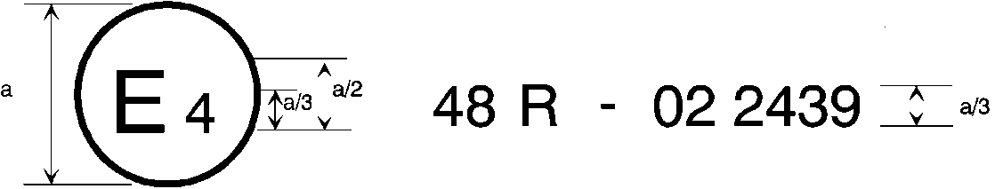
07
a = 8 mm min.
The above approval mark affixed to a vehicle shows that the vehicle type concerned has, with regard to the installation of lighting and light-signalling devices, been approved in the Netherlands (E 4) pursuant to Regulation No. 48 as amended by the 06 [07] series of amendments. The approval number indicates that the approval was granted in accordance with the requirements of Regulation No. 48 as amended by the 06 [07] series of amendments.
Model B
(See paragraph 4.5. of this Regulation)

1. 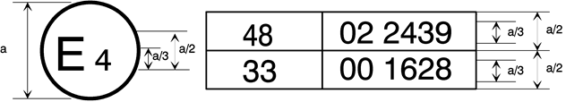
0706
a = 8 mm min.
The above approval mark affixed to a vehicle shows that the vehicle type concerned has been approved in the Netherlands (E 4) pursuant to Regulation No. 48 as amended by the 06 [07] series of amendments and Regulation No. 33.[] The approval number indicates that, at the dates when the respective approvals were given, Regulation No. 48 was amended by the 06 [07] series of amendments and Regulation No. 33 was still in its original form.
Annex 9, paragraph 1.3. and related sub-paragraphs, amend to read:
1.3. Alignment Vertical orientation of dipped-beam headlamps and class "F3" front fog lamps towards the front.
1.3.1. The vertical orientation of a dipped-beam headlamp and of a basic dipped-beam of an AFS shall be checked respectively in accordance with paragraphs 6.2.6. and 6.22.6.1. (and related sub-paragraphs and referenced Annexes) of this Regulation. [No CoP tolerances shall be applied to the limits prescribed in the above-cited paragraphs.]
1.3.2. The vertical orientation of a front fog lamp shall be checked in accordance with the following requirements.
1.3.2.1. Initial downward inclination
The initial downward inclination of the cut-off of the dipped-beam and the class "F3" front fog lamps shall be set to the plated figure as required and shown in Annex 7.
Alternatively the manufacturer shall set the initial aim to a figure that is different from the plated figure where it can be shown to be representative of the type approved when tested in accordance with the procedures contained in Annex 6 and in particular paragraph 4.1.
1.3.2.2. Variation of inclination with load
The variation of the dipped-beam downward inclination as a function of the loading conditions specified within this section shall remain within the range:
0.2 per cent to 2.8 per cent for headlamp mounting height h < 0.8;
0.2 per cent to 2.8 per cent for headlamp mounting height 0.8 ≤ h ≤ 1.0;
or
0.7 per cent to 3.3 per cent (according to the aiming range chosen by the manufacturer at the approval);
0.7 per cent to 3.3 per cent for headlamp mounting height 1.0 < h ≤ 1.2 m;
1.2 per cent to 3.8 per cent for headlamp mounting height h > 1.2 m.
In the case of a class "F3" front fog lamp with (a) light source(s) having a total objective luminous flux which exceeds 2,000 lumens, the variation of the downward inclination as a function of the loading conditions specified within this section shall remain within the range:
0.7 per cent to 3.3 per cent for front fog lamp mounting height h ≤ 0.8 ;
1.2 per cent to 3.8 per cent for front fog lamp mounting height h > 0.8 m.
The states of loading to be used shall be as follows, as indicated in Annex 5 of this Regulation, for every system adjusted accordingly.
1.3.2.2.1. Vehicles in category M₁:
Paragraph 2.1.1.1.
Paragraph 2.1.1.6. taking into account
Paragraph 2.1.2.
1.3.2.2.2. Vehicles in category M₂ and M₃:
Paragraph 2.2.1.
Paragraph 2.2.2.
1.3.2.2.3. Vehicles in category N with load surfaces:
Paragraph 2.3.1.1.
Paragraph 2.3.1.2.
1.3.2.2.4. Vehicles in category N without load surfaces:
1.3.2.2.4.1. Drawing vehicles for semi-trailers:
Paragraph 2.4.1.1.
Paragraph 2.4.1.2.
1.3.2.2.4.2. Drawing vehicles for trailers:
Paragraph 2.4.2.1.
Paragraph 2.4.2.2.
II. Justification
1. The cut-off inclination tolerances proposed by ECE/TRANS/WP.29/ GRE/2019/3 are too wide in regard to minimum safety requirements.
2. GTB Glare and Visibility Forum, Geneva, 22 October 2018 clearly showed that:
- Real road illumination distance for existing passing beam is between 20m and 100m with average value of 48m [J. Kobbert, K. Kosmas, T. Q. Khanh, Glare and Visibility in Automotive Lighting]. This is insufficient for minimum safety by allowed maximum speed. This results are in high correlation with earlier scientific analysis (e.g. GRE-65-30, GRE-71-32).
- Relation between number of fatal accidents during day and night with pedestrians and animals are like 1:4.5 [M. J. Flannagan, Importance of visibility improvements for safety in automotive lighting]
3. Even worse results were obtained by last analysis of accidents with pedestrians outside built-up areas which happened a few days before and after autumn time change date in Poland [Polish Traffic Road Safety Observatory Database]. Average value for 2013-2017 was 8% before sunset an 92% after it. It means that risk of accident with pedestrian is 12 time higher after sunset then before at a time while the only illumination are (passing beam) headlights and when exclude most interfering factors. The most important influence is insufficient road illumination distance which is caused by legal lowest down cut-off inclination (road illumination distance 20 m only).
4. Manufacturers were detail asked long time ago about vehicle manufacturing tolerances in regard to their request of initial aim range of 1.6% (VGL-10-06) but did not give any answer. It was practically checked that (static) automatic levelling devices for many used systems can control levelling better than possible to measure. However in proposal it is still possible to use manual levelling device.
5. Require the minimum road illumination distance of 50 m [or declare the maximum speed restriction for special vehicles to 50km/h and reduce road illumination distance to 30m] should significantly improve nightime road traffic safety dependent on passing beam headlights.

[] The second number is given merely as an example

