|  |  |  |  |
| --- | --- | --- | --- |
|  | United Nations | ECE/TRANS/WP.29/GRBP/2019/26 | |
| Description: _unlogo | **Economic and Social Council** | | Distr.: General  27 June 2019  Original: English |

**Economic Commission for Europe**

Inland Transport Committee

**World Forum for Harmonization of Vehicle Regulations**

**Working Party on Noise**

**Seventieth session**

Geneva, 11-13 September 2019

Item 14 of the provisional agenda

**Other business**

Proposal for a Supplement to UN Regulation No. 28 (Audible warning devices)

Submitted by the experts from France\*

The text reproduced below was prepared by the experts from France with the aim to amend UN Regulation No. 28. The modifications to the existing text of the Regulation are marked in bold for new or strikethrough for deleted characters.

I. Proposal

*Paragraph 2, « Definitions» amend to read:*

"…

2.4. Principles of operation of audible warning device, audible warning system, multiple audible warning system:

2.4.1. "Pneumatic" means a principle of operation by an external compressed air source;

2.4.2. "Electro-pneumatic" means a principle of operation by a compressed air source which is controlled by electrical supply (direct or alternating current);

2.4.3. "Electro-magnetic with resonator disc" means a principle of operation by electro-magnetic force amplified by resonator disc;

2.4.4. "Electro-magnetic with horn" means a principle of operation by electro-magnetic force amplified by a horn;

**2.4.5. "Electronic" means a principle of operation by electric or electro-magnetic force with amplifier and speaker or resonator;**

**…"**

**II. Justification**

1. This proposal aims to take into account new technologies that permit to emit an acoustic signal which is intended to give audible warning of the presence of a vehicle in a dangerous road traffic situation and which is intentionally operated by the driver.

2. It is the case especially for piezo-electric devices, such as a loudspeaker that could emit an acoustic signal.

**Figure**

**Simplified drawing of an assembled electronic warning device**

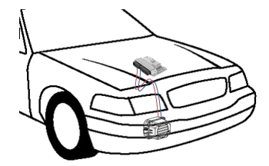

3. The use under normal driving conditions could be done according to a control unit with the key-on (audible warning system is supplied with current).

4. As the testing procedure is performed with the current supplies, the approval test remains the same.

5. Moreover, for quiet road transport vehicles, the same device could be used for both audible warning signals and Acoustic Vehicle Alerting System (AVAS).

\_\_\_\_\_\_\_\_\_\_\_\_\_\_\_\_