|  |  |  |  |
| --- | --- | --- | --- |
|  | United Nations | ECE/TRANS/WP.29/2019/108 | |
| _unlogo | **Economic and Social Council** | | Distr.: General  28 august 2019  Original: English |

**Economic Commission for Europe**

Inland Transport Committee

**World Forum for Harmonization of Vehicle Regulations**

**179th session**

Geneva, 12-14 November 2019

Item 4.8.6 of the provisional agenda

**1958 Agreement:  
consideration of draft amendments to existing   
UN Regulations submitted by GRSP**

Proposal for Supplement 17 to the 04 series of amendments to UN Regulation No. 44 (Child Restraint Systems)

Submitted by the experts from the Working Party on Passive Safety[[1]](#footnote-2)\*

The text reproduced below was adopted by the Working Party on Passive Safety (GRSP) at its sixty-fifth session (ECE/TRANS/WP.29/GRSP/65, para. 25). It is based on GRSP-65-28, as reproduced in Annex III to the report. It is submitted to the World Forum for Harmonization of Vehicle Regulations (WP.29) and to the Administrative Committee (AC.1) for consideration at their November 2019 sessions.

Supplement 17 the 04 series of amendments to UN Regulation No. 44 (Child Restraint Systems)

*Amend paragraph 7.1.4.2.2.* to read:

"7.1.4.2.2. The vertical component of the acceleration from the abdomen towards the head, "-z", when the measurement procedures defined in paragraph 8.5 of this document are followed, shall not exceed 30 g except during periods whose sum does not exceed 3 ms. The measurement procedures defined in paragraph 8.5 of this document follow those of ISO 6487 with SAE J211 sign convention, as shown in Figure A.

Figure A

**SAE J211 sign convention**

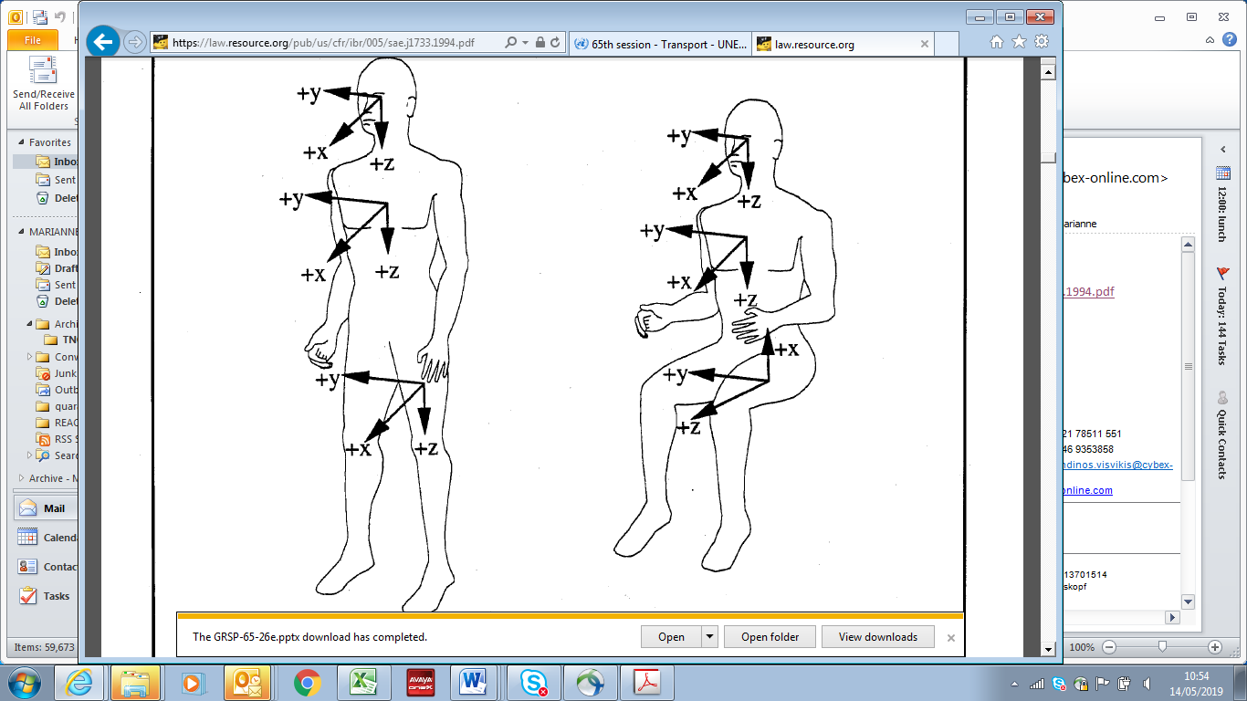"

1. \* In accordance with the programme of work of the Inland Transport Committee for 2018–2019 (ECE/TRANS/274, para. 123 and ECE/TRANS/2018/21/Add.1, Cluster 3.1), the World Forum will develop, harmonize and update UN regulations to enhance the performance of vehicles. The present document is submitted in conformity with that mandate. [↑](#footnote-ref-2)