|  |  |  |  |
| --- | --- | --- | --- |
|  | United Nations | ECE/TRANS/WP.15/AC.1/2019/17 | |
| _unlogo | **Economic and Social Council** | | Distr.: General  28 December 2018  Original: English |

**Economic Commission for Europe**

Inland Transport Committee

**Working Party on the Transport of Dangerous Goods**

**Joint Meeting of the RID Committee of Experts and the**

**Working Party on the Transport of Dangerous Goods**

Bern, 18–22 March 2019

Item 2 of the provisional agenda

**Tanks**

Clarification of protection required for the fittings and accessories mounted on the upper part of Vacuum-Operated Waste Tanks

Transmitted by the Government of the United Kingdom[[1]](#footnote-2), [[2]](#footnote-3)\*\*

|  |
| --- |
| *Summary* |
| **Executive summary:**  This proposal follows on from discussions in the Working Group on Tanks at the March and September 2018 sessions of the RID/ADR/ADN Joint Meeting regarding overturn protection that may be required for fittings and accessories mounted on the upper part of Vacuum-Operated Waste Tanks. In light of the views expressed at the September session it was decided that this topic would benefit from an official document from the United Kingdom. |
| **Action to be taken:** Proposal to amend subsection 6.10.3.1 to make it clear that the requirements of subsection 6.8.2.1.28 apply to items of equipment that may be placed in the so called ‘protected area’ at the top part of the tank. And a proposal for a new transitional measure in subsection 1.6.3.30. |
| **Related documents:** Informal document INF.47 (paragraph 42) of the March 2018 session, and informal documents INF.17 and INF.30 (paragraphs 22 – 25) of the September 2018 session. |
|  |

Introduction

1. Under agenda item 8 at the meeting of the Working Group on Tanks in September 2018, a discussion took place regarding the interpretation of the requirements for overturn protection on Vacuum-Operated Waste Tanks. This was prompted by an informal document submitted by the United Kingdom and, given that the requirements in ADR were considered to be unclear and appear to have been interpreted in two different ways, it was agreed that this topic would benefit from this official document from the United Kingdom.

2. Concerns were expressed that it could be difficult for overturn protection to be provided to suction booms that might be fitted to these tanks. Paragraph 6.10.3.7 (c) however requires the boom to be constructed in such a way that the tank will not leak in the event of an accidental impact on the boom. It would seem therefore that the boom should be considered sacrificial and not subject to the overturn protection required by 6.8.2.1.28. Furthermore, given the non-prescriptive nature of 6.8.2.1.28, it should be possible for protection to be provided to service equipment in such a way that operation of the boom is unhindered.

3. This purpose of this paper is therefore to propose amendments that clarify the text in respect to overturn protection for Vacuum-Operated Waste Tanks, provide justification for the amendments and propose transitional measures for tanks not meeting these requirements before the amendments enter into force.

Proposals

**Proposal 1**

Introduce new text to 6.10.3.1 to read (new wording in Bold and underlined):

“6.10.3.1 The items of equipment shall be so arranged as to be protected against the risk of being wrenched off or damaged during carriage or handling. This requirement can be fulfilled by placing the items of equipment in a so called "protected area" (see 6.10.1.1.1). **If items of equipment are placed in the “protected area” at the top part of the tank (see 6.10.1.1.1(b)), then the requirements of 6.8.2.1.28 shall apply so as to give effective protection against damage caused by overturning.”**

Proposal 2

Introduce a new transitional measure in 1.6.3.30 to read (new wording in Bold and underlined):

**“1.6.3.30 Vacuum-Operated Waste Tanks constructed before 1 July 2021 in accordance with the requirements in force up to 31 December 2020 but which do not conform to the requirements of 6.8.2.1.28 applicable from 1 January 2021 may still be used.”**

Justification

4. The current text of RID/ADR defines a “protected area” (6.10.1.1.1(b)) on the upper part of the tank in which items of equipment are considered protected against the risk of being wrenched off or damaged during carriage or handling. However, whilst items of equipment are considered protected against being wrenched off or damaged in this area, the text of RID/ADR is not clear on whether items of equipment must also be protected against damage that may be caused by overturning (see informal document INF.17 of September 2018 session).

5. Given that two different interpretations are considered possible, the above proposals seek to clarify the text to make it clear that the overturn protection requirements of paragraph 6.8.2.1.28 apply to Vacuum-Operated Waste Tanks and allow the continued use of any tanks constructed before this clarification enters into force. These amendments are needed to ensure a consistent approach is taken by all contracting parties.

6. Whilst two different interpretations of RID/ADR would seem to be possible, we estimate that if a United Kingdom court of law was to rule on the matter it is likely they would interpret ADR as requiring service equipment on the top part of Vacuum-Operated Waste Tanks to be protected against damage that may be caused by overturning.

7. It is recognised that Courts in other jurisdictions are likely to approach the interpretation of RID/ADR in different ways but from a United Kingdom perspective, the requirements of RID/ADR in respect of overturn protection for these vehicles is unclear and therefore requires clarification.

8. The Oxford English dictionary defines ‘overturn’ as being to “Tip something over so that it is on its side or upside down.”. The intention of paragraph 6.8.2.1.28 would therefore seem to be to provide protection to fittings and accessories mounted on the upper part of the tank in the event of the tank rolling through 90° or 180° during an incident.

9. We are aware of a number of incidents in the United Kingdom where Vacuum-Operated Waste Tanks have been subject to an overturn of 90°. We are not aware of any incidents that have involved a 180° overturn but nevertheless, as seen in the images below, the top of these tanks may be subject to damage during 90° overturns.

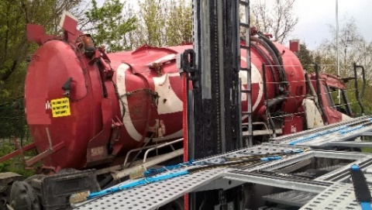 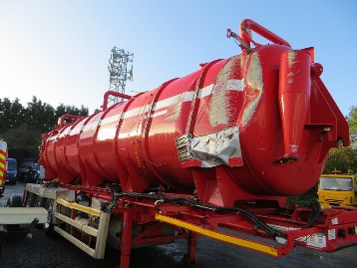

10. During carriage the service equipment located at the top of tank-containers, including tank swap bodies, is required to be protected against damage that might be caused in the event of an overturn. Given that section 4.3.2.3.2 of RID/ADR requires such protection to be provided for the service equipment of these vessels, it would seem to be appropriate for protection to be required for the service equipment on tanks permitted by ADR/RID 6.10.

11. The interpretation of this issue was previously discussed at the Joint Meeting in September 2011. An informal document sought to clarify the applicability of TE19 and EN 13094:2008 for Vacuum-Operated Waste Tanks and during that discussion the majority of the experts were of the view that ADR 6.8.2.1.28 and TE19 apply to Vacuum-Operated Waste Tanks.

12. Thus, all things considered it would seem appropriate to amend RID/ADR in accordance with Proposal 1 and Proposal 2 above.

1. In accordance with the programme of work of the Inland Transport Committee for 2018-2019, (ECE/TRANS/WP.15/237, annexe V, (9.2)). [↑](#footnote-ref-2)
2. \*\* Circulated by the Intergovernmental Organisation for International Carriage by Rail (OTIF) under the symbol OTIF/RID/RC/2019/17. [↑](#footnote-ref-3)