UN/SCETDG/56/INF.9

Committee of Experts on the Transport of Dangerous Goods
and on the Globally Harmonized System of Classification
and Labelling of Chemicals 4 November 2019
Sub-Committee of Experts on the Transport of Dangerous Goods
Fifty-sixth session

Geneva, 2-11 December 2019
Item 6 (e) of the provisional agenda
Miscellaneous proposals for amendments to the Model Regulations
on the Transport of Dangerous Goods:
other miscellaneous proposals
Increase of the maximum allowed internal pressure for aerosol dispensers
Transmitted by the European Aerosol Federation (FEA) and the Household and Commercial Products Association (HCPA)
Introduction
1. This informal document support working document ST/SG/AC.10/C.3/2019/55 in providing more technical background information.
2. Before submission, the proposal has been discussed and endorsed by FEA (EU + Switzerland and Turkey) and HCPA (USA), but also by our sister aerosol associations in Argentina, Australia, Brazil, Chile, China, India, Japan, Mexico, New Zealand, South Africa and Thailand.
3. FEA and HCPA proposes to amend special provision 63; however those provisions may be included in another section of the UN Model Regulations that the Sub-Committee considers more appropriate.
Technical background
4. See Annex.
Annex [English only]
Increase in maximum allowable internal pressure at 50 °C
Introduction
The aerosol industry is constantly striving to reduce the environmental impact of aerosol products and to design these products and their handling in a permanently sustainable manner.
Using non-flammable compressed gas propellants, is an option for certain products but has had limited uptake due to loss of performance during the lifetime of aerosol dispenser.
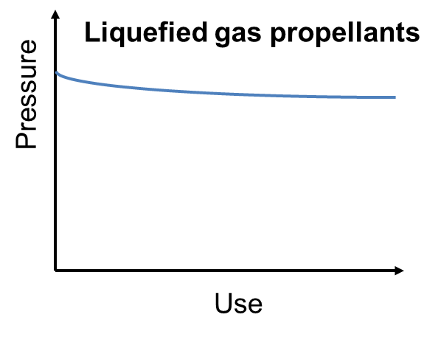
Liquefied gas propellants act as a co-solvent for the formulation and maintain a constant internal pressure for as long as there is any liquefied gas present in the dispenser and so ensure that the last spray is a good as the first spray. Because the liquefied gas is a co-solvent, as well as providing the propellant pressure it also assists in the formation of the spray, by rapidly vaporising as it exits the dispenser and thus creating a fine and consistent spray.
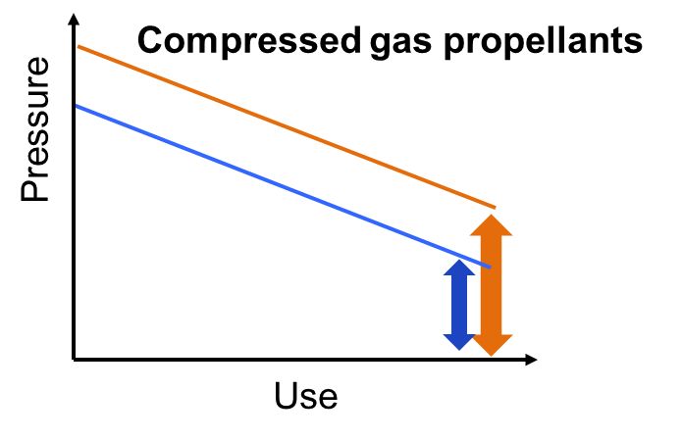
Compressed gas propellants can also provide the driving force for dispensing but do not mix with the formulation, instead they occupy the headspace above the formulation and remain in the dispenser throughout the pack lifetime. Product is dispensed by the propellant acting like a piston and pushing the product formulation through the valve where the spray is formed by the mechanical break-up action of the actuator. The quality of the spray is determined by the force being applied by the compressed gas pressure. However, the pressure of the compressed gas propellant is subject to Boyle’s Law (pressure is proportional to volume) and so decreases as the dispenser is emptied of product with the consequence that the spray delivery, and spray quality decline as the dispenser empties. One option to improve the final spray performance for compressed gas propellants is increase in the permitted maximum internal pressure at 50°C.
Tests have shown that, where compressed gases are used as propellants, an increase to 15 bar at 50 C can lead to good results for the efficacy and performance of some products.
Increase in internal pressure with temperature
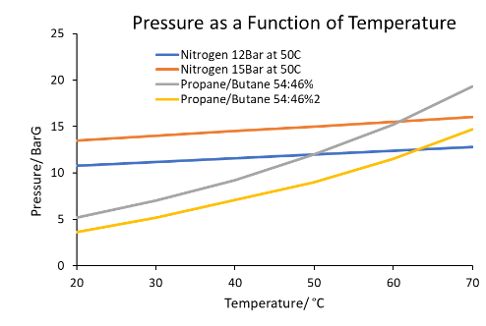
Compressed gases have much lower temperature/pressure increase characteristics than liquefied gas propellants, so that the burst hazard due to over-heating of the dispenser is significantly lower in the case of compressed gases.

Aerosol Container and Valve Manufacture
During manufacture, the aerosol container and valve are subjected to numerous inspections.
Current legislation within EU for the marketing of aerosols (Aerosol Dispensers Directive 75/324/EEC) and for the transport of dangerous goods by road (ADR) already allows aerosol dispensers pressurised at 15 bar at 50 C if they contain non-flammable gas propellants. The proposed pressure increase is therefore technically feasible, and the safety of the pressurised aerosol dispensers can be reliably ensured. The quality systems that are already in place at all levels of the aerosol industry will ensure that the relevant safety requirements are fully met.
The valve, the container, and the container/valve assembly have been adapted in design and performance to suit the higher-pressure level and will thus be safe.
Aerosol Valves
Material and design of cups (valves), crimp and clinch for "15 bar" applications have to be chosen so that leak tightness is ensured.
In preparation, verifying tests to demonstrate compliance with the following parameters have been established:
- The valve cups for 15 bar applications have to be pressure resistant at the adjusted pressure compared to the lower pressure resistance of cups for 13.2 bar applications (i.e. minimum 27.0°bar pressure resistance instead of 23.76 bar).
Aerosol Containers
Both aluminium and tinplate aerosol containers have already been manufactured in "15.0 bar at 50°C" versions.
Such containers have been tested successfully both in internal test series during the aerosol container manufacturing process by container manufacturers and in external tests, using tests designed to check that:
- The containers develop no visible deformation or leak when subjected to a load (deformation pressure) of 22.5 bar (50% higher than the maximum internal pressure at 50°C) for 25 seconds,
- The containers resist a pressure of at least up to 27.0 bar without bursting.
In test conducted by independent test houses in France on 40 aluminium and 40 tinplate empty aerosol cans subjected to a hydraulic test where a test pressure of 22.5 Bar was held for 25 seconds found no visible distortion. Burst testing of the aerosols found none to burst at less than 27 Bar (>120% of the test pressure). When bursting did occur, it was found to be typical of the burst mechanism for tin plate and aluminium aerosol dispensers as shown in the adjacent pictures.
Further testing in France and independently in Germany 80 filled tinplate aerosols and 41 aluminium aerosols found that aerosol dispensers filled with water and a non-flammable compressed gas propellant did not burst, distort or leak when placed in a hot water bath at 50° for up to one hour. In the case of the testing carried out in Germany checks found that the aerosol dispensers had not leaked after 28 days
The required pressure resistance was obtained by adapting the material thickness in the container geometry, thus meeting the demand for increased deformation and burst pressure levels.
Aerosol Container Filling Process
Aerosol containers are filled under the most stringent safety conditions. The filling equipment used in the industry today can be adapted without difficulty to suit the slightly higher-pressure level.
As is the current practice, safety devices will be used to prevent overfilled containers from being brought into circulation. Similarly, controls will be in place to ensure that the appropriate valve and aerosol container are selected and correctly clinched to create a gas tight seal.
The safety of the aerosol container/valve assembly will then be guaranteed by a 100 % water bath test or an alternative test method.
As reported above other tests with aerosols pressurised to 15 bar at 50 °C have demonstrated that such aerosols can be produced without showing any visible permanent distortion or leakage.
All other tests required by legislation that are designed to guarantee the mechanical strength and chemical compatibility of aerosol packages have, of course, also to be performed.

