|  |  |  |  |
| --- | --- | --- | --- |
|  | United Nations | ST/SG/AC.10/C.3/2019/61 | |
| _unlogo | **Secretariat** | | Distr.: General 11 September 2019  Original: English |

**Committee of Experts on the Transport of Dangerous Goods  
and on the Globally Harmonized System of Classification  
and Labelling of Chemicals**

**Sub-Committee of Experts on the Transport of Dangerous Goods**

**Fifty-sixth session**

Geneva, 2-11 December 2019  
Item 3 of the provisional agenda

**Listing, classification and packing**

New entry for aerosol generating, fire suppression devices

Transmitted by the Council on Safe Transportation of Hazardous Articles (COSTHA)[[1]](#footnote-2)\*

Introduction

1. There are several innovative fire suppression safety devices that disperse fine particles using an explosive initiator that are commonly transported worldwide. The classification of these devices is sometimes challenged because they contain a small amount of 1.4 explosives. The explosive device is used to disperse aerosol fire suppression material intended to extinguish fires. These devices are used in many applications including vehicles, power generation plants, data storage facilities, flammable liquid storage cabinets, unit load devices on aircraft, in restaurant frying cabinets and for many other applications. Based on statistics from one manufacturer of these fire suppression articles more than 400,000 of these articles have been shipped all over the world without any indication of an accidental discharge nor fire damage caused by any packaged unit.
2. The aerosol fire suppression technology is recognized as a distinct fire extinguishing technology from all other fire extinguishing technologies. The National Fire Protection Association (NFPA), based in the United States of America, governs this technology under NFPA 2010, Standard for Fixed Aerosol Fire-Extinguishing Systems. Per NFPA 2010, the specific description for these products is listed as “Condensed Aerosol” agents. A “Condensed Aerosol” is defined as an extinguishing medium consisting of finely divided solid particles, generally less than 10 microns in diameter, and gaseous matter, generated by a combustion process of a solid aerosol-forming compound. The solid fire suppression particles that are dispersed from the article are not combustible “smoke” that results from a typical pyrotechnic combustion or explosion, but alkali metal salts such as potassium carbonate K2CO3 and potassium bi-carbonate KHCO3. The aerosol fire suppressant extinguishes flames where the micro-particle solids contact the flame as a total flooding system. The thermal decomposition of the aerosol potassium-based particle disrupts the combustion process forming the flame where the potassium radical is freed from the aerosol particle and bonds with the flame free radicals. This continuous reaction between the dense cloud of aerosol surrounding the flame, depopulates the available flame free radicals in the combustion process causing the flame to snuff out and extinguish. In other words, this fire suppression agent interferes with the chemical chain reactions that sustains combustion and flame.
3. The fire suppression products are articles as opposed to substances that can be considered safety devices. They are not intended to function with an explosive or pyrotechnic effect and therefore have been approved by the United States Department of Transport (US DOT) according to DOT-SP 20600 for transport as a Safety Device, UN 3268. The DOT approved them as a safety device based on technical and test data provided, and on the basis that they were subjected to the 6(c) tests with no explosion of the device, no fragmentation of device casing or pressure receptacle, and no projection hazard nor thermal effect which would significantly hinder fire-fighting or emergency response efforts in the immediate vicinity. While they are used as a safety device in vehicles, they have many other uses which sometimes calls into question their designation under UN 3268 and special provision 280 which applies to vehicles, vessels or aircraft. Shippers of these articles have experienced challenges shipping internationally based on various interpretations on how they should be classified.

Device description and operation

1. The device can ONLY be initiated when incorporated into a complete system. The device is started in two possible ways:
2. Electric initiator. An electric initiator is placed in the center of the ‘pellet’ and is electrically ignited from a monitoring control box or panel. Typically, the control panel interprets the signal from a fire detection device (flame, smoke, or heat), and then initiates the electric match

**Figure I: Typical aerosol generator components**

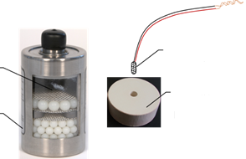

Cavity for aerosol pellet

Aerosol generator

Electric match

Aerosol pellet

Figure I shows the typical components that make up the aerosol generator. The electric initiator is installed through the top of the unit, resting inside the aerosol pellet. The electric initiator consists of an electric match and a gel capsule filled with a small amount of explosive powder. The electric initiator is shorted and stored under the protective cap for shipment, shown in Figure II. It cannot be accessed by any electrical charge during shipment. In this scenario, the largest electric initiator contains approximately 4.4 grams of explosive, contained powder.

**Figure II: Electric initiator installed. Lead wires coiled and shorted prior to installing protective cap**

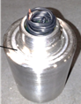

Prior to completed assembly

1. Thermal activation head. Thermally actuated units activate ONLY using a thermally activated head, installed on the top of the unit. These units have slightly different interior components, allowing actiation using a spring-loaded impact, after the thermally sensitive material has melted and unlatched the actuator. The pin strikes a primer cap, which in turn ignites a small bag containing explosive powder, and initiates the aerosol forming reaction. The largest thermally activated units contain approximately 3.0 grams of explosive, contained powder inside the bag. The thermally activated head, and the aerosol generator unit are ALWAYS shipped separately. Figure 3 shows the thermally activated head both alone (as shipped) and installed on the generator (as installed). The primer cap is fitted with a transportation plug which protects the primer from accidental impact during shipping and handling.

**Figure III: Picture of various thermal head units. Diagram of how the thermal activation unit is installed on the aerosol generator, AT THE TIME of installation**

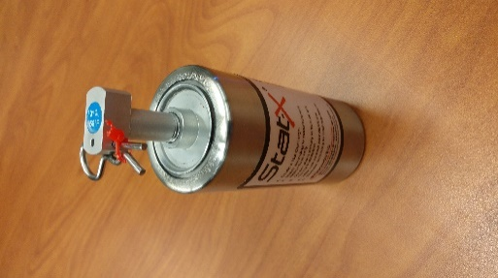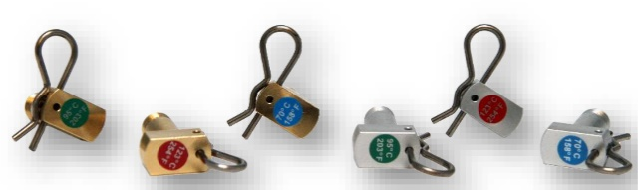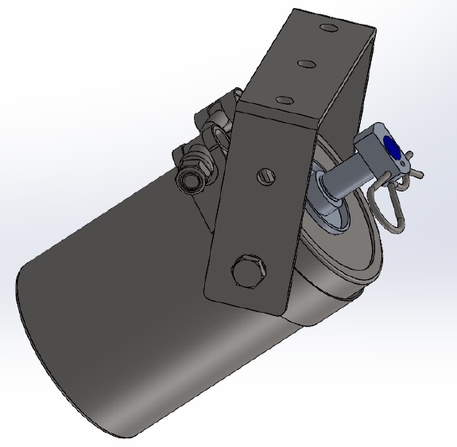

Thermally activated head

Safety benefits and contribution to public safety

1. The following are examples of how the use of these articles have contributed to public safety:

(a) Vehicle protection. Aerosol generators are an excellent option for the protection of engine spaces within US military armoured combat vehicles, commercial vehicles, mining equipment, trucks, commercial buses and school buses. Recently, the United States National Transportation Safety Board (NTSB) issued document HWY18MH003 recommending fire suppression be installed on all new and in-service school buses throughout the United States of America. Aerosol generators are an excellent solution to this known fire hazard that can have tragic consequences.

(b) <https://statx.com/testimonial/stat-x-protect-western-australia-mine-major-damage/>  
In the incident noted above, an aerosol fire suppression system, deployed in an electrical switch gear room, within a large mining vehicle. The installing contractor noted: “The customer was pleased with the fire suppression system which quickly extinguished the fire and prevented further damage to the multi-million-dollar machine”. As with nearly all applications, the objective is to save lives and property, which was successfully achieved in this installation.

(c) Renewable Energy. Aerosol systems are currently being used for the protection of massively growing industrial applications like wind turbine generators and energy storage systems. Aerosol generators are an excellent solution for wind turbines due to their ease of installation, small footprint and weight, and simple maintenance requirements. Wind Turbine Generator (WTG) manufacturers and their end users have found aerosol generators to mitigate risk for the community and first responders, while meeting insurance requirements, all in an economical fire suppression system. Further, aerosols have found to be effective in containing and in some cases extinguishing battery storage fires, which often accompany renewable energy farms. Many of these energy storage systems are integrated into the electrical grid or power generation facility to help maintain electrical service to the utility and end-use customers in peak demand periods.

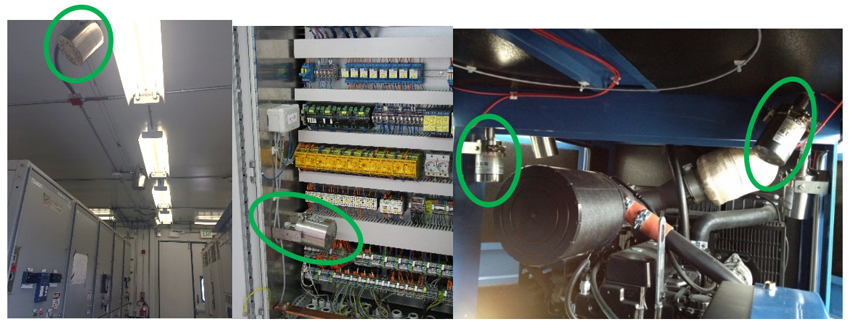

(d) Marine Engine Room Protection. Aerosol systems have been performance and component tested and approved by national marine authorities and various marine classification societies for the protection of marine vessel machinery spaces. These systems are protecting naval and government boats, small commercial vessels, fishing vessels, and offshore support vessels.

(e) At least two independent aerosol fire suppression systems are tested and listed under UL2775, “Standard for Fixed Condensed Aerosol Extinguishing Systems Units”. The scope of this document states:

*These requirements cover the construction and operation of fixed condensed aerosol extinguishing system units inclusive of aerosol generating extinguishing system units and aerosol generating automatic extinguisher units intended for total flooding applications when installed, inspected, tested, and maintained in accordance with the Standard for Fixed Aerosol Fire Extinguishing Systems, NFPA 2010.*

(f) United States Environmental Protection Agency (EPA) has included at least two manufacturer’s systems on their SNAP (Significant New Alternatives Policy) list for use in occupied spaces. Details can be found at:

40 CFR Part 82

I. Listing of New Acceptable Substitutes

C. Fire Suppression and Explosion Protection

6. Powered Aerosol D (Aero-K, Stat-X)

6. In summary, COSTHA believes it would be in the interest of global commerce, reduced confusion and overall safety to establish a new UN entry for, “Aerosol generating, fire suppression device”. There is no risk of accidental discharge during transport, based on the device design and many years of safe transportation throughout the world. Based on the safety history of the units during transportation, and the current US DOT special permit 20600, COSTHA requests that a new entry be included in the Dangerous goods List and Index and that a new special provision similar to SP 280 but tailored to these articles be assigned to the entry.

Proposal

7. It is proposed that a new entry be added in the Dangerous Goods List as follows:

|  |  |  |  |  |  |  |  |  |  |  |  |  |
| --- | --- | --- | --- | --- | --- | --- | --- | --- | --- | --- | --- | --- |
| **UN No.** | **Name and description** | **Class or division** | **Subsidiary hazard** | **UN packing group** | **Special**  **provisions** | **Limited and excepted quantities** | | **Packagings**  **and IBCs** | | | **Portable tanks and bulk containers** | |
| **Packing instruction** | | **Special packing provisions** | **Instructions** | **Special provisions** |
| 35XX | Aerosol generating, fire suppression device | 9 |  |  | XYZ | 0 | EO | P003 |  | |  |  |

A new special provision XYZ is proposed as follows:

“XYZ Aerosol generating, fire suppression devices are intended to provide a safety benefit based on their ability to extinguish flames by dispersing micro-particle solids that when in contact with fire or flame provide a total flooding system. The devices may be either electrically activated or thermally activated and shall be designed to prevent inadvertent activation either by shipping the actuation component separately (e.g. thermally activated head, and the aerosol generator unit are shipped separately) or by ensuring that the electrically initiated devices are not electrically connected and there is a secondary means of protection to prevent activation. Devices may contain dangerous goods of Division 1.4, if they have been tested in accordance with Test Series 6(c) of Part 1 of the Manual of Tests and Criteria, with no explosion of the device, no fragmentation of device casing or pressure receptacle, and no projection hazard nor thermal effect which would significantly hinder fire-fighting or emergency response efforts in the immediate vicinity which the exception of the intended generation of a dense fire suppressing cloud of particles that are dispersed from the article and are not combustible “smoke” or fuel that results from a typical pyrotechnic combustion or explosion.”

In the Index add the following:

|  |  |  |
| --- | --- | --- |
| **Name and description** | **Class** | **UN Number** |
| Aerosol generating, fire suppression device | 9 | 35XX |

1. \* In accordance with the programme of work of the Sub-Committee for 2019–2020 approved by the Committee at its ninth session (see ST/SG/AC.10/C.3/108, paragraph 141 and ST/SG/AC.10/46, paragraph 14). [↑](#footnote-ref-2)