|  |  |  |  |
| --- | --- | --- | --- |
|  | United Nations | ST/SG/AC.10/C.3/2019/42 | |
| _unlogo | **Secretariat** | | Distr.: General  9 September 2019  Original: English |

**Committee of Experts on the Transport of Dangerous Goods  
and on the Globally Harmonized System of Classification  
and Labelling of Chemicals**

|  |
| --- |
| **Sub-Committee of Experts on the Transport of Dangerous Goods** |
| **Fifty-sixth session**  Geneva, 2-11 December 2019 Item 3 of the provisional agenda  **Listing, classification and packaging** |

Transport of transformers with gas cylinders

Transmitted by the expert from Germany[[1]](#footnote-2)\*

Introduction

1. The expert from Germany presented a document on the transport of transformers with gas cylinders at the previous session of the Sub-Committee (ST/SG/AC.10/C.3/2019/38). The Sub-Committee agreed to pursue the work on this topic but noted that additional issues should still be addressed.

Background

2. For operational reasons, transformers are pressurized with nitrogen or with synthetic or dried air or also with a mixture of these gases. However, as the transformers are not gas-tight, low quantities of gas are constantly supplied through a pressure regulator from a gas cylinder connected to the transformer. So far, transformers have been transported by sea under UN 3363, Class 9. Due to the quantity limit of dangerous goods in machinery or apparatus having been exceeded, an approval in accordance with special provision 301 was issued by the competent authority. For this approval, it was implicitly taken into account that the transformer is not gas-tight and the condition was stipulated that the transformer must be transported on deck or in a well-ventilated cargo hold.

3. As of 1 January 2020, at the latest, such transformers will fall under UN 3538, Division 2.2. It must therefore be clarified how the problem of the lack of gas-tightness of the transformers should be dealt with.

4. Packing instruction P006 which applies to UN 3538 provides that transformers may be transported unpackaged. It does not explicitly require the transformer to be gas-tight. With regard to the connected gas cylinder, however, (3)(d) of the packing instruction applies; therefore 4.1.6 and 6.2 must complied with. In accordance with 4.1.6.1.5, the valves shall remain closed during transport.

Conclusion

5. With regard to safety, it generally does not present a problem if low quantities of gases which are not flammable, toxic, corrosive or oxidizing are released into the environment provided that an asphyxiant gas accumulation in confined spaces is prevented. This is also shown by the comparison with cryogenic receptacles: in the refrigerated liquefied state, such gases may be transported in open cryogenic receptacles which allow for continuous venting of the gas in order to maintain the receptacle at atmospheric pressure. A requirement for manufacturing gas-tight transformers would thus be disproportionate.

6. To avoid the necessity of issuing an exemption each time such transformers are transported, the regulations should contain a provision to this effect. A special provision should be assigned to UN 3538 laying down safety requirements for pressurizing transformers with gas. Pictures with examples of such transformers are included in the Annex.

7. Following the comments of the Sub-Committee, the revised proposal also reflects the risks of asphyxiation if cylinders with nitrogen are used. Some experts were of the view that ventilation requirements could be covered by the different transport modes. But it seems appropriate to include at least the same requirement as for substances presenting a risk of asphyxiation when used for cooling or conditioning purposes: 5.5.3.3 stipulates that packages shall be transported in well ventilated cargo transport units. This ensures that the issue of ventilation and stowage, for example the stowage on deck for sea transport, will be further reviewed by the modes. Compliance with the ventilation requirement presupposes information on the type of gas used in the article. Therefore this information should be included in the transport document. Furthermore, cargo transport units containing such articles should be marked in the same way as cargo transport units containing dangerous goods used for cooling or conditioning purposes.

Proposal

8. Add the following special provision in Chapter 3.3:

“XXX Where large and robust articles are transported with connected gas cylinders containing nitrogen of UN 1066 or compressed or synthetic air of UN 1002 or UN 1956, the valves of the gas cylinders may remain open provided:

(a) The gas cylinders are connected with the article through pressure regulators and fixed piping in such a way that the pressure of the gas (gauge pressure) in the article does not exceed 35 kPa (0.35 bar).

(b) Gas cylinders shall be properly secured so that they cannot move in relation to the article and be connected with strong flexible reinforced and pressure resistant hoses and pipes such as to minimize the risk of damage.

(c) Gas cylinders, pressure regulators and piping shall be protected by wooden crates or other suitable means.

(d) The transport documents shall include the following statement “Transport in accordance with special provision XXX, contains UN 1066” or “Transport in accordance with special provision XXX, contains UN 1002” or” “Transport in accordance with special provision XXX, contains UN 1956”, as appropriate

(e) Cargo transport units containing articles with cylinders containing UN 1066 shall be well ventilated and shall be marked in accordance with 5.5.3.6.“

9. In Chapter 3.2, insert “xxx” in column 6 of the Dangerous Goods List for UN 3538.

Annex

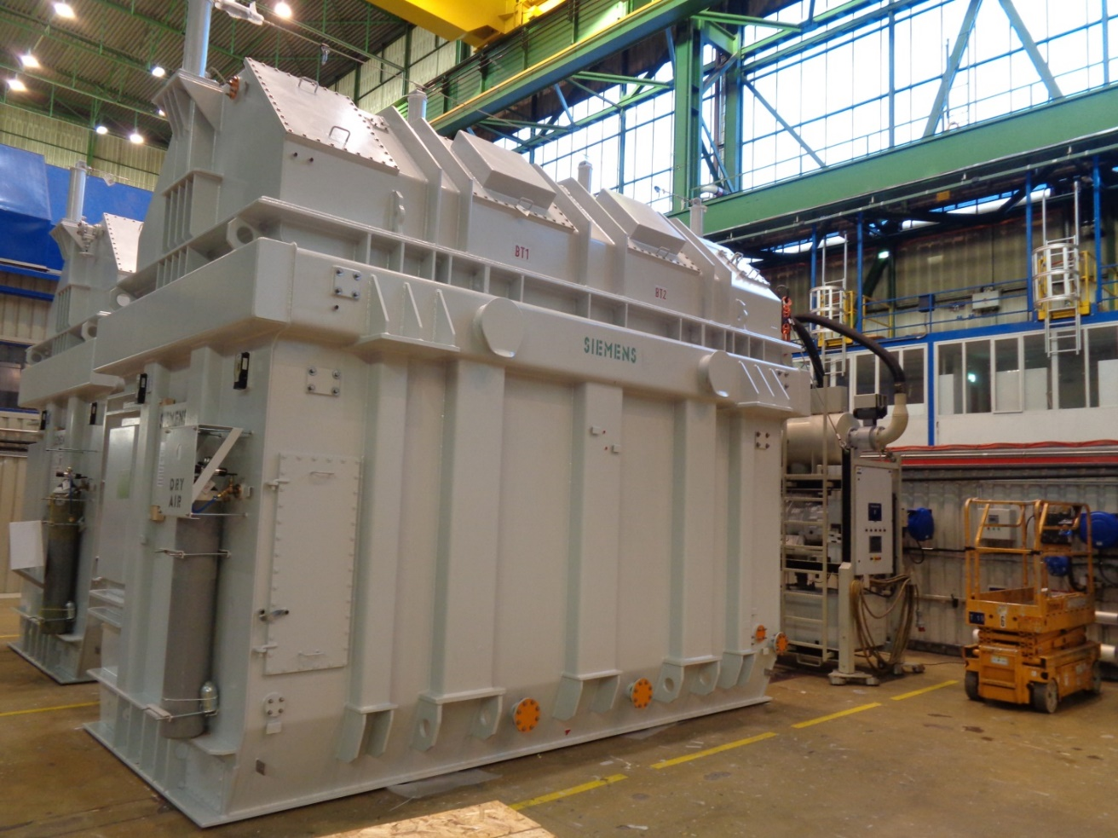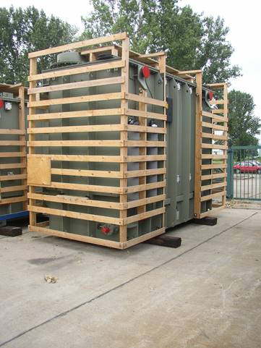



1. \* In accordance with the programme of work of the Sub-Committee for 2019–2020 approved by the Committee at its ninth session (see ST/SG/AC.10/C.3/108, paragraph 141 and ST/SG/AC.10/46, paragraph 14). [↑](#footnote-ref-2)