|  |  |  |  |
| --- | --- | --- | --- |
|  | United Nations | ST/SG/AC.10/C.3/2019/19 | |
| _unlogo | **Secretariat** | | Distr.: General  5 April 2019  Original: English |

**Committee of Experts on the Transport of Dangerous Goods  
and on the Globally Harmonized System of Classification  
and Labelling of Chemicals**

Sub-Committee of Experts on the Transport of Dangerous Goods

**Fifty-fifth session**

Geneva, 1-5 July 2019  
Item 6 (a) of the provisional agenda  
**Miscellaneous proposals for amendments to the**

**Model Regulations on the Transport of Dangerous Goods:**

**marking and labelling**

Optical differentiation of labels/placards for gases

Submitted by the expert from Spain and the International Association of Fire and Rescue Services (CTIF)[[1]](#footnote-2)

Introduction

1. For different labels corresponding to different classes, the labels are only differentiated by the numbers indicated in the lower part of the label. This occurs for labels 2.1 and 3, and labels 2.3 and 6:

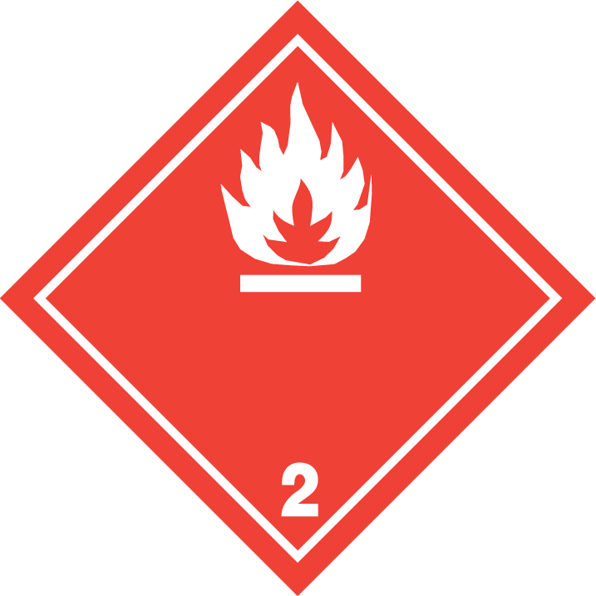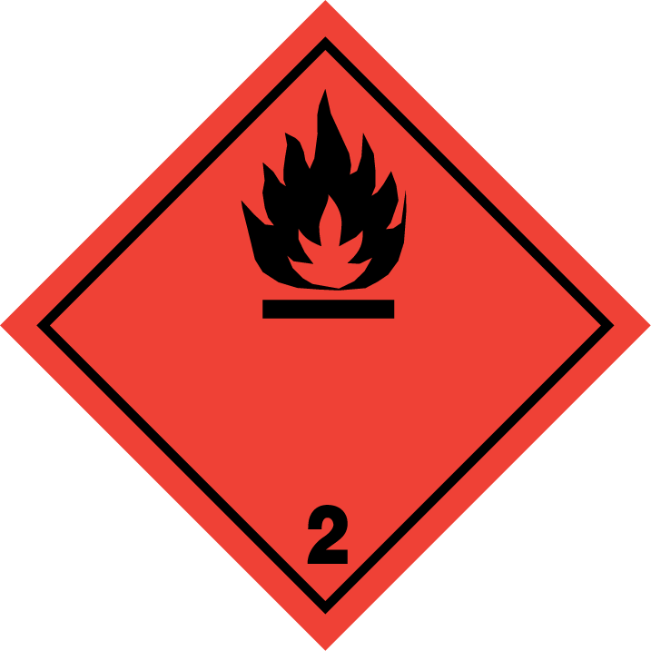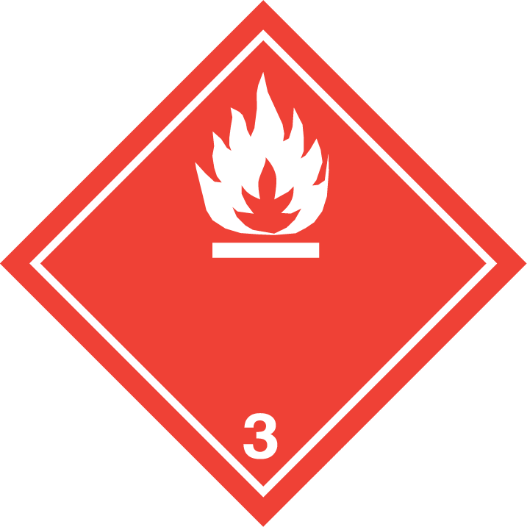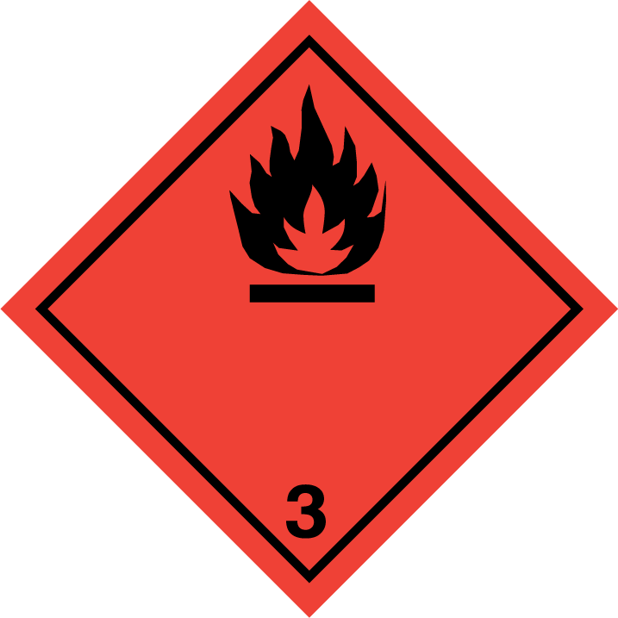

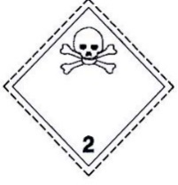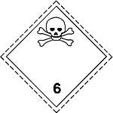

2. This situation can create some difficulties for the first emergency responders (police, firefighters, etc), which should be able to distinguish easily one label from another. A possible mix up could lead to erroneous responses at the site of an accident.

3. At the last session of the Sub-Committee, Spain presented document ST/SG/AC.10/C.3/2018/102 for discussion. Spain proposed to modify the labels for gases by including a different colour (green as in label 2.2) in the lower part of the labels 2.1 and 2.3. CTIF offered some alternative designs that would also make it easier to identify the labels for flammable (2.1) and toxic (2.3) gases from the labels for the flammable liquids (3) and toxic substances (6.1). Following the comments made during that session the proposal has been redrafted and is presented in this document for discussion.

Analysis

4. Responses to incidents with flammable gases are very different from those involving flammable liquids, and the responses also differ between a toxic gas and a toxic liquid or solid. Visibility and identifying the physical state from a distance is a very important issue.

5. If there is a large gas release a dangerous cloud can spread several kilometres. In case of fire there is a significant danger for bursting, together with heat radiation and debris from the gas container.

6. Symbols like the ones used in the label 2.2 (gas receptacle), rather than coded or written information, helps to be more aware of the possible danger, also for others (i.e. the public) than trained emergency responders.

7. The physical state of a released product has a great impact on the emergency measures taken to minimize the damage for the population and environment. The sooner qualified actions is taken, the better response is possible.

8. If gas is transported not in a specific tank vehicle, but in pressure receptacles (for example LNG, LH2) in a vehicle together with other goods, or inside a container, an identification from the distance is also for specialist not always possible because the labels for flammable gases/liquids and toxic gases/liquids look very similar.

9. Labels 2.1 and 2.3 have the same colour and symbol (flame and crossbones) like labels 3 and 6, and the only difference is the class number indicated in the lower part of the label. The labels could be differentiated from others by including an additional symbol into the labels. This symbol included into the labels lower part could be the gas cylinder that is now included into label 2.2, and is well known and identified as gas:

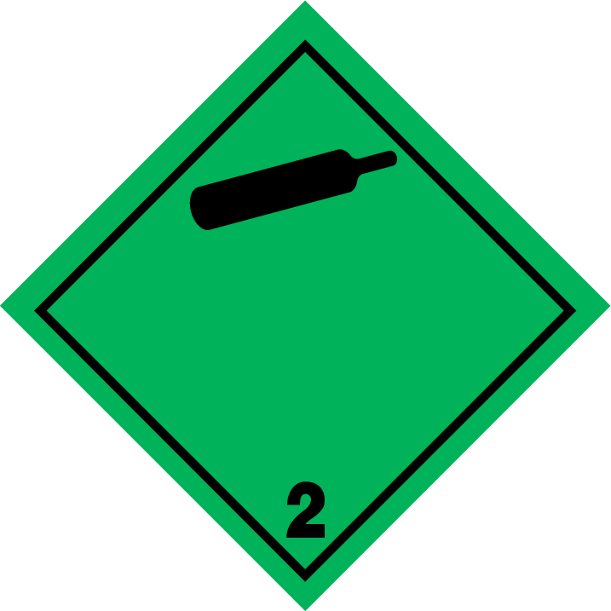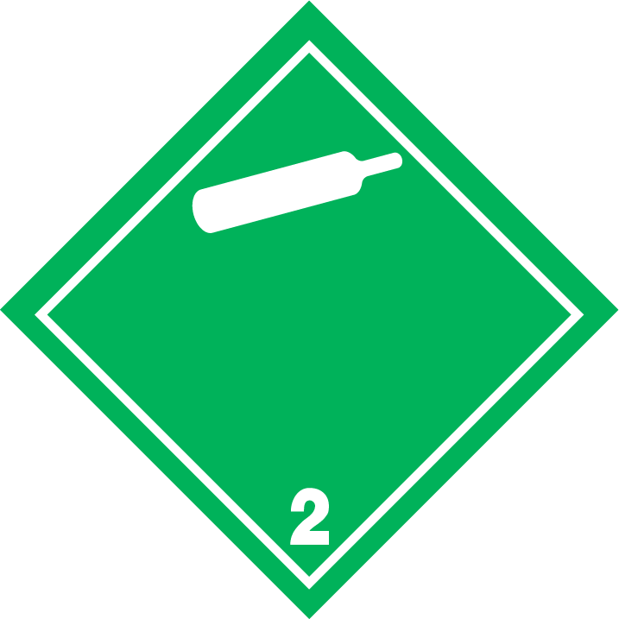

10. This symbol could be included into the lower half of the labels; including a symbol into the lower half of the label has already been done for the 9A label. A possible design could be as follows:

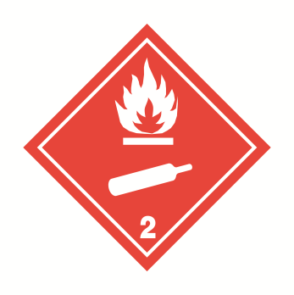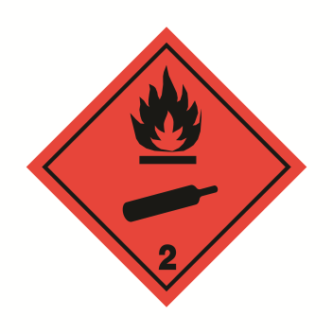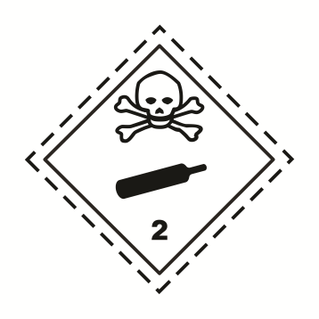

11. In this design, the label remains like in its present design, and the gas cylinder, already clearly associated to gases, would be included into the lower half. All gas labels would then include the symbol for the gas cylinder, and this would allow an easy recognition of these labels from the distance.

12. This additional symbol would enhance safety, with no or a very small cost. The new labels could be included into the modal regulations with a very long transitional period. As the new labels only add information to the existing ones, there is little risk that they could cause confusion or be mistaken. Furthermore, no additional specific training would be needed for the rescue services or other stakeholders.

13. Complimentary information on what is transported, and indication that it is a gas, may be available for some transport modes in some geographical areas. Nevertheless, this modification of the labels for 2.1 and 2.3 would convey this information for all the modes and for all the regions applying the Model Regulations.

14. Introducing this symbol into the labels would convey the information of being a gas also very easily to a big public, as the labels for transport of dangerous goods are the most well-known part of all the Regulations. For being able to get some additional information from other marks or documentation, a more in depth information on transport of dangerous goods may be needed.

Proposal

15. The expert from Spain and CTIF propose to modify labels 2.1 and 2.3 to include the gas receptacle symbol into the lower part of the label.

16. Therefore, the expert from Spain and CTIF propose to modify 5.2.2.2.2 for label numbers 2.1 and 2.3. Deleted text is ~~stricken through~~, new text is underlined; for the specimen labels of labels 2.1 and 2.3, only the new labels are shown, as it is not possible to strike through or underline the labels in the existing text.

|  |  |  |  |  |  |  |  |
| --- | --- | --- | --- | --- | --- | --- | --- |
| **Label model No.** | **Division or Category** | **Symbol and symbol colour** | **Background** | **Figure in bottom corner (and figure colour)** | **Specimen labels** | | **Note** |
| **Class 2: Gases** | | | | | | | |
| 2.1 | Division 2.1: Flammable gases (except as provided for in 5.2.2.2.1.6 d)) | Flame in upper half: black or white  Gas cylinder in lower half: black or white | Red | 2  (black or white) |  |  | - |
| 2.2 | Division 2.2:  Non-flammable, non-toxic gases | Gas cylinder: black or white | Green | 2  (black or white) |  |  | - |
| 2.3 | Division 2.3: Toxic gases | Skull and crossbones in upper half: black  Gas cylinder in lower half: black | White | 2  (black) |  | | - |

17. As a consequential amendment, 5.2.2.2.1.3 should be modified, including the following new third sentence:

“5.2.2.2.1.3 With the exception of labels for division 1.4, 1.5 and 1.6 of Class 1, the upper half of the label shall contain the pictorial symbol and the lower half shall contain the class or division number 1,2,3,4,5.1,5.2,6,7,8 or 9 as appropriate. However, for label model No.9A, the upper half of the label shall only contain the seven stripes of the symbol and the lower half shall contain the group of batteries of the symbol and the class number. Labels for division 2.1 and 2.3 shall contain a symbol for the gas cylinder in the lower half of the label. Except for label model No.9A, the label may include such text as the UN number, or words describing the hazard class (e.g. “flammable”) in accordance with 5.2.2.2.1.5 provided that the text does not obscure or detract from the other required label elements.”

18. Additionally, it should be recommended to include a transitory period for these labels, of at least 4 years, to allow the older models of labels to still be used. Add a note to 5.2.2.2.2:

“***NOTE:*** *The provisions of 5.2.2.2.2 from the twenty-first revised edition of the Recommendations on the Transport of Dangerous Goods, Model Regulations may continue to be applied until 31 December 2025”.*

1. In accordance with the programme of work of the Sub-Committee for 2019-2020 approved by the Committee at its ninth session (see ST/SG/AC.10/C.3/108, paragraph 141 and ST/SG/AC.10/46, paragraph 14). [↑](#footnote-ref-2)