|  |  |  |  |
| --- | --- | --- | --- |
|  | United Nations | ST/SG/AC.10/C.3/2019/18 | |
| _unlogo | **Secretariat** | | Distr.: General  8 April 2019  Original: English |

**Committee of Experts on the Transport of Dangerous Goods  
and on the Globally Harmonized System of Classification  
and Labelling of Chemicals**

**Sub-Committee of Experts on the Transport of Dangerous Goods**

**Fifty-fifth session**

Geneva, 1-5. July 2019  
Item 3 of the provisional agenda  
**Listing, classification and packing**

Exemptions for polymerizing substances

Transmitted by the European Chemical Industry Council (CEFIC)[[1]](#footnote-2)\*

Introduction

1. The Sub-Committee adopted new criteria and UN numbers for polymerizing substances in Division 4.1 for the nineteenth edition of the Model Regulations,.

2. The definition of section 2.4.2.5.1 describes polymerizing substances as “substances which, without stabilization, are liable to undergo a strongly exothermic reaction resulting in the formation of larger molecules or resulting in the formation of polymers under conditions normally encountered in transport.”

3. In most chemical textbooks, the ability to polymerize is linked to the existence of unsaturated (i.e. double or triple) bonds or strained rings in the molecule. Thus, polymerization is essentially the formation of larger molecule by addition of small reactive units – the so called monomers – to the activated end of a growing chain. The polymerization starts with the initialization followed by the propagation phase, in which the polymer chain is growing. Towards the end (the termination) stops the creation of the polymer. Typical polymerization reactions are:

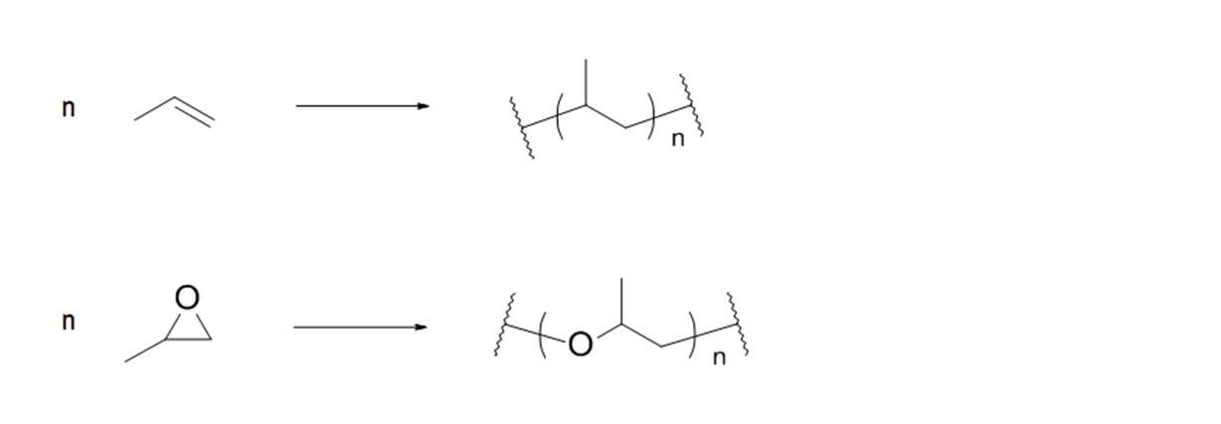

4. Due to the nature of reaction type the formation of gases are not to be expected. Technically in some cases the monomer mixtures contain isocyanates which react with water (humidity of the surroundings) resulting in the formation of carbon dioxide. This effect is intentionally used to foam the polymer. However, this reaction does not release the gas, as it is used to create the foam and therefore, the gas is trapped inside the polymer:

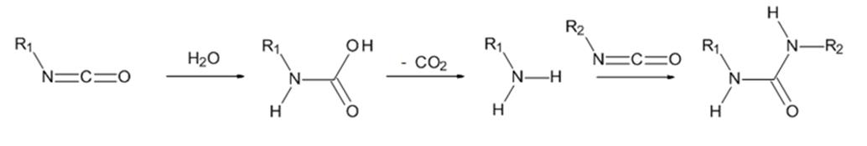

5. Isocyanates are generally not considered polymerizing substances (many of them are listed by name in the Model Regulations) because they do not polymerize by themselves but need addition of other compounds (such as alcohols or amines) to form plastic material.

6. The heat of polymerization is released during the creation of the polymer. After the polymerisation has stopped (termination reaction, see above) no further heat is produced. This effect can be seen in the differential scanning calorimetry (DSC) diagrams of the monomer and the polymer. In the monomer the first reaction peak is attributed to the polymerisation reaction and thus this peak is missing in the DSC diagram of the polymer. Therefore, the heat of polymerisation can be determined by comparison of the DSC diagrams of the monomer and polymer. If the heat of polymerisation is less than 500 J/g, a strongly exothermic reaction can be excluded. Therefore, CEFIC proposes to use this as a criterion to exempt small packages of polymerizing substances.

7. Small packages in this context are packages with a net content of less than or equal to 50 kg. Metal packages (e.g. drum and canisters) should be prohibited in order to prevent high confinement.

8. In response to the suggested testing for the effect of heating under confinement (Koenen-Test), CEFIC thinks that this test should not be applied for small packages for several reasons:

(a) The products will polymerize in the test apparatus, and as a result, the lab equipment would be damaged beyond repair;

(b) Products of high viscosity will clog the orifice of the test apparatus and lead to a false positive result because of mechanical overpressure and not explosive pressure build-up due to gaseous decomposition products;

(c) The proposed criteria rather refer to the damage that the package would suffer itself, so the substance under confinement is taken into account by the tests proposed for this exemption (see 2.4.2.5.3 (b) in the proposal below).

9. Based on the above, CEFIC suggests including an exemption based on the maximum temperature on the surface, the heat of polymerisation and criteria for minor damage of the packaging:

10. As this proposal covers only small packages (≤ 50 kg net weight) IBCs and tanks are excluded from the exemption in the first step, to gain experience. The packages are tested as used for the transport and not combined to a certain amount.

Proposal

11. In the Model Regulations, insert a new section 2.4.2.5.3 to read as follows:

“2.4.2.5.3 Any substance packed in small packages (≤ 50 kg net weight) shall be exempted from classification as a polymerizing substance of Division 4.1 in that package, provided that upon thermal initiation of the polymerization:

(a) No external surface shall have a temperature of more than 65°C. A momentary spike in temperature up to 200°C is acceptable.

(b) There is no effect outside the package, except that the package might open without release of its contents; and

(c) The heat of polymerization is less than 500 J/g as determined by comparison of the DSCs of the monomer and the polymer.

The assessment shall be based on evidence obtained either by experiment in a 1:1 scale on the package size used for transport or by a model derived from experimental kinetic data in consideration of the heat loss of the package.

12. In the Model Regulations, insert a new special packaging provision under P520 to read as follows:

“PPXX: when using the exemption for polymerising substances in small packages, no metal packaging is allowed.”.

Justification

13. The above proposed criteria are supported by the following test:

An epoxy adhesive, formerly classified as UN3240, Self-Reactive Solid Type F, temperature controlled, packaged in sheet form with 80 individual sheets with a net weight of 14.56 kg, exhibiting a heat of polymerization of 345 J/g determined by differential scanning calorimetry (DSC), was determined to have a Self-accelerating polymerization temperature (SAPT) of 55 °C. The package exhibited swelling due to the product design which is intended to expand upon curing.

14. The DSC diagrams for the uncured product (showing the polymerization reaction) and for the cured product (showing the decomposition) are provided in informal document INF.6.



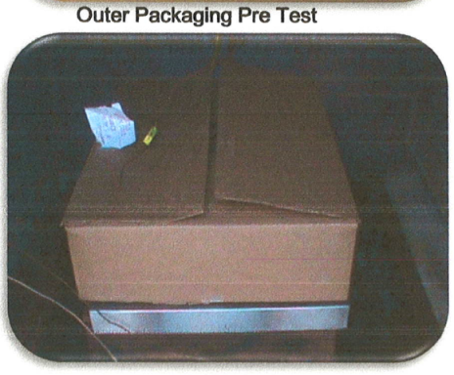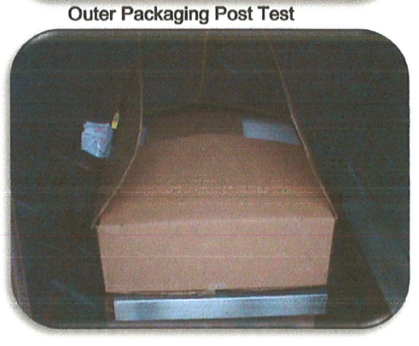

15. Prior to the test, the package had been opened to place the thermocouples into the middle of the material. In spite of this weakening effect, no product could escape, as it was fully polymerized. The package was not damaged by the heat that developed during the test. Therefore, the criteria that are proposed are fulfilled:

(a) The temperature on the surface of the package did not exceed 65 °C,

(b) There was no effect outside the package except that the packages might open without release of its contents*, there is no effect like spillage outside the package and the package itself is not damaged, just open, and*

(c) No gases had been released at all.

16. There was also a package tested with only 7 sheets of the above described product. The 7-sheet package configuration was also tested at 55 °C and that package passed the test. The package never exceeded a 6 °C rise in temperature. There was no change in the package after testing. Therefore, it makes sense for these products, to test the package used for transport instead of a 50 kg package.

1. \* In accordance with the programme of work of the Sub-Committee for 2019-2020 approved by the Committee at its ninth session (see ST/SG/AC.10/C.3/108, paragraph 141 and ST/SG/AC.10/46, paragraph 14). [↑](#footnote-ref-2)