Proposal for Supplement 5 to the 02 series of amendments to UN Regulation No. 129
Submitted by the expert from Spain
The text reproduced below was prepared by the expert from Spain on behalf of the Technical Services Group (TSG) on UN Regulation No. 129. The modifications to the current text of Regulation are marked in bold for new or strikethrough for deleted characters.
I. Proposal
Annex 2., amend to read:
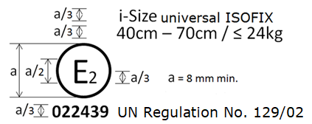
…
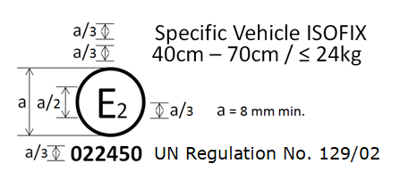
…
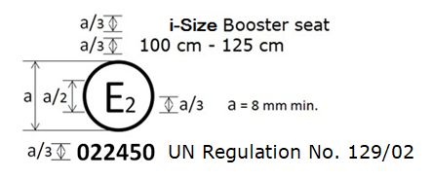
…
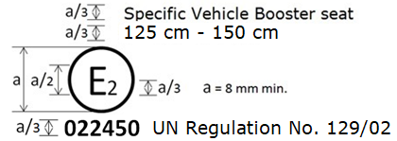
The Enhanced Child Restraint System bearing the above approval mark…125 cm - 150 cm size range…
II. Justification
- Dimension of the approval number is currently not specified
- Correct wording for regulation used. UN Regulation No. 129/02 instead of Regulation No. 129/02
- Changed the 145 cm stature of the Specific Vehicle Booster seat to 150 cm stature as this is the upper limit.

