Proposal for Supplement 2 to the 03 series of amendments to UN Regulation No. 129
Submitted by the expert from Spain
The text reproduced below was prepared by the expert from Spain on behalf of the Technical Services Group (TSG) on UN Regulation No. 129. The modifications to the current text of Regulation are marked in bold for new or strikethrough for deleted characters.
I. Proposal
Annex 2., amend to read:
Arrangements of the approval mark
…
In case of combinations, for example an Enhanced Child Restraint System, that is approved as an i-Size Booster seat from 100 cm – 125 cm and from 125 cm – 150 cm as an Specific Vehicle Booster seat, the approval marked is to be combined as given below.
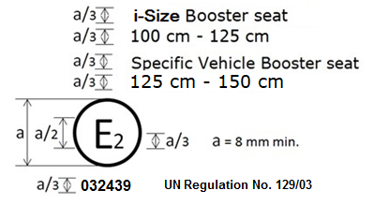
Combinations can only be made for those allowed by paragraph 3.2.2.
II. Justification
1. Combinations of approval marks can be made as long as the categories are able to be combined (category wise as given in paragraph 3.2.2 and as long as it is one approval number)
2. By combining approval marks, space on the Enhanced Child Restraint can be saved and more space is available for clear installation and use instructions.
3. Create a consistency between technical services and approval authorities.
4. Create a consistency between labels for 02 series products and 03 series products.

