Proposal for Supplement 2 to the 03 series of amendments to UN Regulation No. 129
Submitted by the expert from Spain
The text reproduced below was prepared by the expert from Spain on behalf of the Technical Services Group (TSG) on UN Regulation No. 129. The modifications to the current text of Regulation are marked in bold for new or strikethrough for deleted characters.
I. Proposal
Annex 2., amend to read:
1. Arrangements of the approval mark
… according to which the approval has been granted.
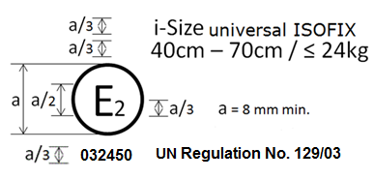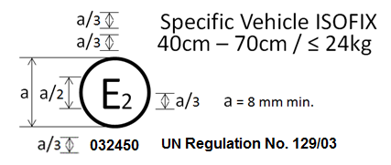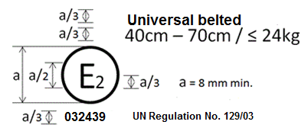
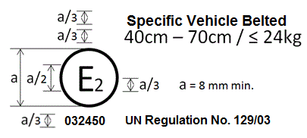
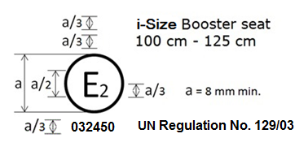
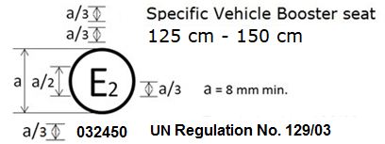
The Enhanced Child Restraint System bearing the above approval mark…
125 cm - 150 cm size range

2. Arrangements of the approval mark in combination with a module mark
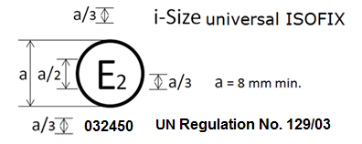
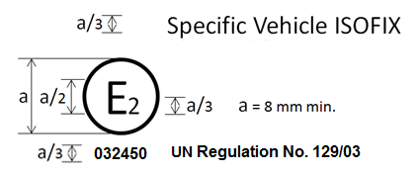
II. Justification
- Dimension of the approval number is currently not specified
- i-Size universal ISOFIX, Specific Vehicle ISOFIX, i-Size Booster seat and Specific Vehicle Booster seat are not updated to 03 numbering in ECE-TRANS-WP29-2018-045e
- Dimensions marks for arrangements of the approval mark in combination with the module mark re-arranged.
- Changed the 145 cm stature of the Specific Vehicle Booster seat to 150 cm stature as this is the upper limit.

