Proposal for

Submitted by the expert from the European Association of Automotive Suppliers
The text reproduced below was prepared by the expert from the European Association of Automotive Suppliers (CLEPA) to clarify that certain information for users is displayed sufficiently. The modifications to the current text of UN Regulation No. 129 are marked in bold for new or strikethrough for deleted characters.

I. Proposal for Supplement 8 to the 00 series of amendments, Supplement 5 to the 01 series of amendments, Supplement 4 to the 02 series of amendments and Supplement 1 to the 03 series of amendments to UN Regulation No. 129
Paragraph 4.5. amend to read:
"4.5. In the case of Integral Enhanced Child Restraint Systems that can be used forward and rearward facing, it shall have the following label permanently attached on the part hosting the child and visible to the person installing an Enhanced Child Restraint System in the vehicle:
The manufacturer shall be permitted to include the word "months" to explain the symbol "M" in the label. The word "months" should be in a language commonly spoken in the country or countries where the product is sold. More than one language is allowed.
Minimum label size 40 x 40 mm

All text black on yellow or amber background
Top symbol white on black background

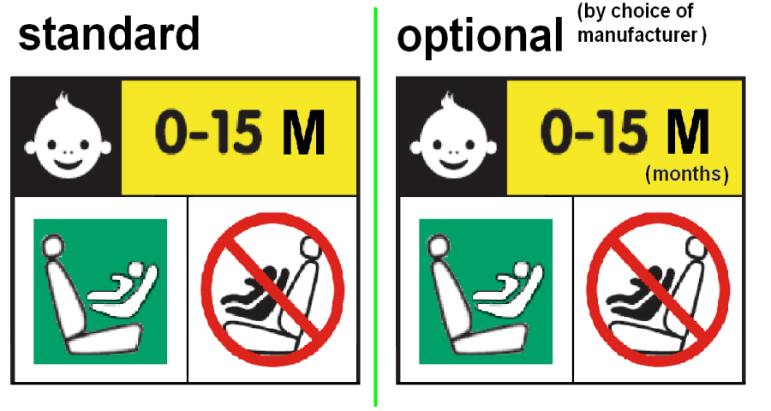
Background white
Square - green
Forbidden sign – red

Background white
Label outline, vertical and horizontal lines black

"

Paragraph 14.3.3. amend to read:
"14.3.3. For integral forward facing Enhanced Child Restraint Systems, the following information shall be clearly visible on the exterior of the packing:
"IMPORTANT – DO NOT USE FORWARD FACING BEFORE THE CHILD’S AGE EXCEEDS 15 MONTH (Refer to instruction)".
For integral Enhanced Child Restraint Systems that can be used forward and rearward facing, the following information shall be clearly visible on the exterior of the packing:
"IMPORTANT – DO NOT USE FORWARD FACING BEFORE THE CHILD’S AGE EXCEEDS 15 MONTH (Refer to instruction)".
"
II. Justification
- The label from paragraph 4.5. is intended for ECRSs which can be used forward and rearward facing which need to be clarified in the wording.

- Currently the information from paragraph 14.3.3 is required to be on the packing of every forward facing ECRS. As this is only appropriate for integral ECRSs the wording of this paragraph should be amended as proposed.
The current wording of this information might be misleading for child seats which are only usable forward facing. Therefore it is proposed to have separate information for different configurations.

