Submitted by the expert from OICA | Informal document GRSP-63-07  (63rd GRSP, 14-18 May 2018,  agenda item 16)

Proposal for Supplement 7 to the 03 series of amendments to
UN Regulation No. 95 (Lateral collision)

The text reproduced below was prepared by the experts from OICA. It proposes some slight modifications to the proposal submitted by the expert from Germany and reproduced in document ECE/TRANS/WP.29/GRSP/2017/40

- Proposal

Document ECE/TRANS/WP.29/GRSP/2017/40, Paragraph 5.3.1., replace by (rest of the proposal remains unchanged):
"5.3.1. No door shall open during the test.
This requirement is deemed to be fulfilled:
(a) if it is clearly visible, that the door lock is latched; or
(b) if the door does not open under a force of at least [400 N] in the y-direction applied to the door, according to the Figure below, as close as possible to the window sill and to the edge of the door opposite to the hinged side, except to the door handle itself."

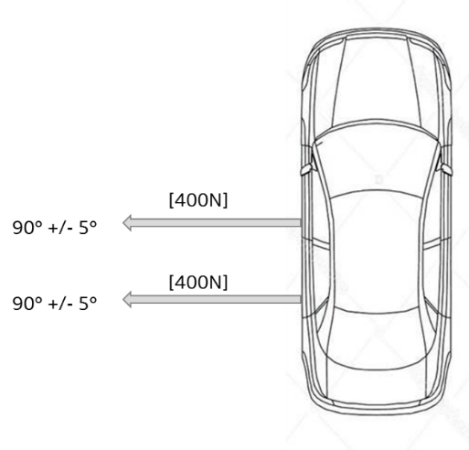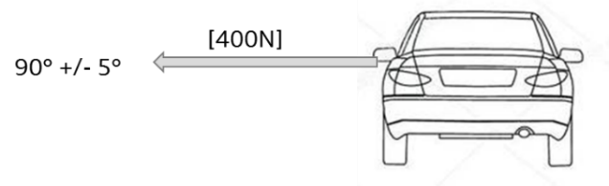
Figure

II. Justification

While generally agreeing with the aim of the German proposal GRSP/2017/40, OICA considers it necessary to better specify the test procedure in order to avoid different interpretations among the Technical Services.

OICA also proposes to slightly reduce the suggested force level, since according to test engineers, applying a force of 500 N on a slippery test floor might be difficult to achieve. Also, the traction device/clamp might tear loose creating a safety risk if the force level is maintained at 500 N.

__________

