|  |  |  |  |
| --- | --- | --- | --- |
|  | United Nations | ECE/TRANS/WP.29/GRSP/2018/12 | |
| _unlogo | **Economic and Social Council** | | Distr.: General  28 February 2018  Original: English |

**Economic Commission for Europe**

Inland Transport Committee

**World Forum for Harmonization of Vehicle Regulations**

**Working Party on Passive Safety**

**Sixty-third session**

Geneva, 14-18 May 2018

Item 8 of the provisional agenda

**UN Regulation No. 14 (Safety-belt anchorages)**

Proposal for Corrigendum 2 to Revision 5 to UN Regulation No. 14 (Safety-belt anchorages)

Note by the secretariat [[1]](#footnote-2)\*

The text reproduced below was prepared by the secretariat to correct and improve the quality of the image of Figure 1a of Annex 5 to the UN Regulation.

I. Proposal

*Annex 5,*

*Figure 1a,* shall be deleted

*Insert new figure 1a,* to read:

"

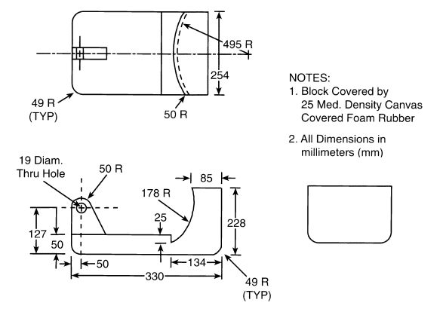  
"

II. Justification

The text reproduced below was prepared by the secretariat to correct and improve the quality of the image of Figure 1a of Annex 5 to the UN Regulation.

1. \* In accordance with the programme of work of the Inland Transport Committee for 2014–2018 (ECE/TRANS/240, para. 105 and ECE/TRANS/2014/26, programme activity 02.4), the World Forum will develop, harmonize and update UN Regulations in order to enhance the performance of vehicles. The present document is submitted in conformity with that mandate. [↑](#footnote-ref-2)