|  |  |  |  |
| --- | --- | --- | --- |
|  | United Nations | ECE/TRANS/WP.29/GRSG/2018/19 | |
| _unlogo | **Economic and Social Council** | | Distr.: General  20 July 2018  English  Original: English and French |

**Economic Commission for Europe**

Inland Transport Committee

**World Forum for Harmonization of Vehicle Regulations**

**Working Party on General Safety Provisions**

**115th session**

Geneva, 9-12 October 2018

Item 10 of the provisional agenda

**UN Regulation No. 73 (Lateral protection devices)**

Proposal for Supplement 2 to the 01 series of amendments and for Supplement 1 to the 02 series of amendments to UN Regulation No. 73 (Lateral protection devices)

Submitted by the expert from France[[1]](#footnote-2)\*

The text reproduced below was prepared by the expert from France, proposing an amendment to UN Regulation No. 73 to restore consistency between the provisions related to the installation of Lateral Protection Devices (LPD) of an approved type according to Part II of the Regulation and those related to vehicles with regard to their LPD. The modifications to the current text of UN Regulation No. 73 are marked in bold characters.

**I. Proposal**

PART III – APPROVAL OF A VEHICLE WITH REGARD TO THE INSTALLATION OF A LATERAL PROTECTION DEVICE (LPD) OF AN APPROVED TYPE ACCORDING TO PART II OF THIS REGULATION

*Insert a new paragraph 15.2.1.4.,* to read:

**"15.2.1.4. On a central axle trailer: in the area forward of the transverse plane passing through the centre of the front axle but not more than the front of the bodywork, if any, to ensure the normal manoeuvrability of the trailer."**

II. Justification

1. Paragraph 15.2.1. sets out the provisions related to the positioning of the LPD forward edge on vehicles of categories N2, N3, O3 and O4 in case of the installation of a type-approved LPD according to Part II of this Regulation. It is similar to paragraph 12.4.1. which provides requirements related to the positioning of the LPD forward edge on vehicles of the same categories of which lateral protection approval is granted according to Part I of this Regulation.

2. Regarding vehicles of categories O3 and O4, this Regulation specifies in paragraphs 12.4.1.2., 12.4.1.3. and 12.4.1.4. further requirements that drawbar, semi- and central axle trailers have to meet. However, below paragraph 15.2.1., only paragraphs 15.2.1.2. and 15.2.1.3. exist and provide requirements for drawbar trailers and semi-trailers respectively.

3. The requirement set out in paragraph 15.2.1.2. for drawbar trailers is exclusively dedicated to trailers designed as in the example below; central axle trailers, even though equipped with drawbars, cannot be included in the scope of paragraph 15.2.1.2.

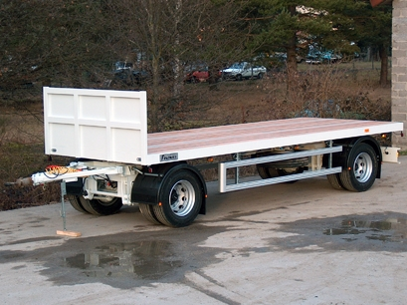4. Therefore, in the absence of any provision in Part III on the positioning of the forward edge of a type-approved LPD on central axle trailers, a random positioning could result in a situation rather dangerous than safe and go against the purpose of the text specified in paragraph 12.4.1.4. This proposal aims to align the provisions of Part III accordingly.

1. \* In accordance with the programme of work of the Inland Transport Committee for 2014–2018 (ECE/TRANS/240, para. 105 and ECE/TRANS/2014/26, cluster 02.4), the World Forum will develop, harmonize and update UN regulations in order to enhance the performance of vehicles. The present document is submitted in conformity with that mandate. [↑](#footnote-ref-2)