## B.1. Text of the regulation, general requirements

### 1. Purpose

1.1. This regulation provides a worldwide-harmonized measurement method for the determination of the levels of gaseous pollutant emissions at the tailpipe, the emissions of carbon dioxide and the energy efficiency in terms of fuel consumption of two-wheeled motor vehicles that are representative for real world vehicle operation

### 2. Scope

2.1 Two-  wheeled motor vehicles equipped with a propulsion unit in accordance with table B.1-1.

|  |  |  |
| --- | --- | --- |
|  | Vehicle with PI engines(Petrol) | Vehicle with PI engines(Diesel) |
| Type I Test | Yes | Yes |
| Type I Test particulate mass | Yes (only for DI) | Yes |
| Type II Test | Yes | Yes |
| Type VII Test | Yes | Yes |

Note: For vehicles with Bi fuels, if the petrol fuel tank (provided for limp home or for starting) capacity is not exceeding two litres, Type I test need not be done in gasoline mode.

### 3. Vehicle sub-classification

3.1 Figure B.1-1 provides a graphical overview of the vehicle sub-classification in terms of engine capacity and maximum vehicle speed if subject to the environmental test types indicated by the (sub-)class numbers in the graph areas. The numerical values of the engine capacity and maximum vehicle speed shall not be rounded up or down.

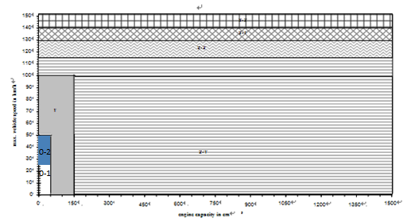

Figure B.1.-1: Vehicle sub-classification for environmental testing, test types I and VII

3.2. **Class 0**

Vehicles that fulfil the following specifications belong to class 0 and shall be sub-classified in:

|  |  |
| --- | --- |
| Engine Capacity ≤ 50cm3 and vmax ≤ 25km/h | Sub-class 0-1 |
| Engine Capacity ≤ 50cm3 and 25km/h < vmax ≤ 50km/h | Sub-class 0-2 |

Table B.1.-2: sub-classification criteria for class 0 Two wheeled vehicles

3.3 **Class 1**

Vehicles that fulfil the following specifications belong to class 1:

|  |  |
| --- | --- |
| 50cm3 < Engine Capacity < 150cm3 and vmax ≤ 50km/h  Or  Engine Capacity < 150cm3 and 50km/h < vmax < 100km/h | Class 1 |

Table B.1.-3: Classification criteria for class 1 Two wheeled vehicles

3.4. **Class 2**

Vehicles that fulfil the following specifications belong to class 2 and shall be sub-classified in:

|  |  |
| --- | --- |
| Engine Capacity <150cm3 and 100km/h ≤vmax <115km/h  Or  Engine Capacity ≥ 150cm3 and vmax < 115km/h | Sub-class 2-1 |
| 115km/h ≤ vmax < 130km/h | Sub-class 2-2 |

Table B.1.-4: sub-classification criteria for class 2 Two wheeled vehicles

3.5. **Class 3**

Vehicles that fulfil the following specifications belong to class 3 and shall be sub-classified in:

|  |  |
| --- | --- |
| 130km/h ≤ vmax < 140km/h | Sub-class 3-1 |
| vmax ≥ 140km/h | Sub-class 3-2 |

Table B.1.-5: sub-classification criteria for class 3 Two wheeled vehicles

4. Definitions

The following definitions shall apply in this GTR:

4.1 "Equivalent inertia" determined in relation to the unladen mass as prescribed in paragraph 4.3, to this regulation, and

4.2 "Engine and vehicle characteristics": Subject to the provisions of paragraph 6.2.1, the engine and vehicle characteristics as defined in Annex 4 to this regulation.

4.3 "Unladen mass" (mk) means the nominal mass of a complete vehicle as determined by the following criteria:

Mass of the vehicle with bodywork and all factory fitted equipment, electrical and auxiliary equipment for normal operation of vehicle, including liquids, tools, fire extinguisher, standard spare parts, chocks and spare wheel, if fitted.

The fuel tank shall be filled to at least 90 per cent of rated capacity and the other liquid containing systems to 100 per cent of the capacity specified by the manufacturer

4.4 "Driver mass" means the nominal mass of a driver that shall be 75 kg (subdivided into 68 kg occupant mass at the seat and 7 kg luggage mass in accordance with ISO standard 2416-1992)

4.5 "Gaseous pollutants" means carbon monoxide (CO), oxides of nitrogen (NOx) expressed in terms of nitrogen dioxide (NO2) equivalence, and hydrocarbons (HC), assuming a ratio of:

C1H1.85 for petrol,

C1H1.86 for diesel fuel.

4.6 "CO2 emissions" means carbon dioxide.

4.7 "Fuel consumption" means the amount of fuel consumed, calculated by the carbon balance method.

4.8 "Maximum vehicle speed" (vmax) is the maximum speed of the vehicle as declared by the manufacturer, measured in accordance with Appendix 1 and Appendix 1.1 of Annex-X of European Union (EU) Regulation no. 134-2014(on the maximum design speed, maximum torque and maximum net engine power of two wheeled motor vehicles).

4.9 "Maximum net engine power" is the maximum net engine power of the vehicle as declared by the manufacturer, measured in accordance with Appendix 2, Appendix 2.2, Appendix 2.2.1 and Appendix 2.3 of Annex X of European of Union (EU) Regulation (EU) No. 134-2014.

4.10 ‘Actuator’ means a converter of an output signal from a control unit into motion, heat or other physical state in order to control the powertrain, engine(s) or drive train;

4.11 ‘Air intake system’ means a system composed of components allowing the fresh-air charge or air-fuel mixture to enter the engine and includes, if fitted, the air filter, intake pipes, resonator(s), the throttle body and the intake manifold of an engine;

4.12 ‘Boost control’ means a device to control the boost level produced in the induction system of a turbocharged or supercharged engine;

4.13 ‘Carburettor’ means a device that blends fuel and air into a mixture that can be combusted in a combustion engine;

4.14 ‘Catalytic converter’ means an emission pollution-control device which converts toxic by-products of combustion in the exhaust of an engine to less toxic substances by means of catalysed chemical reactions;

4.15 ‘Cold-start device’ means a device that temporarily enriches the air/fuel mixture of the engine, or any device or means which can assist to start the engine.

4.16 ‘Common rail’ means a fuel supply system to the engine in which a common high pressure is maintained;

4.17 ‘Compression ignition engine’ or ‘CI engine’ means a combustion engine working according to the principles of the ‘Diesel’ cycle;

4.18 ‘Defeat device’ means any element of design which senses temperature, vehicle speed, engine rotational speed, drive gear, manifold vacuum or any other parameter for the purpose of activating, modulating, delaying or deactivating the operation of any part of the emission control and exhaust after-treatment system that reduces the effectiveness of the emission control system under conditions which may reasonably be expected to be encountered in normal vehicle operation and use. Such an element of design may not be considered a defeat device if:

(a) The need for the device is justified in terms of protecting the engine against damage or accident and for safe operation of the vehicle; or

(b) The device does not function beyond the requirements of engine starting; or

(c) Conditions are substantially included in the Type 1 test procedures.

4.19 ‘Drive train control unit’ means the on-board computer that partly or entirely controls the drive train of the vehicle;

4.20 ‘Drive train’ means the part of the powertrain downstream of the output of the propulsion unit(s) that consists if applicable of the torque converter clutches, the transmission and its control, either a drive shaft or belt drive or chain drive, the differentials, the final drive, and the driven wheel tyre (radius);

4.21 ‘Electronic throttle control’ (ETC) means the control system consisting of sensing of driver input via the accelerator pedal or handle, data processing by the control unit(s), resulting actuation of the throttle and throttle position feedback to the control unit in order to control the air charge to the combustion engine;

4.22 ‘Engine capacity’ means:

(a) for reciprocating piston engines, the nominal engine swept volume;

(b) for rotary-piston (Wankel) engines, double the nominal engine swept volume;

4.23 ‘Engine control unit’ means an on-board computer that partly or entirely controls the engine(s) and all emission related devices / systems of the vehicle;

4.24 ‘Exhaust emissions’ means tailpipe emissions of gaseous pollutants and particulate matter;

4.25 ‘Exhaust gas recirculation (EGR) system’ means a part of the exhaust gas flow led back to the combustion chamber of an engine in order to lower the combustion temperature;

4.26 ‘Intercooler’ means a heat exchanger that removes waste heat from the compressed air by a charger before entering into the engine, thereby improving volumetric efficiency by increasing intake air charge density;

4.27 ‘Distance accumulation’ means a representative test vehicle or a fleet of representative test vehicles driving a predefined distance as set out in [point 5 of section B.4.] in accordance with the test requirements of [Annex B.4.1. or B.4.2.];

4.28 ‘Mono-fuel vehicle’ means a vehicle that is designed to run on one type of fuel;

4.29 ‘Opacity’ means an optical measurement of the density of particulate matter in the exhaust flow of an engine, expressed in m-1;

4.30 ‘Parent vehicle’ means a vehicle that is representative of a propulsion unit family set out in [Annex B.5.10 ];

4.31 ‘Particulate filter’ means a filtering device fitted in the exhaust system of a vehicle to reduce particulate matter from the exhaust flow;

4.32 ‘Particulate matter (PM)’ means the mass of any particulate material from the vehicle exhaust quantified according to the dilution, sampling and measurement methods as specified in this UN GTR

Particle number emissions" (PN) means the total number of solid particles emitted from the vehicle exhaust quantified according to the dilution, sampling and measurement methods as specified in this UN GTR.

4.33 ‘Pollution-control device’ means those components (hardware or software) of a vehicle that control or reduce emissions;

4.34 ‘Positive ignition engine’ or ‘PI engine’ means a combustion engine working according to the principles of the ‘Otto’ cycle;

4.35 ‘Powertrain’ means the components and systems of a vehicle that generate power and deliver it to the road surface, including the engine(s), the engine management systems or any other control module, the pollution environmental protection control devices including pollutant emissions and noise abatement systems, the transmission and its control, either a drive shaft or belt drive or chain drive, the differentials, the final drive, and the driven wheel tyre (radius);

4.36 ‘Powertrain calibration’ means the application of a specific set of data maps and parameters used by the control unit’s software to tune the vehicle’s powertrain, propulsion or drive train unit(s)’s control;

4.37 ‘Powertrain control unit’ means a combined control unit of combustion engine(s), electric traction motors or drive train unit systems including the transmission or the clutch;

4.38 ‘Powertrain software’ means a set of algorithms concerned with the operation of data processing in powertrain control units, propulsion control units or drive-train control units, containing an ordered sequence of instructions that change the state of the control units;

4.39 ‘Properly maintained and used’ means that when selecting a test vehicle it satisfies the criteria with regard to a good level of maintenance and normal use according to the recommendations of the vehicle manufacturer for acceptance of such a test vehicle;

4.40 ‘Propulsion unit’ means a combustion engine, an electric motor, any hybrid application or a combination of those engine types or any other engine type;

4.41 ‘Reference mass’ means the unladen mass of the vehicle increased with the mass of the driver (75 kg);

4.42 ‘Scavenging port’ means a connector between crankcase and combustion chamber of a two-stroke engine through which the fresh charge of air, fuel and lubrication oil mixture enters the combustion chamber;

4.43 ‘Sensor’ means a converter that measures a physical quantity or state and converts it into an electric signal that is used as input to a control unit;

4.44 ‘Stop-start system’ means automatic stop and start of the propulsion unit;

4.45 [‘Forced Induction System’ is the process of delivering compressed air / air-fuel mixture to the intake of an internal combustion engine.

4.45.1 ‘Super-charger’ means an intake air/air fuel mixture compressor run by any means other than engine exhaust and used for forced induction of a combustion engine, thereby increasing propulsion unit performance;

4.45.2 ‘Turbocharger’ means an exhaust gas turbine-powered centrifugal compressor boosting the amount of air charge into the combustion engine, thereby increasing the propulsion unit performance;]

4.46 ‘Tailpipe emissions’ means the emission of gaseous pollutants and particulate matter at the tailpipe of the vehicle;

4.47 "Useful life" means the relevant period of distance and/or time over which compliance with the relevant gaseous and particulate emission limits has to be assured.

4.48 "Predominant mode", for the purposes of this gtr, means a single mode that is always selected when the vehicle is switched ‘On’, regardless of the operating mode selected when the vehicle was previously shut down.

**5. General Requirements**

5.1 The manufacturer shall equip two-wheeled vehicles in the scope of this GTR with systems, components and separate technical units affecting the environmental performance of a vehicle that are designed, constructed and assembled so as to enable the vehicle in normal use and maintained according to the prescriptions of the manufacturer to comply with the detailed technical requirements and testing procedures of this GTR during its useful life, as defined by the Contracting Party, including when installed in the vehicle.

5.2 Any hidden strategy that ‘optimises’ the powertrain of the vehicle running the relevant test cycles in an advantageous way, reducing tailpipe emissions and running significantly differently under real-world conditions differently than under emission test laboratory conditions, is considered a defeat strategy and is prohibited, unless the manufacturer has documented and declared it to the satisfaction of the responsible authority.

5.2.1 An element of design shall not be considered a defeat device if any of the following conditions is met:

5.2.1.1 the need for the device is justified in terms of protecting the engine against damage or accident and ensuring safe operation of the vehicle;

5.2.1.2 the device does not function beyond the requirements of engine starting;

5.2.1.3 the operating conditions are included to a substantial extent in the test procedures for verifying if the vehicle complies with this GTR

5.3 The environmental performance type-approval regarding test types I, II and VII shall extend to different vehicle variants, versions and propulsion unit types and families, provided that the vehicle version, propulsion unit or pollution-control system parameters specified in [Annex B.5.10] are identical or remain within the prescribed and declared tolerances in that Annex.

**6. Nomenclature**

6.1 Wherever required, values shall be rounded-off as follows:

When the digit next beyond that last place to be retained, is

(a) less than 5, retain the last digit unchanged. (E.g. 1.243 becomes 1.24)

(b) greater than 5, increase the last digit by one. (E.g. 1.246 becomes 1.25)

(c) equals 5, and there are no digits beyond this, or only zeros, increase the last digit by one, if the last digit is odd (E.g. 1.235 becomes 1.24) and retain the last digit unchanged if it is even (E.g. 1.245 becomes 1.24)

d) equals 5, and there are digits beyond this, increase the last digit by one. (E.g. 1.2451 becomes 1.25)

6.2 Throughout this document the decimal sign is a full stop (period) "." and if used, the thousands separator is a comma ",".

6.3 Temperature shall be measured in °C. Wherever temperature conversion is required in K for calculation purpose, the following equivalence shall be used, °C = 273.15K.

**7. Performance requirements for the type I test of a two-wheeled vehicle**

7.1 The principal requirements of performance are set out in point 7.2 for two-wheeled vehicles. Contracting Parties may also accept compliance with one or more of the alternative performance requirements set out in point 7.3 for two-wheeled vehicles.

7.2 The gaseous pollutant emissions for each class of two-wheeled vehicle set out in point 3. of section B.1., obtained when tested in accordance with the applicable test cycle specified in Annex B.5.14., shall not exceed the pollutant tailpipe emission limit values specified in Table B.1.-6

[

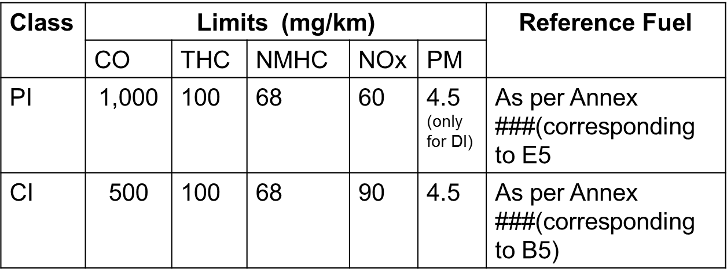

Table B.1.-6: Principal performance requirements.

Note:

DF for PI engine vehicles for CO is 1.3, THC is 1.3, NMHC is 1.3, NOx is 1.3 and PM is 1.0.

DF for CI engine vehicles for CO is 1.3, THC is 1.1, NMHC is 1.1, NOx is 1.1 and PM is 1.0. ]

7.3 Alternative performance requirements

The gaseous emissions for each class of vehicle set out in point 3. of section B.1., obtained when tested in accordance with the applicable test cycle specified in Annex B.5.14., shall not exceed the pollutant emission limit values specified in table B.1.-7, as per the Alternate chosen by the Contracting Party.

[

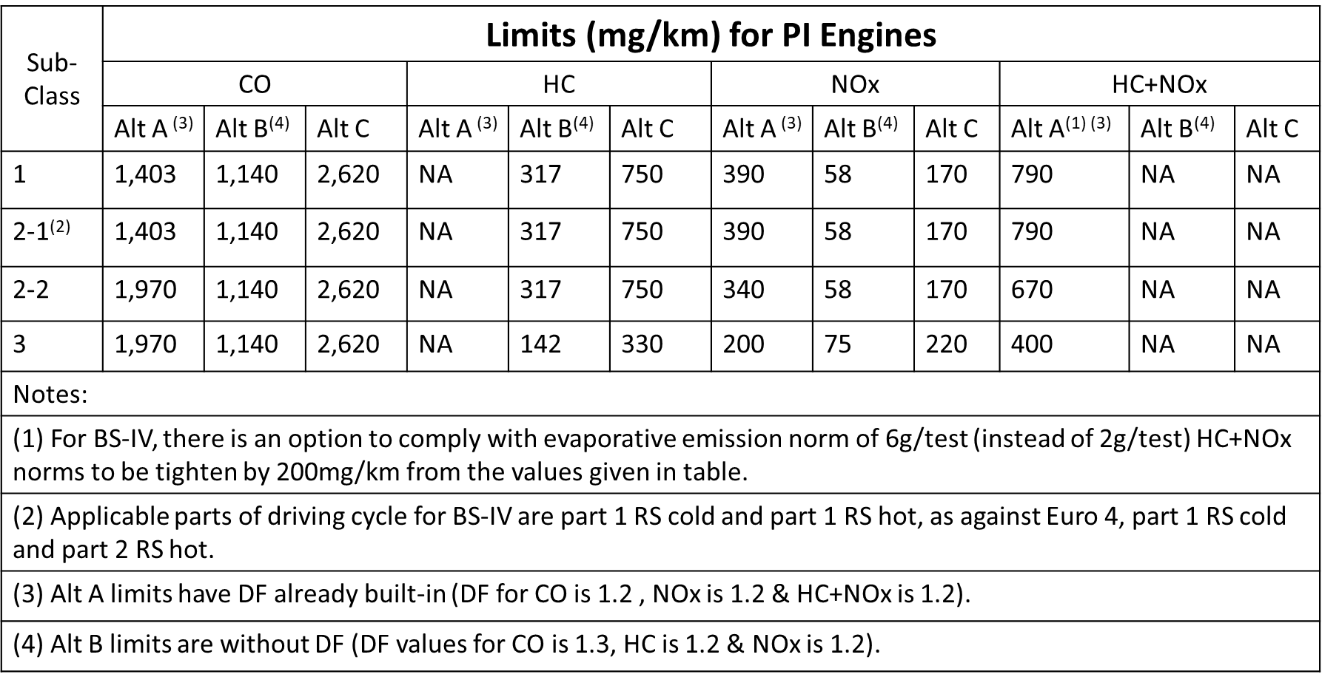]

Table B.1.-7: Alternate performance requirements.

## B.2. Text of the regulation, Test Type I, Exhaust Emissions after Cold Start

### Introduction

* 1. This section provides a harmonised method for the determination of the levels of gaseous pollutant emissions and particulate matter collected at the tailpipe, the emissions of carbon dioxide and is referred to in Annex B.4. to determine the energy efficiency in terms of fuel consumption of the vehicle types within the scope of this GTR that are representative for real world vehicle operation.
  2. The results may form the basis for limiting gaseous pollutants, to report carbon dioxide and the energy efficiency of the vehicle in terms of fuel consumption by the manufacturer within the environmental performance approval procedures in a robust and harmonised way.

1. General Requirements
   1. The components liable to affect the emission of gaseous pollutants, carbon dioxide emissions and affecting the energy efficiency of the vehicle shall be so designed, constructed and assembled as to enable the vehicle in normal use, despite the vibration to which it may be subjected, to comply with the provisions of this GTR.

Note 1: The symbols used in sections B.2., B.3. and B.4. are summarised in Annex B.5.1.

1. Test Conditions
   1. Test room

The test room with the chassis dynamometer and the gas sample collection device shall have a temperature of 25± 5 °C. The room temperature shall be measured in the vicinity of the vehicle cooling blower (fan) before and after the type I test.

The absolute humidity (Ha) of either the air in the test cell or the intake air of the engine shall be such that:5.5 ≤ Ha ≤ 12.2 (g H2O/kg dry air).

* 1. WMTC, test cycle parts

The WMTC test cycle (vehicle speed patterns) for type I, VII and VIII environmental tests consist of up to three parts as set out in Annex B.5.14. Depending on the vehicle classification in terms of engine displacement and maximum design vehicle speed in accordance with point 3. of section B.1., the following WMTC test cycle parts in Table B.2.-1 shall be run:

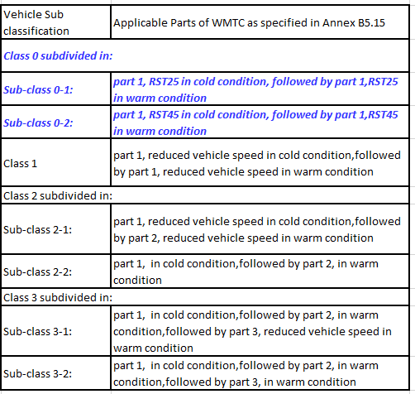

* 1. Specification of the reference fuel

The appropriate reference fuels as specified in Annex B.5.2. shall be used for conducting test type I.

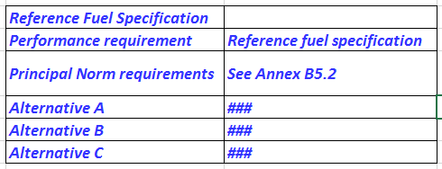

Principal norms for Type I test shall be with E0 or E5 reference fuel for gasoline vehicles. For alternate norms, regional reference fuels used for Type I test by contracting parties may be used.

* 1. Type I test procedure
     1. Driver

The test driver shall have a mass of 75 kg ± 5 kg.

* + 1. Test bench specifications and settings
       1. The chassis dynamometer shall have a single roller in the transverse plane with a diameter of at least 400 mm, alternatively, a chassis dynamometer equipped with two rollers on a single axle in the transverse plane (one for each wheel) is permitted when testing two-wheeled vehicles with twinned wheels.
       2. The dynamometer shall be equipped with a roller revolution counter for measuring actual distance travelled.
       3. Dynamometer flywheels or other means shall be used to simulate the inertia specified in point 4.2.2.
       4. The dynamometer rollers shall be clean, dry and free from anything which might cause the tyre(s) to slip.
       5. Cooling fan specifications as follows:
          1. Throughout the test, a variable-rotation speed cooling blower (fan) shall be positioned in front of the vehicle so as to direct the cooling air onto it in a manner that simulates actual operating conditions. The blower rotation speed shall be such that, within the operating range of 10 to 50 km/h, the linear velocity of the air at the blower outlet is within ±5 km/h of the corresponding roller speed (from which the actual vehicle speed is calculated). At the range of over 50 km/h, the linear velocity of the air shall be within ±10 percent. At a desired vehicle speed of less than 10 km/h, air velocity may be zero.
          2. The air velocity referred to in point 3.4.2.5.1. shall be determined as an averaged value of nine measuring points which are located at the centre of each rectangle dividing the whole of the blower outlet into nine areas (dividing both horizontal and vertical sides of the blower outlet into three equal parts). The value at each of the nine points shall be within 10 percent of the average of the nine values.
          3. The blower outlet shall have a cross-section area of at least 0.4 m2 and the bottom of the blower outlet shall be between 5 and 20 cm above floor level. The blower outlet shall be perpendicular to the longitudinal axis of the vehicle, between 30 and 45 cm in front of its front wheel. The device used to measure the linear velocity of the air shall be located at between 0 and 20 cm from the air outlet.
       6. The detailed requirements regarding the chassis dynamometer are listed in Annex B.5.7.
    2. Exhaust gas measurement system
       1. [The gas-collection device shall be a closed-type device that can collect all exhaust gases at the vehicle exhaust outlets on condition that it satisfies the backpressure condition of ± 1.225 Pa (125 mm H2O). An open system may be used instead if it is confirmed that all the exhaust gases are collected. The gas collection shall be such that there is no condensation which could appreciably modify the nature of exhaust gases at the test temperature. An example of a gas-collection device is illustrated in Figure B.2.-1 a and Figure B.2.-1 b:

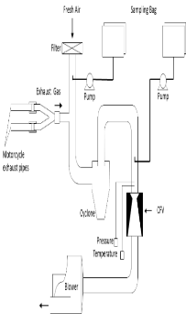

Figure B.2.-1 a. An example of closed-type system for sampling gases and measuring their volume

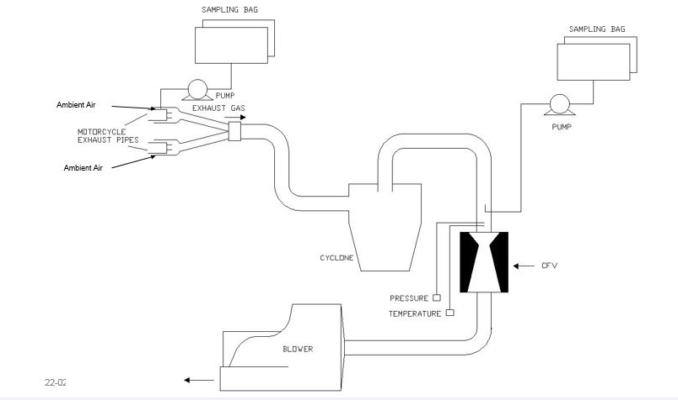

Figure B.2.-1 b. An example of open-type system for sampling gases and measuring their volume]

* + - 1. A connecting tube shall be placed between the device and the exhaust gas sampling system. This tube and the device shall be made of stainless steel, or of some other material which does not affect the composition of the gases collected and which withstands the temperature of these gases.
      2. A heat exchanger capable of limiting the temperature variation of the diluted gases in the pump intake to ± 5 °C shall be in operation throughout the test. This exchanger shall be equipped with a preheating system capable of bringing the exchanger to its operating temperature (with the tolerance of ± 5 °C before the test begins.
      3. A positive displacement pump shall be used to draw in the diluted exhaust mixture. This pump shall be equipped with a motor with several strictly controlled uniform rotation speeds. The pump capacity shall be large enough to ensure the intake of the exhaust gases. A device using a critical-flow venturi (CFV) may also be used.
      4. A device (T) shall be used for the continuous recording of the temperature of the diluted exhaust mixture entering the pump.
      5. Two gauges shall be used, the first to ensure the pressure depression of the dilute exhaust mixture entering the pump relative to atmospheric pressure, and the second to measure the dynamic pressure variation of the positive displacement pump.
      6. A probe shall be located near to, but outside, the gas-collecting device, to collect samples of the dilution air stream through a pump, a filter and a flow meter at constant flow rates throughout the test.
      7. A sample probe pointed upstream into the dilute exhaust mixture flow, upstream of the positive displacement pump, shall be used to collect samples of the dilute exhaust mixture through a pump, a filter and a flow meter at constant flow rates throughout the test. The minimum sample flow rate in the sampling devices shown in Figure B.2.-1 and in point 3.4.3.7. shall be at least 150 litre/hour.
      8. Three-way valves shall be used on the sampling system described in points 3.4.3.7. and 3.4.3.8. to direct the samples either to their respective bags or to the outside throughout the test.
      9. Gas-tight collection bags
         1. For dilution air and dilute exhaust mixture the collection bags shall be of sufficient capacity not to impede normal sample flow and shall not change the nature of the pollutants concerned.
         2. The bags shall have an automatic self-locking device and shall be easily and tightly fastened either to the sampling system or the analysing system at the end of the test.
      10. A revolution counter shall be used to count the revolutions of the positive displacement pump throughout the test.

Note 2: Attention shall be paid to the connecting method and the material or configuration of the connecting parts, because each section (e.g. the adapter and the coupler) of the sampling system can become very hot. If the measurement cannot be performed normally due to heat damage to the sampling system, an auxiliary cooling device may be used as long as the exhaust gases are not affected.

Note 3: With open type devices, there is a risk of incomplete gas collection and gas leakage into the test cell. There shall be no leakage throughout the sampling period.

Note 4: If a constant volume sampler (CVS) flow rate is used throughout the test cycle that includes low and high vehicle speeds all in one (i.e. part 1, 2 and 3 cycles), special attention shall be paid to the higher risk of water condensation in the high vehicle speed range.

* + - 1. Particulate mass emissions measurement equipment
         1. Specification

System overview

The particulate sampling unit shall consist of a sampling probe (PSP) located in the dilution tunnel, a particle transfer tube (PTT), a filter holder(s) (FH), pump(s), flow rate regulators and measuring units. See Figures A5/11 and A5/12.

A particle size pre-classifier (PCF) (e.g. cyclone or impactor) may be used. In such case, it is recommended that it is employed upstream of the filter holder. However, a sampling probe, acting as an appropriate size classification device such as that shown in Figure A5/13, is acceptable.

General Requirements

The sampling probe for the test gas flow for particulates shall be so arranged within the dilution tunnel that a representative sample gas flow can be taken from the homogeneous air/exhaust mixture and shall be upstream of a heat exchanger (if any).

The particulate sample flow rate shall be proportional to the total mass flow of diluted exhaust gas in the dilution tunnel to within a tolerance of ±5 per cent of the particulate sample flow rate. The verification of the proportionality of the PM sampling should be made during the commissioning of the system and as required by the responsible authority.

The sampled dilute exhaust gas shall be maintained at a temperature above 293 K (20 °C) and below 325 K (52 °C) within 20 cm upstream or downstream of the particulate filter face. Heating or insulation of components of the PM sampling system to achieve this is permissible. In the event that the 52 °C limit is exceeded during a test where periodic regeneration event does not occur, the CVS flow rate should be increased or double dilution should be applied (assuming that the CVS flow rate is already sufficient so as not to cause condensation within the CVS, sample bags or analytical system).

The particulate sample shall be collected on a single filter per cycle part applicable according to vehicle class. Weighting factor for PM to be same as applied for all gaseous pollutants. All parts of the dilution system and the sampling system from the exhaust pipe up to the filter holder, which are in contact with raw and diluted exhaust gas, shall be designed to minimise deposition or alteration of the particulates. All parts shall be made of electrically conductive materials that do not react with exhaust gas components, and shall be electrically grounded to prevent electrostatic effects.

If it is not possible to compensate for variations in the flow rate, provision shall be made for a heat exchanger and a temperature control device as specified in Annex B.5.8. so as to ensure that the flow rate in the system is constant and the sampling rate accordingly proportional.

Temperatures required for the PM mass measurement shall be measured with an accuracy of ±1 °C and a response time (t10-t90 ) of fifteen seconds or less.

The PM sample flow from the dilution tunnel shall be measured with an accuracy of ±2.5 per cent of reading or ±1.5 per cent full scale, whichever is the least. The above accuracy of the PM sample flow from the CVS tunnel is also applicable where double dilution is used. Consequently, the measurement and control of the secondary dilution air flow and diluted exhaust flow rates through the PM filter must be of a higher accuracy. All data channels required for the PM mass measurement shall be logged at a frequency of 1 Hz or faster. Typically, these would include:

(a) Diluted exhaust temperature at the PM filter;

(b) PM sampling flow rate;

(c) PM secondary dilution air flow rate (if secondary dilution is used);

(d) PM secondary dilution air temperature (if secondary dilution is used).

For double dilution systems, the accuracy of the diluted exhaust transferred from the dilution tunnel, in the equation is not measured directly but determined by differential flow measurement:

Vep=Vset- Vssd

where:

Vep: is the volume of diluted exhaust gas flowing through particulate filter under standard conditions;

Vset: is the volume of the double diluted exhaust gas passing through the particulate collection filters;

Vssd: is the volume of secondary dilution air.

The accuracy of the flow meters used for the measurement and control of the double diluted exhaust passing through the particulate collection filters and for the measurement/control of secondary dilution air shall be sufficient so that the differential volume [(symbol)] shall meet the accuracy and proportional sampling requirements specified for single dilution. The requirement that no condensation of the exhaust gas should occur in the CVS dilution tunnel, diluted exhaust flow rate measurement system, CVS bag collection or analysis systems shall also apply in the case of double dilution systems.

Each flow meter used in a particulate sampling and double dilution system shall be subjected to a linearity verification as required by the instrument manufacturer.

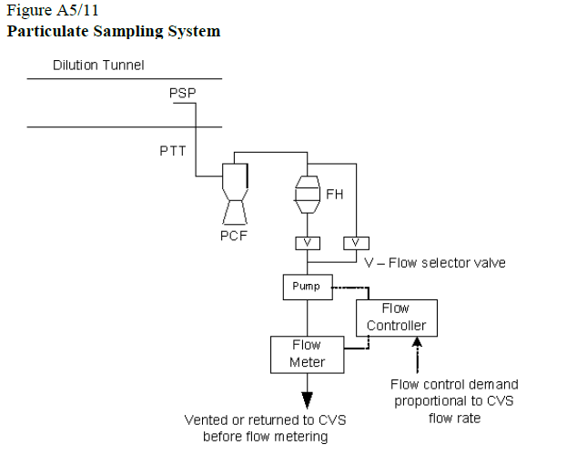

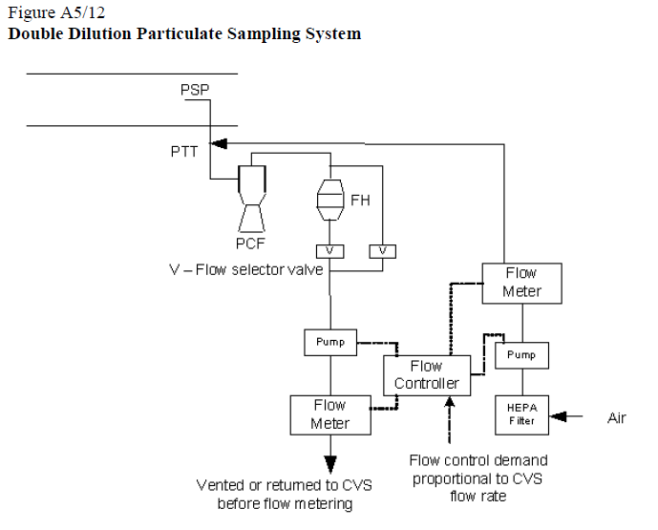

Specific requirements

Particulate Matter (PM) sampling probe

The sample probe shall deliver the particle-size classification performance described in paragraph 4.2.1.3.1.4. below. It is recommended that this performance be achieved by the use of a sharp-edged, open-ended probe facing directly into the direction of flow plus a pre-classifier (cyclone impactor, etc.). An appropriate sampling probe, such as that indicated in Figure A5/13, may alternatively be used provided it achieves the pre-classification performance described in paragraph 4.2.1.3.1.4. below.

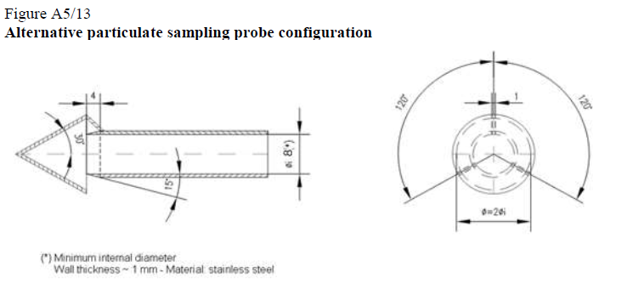

The sample probe shall be installed at least 10 tunnel diameters downstream of the exhaust gas inlet to the tunnel and have an internal diameter of at least 8 mm.

If more than one simultaneous sample is drawn from a single sample probe, the flow drawn from that probe shall be split into identical sub-flows to avoid sampling artefacts.

If multiple probes are used, each probe shall be sharp-edged, open-ended and facing directly into the direction of flow. Probes shall be equally spaced around the central longitudinal axis of the dilution tunnel, with the spacing between probes at least 5 cm.

The distance from the sampling tip to the filter mount shall be at least five probe diameters, but shall not exceed 2,000 mm.

The pre-classifier (e.g. cyclone, impactor, etc.) shall be located upstream of the filter holder assembly. The pre-classifier 50 percent cut point particle diameter shall be between 2.5 µm and 10 µm at the volumetric flow rate selected for sampling particulate mass emissions. The pre-classifier shall allow at least 99 percent of the mass concentration of 1 µm particles entering the pre-classifier to pass through the exit of the pre-classifier at the volumetric flow rate selected for sampling particulate mass emissions. However, a sampling probe, used as an appropriate size-classification device, such as that shown in Figure B.2.-4, is acceptable as an alternative to a separate pre-classifier.

Particle transfer tube (PTT)

Any bends in the PTT shall be smooth and have the largest possible radii.

Secondary dilution

As an option, the sample extracted from the CVS for the purpose of PM measurement may be diluted at a second stage, subject to the following requirements:

1. Secondary dilution air shall be filtered through a medium capable of reducing particles in the most penetrating particle size of the filter material by ≥ 99.95 per cent, or through a HEPA filter of at least class H13 of EN 1822:2009. The dilution air may optionally be charcoal scrubbed before being passed to the HEPA filter. It is recommended that an additional coarse particle filter is situated before the HEPA filter and after the charcoal scrubber, if used.
2. The secondary dilution air should be injected into the PTT as close to the outlet of the diluted exhaust from the dilution tunnel as possible.
3. The residence time from the point of secondary diluted air injection to the filter face shall be at least 0.25 seconds (s), but no longer than five seconds.
4. The diluted exhaust flow extracted from the dilution tunnel shall remain proportional to the CVS flow rate, as required for the single dilution method.
5. If the double diluted PM sample is returned to the CVS, the location of the sample return shall be selected so that it does not interfere with the extraction of other samples from the CVS.

Sample pump and flow meter

The sample gas flow measurement unit shall consist of pumps, gas flow regulators and flow measuring units.

The temperature of the gas flow in the flow meter may not fluctuate by more than ±3 K except

(a) When the PM sampling flow meter has real time monitoring and flow control operating at 1 Hz or faster;

(b) During regeneration tests on vehicles equipped with periodically regenerating after-treatment devices.

In addition, the sample mass flow rate shall remain proportional to the total flow of diluted exhaust gas to within a tolerance of ±5 per cent of the particulate sample mass flow rate. Should the volume of flow change unacceptably as a result of excessive filter loading, the test shall be invalidated. When it is repeated, the rate of flow shall be decreased.

Filter and filter holder

A valve shall be located downstream of the filter in the direction of flow. The valve shall open and close within 1 s of the start and end of test.

It is recommended that the mass collected on the 47mm diameter filter (Pe) is ≥ 20 µg and that the filter loading is maximised in line with the requirements of points 3.4.3.12.1.2.3. and 3.4.3.12.1.3.3.

For a given test, the gas filter face velocity shall be set to a single value within the range 20 cm/s to 105 cm/s and should be set at the start of the test so that 105 cm/s will not be exceeded when the dilution system is being operated with sampling flow proportional to CVS flow rate.

Fluorocarbon coated glass fibre filters or fluorocarbon membrane filters are required.

All filter types shall have a 0.3μm DOP (di-octylphthalate) or PAO (polyalpha-olefin) CS 68649-12-7 or CS 68037-01-4 collection efficiency of at least 99 per cent at a gas filter face velocity of 5.33cm/s measured according to one of the following standards:

(a) U.S.A. Department of Defense Test Method Standard, MIL-STD-282 method 102.8: DOP-Smoke Penetration of Aerosol-Filter Element

(b) U.S.A. Department of Defense Test Method Standard, MIL-STD-282 method 502.1.1: DOP-Smoke Penetration of Gas-Mask Canisters

(c) Institute of Environmental Sciences and Technology, IEST-RPCC021:

Testing HEPA and ULPA Filter Media.

The filter holder assembly shall be of a design that provides an even flow distribution across the filter stain area. The filter shall be round and have a stain area of at least 1075 mm2.

Weighing chamber and analytical balance specifications

Weighing chamber conditions

(a) The temperature of the chamber (or room) in which the particulate filters are conditioned and weighed shall be maintained to within 295 K ± 2 K (22 °C ± 2 °C, 22 °C ± 1 °C if possible) during all filter conditioning and weighing.

(b) Humidity shall be maintained to a dew point of less than 283.5 K (10.5 °C) and a relative humidity of 45 per cent ± 8 per cent.

(c) The levels of ambient contaminants in the chamber (or room) environment that would settle on the particulate filters during their stabilization shall be minimised. Limited deviations from weighing room temperature and humidity specifications will be allowed provided their total duration does not exceed 30 minutes in any one filter conditioning period.

(d) During the weighing operation, no deviations from the specified conditions are permitted.

Analytical balance

The analytical balance used to determine the filter weight shall meet the linearity verification criterion of Table A5/1 below. This implies a precision (standard deviation) of at least 2 μg and a resolution of at least 1 μg. 1 digit = 1 μg).

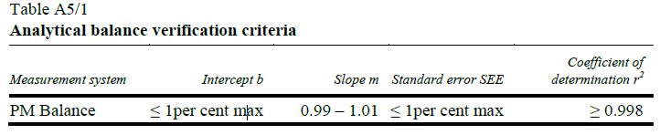

Table A5/1 Analytical balance verification criteria

Elimination of static electricity effects.

The effects of static electricity shall be nullified. This may be achieved by grounding the balance through placement upon an antistatic mat and neutralization of the particulate filters prior to weighing using a polonium neutraliser or a device of similar effect. Alternatively, nullification of static effects may be achieved through equalization of the static charge.

Buoyancy Correction

The sample and reference filter weights shall be corrected for their buoyancy in air. The buoyancy correction is a function of sampling filter density, air density and the density of the balance calibration weight, and does not account for the buoyancy of the PM itself.

If the density of the filter material is not known, the following densities shall be used:

(a) PTFE coated glass fiber filter: 2,300 kg/m3;

(b) PTFE membrane filter: 2,144 kg/m3;

(c) PTFE membrane filter with polymethyl pentene support ring: 920 kg/m3.

For stainless steel calibration weights, a density of 8,000 kg/m³ shall be used. If the material of the calibration weight is different, its density must be known. International Recommendation OIML R 111-1 Edition 2004(E) from International Organization of Legal Metrology on calibration weights should be followed.

The following equation shall be used:

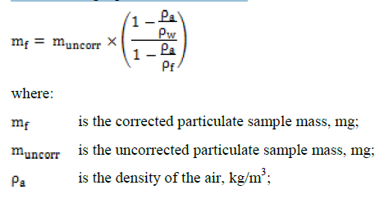

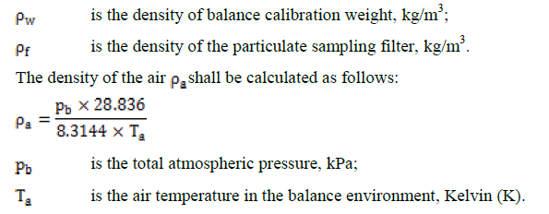

The chamber (or room) environment shall be free of any ambient contaminants (such as dust) that would settle on the particulate filters during their stabilisation.

Limited deviations from weighing room temperature and humidity specifications shall be allowed provided their total duration does not exceed 30 minutes in any one filter conditioning period. The weighing room shall meet the required specifications prior to personal entrance into the weighing room. No deviations from the specified conditions are permitted during the weighing operation.

The effects of static electricity shall be nullified. This may be achieved by grounding the balance through placement on an antistatic mat and neutralisation of the particulate filters prior to weighing using a Polonium neutraliser or a device of similar effect. Alternatively, nullification of static effects may be achieved through equalisation of the static charge.

A test filter shall be removed from the chamber no earlier than an hour before the test begins.

Recommended system description

Figure B.2.-2 is a schematic drawing of the recommended particulate sampling system. Since various configurations can produce equivalent results, exact conformity with this figure is not required. Additional components such as instruments, valves, solenoids, pumps and switches may be used to provide additional information and coordinate the functions of component systems. Further components that are not needed to maintain accuracy with other system configurations may be excluded if their exclusion is based on good engineering judgment.

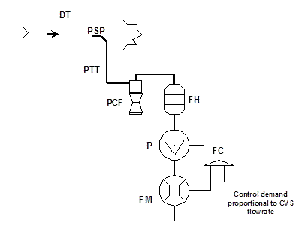

Figure B.2.-2: Particulate sampling system

A sample of the diluted exhaust gas is taken from the full flow dilution tunnel (DT) through the particulate sampling probe (PSP) and the particulate transfer tube (PTT) by means of the pump (P). The sample is passed through the particle size pre-classifier (PCF) and the filter holders (FH) that contain the particulate sampling filters. The flow rate for sampling is set by the flow controller (FC).

* + 1. Driving schedules
       1. Test cycle WMTC

The WMTC test cycles (vehicle speed patterns vs. test time) for the type I test consist of up to three parts, as laid down in Annex B.5.15. The applicable part of WMTC for each sub category shall be as per 3.2 of this section.

* + - 1. Vehicle speed tolerances
         1. The vehicle speed tolerance at any given time on the test cycles prescribed in Annex B.5.14. is defined by upper and lower limits. The upper limit is 3.2 km/h higher than the highest point on the trace within one second of the given time. The lower limit is 3.2 km/h lower than the lowest point on the trace within one second of the given time. Vehicle speed variations greater than the tolerances (such as may occur during gear changes) are acceptable provided they occur for less than two seconds on any occasion. Vehicle speeds lower than those prescribed are acceptable provided the vehicle is operated at maximum available power during such occurrences. Figure B.2.-3 shows the range of acceptable vehicle speed tolerances for typical points.

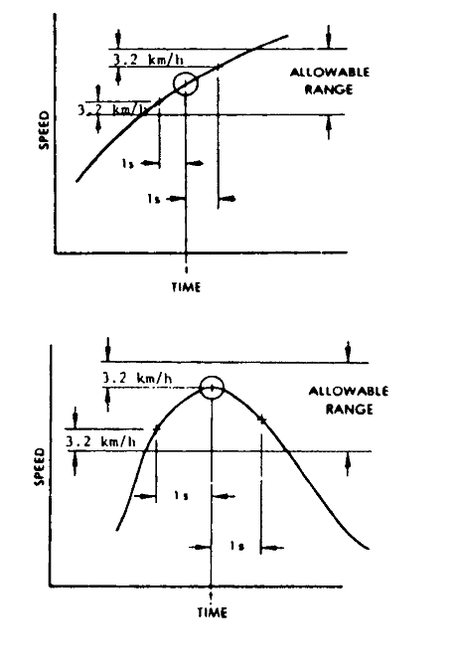

Figure B.2.-3: Drivers trace, allowable range

* + - * 1. If the acceleration capability of the vehicle is not sufficient to carry out the acceleration phases or if the maximum design speed of the vehicle is lower than the prescribed cruising vehicle speed within the prescribed limits of tolerances, the vehicle shall be driven with the throttle fully open until the desired vehicle speed is reached or at the maximum design vehicle speed achievable with fully opened throttle during the time that desired vehicle speed exceeds the maximum design vehicle speed. In both cases, point 3.4.4.2.1. is not applicable. The test cycle shall be carried on normally when desired vehicle speed is again lower than the maximum design speed of the vehicle.
        2. If the period of deceleration is shorter than that prescribed for the corresponding phase, due to the vehicle characteristics, desired vehicle speed shall be restored by a constant vehicle speed or idling period merging into succeeding constant vehicle speed or idling operation. In such cases, point 3.4.4.2.1. is not applicable.
        3. Apart from these exceptions, the deviations of the roller speed (from which the actual vehicle speed is calculated) in comparison to the desired vehicle speed of the cycles shall meet the requirements described in point 3.4.4.2.1. If not, the test results shall not be used for further analysis and the test run shall be repeated.
    1. Gearshift prescriptions for the WMTC prescribed for the test cycles set out in Annex B.5.15. and explained in more detail in Annex B.5.15.
       1. Test vehicles equipped with an automatic transmission
          1. Vehicles equipped with transfer cases, multiple sprockets, etc., shall be tested in the configuration recommended by the manufacturer for street or highway use.
          2. Vehicles equipped with automatic-shift transmissions shall be tested in the predominant mode. The accelerator control shall be used in such a way as to accurately follow the desired vehicle speed trace of the test cycle.

[In addition to testing in predominant mode, based on the information provided by the manufacturer on different operating modes, the test agency will test a vehicle in a selected mode(s) after discussion and mutual agreement between test agency.]

* + - * 1. Idle modes shall be run with automatic transmissions in ‘Drive’ and the wheels braked. For the vehicles fitted with idle start stop option, shall be tested with idle start stop in 'OFF' condition, provided such provision is available in the vehicle. After initial engagement, the selector shall not be operated at any time during the test. Idle modes shall be run with automatic transmissions in ‘Drive’ and the wheels braked.
        2. Automatic transmissions shall shift automatically through the normal sequence of gears. The torque converter clutch, if applicable, shall operate as under real-world conditions.
        3. The deceleration modes shall be run in gear using brakes or throttle as necessary to maintain the desired vehicle speed.
      1. Test vehicles equipped with a semi-automatic transmission
         1. Vehicles equipped with semi-automatic transmissions shall be tested using the gears normally employed for driving, and the gear shift used in accordance with the instructions in the owner's manual.
         2. Idle modes shall be run with semi-automatic transmissions in ‘Drive’ and the wheels braked. For the vehicles fitted with idle start stop option, shall be tested with idle start stop in 'OFF' condition, provided such provision is available in the vehicle. After initial engagement, the selector shall not be operated at any time during the test. Idle modes shall be run with automatic transmissions in ‘Drive’ and the wheels braked.
      2. Test vehicles equipped with manual transmission
         1. Mandatory requirements

Step 1 — Calculation of desired vehicle speeds to shift gear

Upshift desired vehicle speeds (v1→2 and vi→i+1) in km/h during acceleration phases shall be calculated using the following formulae:

Equation B.2.-3:

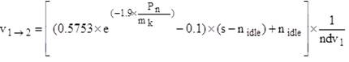

Equation B.2.-4:

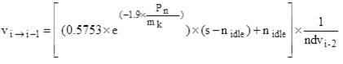

i = 2 to ng -1

where: (Secretariat note: To change mk to mref while re-writing the equations)

‘i’ is the gear number (≥ 2)

‘ng’ is the total number of forward gears

‘Pn’ is the rated power in kW

‘mref’is the reference mass in kg

‘nidle’ is the idling engine speed in min-1

‘s’ is the rated engine speed in min-1

‘ndvi’ is the ratio between engine speed in min-1 and vehicle speed in km/h in gear ‘i’.

Downshift desired vehicle speeds (vi→i-1) in km/h during cruise or deceleration phases in gears 4 (4th gear) to ng shall be calculated using the following formula:

Equation B.2.-5:

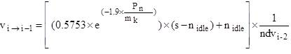

i = 4 to ng

where:

i is the gear number (≥ 4)

ng is the total number of forward gears

Pn is the rated power in kW

mref is the reference mass in kg

nidle is the idling engine speed in min-1

s is the rated engine speed in min-1

ndvi-2 is the ratio between engine speed in min-1 and vehicle speed in km/h in gear i-2

The downshift desired vehicle speed from gear 3 to gear 2 (v 3→2) shall be calculated using the following equation:

Equation B.2.-6:

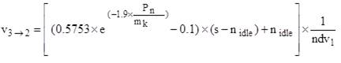

where:

Pn is the rated power in kW

mref is the reference mass in kg

nidle is the idling engine speed in min-1

s is the rated engine speed in min-1

ndv1 is the ratio between engine speed in min-1 and vehicle speed in km/h in gear 1.

The downshift desired vehicle speed from gear 2 to gear 1 (v 2→1) shall be calculated using the following equation:

Equation B.2.-7:



where:

ndv2 is the ratio between engine speed in min-1 and vehicle speed in km/h in gear 2.

Since the cruise phases are defined by the phase indicator, slight vehicle speed increases could occur and it may be appropriate to apply an upshift. The upshift desired vehicle speeds (v1→2, v2→3and vi→i+1) in km/h during cruise phases shall be calculated using the following equations:

Equation B.2.-8:



Equation B.2.-9:

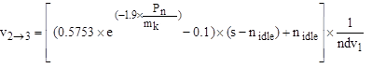

Equation B.2.-10:

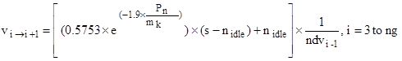

Step 2 — Gear choice for each cycle sample

In order to avoid different interpretations of acceleration, deceleration, cruise and stop phases, corresponding indicators are added to the vehicle speed pattern as integral parts of the cycles (see tables in Annex B.5.15.).

The appropriate gear for each sample shall then be calculated according to the vehicle speed ranges resulting from equations to determine the desired vehicle speeds to shift gears of point 3.4.5.3.1.1. and the phase indicators for the cycle parts appropriate for the test vehicle, as follows:

Gear choice for stop phases:

For the last five seconds of a stop phase, the gear lever shall be set to gear 1 and the clutch shall be disengaged. For the previous part of a stop phase, the gear lever shall be set to neutral or the clutch shall be disengaged.

Gear choice for acceleration phases:

gear 1, if v ≤ v1→2

gear 2, if v1→2 < v ≤ v2→3

gear 3, if v2→3 < v ≤ v3→4

gear 4, if v3→4 < v ≤ v4→5

gear 5, if v4→5 < v ≤ v5→6

gear 6, if v > v5→6

Gear choice for deceleration or cruise phases:

gear 1, if v < v2→1

gear 2, if v < v3→2

gear 3, if v3→2 ≤ v < v4→3

gear 4, if v4→3 ≤ v < v5→4

gear 5, if v5→4 ≤ v < v6→5

gear 6, if v ≥ v4→5

The clutch shall be disengaged, if:

1. the vehicle speed drops below 10 km/h, or
2. the engine speed drops below nidle + 0.03×(s — nidle);
3. there is a risk of engine stalling during cold-start phase.

Step 3 — Corrections according to additional requirements

The gear choice shall be modified according to the following requirements:

(a) no gearshift at a transition from an acceleration phase to a deceleration phase. The gear that was used for the last second of the acceleration phase shall be kept for the following deceleration phase unless the vehicle speed drops below a downshift desired vehicle speed;

(b) no upshifts or downshifts by more than one gear, except from gear 2 to neutral during decelerations down to stop;

(c) upshifts or downshifts for up to four seconds are replaced by the gear before, if the gears before and after are identical, e.g. 2 3 3 3 2 shall be replaced by 2 2 2 2 2, and 4 3 3 3 3 4 shall be replaced by 4 4 4 4 4 4.

In the cases of consecutive circumstances, the gear used longer takes over, e.g. 2 2 2 3 3 3 2 2 2 2 3 3 3 will be replaced by 2 2 2 2 2 2 2 2 2 2 3 3 3

If used for the same time, a series of succeeding gears shall take precedence over a series of preceding gears, e.g. 2 2 2 3 3 3 2 2 2 3 3 3 will be replaced by 2 2 2 2 2 2 2 2 2 3 3 3;

(d) no downshift during an acceleration phase.

* + - * 1. Optional provisions

The gear choice may be modified according to the following provisions:

The use of gears lower than those determined by the requirements described in point 3.4.5.2.1. is permitted in any cycle phase. Manufacturers’ recommendations for gear use shall be followed if they do not result in gears higher than determined by the requirements of point 3.4.5.2.1.

* + - * 1. Optional provisions

Note 5: The calculation programme to be found on the UN website at the following URL may be used as an aid for the gear selection:

<http://live.unece.org/trans/main/wp29/wp29wgs/wp29grpe/wmtc.html>

Explanations of the approach and the gearshift strategy and a calculation example are given in Annex B.5.15.

* + - * 1. Idle modes shall be run with manual transmissions with wheels braked. For the vehicles fitted with idle start stop option, shall be tested with idle start stop in 'OFF' condition, provided such provision is available in the vehicle.
    1. Dynamometer settings

A full description of the chassis dynamometer and instruments shall be provided in accordance with Annex B.5.13. Measurements shall be taken to the accuracies specified in point 3.4.7. The running resistance force for the chassis dynamometer settings can be derived either from on-road coast-down measurements or from a running resistance table, with reference to Annexes B.5.4. or B.5.5. for a vehicle equipped with one wheel on the powered axle and to Annexes B.5.4. or B.5.6. for a vehicle with two wheels on the powered axles in case of twinned wheel vehicles.

* + - 1. Chassis dynamometer setting derived from on-road coast-down measurements

To use this alternative, on-road coast-down measurements shall be carried out as specified in Annex B.5.5. for a vehicle equipped with one wheel on the powered axle and Annex B.5.6. for a vehicle equipped with two wheels on the powered axles in case of twinned wheel vehicles.

(Secretariat note: The Annex numbers above, to check after finalization)

* + - * 1. Requirements for the equipment

The instrumentation for the roller speed (actual vehicle speed), desired vehicle speed and time measurement shall have the accuracies specified in point 3.4.7.

* + - * 1. Inertia mass setting

The equivalent inertia mass mi for the chassis dynamometer shall be the flywheel equivalent inertia mass, mfi, closest to the sum of the mass in running order of the vehicle, the mass of the driver (75 kg). Alternatively, the equivalent inertia mass mi can be derived from Annex B.5.4.

If the reference mass mref cannot be equalised to the flywheel equivalent inertia mass mi, to make the target running resistance force F* equal to the running resistance force FE (which is to be set to the chassis dynamometer), the corrected coast-down time ΔTE may be adjusted in accordance with the total mass ratio of the target coast-down time ΔTroad in the following sequence:

Equation B.2.-11:



Equation B.2.-12:



Equation B.2.-13:



Equation B.2.-14:



with 

where:

mr1 may be measured or calculated, in kilograms, as appropriate. As an alternative, mr1 may be estimated as 4 percent of m.

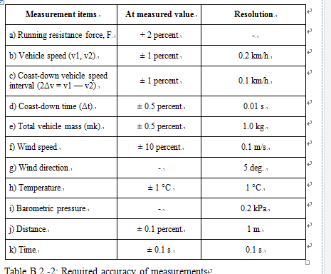

* + - 1. Running resistance force derived from a running resistance table or on road coast down
         1. The chassis dynamometer may be set by the use of the running resistance table instead of the running resistance force obtained by the coast-down method. In this table method, the chassis dynamometer shall be set by the mass in running order regardless of particular vehicle characteristics.

Note 6: Care shall be taken when applying this method to vehicles with extraordinary characteristics.

* + - * 1. The flywheel equivalent inertia mass mfi shall be the equivalent inertia mass mi specified in Annexes B.5.4., B.5.5. or B.5.6. where applicable. The chassis dynamometer shall be set by the rolling resistance of the non-driven wheels (a) and the aero drag coefficient (b) specified in Annex B.5.4., or determined in accordance with the procedures set out in B.5.5. or B.5.6. respectively. (Secretariat note: The Annex numbers above, to check after finalization)
        2. The running resistance force on the chassis dynamometer FE shall be determined using the following equation:

Equation B.2.-15:



* + - * 1. The target running resistance force F* shall be equal to the running resistance force obtained from the running resistance table FT, because the correction for the standard ambient conditions is not necessary.
    1. Measurement accuracies

Measurements shall be taken using equipment that fulfils the accuracy requirements in Table B.2.-2:

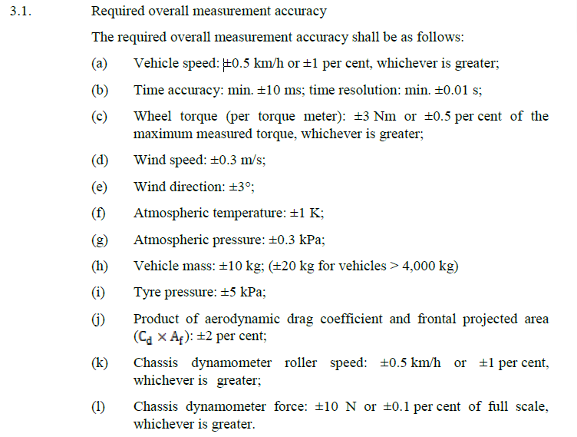

Table B.2.-2: Required accuracy of measurements

1. **Test procedures**
   1. Description of the type I test

The test vehicle shall be subjected, according to its category, to test type I requirements as specified in this point 4 and comply with the requirements set out in Annex B.5.3.

* + 1. Type I test (verifying the average emission of gaseous pollutants, PM for GDI and diesel vehicle, CO2 emissions and fuel consumption in a characteristic driving cycle)
       1. The test shall be carried out by the method described in point 4.2. The gases shall be collected and analysed by the prescribed methods.
       2. Number of tests
          1. The number of tests shall be determined as shown in Figure B.2.-4. Ri1 to Ri3 describe the final measurement results for the first (No 1) test to the third (No 3) test and the gaseous pollutant, carbon dioxide emission, fuel consumption as laid down in Annex B.4. ‘Lx’ represents the limit values L1 to L5 as defined in the emission limits in point B.1.9.
          2. In each test, the masses of the carbon monoxide, hydrocarbons, nitrogen oxides, carbon dioxide and the fuel consumed during the test shall be determined. The mass of particulate matter shall be determined only for vehicles equipped with a CI or a direct injected PI combustion engine.

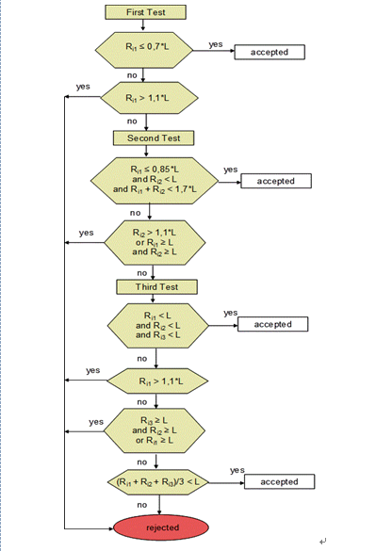

Figure B.2.-4: Flowchart for the number of type I tests

Exhaust emissions may be sampled during preparation tests for type I testing or during verification tests for test types IV, VII or VIII but the results of these tests shall not be used for the purpose of exhaust emission [approval / certification] to satisfy the requirements set out in point 4.1.1.2.2.

* 1. Type I test
     1. Introduction
        1. The type I test consists of prescribed sequences of dynamometer preparation, fuelling, parking, and operating conditions.
        2. The test is designed to determine hydrocarbon, carbon monoxide, oxides of nitrogen, carbon dioxide, particulate matter mass emissions if applicable and energy efficiency measurements such as fuel consumption while simulating real-world operation. The test consists of engine start-ups and vehicle operation on a chassis dynamometer, through a specified driving cycle. A proportional part of the diluted exhaust emissions is collected continuously for subsequent analysis, using a constant volume (variable dilution) sampler (CVS).
        3. Except in cases of component malfunction or failure, all emission-control systems installed on or incorporated in a tested vehicle shall be functioning during all procedures.
        4. Background concentrations are measured for all emission constituents for which emissions measurements are taken. For exhaust testing, this requires sampling and analysis of the dilution air.
        5. Background particulate mass measurement

The particulate background level of the dilution air may be determined by passing filtered dilution air through the particulate filter. This shall be drawn from the same point as the particulate matter sample, if a particulate mass measurement is applicable according to point 4.1.1.2.2. One measurement may be performed prior to or after the test. Particulate mass measurements may be corrected by subtracting the background contribution from the dilution system. The permissible background contribution shall be ≤ 1 mg/km (or equivalent mass on the filter). If the background contribution exceeds this level, the default figure of 1 mg/km (or equivalent mass on the filter) shall be used. Where subtraction of the background contribution gives a negative result, the particulate mass result shall be considered to be zero.

* + 1. Dynamometer settings and verification
       1. Test vehicle preparation

The test vehicle shall comply with the requirements set out in Annex B.5.3.

* + - * 1. The manufacturer shall provide additional fittings and adapters, as required to accommodate a fuel drain at the lowest point possible in the tanks as installed on the vehicle, and to provide for exhaust sample collection.
        2. The tyre pressures shall be adjusted to the manufacturer’s specifications to the satisfaction of the technical service or so that the speed of the vehicle during the road test and the vehicle speed obtained on the chassis dynamometer are equal.
        3. The test vehicle shall be warmed up on the chassis dynamometer to the same condition as it was during the road test.
      1. Chassis dynamometer preparation, if settings are derived from on-road coast-down measurements:

Before the test, the chassis dynamometer shall be appropriately warmed up to the stabilised frictional force Ff. The load on the chassis dynamometer FE is, in view of its construction, composed of the total friction loss Ff, which is the sum of the chassis dynamometer rotating frictional resistance, the tyre rolling resistance, the frictional resistance of the rotating parts in the powertrain of the vehicle and the braking force of the power absorbing unit (pau) Fpau, as in the following equation:

Equation B.2.-16:



The target running resistance force F* derived from Annex B.5.4. and; for a vehicle equipped with one wheel on the powered axle Annex B.5.5. or for a vehicle with two or more wheels on the powered axles Annex B.5.6., shall be reproduced on the chassis dynamometer in accordance with the vehicle speed, i.e.:

Equation B.2.-17



The total friction loss Ff on the chassis dynamometer shall be measured by the method in point 4.2.2.2.1. or 4.2.2.2.2.

* + - * 1. Motoring by chassis dynamometer

This method applies only to chassis dynamometers capable of driving an vehicle. The test vehicle shall be driven steadily by the chassis dynamometer at the reference vehicle speed v0 with the drive train engaged and the clutch disengaged. The total friction loss Ff (v0) at the reference vehicle speed v0 is given by the chassis dynamometer force.

* + - * 1. Coast-down without absorption

The method for measuring the coast-down time is the coast-down method for the measurement of the total friction loss Ff. The vehicle coast-down shall be performed on the chassis dynamometer by the procedure described in Annexes B.5.4. and B.5.5. for a vehicle equipped with one wheel on the powered axle and Annexes B.5.4. and B.5.6. for a vehicle equipped with two or more wheels on the powered axles, with zero chassis dynamometer absorption. The coast-down time Δti corresponding to the reference vehicle speed v0 shall be measured. The measurement shall be carried out at least three times, and the mean coast-down time  shall be calculated using the following equation:

Equation B.2.-18:



* + - * 1. Total friction loss

The total friction loss Ff(v0) at the reference vehicle speed v0 is calculated using the following equation:

Equation B.2.-19:



* + - * 1. Calculation of power-absorption unit force

The force Fpau(v0) to be absorbed by the chassis dynamometer at the reference vehicle speed v0 is calculated by subtracting Ff(v0) from the target running resistance force F*(v0) as shown in the following equation:

Equation B.2.-20:



* + - * 1. Chassis dynamometer setting

Depending on its type, the chassis dynamometer shall be set by one of the methods described in points 4.2.2.2.5.1. to 4.2.2.2.5.4. The chosen setting shall be applied to the pollutant and CO2 emission measurements as well as fuel consumption laid down in Annex B.4.

Chassis dynamometer with polygonal function

In the case of a chassis dynamometer with polygonal function, in which the absorption characteristics are determined by load values at several specified vehicle speed points, at least three specified vehicle speeds, including the reference vehicle speed, shall be chosen as the setting points. At each setting point, the chassis dynamometer shall be set to the value Fpau (vj) obtained in point 4.2.2.2.4.

Chassis dynamometer with coefficient control

In the case of a chassis dynamometer with coefficient control, in which the absorption characteristics are determined by given coefficients of a polynomial function, the value of Fpau (vj) at each specified vehicle speed shall be calculated by the procedure in point 4.2.2.2.

Assuming the load characteristics to be:

Equation B.2.-21:



where:

the coefficients a, b and c shall be determined by the polynomial regression method.

The chassis dynamometer shall be set to the coefficients a, b and c obtained by the polynomial regression method.

Chassis dynamometer with F* polygonal digital setter

In the case of a chassis dynamometer with a polygonal digital setter, where a central processor unit is incorporated in the system, F*is input directly, and Δti, Ff and Fpau are automatically measured and calculated to set the chassis dynamometer to the target running resistance force:

Equation B.2.-22:



In this case, several points in succession are directly input digitally from the data set of F*j and vj, the coast-down is performed and the coast-down time Δtj is measured. After the coast-down test has been repeated several times, Fpau is automatically calculated and set at vehicle speed intervals of 0.1 km/h, in the following sequence:

Equation B2.-23:



Equation B.2.-24:



Equation B.2.-25:



Chassis dynamometer with f*0, f*2 coefficient digital setter

In the case of a chassis dynamometer with a coefficient digital setter, where a central processor unit is incorporated in the system, the target running resistance force  is automatically set on the chassis dynamometer.

In this case, the coefficients f*0 and f*2 are directly input digitally; the coast-down is performed and the coast-down time Δti is measured. Fpau is automatically calculated and set at vehicle speed intervals of 0.06 km/h, in the following sequence:

Equation B.2.-26:



Equation B.2.-27:



Equation B.2.-28:



* + - * 1. Dynamometer settings verification

Verification test

Immediately after the initial setting, the coast-down time ΔtE on the chassis dynamometer corresponding to the reference vehicle speed (v0) shall be measured by the procedure set out in Annexes B.5.4. and B.5.5. for a vehicle equipped with one wheel on the powered axle and in Annexes B.5.4. and B.5.6. for a vehicle with two or more wheels on the powered axles. The measurement shall be carried out at least three times, and the mean coast-down time ΔtE shall be calculated from the results. The set running resistance force at the reference vehicle speed, FE (v0) on the chassis dynamometer is calculated by the following equation:

Equation B.2.-29:



Calculation of setting error

The setting error ε is calculated by the following equation:

Equation B.2.-30:



The chassis dynamometer shall be readjusted if the setting error does not satisfy the following criteria:

ε ≤ 2 percent for v0≥ 50 km/h

ε≤ 3 percent for 30 km/h ≤ v0< 50 km/h

ε ≤ 10 percent for v0< 30 km/h

The procedure in points 4.2.2.2.6.1. to 4.2.2.2.6.2. shall be repeated until the setting error satisfies the criteria. The chassis dynamometer setting and the observed errors shall be recorded. Template record forms are provided in the template in accordance with Annex B.5.14.

* + - 1. Chassis dynamometer preparation, if settings are derived from a running resistance table
         1. The specified vehicle speed for the chassis dynamometer

The running resistance on the chassis dynamometer shall be verified at the specified vehicle speed v. At least four specified vehicle speeds shall be verified. The range of specified vehicle speed points (the interval between the maximum and minimum points) shall extend either side of the reference vehicle speed or the reference vehicle speed range, if there is more than one reference vehicle speed, by at least Δv, as defined in Annex B.5.4. and B.5.5. for a vehicle equipped with one wheel on the powered axle and in Annex B.5.4. and B.5.6. for a vehicle with two or more wheels on the powered axles. The specified vehicle speed points, including the reference vehicle speed points, shall be at regular intervals of no more than 20 km/h apart.

* + - * 1. Verification of chassis dynamometer

Immediately after the initial setting, the coast-down time on the chassis dynamometer corresponding to the specified vehicle speed shall be measured. The vehicle shall not be set up on the chassis dynamometer during the coast-down time measurement. The coast-down time measurement shall start when the chassis dynamometer vehicle speed exceeds the maximum vehicle speed of the test cycle.

The measurement shall be carried out at least three times, and the mean coast-down time ΔtE shall be calculated from the results.

The set running resistance force FE(vj) at the specified vehicle speed on the chassis dynamometer is calculated using the following equation:

Equation B.2.-31:



The setting error ε at the specified vehicle speed is calculated using the following equation:

Equation B.2.-32:



The chassis dynamometer shall be readjusted if the setting error does not satisfy the following criteria:

ε ≤ 2 percent for v ≥ 50 km/h

ε≤ 3 percent for 30 km/h ≤ v < 50 km/h

ε≤ 10 percent for v < 30 km/h

The procedure described in points 4.2.2.3.2.1. to 4.2.2.3.2.5. shall be repeated until the setting error satisfies the criteria. The chassis dynamometer setting and the observed errors shall be recorded.

* + - 1. The chassis dynamometer system shall comply with the calibration and verification methods laid down in Annex B.5.6.
    1. Calibration of analysers
       1. Analyzer calibration procedures

Each analyser shall be calibrated as specified by the instrument manufacturer

or at least as often as described in Table A5/3.

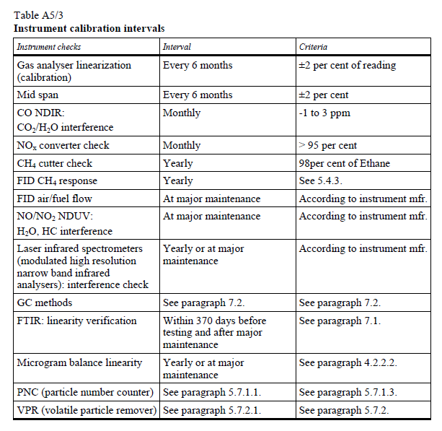

Non-dispersive infrared absorption analysers shall be checked at the same intervals using nitrogen/ CO and nitrogen/ CO2 mixtures in nominal concentrations equal to 10, 40, 60, 85 and 90 percent of full scale.

* + - 1. Each normally used operating range shall be linearized by the following procedure:
         1. The analyser linearization curve shall be established by at least five calibration points spaced as uniformly as possible. The nominal concentration of the calibration gas of the highest concentration shall be not less than 80 per cent of the full scale.
         2. The calibration gas concentration required may be obtained by means of a gas divider, diluting with purified N2 or with purified synthetic air.
         3. The linearization curve shall be calculated by the least squares method. If the resulting polynomial degree is greater than 3, the number of calibration points shall be at least equal to this polynomial degree plus 2.
         4. The linearization curve shall not differ by more than ±2 per cent from the nominal value of each calibration gas.
         5. From the trace of the linearization curve and the linearization points, it is possible to verify that the calibration has been carried out correctly. The different characteristic parameters of the analyser shall be indicated, particularly:

(a) Scale;

(b) Sensitivity;

(c) Zero point;

(d) Date of the linearization.

* + - * 1. If it can be shown to the satisfaction of the responsible authority that alternative technologies (e.g. computer, electronically controlled range switch, etc.) can give equivalent accuracy, these alternatives may be used.
      1. Analyser zero and calibration verification procedure
         1. Each normally used operating range shall be checked prior to each analysis in accordance with the following subparagraphs.

The calibration shall be checked by use of a zero gas and by use of a calibration gas according to Annex 6, paragraph 1.2.14.2.3.

After testing, zero gas and the same calibration gas shall be used for rechecking according to Annex 6, paragraph 1.2.14.2.4.

* + - 1. FID hydrocarbon response check procedure
         1. Detector response optimisation

The FID shall be adjusted as specified by the instrument manufacturer. Propane in air should be used on the most common operating range.

* + - * 1. Calibration of the HC analyser

The analyser shall be calibrated using propane in air and purified synthetic

air. A calibration curve as described in paragraph 5.2.2. [of this annex] shall be

established.

* + - * 1. Response factors of different hydrocarbons and recommended limits

The response factor (Rf), for a particular hydrocarbon compound is the ratio of the FID C1 reading to the gas cylinder concentration, expressed as ppm C1. The concentration of the test gas shall be at a level to give a response of approximately 80 per cent of full-scale deflection, for the operating range. The concentration shall be known to an accuracy of ±2 per cent in reference to a gravimetric standard expressed in volume. In addition, the gas cylinder shall be pre-conditioned for 24 hours at a temperature between 293 K and 303 K (20 and 30 °C).

Response factors shall be determined when introducing an analyser into service and thereafter at major service intervals. The test gases to be used and the recommended response factors are:

Methane and purified air: 1.00 < Rf < 1.15 or 1.00 < Rf < 1.05 for NG/biomethane-fuelled vehicles

Propylene and purified air: 0.90 < Rf < 1.00

Toluene and purified air: 0.90 < Rf < 1.00

These are relative to a response factor (Rf) of 1.00 for propane and purified air.

* + - * 1. NOx converter efficiency test procedure

Using the test set up as shown in Figure A5/15 and the procedure described below, the efficiency of converters for the conversion of NO2 into NO shall be tested by means of an ozonator as follows:

The analyser shall be calibrated in the most common operating range following the manufacturer's specifications using zero and calibration gas (the NO content of which shall amount to approximately 80 per cent of the operating range and the NO2 concentration of the gas mixture shall be less than 5 per cent of the NO concentration). The NOx analyser shall be in the NO mode so that the calibration gas does not pass through the converter. The indicated concentration shall be recorded.

Via a T-fitting, oxygen or synthetic air shall be added continuously to the calibration gas flow until the concentration indicated is approximately 10 per cent less than the indicated calibration concentration given in paragraph 4.2.3.4.4.1.1 above. The indicated concentration (c) shall be recorded. The ozonator shall be kept deactivated throughout this process.

The ozonator shall now be activated to generate enough ozone to bring the NO concentration down to 20 per cent (minimum 10 per cent) of the calibration concentration given in paragraph 4.2.3.4.4.1.1 above. The indicated concentration (d) shall be recorded.\

The NOx analyser shall then be switched to the NOx mode, whereby the gas mixture (consisting of NO, NO2, O2 and N2) now passes through the converter. The indicated concentration (a) shall be recorded.

The ozonator shall now be deactivated. The mixture of gases described in paragraph 4.2.3.4.4.1.2 above shall pass through the converter into the detector. The indicated concentration (b) shall be recorded.

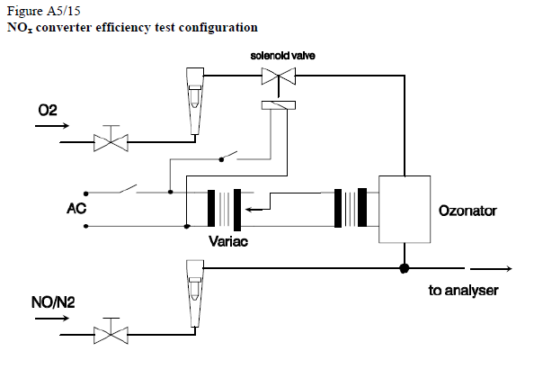

With the ozonator deactivated, the flow of oxygen or synthetic air shall be shut off. The NO2 reading of the analyser shall then be no more than 5 per cent above the figure given in paragraph 4.2.3.4.4.1.1 above.

The efficiency of the NOx converter shall be calculated using the concentrations a, b, c and d determined in paragraphs 4.2.3.4.4.1.2 through 4.2.3.4.4.1.5 above as follows:



The efficiency of the converter shall not be less than 95 per cent. The efficiency of the converter shall be tested in the frequency defined in Table A5/3.

* + - 1. Calibration of the microgram balance

The calibration of the microgram balance used for particulate filter weighing shall be traceable to a national or international standard. The balance shall comply with the linearity requirements given in paragraph 4.2.2.2 of this annex. The linearity verification shall be performed at least every 12 months or whenever a system repair or change is made that could influence the calibration.

Calibration and validation of the particle sampling system

Examples of calibration/validation methods are available at: http://www.unece.org/trans/main/wp29/wp29wgs/wp29grpe/pmpFCP.html.

* + - * 1. Flow meter calibration

The technical service shall check that a calibration certificate has been issued for the flow meter demonstrating compliance with a traceable standard within a 12-month period prior to the test, or since any repair or change which could influence calibration.

* + - * 1. Microbalance calibration

The technical service shall check that a calibration certificate has been issued for the microbalance demonstrating compliance with a traceable standard within a 12-month period prior to the test.

* + - * 1. Reference filter weighing

To determine the specific reference filter weights, at least two unused reference filters shall be weighed within eight hours of, but preferably at the same time as, the sample filter weighing. Reference filters shall be of the same size and material as the sample filter.

If the specific weight of any reference filter changes by more than ± 5 µg between sample filter weighings, the sample filter and reference filters shall be reconditioned in the weighing room and then reweighed.

This shall be based on a comparison of the specific weight of the reference filter and the rolling average of that filter’s specific weights.

The rolling average shall be calculated from the specific weights collected in the period since the reference filters were placed in the weighing room. The averaging period shall be between one day and 30 days.

Multiple reconditioning and re-weighings of the sample and reference filters are permitted up to 80 hours after the measurement of gases from the emissions test.

If, within this period, more than half the reference filters meet the ± 5 µg criterion, the sample filter weighing can be considered valid.

If, at the end of this period, two reference filters are used and one filter fails to meet the ± 5 µg criterion, the sample filter weighing may be considered valid provided that the sum of the absolute differences between specific and rolling averages from the two reference filters is no more than 10 µg.

If fewer than half of the reference filters meet the ± 5 µg criterion, the sample filter shall be discarded and the emissions test repeated. All reference filters shall be discarded and replaced within 48 hours.

In all other cases, reference filters shall be replaced at least every 30 days and in such a manner that no sample filter is weighed without comparison with a reference filter that has been in the weighing room for at least one day.

If the weighing room stability criteria outlined in point 3.4.3.12.1.3.4. are not met but the reference filter weighings meet the criteria listed in point 4.2.3.5.3., the vehicle manufacturer has the option of accepting the sample filter weights or voiding the tests, fixing the weighing room control system and re-running the test.

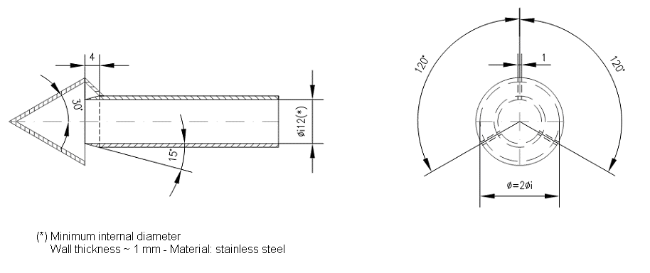

Figure B.2.-4: Particulate sampling probe configuration

* + - 1. Reference gases
         1. Pure gases

The following pure gases shall be available, if necessary, for calibration and operation:

Purified nitrogen: (purity: ≤ 1 ppm C1, ≤ 1 ppm CO, ≤ 400 ppm CO2, ≤ 0.1 ppm NO);

Purified synthetic air: (purity: ≤ 1 ppm C1, ≤ 1 ppm CO, ≤ 400 ppm CO2, ≤ 0.1 ppm NO); oxygen content between 18 and 21 percent by volume;

Purified oxygen: (purity > 99.5 percent vol. O2);

Purified hydrogen (and mixture containing helium): (purity ≤ 1 ppm C1, ≤ 400 ppm CO2);

Carbon monoxide: (minimum purity 99.5 percent);

Propane: (minimum purity 99.5 percent).

* + - * 1. Calibration gases

The true concentration of a calibration gas shall be within ±1 per cent of the stated value or as given below. Mixtures of gases having the following compositions shall be available with a bulk gas specification according to paragraphs [4.2.3.6.1 or 4.2.3.6.2] of this annex:

1. C3H8 in synthetic air (see point 4.2.3.6.1 above);
2. CO in nitrogen;
3. CO2 in nitrogen;
4. CH4 in synthetic air
5. NO in Nitrogen (the amount of NO2 contained in this calibration gas shall not exceed 5 percent of the NO content).
6. NO2 in nitrogen (tolerance ±2 per cent);
7. N2O in nitrogen (tolerance ±2 per cent);
8. C2H5OH in synthetic air or nitrogen (tolerance ±2 per cent).

The true concentration of a calibration gas shall be within ± 2 percent of the stated figure.

* + - 1. Calibration and verification of the dilution system

The dilution system shall be calibrated and verified and shall comply with the requirements of Annex B.5.7.

* + 1. Test vehicle preconditioning
       1. The test vehicle shall be moved to the test area and the following operations performed:

- The fuel tanks shall be drained through the drains of the fuel tanks provided and charged with the test fuel requirement as specified in Annex B.5.2. to half the capacity of the tanks.

- The test vehicle shall be placed, either by being driven or pushed, on a dynamometer and operated through the applicable test cycle as specified for the vehicle (sub-)category in Annex B.5.14. The vehicle need not be cold, and may be used to set dynamometer power.

* + - 1. Practice runs over the prescribed driving schedule may be performed at test points, provided an emission sample is not taken, for the purpose of finding the minimum throttle action to maintain the proper vehicle speed-time relationship, or to permit sampling system adjustments.
      2. Within five minutes of completion of preconditioning, the test vehicle shall be removed from the dynamometer and may be driven or pushed to the soak area to be parked. The vehicle shall be stored for between six and 36 hours prior to the cold start type I test or until the engine oil temperature TO or the coolant temperature TC or the sparkplug seat/gasket temperature TP (only for air-cooled engine) equals the air temperature of the soak area within 2 °C.
      3. For the purpose of measuring particulates, between six and 36 hours before testing, the applicable test cycle set out in Annex B.5.14. shall be conducted. The technical details of the applicable test cycle are laid down in Annex B.5.14. and the applicable test cycle shall also be used for vehicle pre-conditioning. Three consecutive cycles shall be driven. The dynamometer setting shall be indicated as in point 3.4.6.
      4. At the request of the manufacturer, vehicles fitted with indirect injection positive-ignition engines may be preconditioned with one Part One, one Part Two and two Part Three driving cycles, if applicable, from the WMTC.

In a test facility where a test on a low particulate emitting vehicle could be contaminated by residue from a previous test on a high particulate emitting vehicle, it is recommended that, in order to pre-condition the sampling equipment, the low particulate emitting vehicle undergo a 20 minute 120 km/h steady state drive cycle or at 70% of the maximum design vehicle speed for vehicles not capable of attaining 120 km/h followed by three consecutive Part Two or Part Three WMTC cycles, if feasible.

After this preconditioning, and before testing, vehicles shall be kept in a room in which the temperature remains relatively constant at 25 ± 5°C. This conditioning shall be carried out for at least six hours and continue until the engine oil temperature and coolant, if any, are within ± 2.0 °C of the temperature of the room.

If the manufacturer so requests, the test shall be carried out not later than 30 hours after the vehicle has been run at its normal temperature.

* + 1. Emissions tests
       1. Engine starting and restarting
          1. The engine shall be started according to the manufacturer’s recommended starting procedures. The test cycle run shall begin when the engine starts.
          2. Test vehicles equipped with automatic chokes shall be operated according to the instructions in the manufacturer’s operating instructions or owner’s manual covering choke-setting and ‘kick-down’ from cold fast idle. In the case of the WMTC set out in Annex B.5.14., the transmission shall be put in gear 15 seconds after the engine is started. If necessary, braking may be employed to keep the drive wheels from turning.
          3. Test vehicles equipped with manual chokes shall be operated according to the manufacturer’s operating instructions or owner’s manual. Where times are provided in the instructions, the point for operation may be specified, within 15 seconds of the recommended time.
          4. The operator may use the choke, throttle, etc. where necessary to keep the engine running.
          5. If the manufacturer’s operating instructions or owner’s manual do not specify a warm engine starting procedure, the engine (automatic and manual choke engines) shall be started by opening the throttle about half way and cranking the engine until it starts.
          6. If, during the cold start, the test vehicle does not start after ten seconds of cranking or ten cycles of the manual starting mechanism, cranking shall cease and the reason for failure to start determined. The revolution counter on the constant volume sampler shall be turned off and the sample solenoid valves placed in the ‘standby’ position during this diagnostic period. In addition, either the CVS blower shall be turned off or the exhaust tube disconnected from the tailpipe during the diagnostic period.
          7. In case of an operational error, that causes a delay in the starting of sampling collection at the initiation of engine start up procedure, the test vehicle shall be rescheduled for testing from a cold start. If failure to start is caused by vehicle malfunction, corrective action (following the unscheduled maintenance provisions) lasting less than 30 minutes may be taken and the test continued (During the corrective action sampling system shall be deactivated). The sampling system shall be reactivated at the same time cranking is started. The driving schedule timing sequence shall begin when the engine starts. If failure to start is caused by vehicle malfunction and the vehicle cannot be started, the test shall be voided, the vehicle removed from the dynamometer, corrective action taken (following the unscheduled maintenance provisions) and the vehicle rescheduled for test from a cold start. The reason for the malfunction (if determined) and the corrective action taken shall be reported.
          8. If the test vehicle does not start during the warm start after ten seconds of cranking or ten cycles of the manual starting mechanism, cranking shall cease, the test shall be voided, the vehicle removed from the dynamometer, corrective action taken and the vehicle rescheduled for test. The reason for the malfunction (if determined) and the corrective action taken shall be reported.
          9. If the engine ‘false starts’, the operator shall repeat the recommended starting procedure (such as resetting the choke, etc.)
       2. Stalling
          1. If the engine stalls during an idle period, it shall be restarted immediately and the test continued. If it cannot be started soon enough to allow the vehicle to follow the next acceleration as prescribed, the driving schedule indicator shall be stopped. When the vehicle restarts, the driving schedule indicator shall be reactivated.
          2. If the engine stalls during some operating mode other than idle, the driving schedule indicator shall be stopped, the test vehicle restarted and accelerated to the vehicle speed required at that point in the driving schedule, and the test continued. During acceleration to this point, gearshifts shall be performed in accordance with point 3.4.5.
          3. If the test vehicle will not restart within one minute, the test shall be voided, the vehicle removed from the dynamometer, corrective action taken and the vehicle rescheduled for test. The reason for the malfunction (if determined) and the corrective action taken shall be reported.
    2. Drive instructions
       1. The test vehicle shall be driven with minimum throttle movement to maintain the desired vehicle speed. No simultaneous use of brake and throttle shall be permitted.
       2. If the test vehicle cannot accelerate at the specified rate, it shall be operated with the throttle fully opened until the roller speed (actual vehicle speed) reaches the value prescribed for that time in the driving schedule.
    3. Dynamometer test runs
       1. The complete dynamometer test consists of consecutive parts as described in Annex B.5.14.
       2. The following steps shall be taken for each test:

(a) place drive wheel of vehicle on dynamometer without starting engine;

(b) activate vehicle cooling fan;

(c) for all test vehicles, with the sample selector valves in the ‘standby’ position, connect evacuated sample collection bags to the dilute exhaust and dilution air sample collection systems;

(d) start the CVS (if not already on), the sample pumps and the temperature recorder. (The heat exchanger of the constant volume sampler, if used, and sample lines shall be preheated to their respective operating temperatures before the test begins);

(e) adjust the sample flow rates to the desired flow rate and set the gas flow measuring devices to zero;

- For gaseous bag (except hydrocarbon) samples, the minimum flow rate is 0.08 litre/second;

- For hydrocarbon samples, the minimum flame ionisation detection (FID) (or heated flame ionisation detection (HFID) in the case of methanol-fuelled vehicles) flow rate is 0.031 litre/second;

(f) attach the flexible exhaust tube to the vehicle tailpipes;

(g) start the gas flow measuring device, position the sample selector valves to direct the sample flow into the ‘transient’ exhaust sample bag, the ‘transient’ dilution air sample bag, turn the key on and start cranking the engine;

(h) put the transmission in gear;

(i) begin the initial vehicle acceleration of the driving schedule;

(j) operate the vehicle according to the driving cycles specified in Annex B.5.14.;

(k) at the end of part 1 or part 1 in cold condition, simultaneously switch the sample flows from the first bags and samples to the second bags and samples, switch off gas flow measuring device No 1 and start gas flow measuring device No 2;

(l) in case of vehicles capable of running Part 3 of the WMTC, at the end of Part 2 simultaneously switch the sample flows from the second bags and samples to the third bags and samples, switch off gas flow measuring device No 2 and, start gas flow measuring device No 3;

(m) before starting a new part, record the measured roll or shaft revolutions and reset the counter or switch to a second counter. As soon as possible, transfer the exhaust and dilution air samples to the analytical system and process the samples according to point 6., obtaining a stabilised reading of the exhaust bag sample on all analysers within 20 minutes of the end of the sample collection phase of the test;

(n) turn the engine off two seconds after the end of the last part of the test;

(o) immediately after the end of the sample period, turn off the cooling fan;

(p) turn off the constant volume sampler (CVS) or critical-flow venturi (CFV) or disconnect the exhaust tube from the tailpipes of the vehicle;

(q) disconnect the exhaust tube from the vehicle tailpipes and remove the vehicle from the dynamometer;

(r) for comparison and analysis reasons, second-by-second emissions (diluted gas) data shall be monitored as well as the bag results.

1. **Analysis of results**
   1. Type I tests
      1. Exhaust emission and fuel consumption analysis
         1. Analysis of the samples contained in the bags

The analysis shall begin as soon as possible, and in any event not later than 20 minutes after the end of the tests, in order to determine:

- the concentrations of hydrocarbons, carbon monoxide, nitrogen oxides, particulate matter if applicable and carbon dioxide in the sample of dilution air contained in bag(s) B;

- the concentrations of hydrocarbons, carbon monoxide, nitrogen oxides, carbon dioxide and particulate matter if applicable in the sample of diluted exhaust gases contained in bag(s) A.

* + - 1. Calibration of analysers and concentration results

The analysis of the results has to be carried out in the following steps:

(a) prior to each sample analysis, the analyser range to be used for each pollutant shall be set to zero with the appropriate zero gas;

(b) the analysers are set to the calibration curves by means of span gases of nominal concentrations of 70 to 100 percent of the range;

(c) the analysers’ zeroes are rechecked. If the reading differs by more than 2 percent of range from that set in (b), the procedure is repeated;

(d) the samples are analysed;

(e) after the analysis, zero and span points are rechecked using the same gases. If the readings are within 2 percent of those in point (c), the analysis is considered acceptable;

(f) at all points in this section the flow-rates and pressures of the various gases shall be the same as those used during calibration of the analysers;

(g) the figure adopted for the concentration of each pollutant measured in the gases is that read off after stabilisation on the measuring device.

* + - 1. Measuring the distance covered

The distance (S) actually covered for a test part shall be calculated by multiplying the number of revolutions read from the cumulative counter (see point 3.4.2.2.) by the circumference of the roller. This distance shall be expressed in km to three decimal places.

* + - 1. Determination of the quantity of gas emitted

The reported test results shall be computed for each test and each cycle part by use of the following formulae. The results of all emission tests shall be rounded.

* + - * 1. Total volume of diluted gas

The total volume of diluted gas, expressed in m3/cycle part, adjusted to the reference conditions of 0 °C and 101.3 kPa, is calculated by Equation B.2.-33:



where:

V0 is the volume of gas displaced by pump P during one revolution, expressed in m3/revolution. This volume is a function of the differences between the intake and output sections of the pump;

N is the number of revolutions made by pump P during each part of the test;

Pa is the ambient pressure in kPa;

Pi is the average under-pressure during the test part in the intake section of pump P, expressed in kPa;

TP is the temperature (expressed in °C) of the diluted gases during the test part, measured in the intake section of pump P.

* + - * 1. Hydrocarbons (HC)

The mass of unburned hydrocarbons emitted by the exhaust of the vehicle during the test shall be calculated using the following formula:

Equation B.2.-34:



where:

HCm is the mass of hydrocarbons emitted during the test part, in mg/km;

S is the distance defined in point 5.1.1.3.;

V is the total volume, defined in point 5.1.1.4.1.;

dHC is the density of the hydrocarbons at reference temperature and pressure (0.0 °C and 101.3 kPa);

dHC

=619x103mg/m3 for petrol (E0) C1H1.85);

=631x103mg/m3 for petrol (E5) C1H1.89O0.016);

=646x103mg/m3 for petrol (E10) C1H1.93O0.033);

HCc is the concentration of diluted gases, expressed in parts per million (ppm) of carbon equivalent (e.g. the concentration in propane multiplied by three), corrected to take account of the dilution air by the following equation:

Equation B.2.-35:

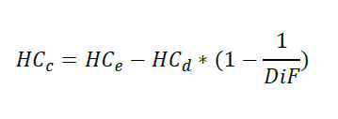

where:

HCe is the concentration of hydrocarbons expressed in parts per million (ppm) of carbon equivalent, in the sample of diluted gases collected in bag(s) A;

HCd is the concentration of hydrocarbons expressed in parts per million (ppm) of carbon equivalent, in the sample of dilution air collected in bag(s) B;

DiF is the coefficient defined in point 5.1.1.4.7.

The non-methane hydrocarbon (NMHC) concentration is calculated as follows:

Equation B.2.-36:

CNMHC = CTHC - (Rf CH4 · CCH4)

where:

CNMHC = corrected concentration of NMHC in the diluted exhaust gas, expressed in ppm carbon equivalent;

CTHC = concentration of total hydrocarbons (THC) in the diluted exhaust gas, expressed in ppm carbon equivalent and corrected by the amount of THC contained in the dilution air;

CCH4 = concentration of methane (CH4) in the diluted exhaust gas, expressed in ppm carbon equivalent and corrected by the amount of CH4 contained in the dilution air;

RfCH4 is the FID response factor to methane as defined in point 4.2.3.4.1.

* + - * 1. Carbon monoxide (CO)

The mass of carbon monoxide emitted by the exhaust of the vehicle during the test shall be calculated using the following formula:

Equation B.2.-37:



where:

COm is the mass of carbon monoxide emitted during the test part, in mg/km;

S is the distance defined in point 5.1.1.3.;

V is the total volume defined in point 5.1.1.4.1.;

dCO is the density of the carbon monoxide, dCO = 1.25·106 mg/m3 at reference temperature and pressure (0 °C and 101.3 kPa);

COc is the concentration of diluted gases, expressed in parts per million (ppm) of carbon monoxide, corrected to take account of the dilution air by the following equation:

Equation B.2.-38:



where:

COe is the concentration of carbon monoxide expressed in parts per million (ppm), in the sample of diluted gases collected in bag(s) A;

COd is the concentration of carbon monoxide expressed in parts per million (ppm), in the sample of dilution air collected in bag(s) B;

DiF is the coefficient defined in point 5.1.1.4.7.

* + - * 1. Nitrogen oxides (NOx)

The mass of nitrogen oxides emitted by the exhaust of the vehicle during the test shall be calculated using the following formula:

Equation B.2.-39:



where:

NOxm is the mass of nitrogen oxides emitted during the test part, in mg/km;

S is the distance defined in point 5.1.1.3.;

V is the total volume defined in point 5.1.1.4.1.;

dNO2 is the density of the nitrogen oxides in the exhaust gases, assuming that they will be in the form of nitric oxide, dNO2= 2.05·106 mg/m3 at reference temperature and pressure (0 °C and 101.3 kPa);

NOxc is the concentration of diluted gases, expressed in parts per million (ppm), corrected to take account of the dilution air by the following equation:

Equation B.2.-40:



where:

NOxe is the concentration of nitrogen oxides expressed in parts per million (ppm) of nitrogen oxides, in the sample of diluted gases collected in bag(s) A;

NOxd is the concentration of nitrogen oxides expressed in parts per million (ppm) of nitrogen oxides, in the sample of dilution air collected in bag(s) B;

DiF is the coefficient defined in point 5.1.1.4.7.;

Kh is the humidity correction factor, calculated using the following formula:

Equation B.2.-41:



where:

H is the absolute humidity in g of water per kg of dry air:

Equation B.2.-42:



where:

U is the relative humidity as a percentage;

pd is the saturated pressure of water at the test temperature in kPa;

pais the atmospheric pressure in kPa.

* + - * 1. Particulate matter mass

Particulate emission Mp (mg/km) is calculated by means of the following equation:

Equation 2-43:



where exhaust gases are vented outside the tunnel;

Equation B.2.-43:



where exhaust gases are returned to the tunnel;

where:

Vmix = volume V of diluted exhaust gases under standard conditions;

Vep = volume of exhaust gas flowing through particulate filter under standard conditions;

Pe = particulate mass collected by filter(s);

S = is the distance defined in point 5.1.1.3.;

Mp = particulate emission in mg/km.

Where correction for the particulate background level from the dilution system has been used, this shall be determined in accordance with point 4.2.1.5. In this case, the particulate mass (mg/km) shall be calculated as follows:

Equation B.2.-44:



where exhaust gases are vented outside the tunnel;

Equation B.2.-45:



where exhaust gases are returned to the tunnel;

where:

Vap = volume of tunnel air flowing through the background particulate filter under standard conditions;

Pa = particulate mass collected by background filter;

DiF = dilution factor as determined in point 5.1.1.4.7.

Where application of a background correction results in a negative particulate mass (in mg/km), the result shall be considered to be zero mg/km particulate mass.

* + - * 1. Carbon dioxide (CO2)

The mass of carbon dioxide emitted by the exhaust of the vehicle during the test shall be calculated using the following formula:

Equation B.2.-46:



where:

CO2m is the mass of carbon dioxide emitted during the test part, in g/km;

S is the distance defined in point 5.1.1.3.;

V is the total volume defined in point 5.1.1.4.1.;

dCO2 is the density of the carbon monoxide, dCO2 = 1.964·103 g/m3 at reference temperature and pressure (0 °C) and 101.3 kPa);

CO2c is the concentration of diluted gases, expressed as a percentage of carbon dioxide equivalent, corrected to take account of the dilution air by the following equation:

Equation B.2.-47:



where:

CO2e is the concentration of carbon dioxide expressed as a percentage of the sample of diluted gases collected in bag(s) A;

CO2d is the concentration of carbon dioxide expressed as a percentage of the sample of dilution air collected in bag(s) B;

DiF is the coefficient defined in point 5.1.1.4.7.

* + - * 1. Dilution factor (DiF)

The dilution factor is calculated as follows:

For each reference fuel, except hydrogen:

Equation B.2.-48:



For a fuel of composition CxHyOz, the general formula is:

Equation B.2.-49:



For the reference fuels contained in annex B.5.2., the values of ‘X’ are as follows:

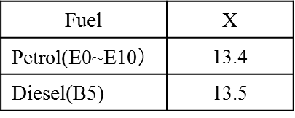

Table B.2.-3: Factor ‘X’ in formulae to calculate DiF

In these equations:

CCO2 = concentration of CO2 in the diluted exhaust gas contained in the sampling bag, expressed in percent by volume,

CHC = concentration of HC in the diluted exhaust gas contained in the sampling bag, expressed in ppm carbon equivalent,

CCO = concentration of CO in the diluted exhaust gas contained in the sampling bag, expressed in ppm,

CH20 = concentration of H2O in the diluted exhaust gas contained in the sampling bag, expressed in percent by volume,

CH20-DA = concentration of H2O in the air used for dilution, expressed in percent by volume,

CH2 = concentration of hydrogen in the diluted exhaust gas contained in the sampling bag, expressed in ppm.

* + - 1. Weighting of type I test results
         1. With repeated measurements (see point 4.1.1.2.), the pollutant (mg/km), and CO2 (g/km) emission results obtained by the calculation method described in point 5.1.1. and fuel consumption determined according to Section B.4. are averaged for each cycle part.
      2. [Weighting of WMTC results

The (average) result of Part 1 or Part 1 reduced vehicle speed is called R1, the (average) result of Part 2 or Part 2 reduced vehicle speed is called R2 and the (average) result of Part 3 or part 3 reduced vehicle speed is called R3. Using these emission (mg/km) and fuel consumption (litres/100 km) results, the final result RF, depending on the vehicle category as defined in point 5.1.1.6.1., shall be calculated using the following equations:

Equation B.2.-52:



where:

w1 = weighting factor cold phase

w2 = weighting factor warm phase

Equation B.2.-53:



where:

wn = weighting factor phase n (n=1, 2 or 3)

* + - * 1. For each gaseous pollutant, PM and carbon dioxide emission the weightings shown in Tables B.2.-4 shall be used.

|  |  |  |
| --- | --- | --- |
| Vehicle Class | Equation | Weighting Factor |
| 0 | B.2 - 52 | w1 = 0.50  w2 = 0.50 |
| 1 | B.2 - 52 | w1 = 0.30  w2 = 0.70 |
| 2 | B.2 - 52 | w1 = 0.30  w2 = 0.70 |
| 3 | B.2 - 53 | w1 = 0.25  w2 = 0.50  w3 = 0.25 |

Table B.2.-4: Type I test cycles (also applicable for test Types VII and VIII), applicable weighting equations and weighting factors.

1. **Records required**
   1. The following information shall be recorded with respect to each test:

(a) test number;

(b) vehicle, system or component identification;

(c) date and time of day for each part of the test schedule;

(d) instrument operator;

(e) driver or operator;

(f) test vehicle: make, vehicle identification number, model year, drivetrain / transmission type, odometer reading at initiation of preconditioning, engine displacement, engine family, emission-control system, recommended engine speed at idle, nominal fuel tank capacity, inertial loading, reference mass recorded at 0 kilometre, and drive-wheel tyre pressure;

(g) dynamometer serial number: as an alternative to recording the dynamometer serial number, a reference to a vehicle test cell number may be used, with the advance approval of the Administration, provided the test cell records show the relevant instrument information;

(h) all relevant instrument information, such as tuning, gain, serial number, detector number, range. As an alternative, a reference to a vehicle test cell number may be used, with the advance approval of the Administration, provided test cell calibration records show the relevant instrument information;

(i) recorder charts: identify zero point, span check, exhaust gas, and dilution air sample traces;

(j) test cell barometric pressure, ambient temperature and humidity;

Note 7: A central laboratory barometer may be used; provided that individual test cell barometric pressures are shown to be within ± 0.1 percent of the barometric pressure at the central barometer location.

(k) pressure of the mixture of exhaust and dilution air entering the CVS metering device, the pressure increase across the device, and the temperature at the inlet. The temperature shall be recorded continuously or digitally to determine temperature variations;

(l) the number of revolutions of the positive displacement pump accumulated during each test phase while exhaust samples are being collected. The number of standard cubic meters metered by a critical-flow venturi (CFV) during each test phase would be the equivalent record for a CFV-CVS;

(m) the humidity of the dilution air.

Note 8: If conditioning columns are not used, this measurement can be deleted. If the conditioning columns are used and the dilution air is taken from the test cell, the ambient humidity can be used for this measurement;

(n) the driving distance for each part of the test, calculated from the measured roll or shaft revolutions;

(o) the actual roller vehicle speed pattern for the test;

(p) the gear use schedule for the test;

(q) the emissions results of the type I test for each part of the test and the total weighted test results;

(r) the second-by-second emission values of the type I tests, if deemed necessary;

(s) the emissions results of the type II test (see Annex B.3.).

Secretariat notes: Pressure symbol to be checked. To use P (and not p) across the document.

Multiplication symbol to be checked. To use x (and not *) across the document.