Submitted by the expert from IMMA Informal document GRE-80-32
(80th GRE, 23-26 October 2018,
agenda item 4)

Proposal for amendments to GRE/2018/33 (LSD)
Submitted by the expert from the International Motorcycle Manufacturers Association*
The text reproduced below was prepared by the experts from International Motorcycle Manufacturers Association (IMMA), to add clarification to GRE/2018/33. The additional text to GRE/2018/33 is highlighted in yellow.
GRE/2018/33
Proposal for Supplement 1 to the original version of the UN Regulation on Light-Signalling Devices
Submitted by the Informal Working Group on Simplification of Lighting and Light-Signalling Regulations (IWG SLR)
The text reproduced below was prepared by IWG SLR, on the basis of an original proposal by the expert from the International Motorcycle Manufactures Association (IMMA), with the aim to amend the inboard visibility angle for rear position lamps in pairs in the new UN Regulation on Light-Signalling Devices (LSD), which was adopted at the seventy-ninth session of the Working Party on Lighting and Light-Signalling (GRE) in April 2018. The modifications to the LSD UN Regulation (ECE/TRANS/WP.29/GRE/2018/2) are marked in bold for new or strikethrough for deleted characters.
I. Proposal
Annex 2, Table A2-1, line "Rear position pair (MR)", amend to read:
"
Lamp | Minimum horizontal angles  (inboard / outboard) | Minimum vertical angles  (above / below) | Additional information
…
Rear position pair (MR) | 4520° / 80°  20° / 80°¹ | 15° / 15°  15° / 5°² | -

———————————

Reduced angles used only below the H-plane for lamps mounted with the H-plane below 750 mm.
2 For lamps to be installed with the H-plane of the lamp at a mounting height of less than 750 mm.

Explanatory note : The reference to the footnote 1 is removed in this proposal for rear position lamps, but still the footnote 1 itself shall be kept in the document, since other categories of lamps continue to refer to the footnote 1.

II. Justification + additional justification as from §5.
1. The proposal from IMMA to amend UN Regulation No. 50 regarding inward geometric visibility requirements for rear position lamps (ECE/TRANS/WP.29/GRE/2018/27), together with the corresponding proposal to amend UN Regulation No. 53 (ECE/TRANS/WP.29/GRE/2018/28), were generally supported by GRE at its seventy-ninth session in April 2018 but could not be submitted to the World Forum for Harmonization of Vehicle Regulations (WP.29) due to the earlier decision to "freeze" UN Regulation No. 50 which would be replaced by the new LSD Regulation.
2. At the same session, the new LSD Regulation (ECE/TRANS/WP.29/GRE/2018/2) was adopted.
3. This amendment introduces the same changes, as contained in document ECE/TRANS/WP.29/GRE/2018/27, into the new LSD Regulation (ECE/TRANS/WP.29/GRE/2018/2).
4. This proposal, once formally approved by GRE, is intended to be sent to WP.29 together with the corresponding proposal to amend Regulation No. 53 (ECE/TRANS/WP.29/GRE/2018/28).
5. Following documents has been so far submitted to GRE on this issue:
GRE/2018/27 on R50 -> GRE/2018/33 on LSD
GRE/2018/28 on R53
6. IMMA has proposed to change the horizontal rear inboard visibility angles, as follows, regardless of the mounting height. No change to the vertical angles were proposed.
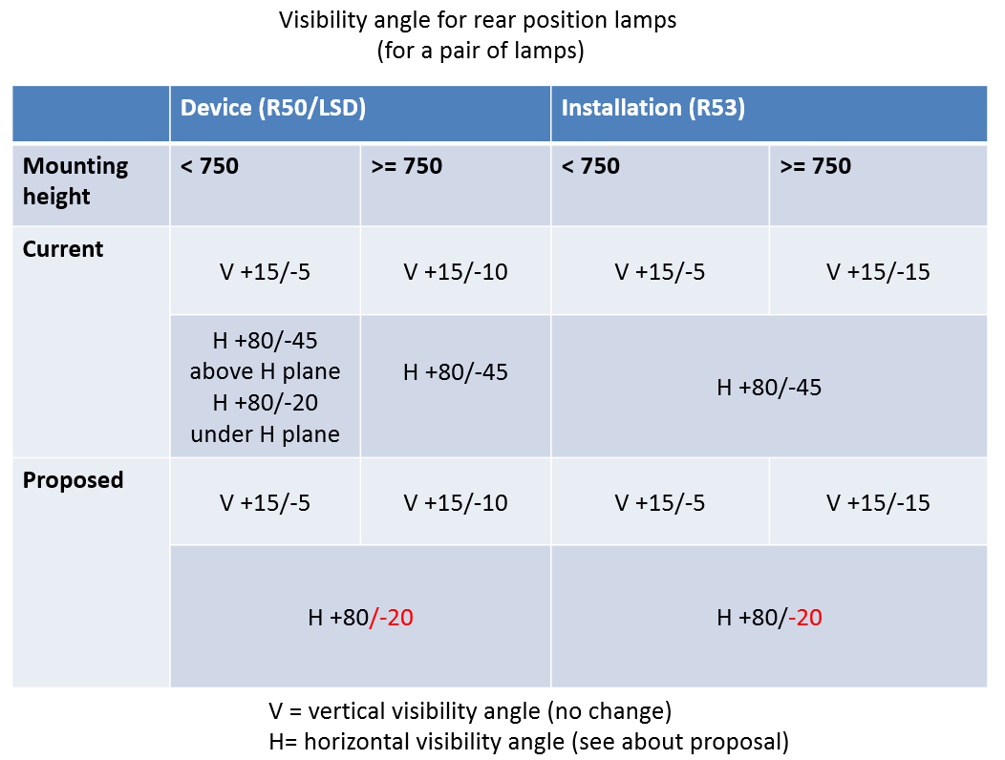

7. IMMA has proposed to change angles of the rear position lamps, to align them with the angles of the front position lamps. The effect of the inward angle difference between 20 deg / 45 deg is negligible in terms of visibility /visibility distance.
8. See below data collected for front position lamps, from the IMMA proposals GRE - 67 - 14 /GRE - 67 – 15 (proposal to ease the FPL inboard visibility angle from 45 degrees to 20 degrees, to conform to that of the direction indicator), which were adopted.

Distance difference between 45deg v. 20deg
(explained in GRE-67-15)
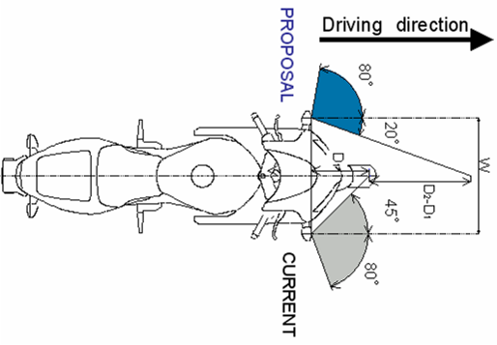
In case of W = 625 mm (typical 600 cm³ motorcycle)
D₁ = 0.5 x 0.625 (tan45°)⁻¹ = 0.312 m
D₂ = 0.5 x 0.625 (tan20°)⁻¹ = 0.858 m
D₂-D₁ = 0.546 m

In case of W = 1100 mm (1800 cm³ touring motorcycle)
D₁ = 0.5 x 1.100 (tan45°)⁻¹ = 0.550 m
D₂ = 0.5 x 1.100 (tan20°)⁻¹ = 1.511 m
D₂-D₁ = 0.961 m

* In accordance with the programme of work of the Inland Transport Committee for 2016–2017 (ECE/TRANS/254, para. 159 and ECE/TRANS/2016/28/Add.1, cluster 3.1), the World Forum will develop, harmonize and update Regulations in order to enhance the performance of vehicles. The present document is submitted in conformity with that mandate.

