Transmitted by the expert from the India | Informal document GRE-79-21  (79th GRE, 24 - 27 April 2018,  agenda item 7(a))
India’s comments submitted by the expert from India for the 06 series of amendments to Regulation No. 10 (Electromagnetic compatibility)
Document no ECE/TRANS/WP.29/GRE/2018/05

The text reproduced below was prepared by the experts from India to propose change in the UN Regulation 10 (Electromagnetic compatibility). This proposal is to change a figure as per EMC-TF document GRE-TF-EMC-12-06e R10.06_Consolidated_Rev4. India’s proposals are marked in strikethrough for deletion of existing text and in bold italic text in blue colour for addition of new text.

A. PROPOSAL
A1) Annex 6, Appendix 1, figure replace:
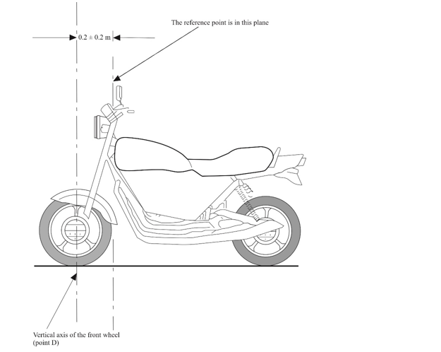

By
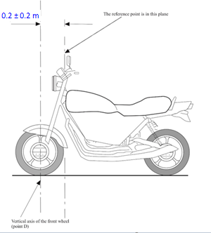

B) Justification

To align as per Annex 6 – Appendix 1 figure 1 “Three wheeled vehicle” This was accepted in EMC-TF and was incorporated in in GRE-TF-EMC-12-06e R10.06_Consolidated_Rev. 4 dated 22.01.18
-----

