Artificial Intelligence and vehicle regulations
I. Introduction
1. In 2015, public figures warned the international community with an Open Letter on Artificial Intelligence about the potential risks related to the use of Artificial Intelligence (AI). In 2017, more than hundred renowned experts wrote a letter to the United Nations stating their position on potential risks related to AI. Also in 2017, an experiment got public attention when it was reported that the experiment had to be abandoned after two artificially intelligent programs involved in the experiment appeared to be chatting to each other in a strange language only they understood, highlighting the risk of a AI systems control loss and recalling some science fictions about the rise of superintelligences that do not act in accordance with human wishes.
2. AI has found some prominent applications in the automotive sector. Some of these applications are related to infotainment and vehicle management (as Human Machine Interface (HMI) enhancement) e.g. infotainment management (incl. destination entry in the navigation systems). Some applications are related to the development of the vehicle self-driving capability.
3. Some AI implications might fall in the remit of the World Forum for the Harmonization of Vehicle Regulations (WP.29), e.g. HMI / distraction as well as the performance of automated vehicles.
II. Some terms and applications
A. Artificial Intelligence
4. AI is a general concept defined in contrast to the natural intelligence, it is the intelligence exhibited by machines or software. In the context of the automotive sector, it finds applications in the understanding of human speech, providing contextual answers, providing intelligent routing and develop self-driving capabilities, as well as in providing support in engineering, design and manufacturing. In a nutshell, AI in its current applications is about searching for optimized solutions to problems, looking for patterns, making deduction from incomplete patterns and finding the probability of future events.
B. Machine learning
5. Machine Learning (ML) is often referred to as a subset of AI. It is a field of computer science that uses data based computational techniques to create an ability to "learn" (i.e. progressively improve performance on tasks) without an explicitly programmed algorithm. It explores the construction of algorithms aimed at making predictions on data. It has strong ties with the mathematical optimization science. Its applications are found in the classification of data, in regression, in clustering and in dimensionality reduction. Learning can be supervised (e.g. classification) and/or unsupervised (e.g., pattern analysis). ML systems are mainly trained using three methods:
6. Supervising learning aims to develop predictive model based both input and output data. The AI system is provided with examples that the AI system should learn to predict. The data provided are labelled i.e. the desired output is included in the data. This method performs well with small, good quality datasets.
7. Unsupervised learning, used e.g. in data mining, aims to discover an internal representation from input data only. The data does not contain labels. The system finds its own metrics and categorization based on recognizing structures in the data. This method need large datasets and can work with incomplete data.
8. Reinforcement Learning (RL), relevant e.g. for defining driving strategies/policies of automated vehicles, is concerned with how a so-called agent should take actions in an environment to maximize some notion of long-term reward. RL algorithms attempt to find a policy that maps states of the environment to the actions the agent ought to take in those states. It differs from the supervised learning problem in that correct input/output pairs are never presented, nor sub-optimal actions explicitly corrected.
9. Now a days ML is often based on computing systems with Artificial Neural Networks (ANNs) that can "learn" (i.e. progressively improve performance on tasks) and that are designed to work by classifying information in the same way a human brain does by considering examples, generally without task-specific programming or models (as found in usual automatic control science and algorithmics), in fields such as computer vision, speech recognition, machine translation ANNs are also applied to problems such as those involved in vehicle routing because of the ability of ANNs to mitigate losses of accuracy even when reducing the discretization grid density for numerically approximating the solution of the original control problems.
C. Deep Learning
10. Deep Learning (DL) is a class of Machine Learning that uses a cascade of multiple layers of nonlinear processing units for feature extraction and transformation. Each successive layer uses the output from the previous layer as input. The next paragraph provides an example of this.
11. In an image recognition application, the raw input may be a matrix of pixels from e.g. a camera, a radar or a Light Detection and Ranging (LIDAR); the first representational layer may abstract the pixels and encode edges; the second layer may compose and encode arrangements of edges; the third layer may encode a nose and eyes; and the fourth layer may recognize that the image contains a face. Importantly, a DL process can learn which features to optimally place in which level on its own.
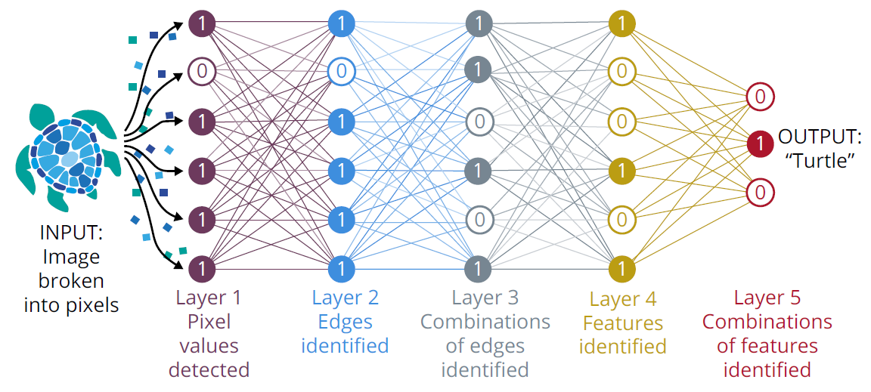
Source: https://www.wired.com/story/new-theory-deep-learning/ [accessed 8 March 2018]
D. Some AI applications in the automotive sector
(a) Building the maps
12. Some stakeholders are communicating about their work on the production of so called HD Maps. One technic is based on the crowdsourcing principle. It is exploiting the proliferation of camera-based ADAS systems ("crowd"). The camera-equipped vehicles collect and transmit data about the driving path's geometry and stationary landmarks around it. The map-relevant information is then analysed (possibly using some sort of AI) in real-time in the vehicles, compressed and sent to the cloud. These elements are then processed (possibly using some sort of AI) and integrated in HD Map. The advantage of this technology is the quick acquisition of data at a low price and the possibility to maintain the HD map as up-to-date as possible.
(b) Image analysis for object and surrounding detection
13. Automated vehicles may rely on sensing technologies to detect road signs, the environment and the other road users. The analysis of this information (e.g. through DL technologies) provides means to represent surrounding of the vehicle in a way that can be interpreted by the vehicle.
(c) Driving policies/strategies for automated driving
14. Based on a representation of the vehicle surrounding and the prediction of the software, the vehicle will make decisions based on the driving policies. These driving policies may be developed using AI and ML (RL). In a context were may traffic rules are qualitative but not defined in such a way that a computer can apply, e.g. because they are not quantified (i.e. "obligation to act prudently" or because they are not formalized ("negotiations" such as the insertion of a vehicle in the traffic flow of a crowded lane e.g. when entering a highway), the application of DL / RL to the problem of forming long term driving strategies for a self-driving system is handy as the behaviours determination is not governed by a written rule or an algorithm but through experiences gathered and the mapping of inputs with desirable outcomes.
(d) Human machine interface
15. AI and DL can provide the basis for efficient Human/Machine interaction with e.g. speech recognition and providing as an output for the driver a personalized driving experience enhanced with intelligent assistants that can be summoned with a voice command. They can potentially provide applications such as driver behaviour monitoring (attention detection, drowsiness detection etc.)
IV. Consideration for WP.29
16. AI can be used:
(a) in the development process of functionalities for road vehicles; as well as
(b) in real time within the vehicle on the road.
17. In both cases, the nature of the technology used raises the question of the validation of models generated by the AI that are not transparent to humans creating it. Especially, the outcome delivered by a AI (e.g. powered by ANNs) may not be traceable and not understood by the engineer deploying it. This can be addressed if the decision traceability is part of the AI goal from the design phase.
18. The difficulty to describe the "mechanism" (defined by AI) that leads to an action (e.g. steering, braking) may cause difficulty in the context of the safety assessment e.g. of a vehicle with AI applications.
19. The use of AI that delivers personalized driving experienced, enriched by graphics, by interactions with a virtual assistant etc. should be carefully considered in the automotive context, having in mind the possible risks in terms of distraction that it may cause.
20. Questions:
(a) Should the models (including those generated using AI) used within vehicles be transparent, traceable, describable, and validated, especially for safety relevant functions as well as for environmental performance relevant functions (unless explicitly specified otherwise in the relevant UN Regulation(s) or UN Global Technical Regulation(s))?
(b) Should all vehicles of a given vehicle type relying on AI should have the same performance? Should AI be used in real time in such a way that one vehicle would develop performances (e.g. a driving strategy/policy) that would differ from the one of another vehicle of the same type?

The text of the open letter can be read here: https://futureoflife.org/ai-open-letter/
The text of the open letter can be read here: https://futureoflife.org/autonomous-weapons-open-letter-2017
Study published by the Facebook's Artificial Intelligence Research (FAIR) in July 2017
Bibliography: - AI – Automotive's new value-creating engine, McKinsey, January 2018 - AI in the UK: ready, willing and able? (16 April 2018) - https://en.wikipedia.org/wiki/Artificial_intelligence, (Wikipedia)

