|  |  |  |  |
| --- | --- | --- | --- |
|  | United Nations | ECE/TRANS/WP.29/2018/133 | |
| Description: _unlogo | **Economic and Social Council** | | Distr.: General  15 August 2018  Original: English |

**Economic Commission for Europe**

Inland Transport Committee

**World Forum for Harmonization of Vehicle Regulations**

**176th session**

Geneva, 13-16 November 2018

Item 4.8.7 of the provisional agenda

**1958 Agreement:  
Consideration of draft amendments to existing   
UN Regulations submitted by GRSP**

Proposal for Supplement 7 to the 03 series of amendments to UN Regulation No. 95 (Lateral collision)

Submitted by the Working Party on Passive Safety[[1]](#footnote-2)\*

The text reproduced below was adopted by the Working Party on Passive Safety (GRSP) at its sixty-third session (ECE/TRANS/WP.29/GRSP/63, para. 27). It is based on ECE/TRANS/WP.29/GRSP/2017/40 as amended in Annex VIII to the report. It is submitted to the World Forum for Harmonization of Vehicle Regulations (WP.29) and to the Administrative Committee AC.1 for consideration at their November 2018 sessions.

Supplement 7 to the 03 series of amendments to UN Regulation No. 95 (Lateral collision)

*Insert new paragraphs 2.36. to 2.39*., to read:

"2.36. "*Latched*" means any coupling condition of the door latch system, where the latch is in a fully latched position, a secondary latched position, or in between a fully latched position and a secondary latched position.

2.37. "*Latch*" is a device employed to maintain the door in a closed position relative to the vehicle body with provisions for deliberate release (or operation).

2.38. "*Fully latched position*" is the coupling condition of the latch that retains the door in a completely closed position.

2.39. "*Secondary latched position*" refers to the coupling condition of the latch that retains the door in a partially closed position."

*Paragraph 5.3.1*., amend to read:

"5.3.1. No door shall open during the test.

This requirement is deemed to be fulfilled:

(a) If it is clearly visible, that the door lock is latched; or

(b) If the door does not open under a static tractive force of at least 400 N in the y-direction applied to the door, according to the Figure below, as close as possible to the window sill and to the edge of the door opposite to the hinged side, except to the door handle itself.

**Figure**

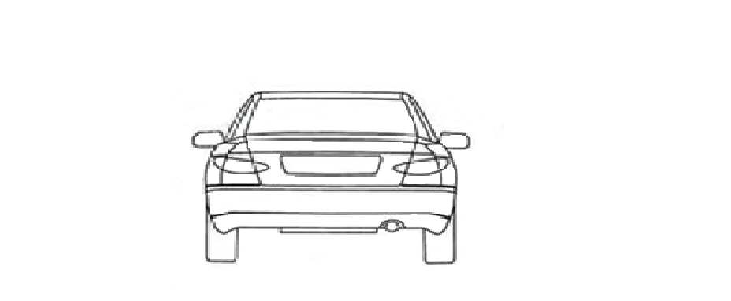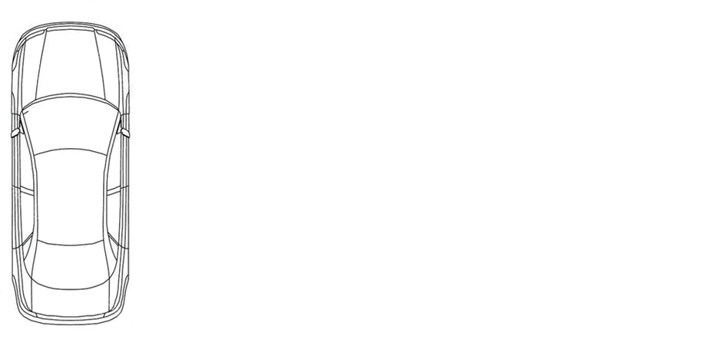

90° +/- 5°

90° +/- 5°

90° +/- 5°

400N

400N

400N

Z

Y

X

Y

"

1. \* In accordance with the programme of work of the Inland Transport Committee for 2018–2019 (ECE/TRANS/274, para. 123 and ECE/TRANS/2018/21/Add.1, cluster 3.1), the World Forum will develop, harmonize and update UN Regulations in order to enhance the performance of vehicles. The present document is submitted in conformity with that mandate. [↑](#footnote-ref-2)