INF.16
Economic Commission for Europe
Inland Transport Committee
Working Party on the Transport of Dangerous Goods
Joint Meeting of the RID Committee of Experts and the
Working Party on the Transport of Dangerous Goods
Bern, 12-16 March 2018 19 February 2018
Item 4 of the provisional agenda
Interpretation of RID/ADR/ADN
Discrepancies and additions to danger labels and placards
Proposal submitted by the International Union of Railways (UIC)
Introduction
5.2.2.2.1 of the ADR/RID stipulates that danger labels must conform to the danger label models shown in 5.2.2.2.2 in terms of colour, symbols and general format. Corresponding models required for other modes of transport, with minor variations which do not affect the obvious meaning of the label, are also acceptable.
5.2.2.2.1.3 is supplemented to specify that, except for label model no. 9A, the labels may include text such as the UN number or words describing the hazard (e.g. "flammable") in accordance with 5.2.2.2.1.5 provided the text does not obscure or detract from the other required label elements.
5.2.2.2.1.5 also specifies that on labels other than those for material of Class 7, the optional insertion of any text (other than the class number) in the space below the symbol shall be confined to particulars indicating the nature of the risk and precautions to be taken in handling.
In practice, placards are also encountered with the corresponding additional details permitted for danger labels.
Examples:
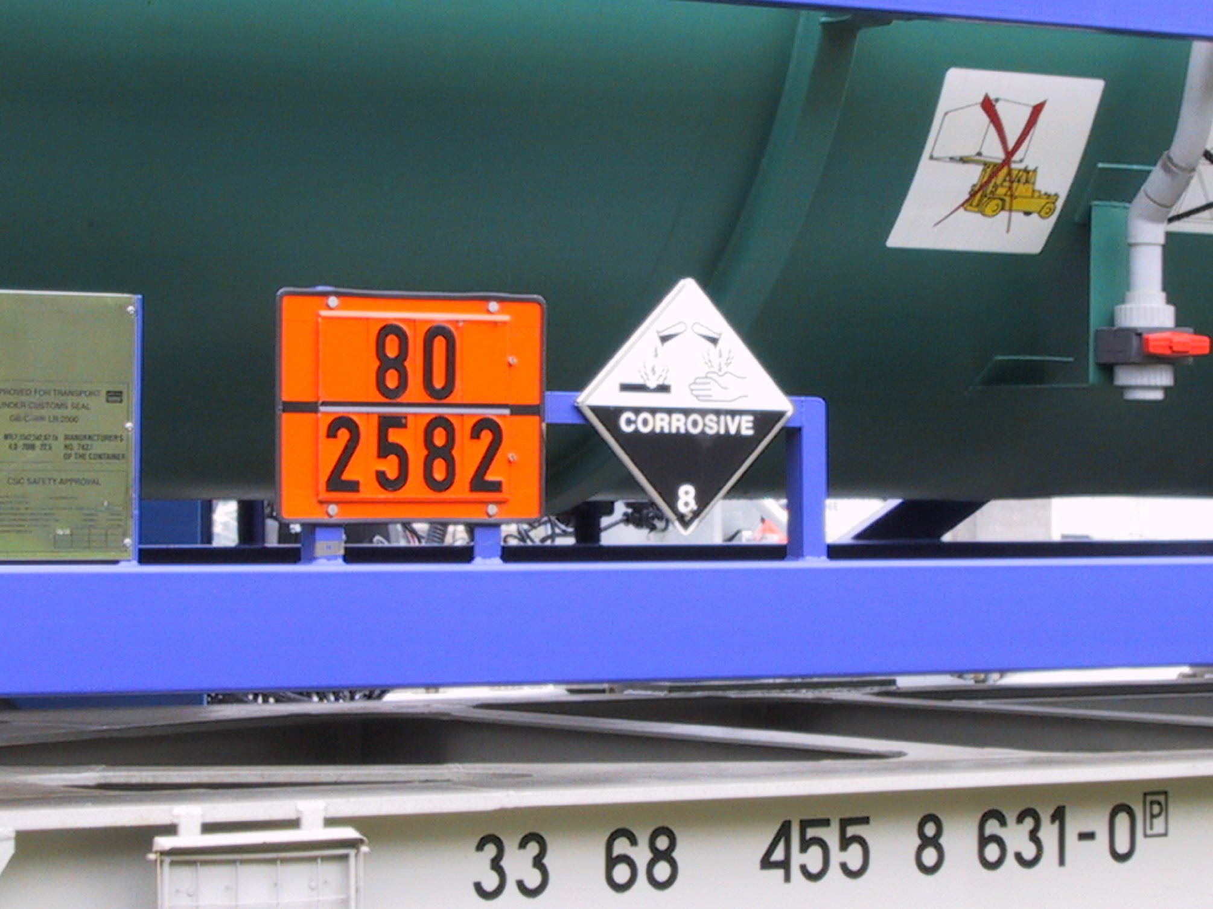

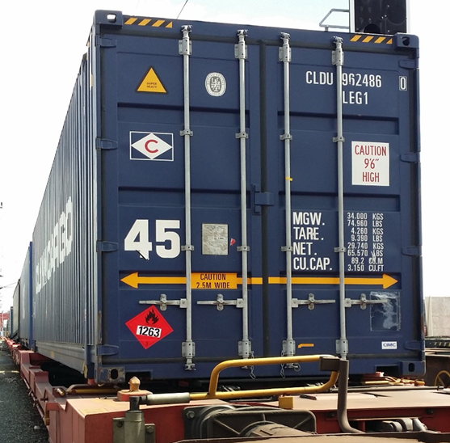

The following provisions are found in 5.3.1.7.1 in respect of the basic principles underlying how placards are displayed:
Except as provided in 5.3.1.7.2 for the Class 7 placard, and in 5.3.6.2 for the environmentally
hazardous substance mark, a placard shall be configured as shown in Figure 5.3.1.7.1. The placard shall be in the form of a square set at an angle of 45° (diamond-shaped). The minimum dimensions shall be 250 mm x 250 mm (to the edge of the placard). The line inside the edge shall be parallel and 12.5 mm from the outside of that line to the edge of the placard. The symbol and line inside the edge shall correspond in colour to the label for the class or division of the dangerous goodsin question. The class or division symbol/numeral shall be positioned and sized in proportion to those prescribed in 5.2.2.2 for the corresponding class or division of the dangerous goods in question. The placard shall display the number of the class or division (and for goods in Class 1, the compatibility group letter) of the dangerous goods in question in the manner prescribed in 5.2.2.2 for the corresponding label, in digits not less than 25 mm high. Where dimensions are not specified, all features shall be in approximate proportion to those shown.
Deviations are permitted only for movements which are part of a transport chain in accordance with 1.1.4.2.1. c.
UIC thus considers that there are no derogations that may be applied purely for land transport that would allow the addition of text or UN numbers in placards.
Proposal
If the Joint Meeting is of the view that it is permissible for placards to show discrepancies in the same way as danger labels, we suggest the addition of the following text for the purposes of clarification:
Add an additional sentence to the end of 5.3.1.7.1:
The deviations specified in 5.2.2.2.1, 5.2.2.2.1.3 and 5.2.2.2.1.5 for danger labels shall apply analogously for placards.

