|  |  |  |  |
| --- | --- | --- | --- |
|  | United Nations | ECE/TRANS/WP.15/2018/2 | |
| _unlogo | **Economic and Social Council** | | Distr.: General  28 February 2018  Original: English |

**Economic Commission for Europe**

Inland Transport Committee

**Working Party on the Transport of Dangerous Goods**

**104th** **session**

Geneva, 15–17 May 2018

Item 5 (b) of the provisional agenda

**Proposals for amendments to annexes A and B of ADR:**

**miscellaneous proposals**

Proposal to include a *Valid From* date in the ADR Driver Training Certificate (8.2.2.8.5)

Transmitted by the Government of Malta[[1]](#footnote-2)\*

1. Malta is proposing to include a *Valid From* date in the ADR Driver Training Certificate in order to make it easier for local and international authorities to identify when a driver obtained his ADR Driver Training Certificate. The motive behind this proposal is that in July 2017 two persons were stopped in a routine traffic check and were found to be driving a dangerous good cargo without having the training certificate. The date for the court sitting was set to January 2018 and in between those two periods both the accused had attended the training and obtained their training certificate. Once in court the accused presented their training certificates and the Court had no option but to dismiss the case on the ground that there was no *Valid From* date.

This is the current ADR Training Certificate as per 8.2.2.8.5

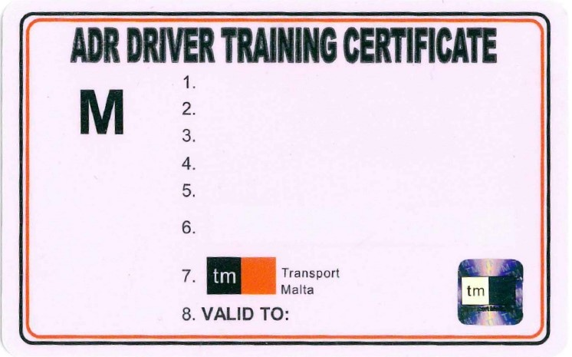

Malta’s proposed ADR Training Certificate

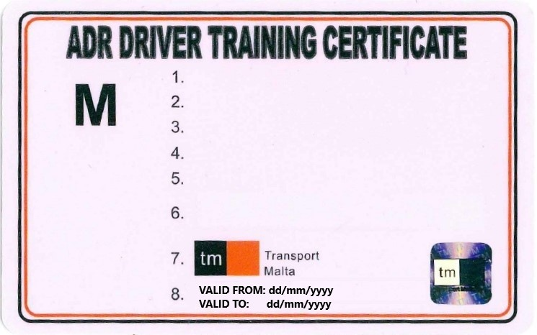

2. Malta is proposing to include the following text in 8.2.2.8.5:

*“Contracting parties can opt whether to include or not in Item 8, Valid From in the ADR Training Certificate”.*

3. Malta is proposing that the inclusion of the *Valid From* date is made at the discretion of each different contracting party since as a country we do not want to impose an additional burden when it comes to printing the training certificate on other countries.

4. Malta believes that no transitional period is required since this will only be a slight amendment to the ADR Training Certificate, which will make enforcement easier since the enforcement authorities will have the date of when the driver obtained his certificate and the expiry, and thus leaving no room for abuse by drivers who are caught without the training certificate as in the case quoted above. The *Valid From* date is mandatory on European driving licenses as per Annex 1, Directive 2006/126/EC.

1. \* In accordance with the draft programme of work of the Inland Transport Committee for 2018-2019, (ECE/TRANS/WP.15/237, annex V, (9.1)). [↑](#footnote-ref-2)