INF.24
Economic Commission for Europe
Inland Transport Committee
Working Party on the Transport of Dangerous Goods
104th session 8 May 2018
Geneva, 15-17 May 2018
Item 8 of the provisional agenda:
Any other business
Changes of the loaded products in tank-vehicles
Transmitted by the Government of the Switzerland
Summary
Executive summary: Tank-vehicles changing the loaded products don’t identify the real dangers present in their compartment and equipment. Is there a need to address such practices in ADR?
Introduction
1. A tank-vehicle with a triple compartment system carried UN 1203 (petrol). After the unloading, the driver loaded the vehicle with biodiesel (no hazardous good according to the safety data sheet). Due to the filling from below, the remainder petrol is pressed in the compartment system, where the gasoline vapors (approx. 2-3 m2) are present above of the biodiesel in the tank compartment. Because of this hazard the driver left the marking of tank vehicle deliberately as “gasoline”, that is 33/1203 in front and rear of the transport unit, and at the side and rear placards of No. 3 and marks following 5.3.6 appear. The police control results in a fine for the reason "Does not remove the ADR marking” because their considered that no dangerous goods were carried.
2. Description of the conditions of the carriage:
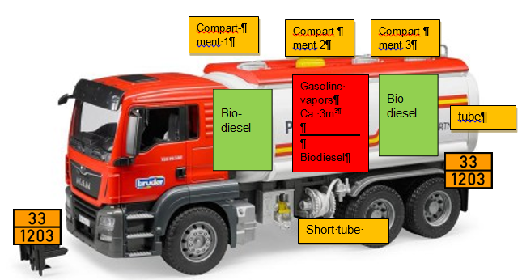
- Approx. 30-40 l of gasoline are in the short tube, which was pressed during the loading process of bio-diesel in the tank space
- In the full tube system between the pump, the counter and the nozzle was still about 100-150 l diesel (UN: 1202)
- Fillingt with biodiesel carried out from below
- The first and the third compartment of the tank-vehicle are filled with biodiesel, the second compartment was filled to the half approximately with biodiesel;
- The driver had a document for biodiesel and probably also a transport document for an empty uncleaned tank (but was not controlled);
- According to ADR 5.1.3.1 and 5.3.1.1.6 no misbehavior can be reproached to the driver. Draining the tube system when changing the product is not prescribed in the ADR.
- According to inquiries within enforcement forces, it would be an advantage to see the danger of gasoline vapors in case of an emergency.
3. Pure "bio-diesel", is also called FAME (fatty acid methyl ester of fatty acid methyl ester = 100%), and is not classified as hazardous. The flash point of this product is significantly higher than 100 °C. => No dangerous goods marking.
4. In the case it's bio-diesel B7, it is a mixture of FAME and diesel (7% FAME + 93% diesel). This product complies with normal diesel in its properties. The flash point of the product is over 55.0 ° C. => Dangerous goods marking with 1202/30; Class 3, environmental hazard.
5. Petrol has a very low flash point, which is well below 0 ° C. Already small amounts of gasoline can lower significantly the flash (0.5% petrol content lowers the flashpoint in diesel to around 10 ° C). In extreme cases, this can affect the quality of the product (non-compliance with the standard limits) and lead, that dangerous goods marking of the vehicle is no longer correct (non-compliance with the dangerous goods regulations and others).
6. Pure diesel has a flash-point above 55 ° c, so that mixing is not a problem with B7 (except it is a dilution of the portion of FAME). However mixing with pure FAME can, depending on the diesel portion, lower the flash point below 100 ° C, so that the mixture becomes a dangerous good.
7. According to this background, it is clear that product mixtures in Tank-vehicles or during the unloading shall be avoided.
- Residual quantities of a precedent load in the tank - depending on the type and quantity of product – causes technical and regulatory difficulties. It is possible to empty a vehicle (without cleaning) so that the remainder is no longer a problem.
- Residual quantity in pipes are no problem for pure products transport. Product change can be a problem, if the content is not emptied.
- Gasoline vapors from a precedent load can also be a problem, if they are not controlled to prevent their release. Gasoline tank-vehicles usually have a gas recirculation connection (vapour) which can be connected even in case of diesel or B7-loading in a petrol station. Pure diesel / heating oil storage stations have no gas recycling facilities. This is also the case for the most FAME producers.
Questions
1. a. Does such a procedure (no draining of the tubes before changing the loaded product) correspond to a skillful behavior? If not, can we prohibit it in ADR or should we take in consideration the actual dangers in the tank-vehicle and apply the corresponding marks and documentation information?
b. In the past we have defined the carriage of additives in tank-vehicles (SP 664 for 400 l capacity). Given that apparently the quantities of dangerous goods remaining in the pipes are not irrelevant (more than 100 l), would the introduction in ADR of a similar approach to the one for additives be necessary for safety reasons?
c. Is it worth to consider the remaining vapors of gasoline (UN 1202) contained in the compartment after filling with diesel (UN 1202) or biodiesel?
2. The concerned industries does not favor the mixing of products but the reality seems to be different. It appears that the situation is unclear for the users and for the control organs. Depending on the interest to solve this uncertainties we would be ready to make proposals in order to address them in a next session.
__________________

