|  |  |
| --- | --- |
| **UN/SCETDG/54/INF.50** |  |
| **Committee of Experts on the Transport of Dangerous Goods and on the Globally Harmonized System of Classification and Labelling of Chemicals**  **Sub-Committee of Experts on the Transport of Dangerous Goods 30 November 2018**  **Fifty-fourth session**  Geneva, 26 November-5 December 2018  Item 2(a), 2(b), 2(c), 2(f), and 7(d) of the provisional agenda  **Review of draft amendments already adopted in the biennium; Explosives and related matters; Listing, classification and packing; Miscellaneous pending issues;** **Use of the Manual of Tests and Criteria in the context of the GHS** |  |

Report of the Working Group on Explosives

Transmitted by the Chairman of the Working Group

Introduction

1. The working group met from 26 – 30 November 2018 in a parallel session to the plenary meeting of the Sub-Committee of Experts on the Transport of Dangerous Goods. This meeting of the working group was well attended with 33 experts in attendance from Belgium, Canada, Finland, France, Germany, Japan, Morocco, Netherlands, Spain, Sweden, United Kingdom, United States of America, Australian Explosives Industry and Safety Group (AEISG), European Chemical Industry Council (CEFIC), European Association of Automotive Suppliers (CLEPA), Dangerous Goods Advisory Council (DGAC), Institute of Makers of Explosives (IME), and Sporting Arms and Ammunition Manufacturers' Institute (SAAMI). Annex 1 of this report provides a list of participants. The group was tasked to discuss technical matters related to official papers and to discuss informal papers as time allowed. Mr. Ed de Jong (Netherlands) served as chair of the working group and Mr. David Boston (IME) as secretary.
2. The working group met from Monday through Thursday to consider the papers assigned to it by the Sub-Committee and on Friday morning to review and approve this report. The latter part of Thursday was spent informally discussing other matters of interest while the secretary prepared this report. Those informal discussions are not reported herein. Throughout this report, the following abbreviations may be used:

* DGL – Dangerous Goods List
* EWG – Working Group on Explosives
* GHS – Globally Harmonized System
* MTC – Manual of Tests and Criteria
* TDG – Transport of Dangerous Goods

1. The working group was tasked by the Sub-Committee to review the following documents:

| **Document** | **Title** | **Paragraph** |
| --- | --- | --- |
| Agenda Item 2(a) | Review of draft amendments already adopted in the biennium |  |
| *ST/SG/AC.10/C.3/2018/64 (Secretariat)* | *Consolidated list of adopted texts* | *4* |
| *ST/SG/AC.10/C.3/2018/65 (Secretariat)* | *Consolidated list of draft amendments* | *4* |
| *ST/SG/AC.10/C.3/100/Add.1 (Secretariat)* | *Annex II, Corrections to the sixth revised edition of the Recommendations on the Transport of Dangerous Goods, Manual of Tests and Criteria* | *4* |
| Agenda Item 2(b) | Explosives and related matters |  |
| *ST/SG/AC.10/C.3/2018/67 – ST/SG/AC.10/C.4/2018/17 (Canada, IME)* | *Recommendations for Test Series 8* | *5* |
| *UN/SCETDG/54/INF.21 – UN/SCEGHS/36/INF.12 - (Canada, IME)* | *Recommendations for Test Series 8:Background for information supporting ST/SG/AC.10/C.3/2018/67−ST/SG/AC.10/C.4/2018/17* | *5* |
| *ST/SG/AC.10/C.3/2018/68 (IME)* | *UN 0222 Ammonium nitrate* | *6* |
| *ST/SG/AC.10/C.3/2018/78 (CEFIC)* | *Transport of energetic samples for further testing* | *7* |
| *ST/SG/AC.10/C.3/2018/81 – ST/SG/AC.10/C.4/2018/19 (Sweden)* | *Inconsequent use of the expression “manufactured with a view to producing a practical explosive or pyrotechnic effect”* | *8* |
| *ST/SG/AC.10/C.3/2018/82 (Sweden)* | *Missing description in test procedure of Test 6 (b) in the Manual of Tests and Criteria* | *9* |
| *ST/SG/AC.10/C.3/2018/85 – ST/SG/AC.10/C.4/2018/20 (Sweden, EWG Chair)* | *Proposed criteria for an amended classification system for Explosives in the GHS* | *10* |
| *UN/SCETDG/54/INF.13 – UN/SCEGHS/36/INF.10 (USA, IME, SAAMI)* | *Technical explosives classification and detailed criteria flowchart support for sub-category 2 of explosives in the GHS Chapter 2.1* | *10* |
| *UN/SCETDG/54/INF.24 – UN/SCEGHS/36/INF.18 (USA, IME, SAAMI)* | *Examples of application of proposed technical explosives classification and detailed criteria flowchart for sub-category 2 of explosives in the GHS Chapter 2.1* | *10* |
| *UN/SCETDG/54/INF.29 – UN/SCEGHS/36/INF.19 (Sweden)* | *Status report on the review of Chapter 2.1 of the GHS* | *10* |
| *ST/SG/AC.10/C.3/2018/87 (USA)* | *Application of the default fireworks classification table for classification of certain articles, pyrotechnic UN0431* | *11* |
| *ST/SG/AC.10/C.3/2018/113 (UK)* | *Amendments to the list of items assigned to LP101* | *12* |
| *ST/SG/AC.10/C.3/2018/114 (UK)* | *Reassigning packing instructions PP67 and L1 to a new special provision* | *13* |
| *UN/SCETDG/54/INF.30 (Finland)* | *Comment on document ST/SG/AC.10/C.3/2018/114, reassigning packing instructions PP67 and L1 to a new special provision* | *13* |
| *UN/SCETDG/54/INF.22 (Sweden)* | *Concerns about some definitions related to Class 1 in the Model Regulations* | *14* |
| Agenda Item 2(c) | Listing, classification and packing |  |
| *ST/SG/AC.10/C.3/2018/75 (Germany)* | *Classification of self-inflating recovery devices* | *15* |
| Agenda Item 2(f) | Miscellaneous pending issues |  |
| *ST/SG/AC.10/C.3/2018/99 (AEISG)* | *Informal working group on Fibre-reinforced plastics (FRP) portable tanks* | *16* |
| Agenda Item 7(d) | Use of the Manual of Tests and Criteria in the context of the GHS |  |
| *ST/SG/AC.10/C.3/2018/61 – ST/SG/AC.10/C.4/2018/15 (EWG Chair)* | *Use of the Manual of Tests and Criteria in the context of GHS (Part II: Sections 20 to 28)* | *17* |
| *UN/SCETDG/54/INF.3 – UN/SCEGHS/36/INF.3 (EWG Chair)* | *Use of the Manual of Tests and Criteria in the context of GHS (Part II: Sections 20 to 28)* | *17* |
| *ST/SG/AC.10/C.3/2018/62 – ST/SG/AC.10/C.4/2018/16 (EWG Chair)* | *Use of the Manual of Tests and Criteria in the context of GHS (Part III: Sections 30 to 37 and 38.1 and 38.2)* | *18* |
| *UN/SCETDG/54/INF.4 – UN/SCEGHS/36/INF.4 (EWG Chair)* | *Use of the Manual of Tests and Criteria in the context of GHS (Part III: Sections 30 to 37 and 38.1 and 38.2)* | *18* |
| *ST/SG/AC.10/C.3/2018/88 – ST/SG/AC.10/C.4/2018/26 (EWG Chair)* | *Use of the Manual of Tests and Criteria in the context of GHS (Part II: Test Series H)* | *19* |
| *UN/SCETDG/54/INF.6 – UN/SCEGHS/36/INF.5 (EWG Chair)* | *Use of the Manual of Tests and Criteria in the context of GHS (Part II: Test Series H)* | *19* |
| *UN/SCETDG/54/INF.19 – UN/SCEGHS/36/INF.11 (Germany)* | *Alignment of the wording of "shall be considered" and "shall be categorised" in the Manual of Tests and Criteria in the context of the GHS* | *20* |
|  | Program of Work | 21 |

Agenda Item 2(a) – Review of draft amendments already adopted during the biennium

1. **Subject.** Review of draft amendments

*Documents:* *ST/SG/AC.10/C.3/2018/64* *(Secretariat)**ST/SG/AC.10/C.3/2018/65* *(Secretariat)  
ST/SG/AC.10/C.3/100/Add.1 (Secretariat)*

*Informal documents: None submitted*

**Discussion:** At the request of the Secretariat, the working group reviewed 2018/64, 2018/65, and 100/Add.1, Annex II (those items related to explosives) and noted some corrections in each.

**Conclusion:** See Annex 5, item 1 for corrections to C.3/2018/64, Annex 5, item 2 for corrections to C.3/2018/65, and Annex 5 item 3 for corrections to C.3/100/Add.1.

Agenda Item 2(b) – Explosives and related matters

1. **Subject.** Test Series 8

*Documents: ST/SG/AC.10/C.3/2018/67 – ST/SG/AC.10/C.4/2018/17 (Canada, IME)*

*Informal documents: UN/SCETDG/54/INF.21 – UN/SCEGHS/36/INF.12 (Canada, IME)*

**Discussion:** The working group reviewed the proposals in 2018/67, agreed that some additional conditions were required to define when it would be appropriate to use the MBP test, and recommended some amendments to the proposals to accomplish this. There was wide support for the proposals as amended by the working group. However, a consensus was not reached. The working group also received a briefing on INF.21.

**Conclusion:** Although a consensus was not reached, the working group has prepared amended proposals for consideration by the Sub-committee. See Annex 3, Amendments 1 – 5 and Annex 4, Amendment 1.

1. **Subject.** UN 0222 Ammonium nitrate

*Documents: ST/SG/AC.10/C.3/2018/68 (IME)*

*Informal documents: None submitted*

**Discussion:** IME had submitted this proposal informally during the previous session in 53/INF.21. During the 53rd session, the working group reviewed that informal proposal and offered several suggestions for improvement. Taking account of the comments from the working group at that session, IME agreed to return with a formal proposal for the current session.

The working group reviewed the formal proposal in 2018/68 and commented that it now was too detailed. Ultimately, the working group decided that it preferred the wording from 53/INF.21 and appropriate amendments to IME’s formal proposal were made.

**Conclusion:** The working group unanimously supported the proposal as amended. See Annex 2, Amendment 1.

1. **Subject.** Transport of energetic samples

*Documents: ST/SG/AC.10/C.3/2018/78 (CEFIC)*

*Informal documents: None submitted*

**Discussion:** The group acknowledged the need for a solution of the issue brought up by CEFIC; however, many in the EWG commented that they had insufficient technical background to understand or evaluate the proposal. Others questioned whether the proposal was too broad and should be cut into smaller pieces. The working group also considered the source of acceptance values in UN screening tests and questioned whether those had been arbitrarily set or were the result of deliberation supported by actual data.

There was very little support for the proposal as presented in 2018/78.

**Conclusion:** CEFIC withdrew the proposal. It will consider the comments from the working group and may return with one or more proposals in the next biennium.

1. **Subject.** Practical explosive or pyrotechnic effect

*Documents: ST/SG/AC.10/C.3/2018/81 – ST/SG/AC.10/C.4/2018/19 (Sweden)*

*Informal documents: None submitted*

**Discussion:** The working group agreed that the removal of a reference to para. 2.1.1.1(c) contained in 2.1.3.3.1 of the Model Regulations was appropriate. However, due to the incomplete nature of the second proposal related to the phrase “practical explosive or pyrotechnic effect”, the working group deferred discussion until next biennium.

**Conclusion:** Regarding the first proposal, the working group recommends amendment of para. 2.1.3.3.1 to remove the reference to para. 2.1.1.1(c). See Annex 2, Amendment 2. Regarding the second proposal, Sweden will consider the comments of the working group and may prepare a new proposal for next biennium.

1. **Subject.** Test Series 6(b): missing description

*Documents: ST/SG/AC.10/C.3/2018/82 (Sweden)*

*Informal documents: None submitted*

**Discussion:** The working group agreed with the comments from Sweden in 2018/82 and made slight amendments to the proposal in 2018/82.

**Conclusion:** The working group unanimously supported amendment of 16.5.1.4(c) as amended. See Annex 3, Amendment 6.

1. **Subject.** GHS Chapter 2.1 review: proposed classification system for explosives

*Documents:* *ST/SG/AC.10/C.3/2018/85 – ST/SG/AC.10/C.4/2018/20* *(Sweden, EWG Chair)*

*Informal documents:* *UN/SCETDG/54/INF.13 – UN/SCEGHS/36/INF.10* *- (USA, IME, SAAMI)**UN/SCETDG/54/INF.24 – UN/SCEGHS/36/INF.18* *- (USA, IME, SAAMI)**UN/SCETDG/54/INF.29 – UN/SCEGHS/36/INF.19* *- (Sweden)*

**Discussion:** At the beginning of this discussion, Spain expressed its objection to the review and to changing the GHS classification system from the transport-oriented current system to the more GHS-style category system. They stated that the current system worked well for storage and that changes could impact that as well as causing consequences under other regulations, such as the EU SEVESO Directive. Germany expressed similar concerns. In response, the GHS Chapter 2.1 review Informal Correspondence Group Chairman and others in the group explained that the proposed GHS-style classification system will retain the explosives divisions, which could be made to address this concern. Further, it was noted that this review was started because of several deficiencies noted in 2018 with Chapter 2.1 as currently written and that the effort was being made to see if solutions could be identified that would address those problems and improve the system overall. It was also noted that, in general, the work of the UN Sub-committees is independent from national, regional, and other regulatory requirements and that implementing nations often make exceptions to the harmonized recommendations of the UN Model Regulations, MTC, and GHS.

Following that discussion, the group reviewed the following topics:

* Criteria for sub-categories in proposed Category 2. After a thorough discussion of the value of the terms “primary packaging” as proposed by USA vs. “immediate container” as currently used in the GHS, it was agreed that use of “immediate container” would cause less confusion within the GHS and that it worked equally well in the criteria scheme proposed by the USA as did “primary packaging”; therefore, the remainder of the review was done using “immediate container”.

The group reviewed the proposed Category 2 criteria by reviewing several real-world examples from INF.24 and by stepping through the flowchart provided in Annex 1 to INF.13 and concluded the following:

* + The reference to “primary packaging” in box 4 should be changed to “immediate container”.
  + Box 3 wording is acceptable.
  + The classification criteria in the flowchart will have the effect that different immediate containers with the same product may result in different classifications (e.g., 2A and 2C). The group agreed that this is normal with regard to explosives and was thus acceptable.
  + Taking account of the above points, the flowchart in Annex 1 of INF.13 and the Category 2 Sub-category classification criteria were acceptable, although some additional fine-tuning may be desirable in the next biennium, for example related to possible adaptation of the Series 6(d) test criteria.

In response to INF.13, Germany had informally submitted a few issues for discussion. After the above discussion, the German expert noted that most of the issues had been addressed and, although there may be some outstanding issues, for the present, was satisfied with the outcome.

* Criteria for entry into the Class of Explosives presented in Annex 1 of 2018/85. The group thoroughly examined all possible routes through the flowchart to determine that appropriate classifications resulted. The group concluded the following:
  + That box 5 was properly placed in the sequence in the flowchart. This conclusion was not unanimous as there were some that felt that boxes 5 and 6 should be switched.
  + That the wording of box 9 may need some revision depending upon the outcome of the proposal before the TDG Sub-Committee from Canada and IME to add the MBP test to the MTC (see para. 5 of this report).
  + That the placement of box 12 is appropriate but needs to cover all possible exemption possibilities. It was noted that this may be a difficult task to accomplish as exemption from the class of explosives is a complicated concept.
  + That boxes 7, 17, and 18 should be deleted and the flowchart adjusted accordingly.
  + That the wording of box 19 was acceptable.
  + That the criteria for entry into the Class of Explosives were acceptable, although some additional fine-tuning is needed in addition to the adjustments listed above.
* The issue of treating energetic samples as self-reactives as described in INF.29 was reviewed. There was general understanding of the problem, but the issue needed further work.
* Possible division of Category 1 into two subcategories. Germany was of the view that it is currently required to perform test series 3 or 4 and that therefore the results are available for the category of unstable explosives. Others were of the view that those tests are only required when the material is to be transported; that a subdivision of category 1 would require further testing which is against the agreed principle of no new mandatory tests. Furthermore, such data is of questionable use outside transport and may miscommunicate hazards. As an alternative, placement of test series 3 data obtained voluntarily could be retained by placing it in the safety data sheet.

**Conclusion:** Noting the above, the flowcharts for assignment of Sub-categories 2A, 2B and 2C and for assignment into the class of explosives were amended and supported. There was no agreement on the splitting of Category 1. Alternatively, the safety data sheet could be used to retain desired sensitivity information.

1. **Subject.** Fireworks and Articles, pyrotechnic

*Documents: ST/SG/AC.10/C.3/2018/87 (USA)*

*Informal documents: None submitted*

**Discussion:** Opinions were divided with some favoring the proposal and others, not. There were no technical objections to the proposal; comments raised were related to local legislation and implementation, including whether classification required the Competent Authority or not. It was questioned why the scope should be limited to stage or theatrical effects rather than apply to all pyrotechnical articles meeting the type descriptions in the default fireworks table.

**Conclusion:** While the EWG had no objections to the proposal on a technical basis, it was noted that there may be a need to discuss the issue further in plenary to engage Sub-committee members on the policy aspects of the proposal.

1. **Subject.** Assignment of items to LP101

*Documents: ST/SG/AC.10/C.3/2018/113 (UK)*

*Informal documents: None submitted*

**Discussion:** The UK reviewed the background related to its proposal to authorize LP packaging for 35 additional entries in the Dangerous Goods List. It advised that the proposal is only about packaging and had nothing to do with classification of explosive. The working group could not identify any specific DGL entries for which the absences of LP packaging options were a problem, nor could it identify those for which LP packaging options were inappropriate.

**Conclusion:** There was some support for the proposal, but a consensus of the working group could not be achieved. Instead, the EWG recommended that the UK present its proposal to the Sub-committee for resolution.

1. **Subject.** Assignment of PP67 and L1 to a new special provision

*Documents: ST/SG/AC.10/C.3/2018/114 (UK)*

*Informal documents: UN/SCETDG/54/INF.30 (Finland)*

**Discussion:** There was some support for the proposal; however, that support was not unanimous. The working group commented that the issue was not technical in nature but was more of a policy issue.

Regarding INF.30, the working group suggested that Finland review section 4.1.5.15 of the Model Regulations to determine if that might provide some assistance with the issue it described in INF.30. It also observed that, under packing instruction P101, the competent authority has the authority to specify if packaging is required or not, and if so, what that packaging must be.

**Conclusion:** As the working group determined that this was a policy issue and not a technical one, it recommends that it be decided by the Sub-committee.

1. **Subject.** Definitions related to Class 1

*Documents: None submitted*

*Informal documents: UN/SCETDG/54/INF.22 (Sweden)*

**Discussion:** The working group discussed the three issues in this paper and determined that:

Issue 1: Definition of Class 1 in 2.1.1.1 (c) – More information is needed why this paragraph was included. Mr. Price volunteered to take on this research and report back to the EWG. After the research results are known, Sweden will consider further and possibly return with more in the next biennium. It should be noted that the EWG recommends this subject as an item for its program of work for the 2019/2020 biennium (see para. 21).

Issue 2: Definition of pyrotechnic substance in 2.1.1.3 (b) – There was wide support for deleting “non-detonative” from the definition of pyrotechnic substance in 2.1.1.3 (b). However, a formal proposal is needed.

Issue 3: Phrase “explosion of the total contents” in the Glossary – there was support in principle to remove or update this entry in the glossary; however, the EWG was reluctant to do so this biennium.

**Conclusion:** As the proposals were contained in an INF paper, the EWG was reluctant to deal with these issues at this session. Sweden may return with new proposals during the next biennium.

Agenda Item 2(c) – Listing, classification and packing

1. **Subject.** Self-inflating recovery devices

*Documents: ST/SG/AC.10/C.3/2018/75 (Germany)*

*Informal documents: None submitted*

**Discussion:** The EWG was reluctant to support the proposal for Class 1, questioned whether existing entries could be used, whether there was a need for a special provision, and suggested that Class 9 may be more appropriate. There was concern that the proposed entry name was too generic, since the predominant effect is not explosive or pyrotechnic. The working group also suggested that the scope of the proposal should be better defined. Should there be a need for a Class 1 entry, the working group suggested to consider 1.4S.

**Conclusion:** Germany may return with a revised proposal.

Agenda Item 2(f) – Miscellaneous pending issues

1. **Subject.** Fiber-reinforced plastics (FRP) portable tanks

*Documents: ST/SG/AC.10/C.3/2018/99 (AEISG)*

*Informal documents: None submitted*

**Discussion:** The working group unanimously supported inclusion of Class 1 dangerous goods within the scope of the new FRP tanks provisions. The working group advised the FRP working group of its unanimous support and its willingness to continue to work with the FRP working group through the next biennium.

**Conclusion:** See “Discussion”.

Agenda Item 7(d) – Use of the Manual of Tests and Criteria in the context of the GHS

1. **Subject.** Part II: Sections 20 to 28

*Documents:* *ST/SG/AC.10/C.3/2018/61 – ST//SG/AC.10/C.4/2018/15* *(EWG Chair)*

*Informal documents:* *UN/SCETDG/54/INF.3 – UN/SCEGHS/35/INF.3* *(EWG Chair)*

**Discussion:** The working group completed its review of the proposed amendments to Part II, Sections 20 – 28 of the MTC and noted some minor amendments that are summarized in Annex 6. Also, the working group considered an issue raised by DGAC regarding when the SAPT test (self-accelerating polymerizing temperature) is required and made modifications to address DGAC’s concerns. The EWG chair noted that this action, along with those described in paras. 18 and 19 complete the review of the MTC in the context of GHS and thanked the working group for its work on this ambitious project.

**Conclusion:** See item 1 in Annex 6.

1. **Subject.** Part III: Sections 30 to 37 and 38.1 and 38.2

*Documents:* *ST/SG/AC.10/C.3/2018/62 – ST//SG/AC.10/C.4/2018/16* *(EWG Chair)*

*Informal documents:* *UN/SCETDG/54/INF.4 – UN/SCEGHS/35/INF.4* *(EWG Chair)*

**Discussion:** The working group completed its review of the proposed amendments to Part III, Sections 30 – 37 and 38.1 and 38.2 of the MTC and noted that no corrections were required.

**Conclusion:** See “Discussion”.

1. **Subject.** Part II: Test Series H

*Documents:* *ST/SG/AC.10/C.3/2018/88 – ST//SG/AC.10/C.4/2018/26* *(EWG Chair)*

*Informal documents:* *UN/SCETDG/54/INF.6 – UN/SCEGHS/35/INF.5* *(EWG Chair)*

**Discussion:** The working group completed its review of the proposed corrections in 2018/88 and noted some minor amendments that are summarized in Annex 6.

**Conclusion:** See item 2 in Annex 6.

1. **Subject.** “Shall be considered” vs. “Shall be categorized”

*Documents: None submitted*

*Informal documents:* *UN/SCETDG/54/INF.19 – UN/SCEGHS/35/INF.11* *(Germany)*

**Discussion:** Some of the EWG expressed concerns that the term “unstable explosives”, which is referred to in INF.19, in conjunction with the discussion of “shall be considered” vs. “shall be categorized” may cause confusion within the contexts of the Model Regulations vs. those of the GHS. Others observed that the term is unsuitable and inappropriate and that its use should be addressed after completion of the MTC review this biennium and the GHS chapter 2.1 review that should be completed next biennium. It was also stated that the concept of “categorized” implies use for GHS purposes whereas “classified” is also used in transport and that proposals such as those in INF.19 could be misunderstood for the transport sector. The EWG concluded that review of these issues should be suspended at this time and until the GHS chapter 2.1 review is completed.

**Conclusion:** In view of the discussion, Germany withdrew INF.19 and may address the wording later.

Program of work

1. The working group reviewed its program of work for the current biennium and reports to the Sub-committee:

* Electronic detonators – completed
* Review of test series 6 – postponed[1]
* Review of tests in parts I, II and III of the Manual of Tests and Criteria – some work has been completed but more work is expected next biennium
  + UN standard detonator –postponed1
  + Minimum burning pressure (MBP) tests as a possible alternate or replacement for the 8(c) and/or the 8(d) tests) – depending on the outcome in the Sub-committee, this item may be considered completed, in which case, no further work is anticipated during the next biennium.
* Guidance for application of Test Series 3 and 4 – completed
* Review of packing instructions for explosives – no work this biennium but this item should remain on the program for the next biennium
* Stability tests for industrial nitrocellulose – completed
* Application of security provisions to explosives N.O.S. – ongoing
* Classification of articles under UN 0349 – replaced by above issue
* Test N.1 for readily combustible solids – in process
* Review of Chapter 2.1 of the GHS – in process

The working group also considered its program of work for the 2019/2020 biennium and recommends the following to the Sub-committee:

* Review of test series 6
* Improvement of test series 8
* Review of tests in parts I, II and III of the Manual of Tests and Criteria
* UN standard detonator
* Review of packing instructions for explosives
* Application of security provisions to explosives N.O.S.
* Test N.1 for readily combustible solids
* Review of Chapter 2.1 of the GHS
* Energetic samples
* Issues related to the definition of explosives
* Review of packaging and transport requirements for ANEs

Annex 1  
Working Group on Explosives (26 – 30 November 2018)  
List of Participants

|  |  |  |
| --- | --- | --- |
| **Name** | **Representing** | **Email address** |
| Arnaud Vandenbroucke | Belgium | arnaud.vandenbroucke@economie.fgov.be |
| Jean-Luc Arpin | Canada | jean-luc.arpin@canada.ca |
| Miina Grönlund | Finland | miina.gronlund@trafi.fi |
| Mikko Ojala | Finland | mikko.ojala@tukes.fi |
| Lionel Aufauvre | France | lionel.aufauvre@ineris.fr |
| Heike Michael-Schulz | Germany | heike.michael-schulz@bam.de |
| Alexander von Oertzen | Germany | alexander.von_oertzen@bam.de |
| Shu Usuba | Japan | shuusuba@live.jp |
| Safouane Kitri | Morocco | s.kitri@mem.gov.ma |
| Ed de Jong | Netherlands | ed.dejong@tno.nl |
| Soedesh Mahesh | Netherlands | soedesh.mahesh@rivm.nl |
| Ramon Gonzalez | Spain | reguren@maxam.net |
| Jose R. Quintana | Spain | jrquintana@maxam.net |
| Shulin Nie | Sweden | shulin.nie@msb.se |
| Lorens Van Dam | Sweden | lorens.van.dam@msb.se |
| Keith White | UK | keith.white@vca.gov.uk |
| Michael Givens | USA | michael.givens@faa.gov |
| Brent Knoblett | USA | brent.e.knoblett.civ@mail.mil |
| Brian Vos | USA | brian.vos@dot.gov |
| Ken Price | AEISG | ken@riskom.com.au |
| Bob Sheridan | AEISG | bob.sheridan@aeisg.org.au |
| Dieter Heitkamp | CEFIC | dieter.heitkamp@bayer.com |
| Werner Lange | CEFIC | dr.werner.lange@icloud.com |
| Peter Schuurman | CEFIC | peter.schuurman@nouryon.com |
| Klaus Pilatus | CLEPA | klaus.pilatus@autoliv.com |
| Edward Altemos | DGAC | ealtemos@pipeline.com |
| David Boston | IME | dboston@ime.org |
| Noel Hsu | IME | noel.hsu@orica.com |
| Jackson Shaver | IME | jackson.shaver@sdi.daicel.com |
| Ben Barrett | SAAMI | ben.barrett@dgadvisor.com |
| Marie-France Dagenais | SAAMI | mfdagenais@dgadvisor.com |
| Robert Ford | SAAMI | rford@smsenergetics.com |
| Brian Osowiecki | SAAMI | bosowiecki@saami.org |

Annex 2  
Working Group on Explosives (26 – 30 November 2018)  
Changes for the Model Regulations (20th Revised Edition)

Notes: Source of proposed change is indicated by *italicized text (Source: XXX)*

~~Red~~ indicates deleted text

Blue indicates inserted text

**Chapter 3.3** – Amend Special Provision 370 as shown below:

370 This entry only applies to ammonium nitrate that meets one of the following criteria:

- Ammonium nitrate with more than 0.2% combustible substances, including any organic substance calculated as carbon, to the exclusion of any added substance; ~~and~~or

- Ammonium nitrate with not more than 0.2% combustible substances, including any organic substance calculated as carbon, to the exclusion of any added substance, that gives a positive result when tested in accordance with Test Series 2 (see Manual of Tests and Criteria, Part I). See also UN 1942.

This entry shall not be used for ammonium nitrate for which a proper shipping name already exists in the Dangerous Goods List of Chapter 3.2 including ammonium nitrate mixed with fuel oil (ANFO) or any of the commercial grades of ammonium nitrate.

*Source: ST/SG/AC.10/C.3/2018/68, Para. 11 as amended by the EWG (Para. 6 of this report).*

**Section 2.1.3.3.1** – Amend the second sentence in 2.1.3.3.1 of the Model Regulations to read as follows:

If the substance is manufactured with a view to producing a practical explosive or pyrotechnic effect ~~(2.1.1.1 (c))~~, it is unnecessary to conduct Test Series 1 and 2.

*Source: ST/SG/AC.10/C.3/2018/81, Para. 10 and Para. 8 of this report.*

Annex 3  
Working Group on Explosives (26 – 30 November 2018)  
Changes for the Test Manual (6th Revised Edition)

Notes: Source of proposed change is indicated by *italicized text (Source: XXX)*

~~Red~~ indicates deleted text

Blue indicates inserted text

Green indicates explanatory note for reference only (not part of adopted text)

**Section 10.4** – Amend Figure 10.4 as shown below:

**Figure 10.4: PROCEDURE FOR AMMONIUM NITRATE EMULSION, SUSPENSION OR GEL, INTERMEDIATE FOR BLASTING EXPLOSIVES**



*Source:* ST/SG/AC.10/C.3/2018/67 – ST/SG/AC.10/C.4/2018/17*, Para. 17(a) as amended by the EWG (Para. 5 of this report).*

**Section 18.1** – Amend the first paragraph as shown below:

The assessment whether a candidate for “ammonium nitrate emulsion or suspension or gel, intermediate for blasting explosives (ANE) is insensitive enough for inclusion in Division 5.1 is answered by series 8 tests and any such candidate for inclusion in Division 5.1 should pass each of the three types of tests comprising the series 8(a), 8(b), and 8(c), or if the substance failed the 8(c) and the substance had a time to reaction in 8(c) longer than 60 seconds and a water content greater than 14%, the series 8(a), 8(b), and 8(e). The ~~three~~ test types are:

Type 8 (a): a test to determine the thermal stability

Type 8 (b): a shock test to determine sensitivity to intense shock

Type 8 (c): a test to determine the effect of heating under confinement

Type 8 (e): a test to determine the effect of pressure on combustion

*Source: EWG amendment, Para. 5 of this report.*

**Section 18.2** – Add the 8(e) test to Table 18.1 as shown below:

**Test Code Name of Test Section**

8(a) Thermal Stability Test for ANEa 18.4

8(b) ANE Gap Testa 18.5

8(c) Koenen Testa 18.6

8(d) Vented Pipe Testsb 18.7

8(e) CanmetCERL Minimum Burning Pressure (MBP) Testa 18.8

*Source: EWG amendment, Para. 5 of this report.*

**Section 18.6.1.4** – Amend the paragraph as shown below:

The result is considered “+” ~~and the substance should not be classified in Division 5.1~~ if three negative (-) results cannot be achieved within a ~~minimum~~maximum of five tests. In such a case, the ANE candidate may either be assigned to the class of explosives or, if the time to reaction exceeds 60 seconds and the substance has greater than 14% water, it can be subjected to Test 8 (e) (as described in 18.8) to determine whether it may be classified in Division 5.1.

*Source:* ST/SG/AC.10/C.3/2018/67 – ST/SG/AC.10/C.4/2018/17*, Para. 17(d) as amended by the EWG (Para. 5 of this report).*

**Section 18.8** – Add new section 18.8 as shown below. In this amendment:

* Normal text indicates unmodified text from 2018/67, para. 17(e)
* ~~Red~~ indicates text deleted by EWG
* Blue indicates text added by EWG

Begin new section 18.8:

**18.8 *Test 8(e~~c)(ii~~): CanmetCERL minimum burning pressure (MBP) Test***

18.8.1~~6.2.1~~ *Introduction*

This test is used to determine the sensitiveness of a candidate ammonium nitrate emulsion or suspension or gel, intermediate for blasting explosive, to the effect of intense localised thermal ignition under high confinement. This test can be performed in case of a positive (“+”) result in Test 8(c)~~(i)~~ when the time to reaction in this test has exceeded 60 seconds and the substance has a water content greater than 14%.

18.8.2~~6.2.2~~ *Apparatus and materials*

18.8.2.1~~6.2.2.1~~ The samples should be loaded in small cylindrical steel pipes (so-called test cells) having a nominal length of 7.6 cm and an internal diameter of at least 1.6 cm. Each test cell should have a 3-mm wide slit machined along the axis to allow combustion gases to escape during the tests (Figure 18.8.1~~6.2.1~~). The interior of each test cell should be painted with high-temperature non-conductive paint. Introduction of the sample into the cell should be done with caution to avoid causing crystallization of the sample and introducing air voids in the sample. Once the ignition wire has been introduced in the sample (see 18.8.2.2~~6.2.2.2~~), the ends of the cell are closed off with No. 0 neoprene, or similar, stoppers which must be reamed at their inside face to accommodate the splice connectors of the ignition wire assembly.

18.8.2.2~~6.2.2.2~~ Ignition is provided by a ~~60/16~~ Ni/Cr wire having a nominal diameter of 0.51 mm (nominal resistance of 5.5 Ω m-1 at 20°C) and a length of 7 cm. Both ends of the ignition wire should be spliced onto 50 cm lengths of 14 AWG (American Wire Gage) (1.628 mm) or larger solid core bare copper wire using appropriate butt-end splice connectors. The ignition wire should be introduced in the sample, along the axis of the test cell. The ~~neoprene~~ stoppers are then inserted in place ~~and the bare copper wires are pulled apart and bent at a 90° angle in order to ensure the ignition wire is held straight onto the axis~~.

18.8.2.3~~6.2.2.3~~ The above test cell should be introduced in a pressure vessel so that the axis of the cell is held horizontal with the slit on top (Figure 18.8.2~~.6.2.2~~). A minimum volume of ~~4~~*~~l~~*4litres and an operating pressure resistance of 20.8 MPa (or 3000 psig) are recommended for this pressure vessel. The vessel must be equipped with two insulated rigid feedthrough electrodes capable of carrying an electric current up to 20 A and sealed so as to have a pressure rating equivalent to that of the vessel itself. ~~For safety reasons, it is recommended that the vessel be installed in a protected test room and should be equipped with a rupture disc assembly designed to vent the vessel at a pressure slightly lower than its maximum operating pressure.~~ The vessel should also be equipped with an inlet and an outlet. ~~In order to vent the vessel after a test, the outlet should be equipped with a high-pressure valve that can be operated remotely.~~ The inlet should be used to pressurize the vessel to a predetermined initial pressure before the test. For convenience, it is recommended that the vessel also be equipped with a 0-25 MPa pressure transducer.

18.8.2.4~~6.2.2.4~~ A gas manifold ~~system operated from a nearby protected room (the instrument room)~~ capable of pressurizing the pressure vessel to a chosen initial pressure using ~~pressurized~~ cylinders of argon. For convenience, this manifold should be equipped with a needle valve that can be used as a bleed valve to adjust the initial pressure in the vessel.

18.8.2.5~~6.2.2.5~~ A ~~constant current~~ power supply capable of delivering a constant current up to 20 A. The current can be monitored by measuring the voltage across a ~~high precision~~ shunt resistor (few mΩ) connected in series with the ignition wire.

18.8.2.6~~6.2.2.6~~ An oscilloscope or PC-based data acquisition system capable of acquiring the pressure transducer signal and the ignition wire current. Minimum acquisition rate should be 100 Hz for time periods up to 5 minutes.

18.8.2.7~~6.2.2.7~~ A multi-meter capable of measuring electrical resistance in the range 0.1 Ω to 10 MΩ.

18.8.3~~6.2.3~~ Procedure

18.8.3.1~~6.2.3.1~~ A test cell prepared as in 18.8.2.1~~6.2.2.1~~ and 18.8.2.2~~6.2.2.2~~ is introduced in the pressure vessel with its axis being horizontal. The bare copper wires from the cell are connected to the vessel’s electrodes inside the vessel and the vessel is closed.

18.8.3.2~~6.2.3.2~~ Using the multi-meter (see 18.8.2.7~~6.2.2.7~~) the operator should check that there is no electrical contact between each electrode and the body of the pressure vessel. ~~Once this has been established, the leads from the power supply (see 18.6.2.2.5) are connected to the electrodes. If any contact is detected between the electrodes and the body of the vessel, the reason(s) for it must be found and the contact eliminated before testing can proceed.~~

18.8.3.3~~6.2.3.3~~ ~~The operator exits the test room and enters the instrument room.~~ The vessel outlet is closed while the vessel inlet is~~n~~ opened. The vessel is then ~~remotely~~ pressurized~~, from the instrument room,~~ approximately to the required initial pressure for the test. If this is the first test with a given substance, this pressure should be an educated guess as the expected MBP, based on the formulation of the sample. The inlet is then closed and the vessel is left pressurized for several minutes ~~before ignition~~ in order to check that the system has no ~~significant~~ leak~~s~~. Once this is established, the pressure is ~~finely~~ adjusted to the required initial value and the vessel inlet is closed.

18.8.3.4~~6.2.3.4~~ The data acquisition (or oscilloscope) is then started ~~manually~~ and a 10.5 A current or higher is allowed to flow through the ignition wire. The current should remain on ~~for a few seconds~~ until the sample ignites and melts the ignition wire or for a maximum of 100 seconds. ~~When this happens, the power supply should be shut off~~

18.8.3.5~~6.2.3.5~~ If the sample burns completely (combustion front reaching wall of the test cell; small amount of sample can be left on the ~~neoprene~~ stoppers), the result is deemed to be a ‘go’, and the~~. The~~ pressure should be decreased for the next test. Otherwise the result is deemed to be a ‘no-go’ and the pressure should be increased for the next test (Figure 18.8.3~~6.2.3~~). The pressure record from the transducer can also be used as evidence of sustained combustion or not (Figure 18.8.4~~6.2.4~~).

~~18.6.2.3.6 Once the test is completed, the outlet valve is opened and all combustion gases should be vented to an exhaust system. A slow purge with argon for a few minutes is also recommended to remove all toxic gas species before opening the vessel.~~

~~18.6.2.3.7 The leads from the power supply are disconnected from the vessel’s electrodes and the vessel is opened. The test cell is recuperated and all visual observations are noted. These evidences can also be further documented by taking photographs. The vessel is then cleaned thoroughly.~~

18.8.3.6~~6.2.3.8~~ Steps 18.8.3.1~~6.2.3.1~~ to 18.8.3.5~~6.2.3.7~~ are repeated while gradually decreasing the magnitude of the pressure increments (or decrements) until the MBP has been determined to the desired degree of precision (see typical examples below). A minimum of 12 tests using this ‘up-and-down’ methodology should be performed. The MBP should be quoted as the mean between the initial pressure of the highest ‘no-go’ event and that of the lowest ‘go’ event.

18.8.4~~6.2.4~~ *Test criteria and method of assessing results*

~~18.6.2.4.1 The result of the test is considered negative (“–”) if the measured MBP of the candidate ammonium nitrate emulsion or suspension or gel, intermediate for blasting explosive is greater or equal to 5.6 MPa (or 800 psig). In this case the candidate ANE can be included in UN 3375, Division 5.1.~~

~~18.6.2.4.2 If the measured MBP is lower than 5.6 MPa (or 800 psig), the result is considered positive (“+”) and the substance should not be classified~~

18.8.4.1 The result is considered positive (“+”) and the substance should not be classified in Division 5.1 if the MBP is less than 5.6 MPa (800 psig).

18.8.5~~6.2.5~~ *Examples of results*

|  |  |  |  |
| --- | --- | --- | --- |
|  | **Substances** | **MBP/MPa (psig)\*** | ***Result*** |
| 1. | 72.5 ammonium nitrate / 6.1 sodium perchlorate / 8.1 water/5.3 oil+wax/5.0 aluminum/3.0 glass S** | 0.93 (120) | + |
| 2. | 69.4 ammonium nitrate/5.7 sodium nitrate/6.4 sodium perchlorate/7.8 water/5.5 oil+wax/5.0 Aluminum/0.2plastic µS** | 1.58 (215) | + |
| 3. | 72.1 ammonium nitrate/11.2 sodium nitrate/11.2 water/5.5 oil+wax | 3.03 (425) | + |
| 4. | 69.3 ammonium nitrate/10.5 sodium nitrate/14.7 water/5.5 oil+wax | 4.17 (590) | + |
| 5. | 83.0 ammonium nitrate/11.7 water/5.3 oil+wax | 4.48 (635) | + |
| 6. | 66.9 ammonium nitrate/10.4 sodium nitrate/17.2 water/5.5 oil+wax | 5.72 (815) | – |
| 7. | 79.9 ammonium nitrate / 14.6 water / 5.5 oil+wax | 6.82 (975) | – |
| 8. | 77.2 ammonium nitrate / 17.4 water / 5.4 oil+wax | 8.18 (1170) | – |
| 9. | 69.8 ammonium nitrate / 24.8 water / 5.4 oil+wax | 14.24 (2050) | – |

* *The pressure in MPa units is absolute while the parenthetical pressure in psi units is gauge.*

*\*\* S refers to micro-spheres*

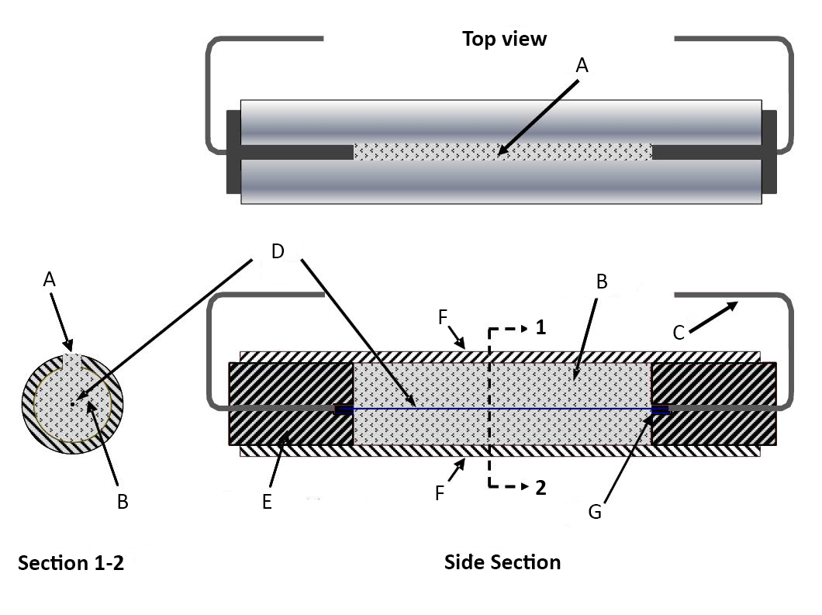

|  |  |  |
| --- | --- | --- |
| (A) Slit  (B) Explosive  (C) Copper conductor | (D) Ni/Cr wire  (E) Rubber plug  (F) Steel pipe | (G) Splice |

**Figure 18.8.1~~6.2.1~~**

**Test cell for Canmet/CERL MBP Test**

**Figure 18.8.2~~6.2.2~~**

**Test cell mounted horizontally under the cover of the pressure vessel (copper conductors connected to vessel’s fixed electrodes)**

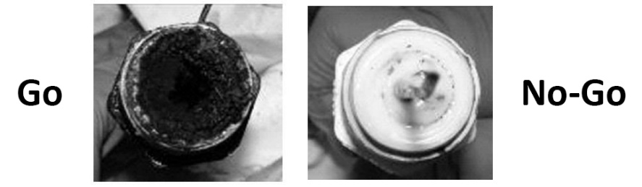

**Figure 18.8.3~~6.2.3~~**

**Typical aspect of the test cell after a ‘go’ (left) and ‘no-go’ (right) event**

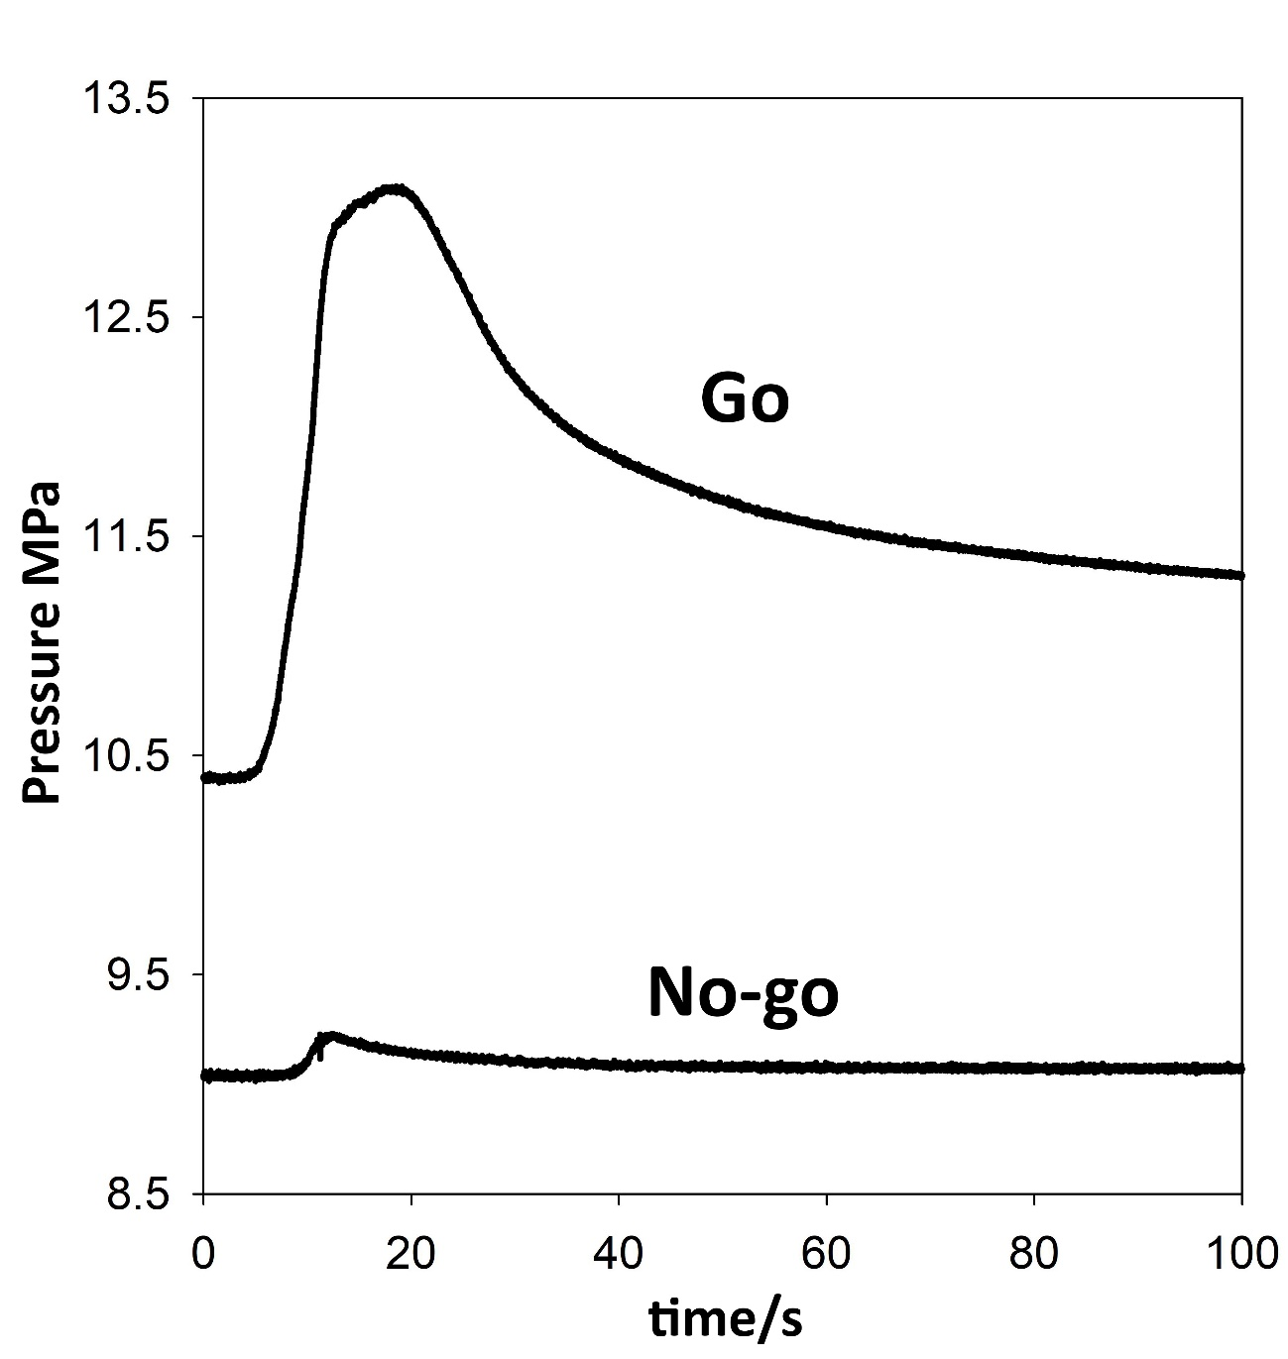**Figure 18.8.4~~6.2.4~~**

**Typical pressure records for ‘Go’ and ‘No-go’ events**

*Source: ST/SG/AC.10/C.3/2018/67 – ST/SG/AC.10/C.4/2018/17, Para. 17(e) as amended by the EWG (Para. 5 of this report).*

**Section 16.5** – Amend 16.5.1.4(c) as shown below

Substances not intended for use as explosives, but provisionally accepted into Class 1, should be tested using whichever initiation system ~~gave a "+" result~~ gave evidence of a mass explosion in a type 6 (a) test.

*Source:* *ST/SG/AC.10/C.3/2018/82**, Para. 4 as amended by the EWG (Para. 9 of this report).*

Annex 4  
Working Group on Explosives (26 – 30 November 2018)  
Changes for the GHS Document (7th Revised Edition)

Notes: Source of proposed change is indicated by *italicized text (Source: XXX)*

~~Red~~ indicates deleted text

Blue indicates inserted text

Green indicates explanatory note for reference only (not part of adopted text)

**Section 2.1.4** – Amend Figure 2.1.4 as shown

**Figure 2.1.4: Procedure for the classification of ammonium nitrate emulsion, suspension or gel (ANE)**



*Source: ST/SG/AC.10/C.3/2018/67 – ST/SG/AC.10/C.4/2018/17, Para. 17(b) as amended by the EWG (Para. 5 of this report).*

Annex 5  
Working Group on Explosives (26 – 30 November 2018)  
Corrections to ST/SG/AC.10/C.3/2018/64, ST/SG/AC.10/C.3/2018/65, and ST/SG/AC.10/C.3/100/Add.1

1. Corrections to ST/SG/AC.10/C.3/2018/64 (Secretariat)
   1. Page 2, Section 51, section 51.4.5.1, delete the open square bracket
   2. Page 2, Appendix 11, delete square brackets
   3. Page 2, Appendix 11, para. 1, delete “UN approved” in the 2nd line referring to fibre board boxes
   4. Page 6, Appendix 11, immediately above “(Reference document …”, delete the close square bracket

*Source: Para. 4 of this report*

1. Corrections to ST/SG/AC.10/C.3/2018/65 (Secretariat)
   1. Page 34, immediately above the table, change the reference to read “Insert a new row under the current row for Test series 7 (~~l~~k)”

*Source: Para. 4 of this report*

1. Corrections to ST/SG/AC.10/C.3/100/Add.1
   1. Annex II, beginning on page 2, items 5, 6, 13, and 17, delete the words “dibutyl phthalate or”

*Source: Para. 4 of this report*

Annex 6  
Working Group on Explosives (26 – 30 November 2018)  
Amendments to ST/SG/AC.10/C.3/2018/61 – ST//SG/AC.10/C.4/2018/15 and ST/SG/AC.10/C.3/2018/88 – ST//SG/AC.10/C.4/2018/26

1. Amendments to ST/SG/AC.10/C.3/2018/61 – ST//SG/AC.10/C.4/2018/15 (EWG Chair)
   1. Page 3, para. 20.2.6, amend the note as shown below:

***NOTE****: If a polymerizing substance meets the criteria for inclusion in transport classes 1 to 8, the SAPT shall be evaluated (e.g., calculated or measured) to determine~~d to evaluate~~ if temperature control is needed (see paragraph 2.4.2.5.2 of the Model Regulations).*

* 1. Page 5, new para. 20.4.1.4, amend the first para. as shown below:

20.4.1.4 The self-accelerating polymerization temperature (SAPT) means the lowest temperature at which self-accelerating polymerization may occur with a substance in the packaging, IBC or portable tank as offered for transport. The SAPT shall~~ould~~ be evaluated (e.g., calculated or measured) to determine~~d in order to decide~~ if a substance should be subjected to temperature control.

* 1. Page 9, paras. 25.4.1.2.2 and 25.4.3.3.1, remove the square brackets

*Source: Para. 17 of this report*

1. Amendments to ST/SG/AC.10/C.3/2018/88 – ST//SG/AC.10/C.4/2018/26 (EWG Chair)
   1. Page 2, para. 28.2.5, amend the note as shown below:

If a substance is being tested to determine whether it is a polymerizing substance, a test of series H, or a suitable alternative ~~test~~ method, should be performed to determine if its SAPT would be less than or equal to 75 °C in its packaging, IBC or portable tank.

*Source: Para. 19 of this report*

1. Pending completion of the review of the MTC in the context of the GHS