UN/SCETDG/53/INF.45

Committee of Experts on the Transport of Dangerous Goods
and on the Globally Harmonized System of Classification
and Labelling of Chemicals 18 June 2018
Sub-Committee of Experts on the
Transport of Dangerous Goods
Fifty-third session

Geneva, 25 June-4 July 2018
Item 4 (f) of the provisional agenda
Electric storage systems: miscellaneous
Sodium-Nickel chloride (Na-NiCl₂)
Transmitted by the expert from Switzerland
Summary
Executive summary: The extensive experience in the technology of Sodium-Nickel Chloride (Na-NiCl2) secondary batteries in electric and hybrid vehicles, in which the safety requirements are more restrictive than those of stationary storage applications, depicts batteries based in the Na-NiCl2 technology as a non-dangerous goods for transport. The risk of ﬁre is negligible because of the intrinsic safety of the cell chemical reactions, related to the sodium-tetrachloroaluminate (NaAlCl4) content into the cell, which acts as a secondary electrolyte (the primary electrolyte being the ceramic β”-alumina electrolyte as common for Na-Beta batteries).
Action to be taken: Exempt the carriage of cells and batteries containing sodium tetrachloroaluminate in a cold state form the Regulations.
Background documents: ST/SG/AC.10/C.3/R.294 (United States of America), ST/SG/AC.10/C.3/2010/30 (United States of America)

Introduction
- Batteries employing elemental sodium afford considerable advantages in certain applications (for example, powering of vehicles) when compared to the more common and conventional battery technologies.
- Two basic sodium battery technologies have emerged thus far, the "sodium/sulphur" battery and the "sodium/metal chloride" battery. While there are differences in these two sodium battery technologies, the basic configuration and operation is similar and batteries employing both technologies are generically described as "sodium/beta" batteries. During the sixth session in July 1992 following the proposal of the United States of America (ST/SG/AC.10/C.3/R.294), the Sub-committee adopted the assignment of a specific UN entry for sodium/beta batteries (UN 3292) with a special provision 239 in chapter 3.3.The proposal however addressed both types of batteries, "sodium/sulphur" battery and the "sodium/metal chloride" and, for purposes of transport, drew no distinction between them. Based in proposals of the United States of America in 1995 other changes in this regulation were introduced for batteries installed in vehicles. Since then batteries installed in vehicles are not subject to the UN Model Regulations (ST/SG/AC.10/R.475). In 2010 based on a proposal of the United States of America (ST/SG/AC.10/C.3/201/30) the UN Model Regulations modified the SP 239 mentioning specifically sodium polysulfides and sodium tetrachloroaluminate. (Amendments to the sixteenth revised edition of the Recommendations on the Transport of Dangerous Goods, Model Regulations (ST/SG/AC.10/1/Rev.16). A detailed information on both art of technologies (Na-S and Na-NiCl₂ cells) is done in the annex to the document ST/SG/AC.10/C.3/2010/30.
- Nowadays however extensive testing and development programme for sodium/beta batteries has been largely completed. Sodium-nickel chloride batteries have been successfully used in electric mobility applications since more than 15 years, always showing top performance about safety. In particular no accident occurred during thousands of carriage in road transports as well as in operation where, despite to the common way of thinking, sodium-nickel chloride batteries have never developed flames. The features of this technology can also prove to be very interesting in critical backup power telecom applications (UPS) and energy storage for on/off grid application. For these reasons during the past 7 years the product has been introduced to serve more different users.
History
- Below a brief history of the development of Sodium Nickel chloride technology:
1966 - Two US researchers working for Ford Motor Company— Neil Weber and Joe Kummer — had demonstrated a major “breakthrough in developing a feasible power source for electric vehicles”. The heart of the new system, the Sodium Sulfur Battery, is a Ford developed crystalline ceramic electrolyte composed largely of aluminum oxide and based on a material known as beta-alumina”.
1967 – British Rail (BR) were interested in developing a new battery, for powering locomotives, the sodium sulfur. During the next 15 years at the British Rail Technical Centre in London Road, Derby, started to work at the development and production of beta alumina, cells and batteries. During this time BR built several batteries but never got to the point of installing them in locomotives. One major problem that had to be overcome was to make the sodium sulfur battery safe enough to use in mobile applications.
1981- The project at British Rail closed down
1982 - Anglo American signed an agreement with BR to do a contract research on a new battery, the Sodium/metal chloride battery and formed Beta Research & Development Ltd.
The new battery had few advantages compared with Sodium Sulfur Battery:
- Higher cell open circuit voltage (2.59V; 2.076 for sodium/sulfur)
- Wider operating temperature range (245°C – 350°C)
- Safer product of reaction. The exothermic heats of reaction are lower and the vapour pressure of the reactants less than atmospheric up to a temperature level of 900°C
- Less metallic components corrosion. The chemistry of the positive electrode is non-aggressive compared to molten Na2Sx
- Assembly in the fully discharged state without the handling of metallic sodium
- Reliable failure mode. If the ceramic electrolyte fails, sodium will react with the secondary electrolyte to short circuit the cell
- Easier reclamation
1984- Zebra Power Systems (ZPS) was formed in South Africa from the Council for Scientific and Industrial Research team (CSIR). A multi-kWh sodium/metal chloride battery, also known as ZEBRA battery, was tested in a vehicle.
1989 - Anglo American Corporation formed a joint venture company with AEG with the aim of industrializing the Zebra battery. At that time AEG was being absorbed into Daimler-Benz who evaluated the battery for electric vehicle applications.
Between 1990 and 1995 Daimler-Benz’s fleet of Mercedes cars, using Na/NiCl2 slim line cells, totted up some 100,000km of road testing. During this time, energy and power was improved and pilot lines went into operation in the UK and Germany.
1993- On the basis of a proposal of the United States of America (ST/SG/AC.10/C.3/R.294) the UN Model Regulations introduced a new entry UN 3292 for this type of cells and batteries together with a special provision 239 (ST/SG/AC.10/R.342 and ST/SG/AC,10/1/Rev.7).
1995- Batteries installed in vehicles are not subject to the UN Regulations (ST/SG/AC.10/R.475 (USA)).
1997- The new one entry UN 3292 appears in RID/ADR.
1998 - AEG Anglo had taken the development of the Zebra battery to the point where it was ready to be put into production.
1999 - A Swiss company called MES-DEA acquired the Zebra technology, including the production and development equipment and Beta R&D Ltd.
2010 – On the basis of a proposal of the United States of America (ST/SG/AC.10/C.3/201/30) the UN Model Regulations modified the SP 239 mentioning specifically sodium polysulfides and sodium tetrachloraluminate. (Amendments to the sixteenth revised edition of the Recommendations on the Transport of Dangerous Goods, Model Regulations (ST/SG/AC.10/1/Rev.16)
2010 - After having developed numerous Sodium-Nickel-Chloride cell prototypes in its laboratories, FIAMM acquired the only manufacturing company of Sodium-Nickel-Chloride batteries in Europe "MES-DEA" founding the FZSONICK SA with the aim of developing and supporting the Sodium-Nickel-Chloride technology "ZEBRA".
2010 - GE Energy Storage invested over £1.7 million ($2.6 million) in Durathon Na/NiCl2 battery research facility in Burton-on-Trent as it expanded its battery technology into new applications.
2015 - General Electric ended Durathon battery manufacturing and engineering operations in Schenectady, New York The energy storage business employed about 450 people.
2017 - Chinese battery maker Chaowei Group has established a Joint Venture (JV) company with General Electric to bring to market a sodium-nickel-chloride battery.
Background: Sodium/metal chloride and sodium/sulphur cells
5. As the original proposal in 1992 demonstrates (ST/SG/AC.10/C.3/R.294), both kind of cells ("sodium/sulphur" battery and the "sodium/metal chloride") are treated in the same special provision 239 assigned to UN 3292. Sodium/metal chloride cells are sometimes regarded as sodium sulfur cells in which the sulfur has been replaced with nickel or iron. This is in some aspects true, but substituting chlorinated nickel or iron in the positive electrode has profound safety impacts. Much of the challenge of creating safe sodium/ sulfur cells derives from the immense need to prevent contact between the sulfur and sodium electrodes, since these substances react violently. The hazards associated with this reaction, and the reactants themselves, are well known. A safe cell is one that under all but the most improbable conditions, did not allow its reactive contents to escape in the event of cell failure or accident. Three general principles for cell safety are mentioned in the literature:
(a) Minimize the quantity of sodium immediately available for reaction after failure of the ceramic electrolyte;
(b) Separate the bulk of cell reactants, and minimize the flow of sodium to the reaction site; and
(c) Protect the outer shell case (for sodium-cored cells) from corrosion by sodium polysulfides,
6. This definition remains valid for sodium/metal chloride cells, but the principles set forth to achieve it do not strongly apply to them since the consequences of failure of the β”-alumina electrolyte in a sodium/metal chloride cell are much less severe than those resulting in cells using sulfur electrodes. Moreover, some of the agents or mechanisms (e.g., corrosion of the cell case by polysulfides) affecting sodium/sulfur cells do not even exist in the sodium/metal chloride system.
7. The purpose of this proposal is that the Experts take account of these safety advantages of the sodium nickel chloride technology and evaluates the possibility to foresee some relaxation of the prescription to the transport of those cells and batteries in the cold state.
Cell basic description
8. Most of the features of Sodium/Nickel chloride (Na/NiCl2) were already explained in 1992 in the proposal of the United States of America proposing the introduction of a specific entry in the UN Regulations for sodium/beta batteries (ST/SG/AC.10/C.3/R.294). Sodium/Nickel chloride cells operate at high temperatures (above 260°C), use a negative electrode composed of liquid metal sodium, and use an ceramic solid electrolyte, that is the Na-β”alumina (Na₂Al₁₁O₁₇), to separate this electrode from the positive electrode. The ceramic electrolyte is an insulator for the electron and has a high sodium ion conductivity at high temperature.
Constitution of a cell

Figure 1: constitution of a cell
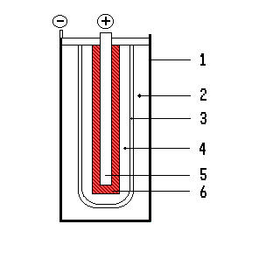

    - steel cell case
    - sodium negative electrode (anode)
    - solid electrolyte solide β-Al2O3
    - liquid electrolyte NaAlCl4
    - metal (Ni) current collector
    - porous M/MCl2 positive electrode (cathode)

Figure 1. Schematic representation of the Na/NiCl2 cell construction
9. The -β”alumina electrolyte serves to physically separate the electrodes, preventing direct chemical reactions between their constituents, but allowing sodium ions to pass. Stability limits and breakdown mechanisms for β”-alumina in sodium/sulfur and Sodium/Nickel chloride cells are essentially the same for the sodium side of the ceramic electrolyte, but very different for the cathode side.
10. Positive electrode is constituted by an insoluble transition metal chloride (some mixture of FeCl₂ and NiCl₂ + minor quantity of other halogenated salts) supported on a sintered nickel metal porous matrix and a secondary electrolyte of molten sodium tetrachloro-aluminate (NaAlCl₄), which serves to conduct sodium ions between this electrode and the surface of the ceramic electrolyte tube.
11. The positive electrode metal chloride phase is fabricated in the discharged state from a mixture of common salt, nickel, iron, and aluminium.
12. The initial charge oxidizes these metals and decomposes the salt to sodium and chloride ions, with the chloride ions combining with the oxidized metals (figure 2).
13. Cell discharging process results in the reverse reaction.
(1)
Figure 2- chemical reaction

14. The tube-like structure ceramic β”alumina serves as a physical separator, preventing direct chemical reactions between the electrode constituents, and as a conductor of sodium ions between the electrodes.
15. The negative electrode consists of sodium generated during the first charge. It is contained between the cell casing and exterior of the β -alumina tube.
16. Every cell is hermetically sealed and tested to ensure the absence of any leakage greater then 1x10E-7 (mbar l/sec).
Composition/information on ingredients of Sodium/Nickel Chloride cell according to different State of Charge (SOC)
17. Each battery is made of single cells; from 88 up to 288 single cells.
18. Each cell has a weight approximately of 0.7kg.
19. As information we mention in the table below the typical composition of Sodium/Nickel Chloride cells. This composition of sodium/nickel chloride cells corresponds the description of sodium/metal chloride batteries envisaged in the two proposals of the United States of America in 1992 where this batteries where introduced in the UN Model Regulations (ST/SG/AC.10/C.3/R.294) and in 2010 (ST/SG/AC.10/C.3/2010/30) where the the mention of sodium tetrachloroaluminate was introduced explicitly in the special provision 239. This means that the presence of other components that the sodium in the batteries (usually Ni or Fe compounds) had already been taken into account by the introduction of the UN No. 3292 in 1992.

Single Cell (ML3X) | CAS | EINECS | Classification | Single Cell
 |  |  |  | 100%SOC* Weight (%) | 0% SOC* Weight (%)
β"-Alumina (Solid Electrolyte) | 12005-48-0 | 234-467-9 | not classified | 17 - 20 | 17 - 20
NaAlCl4 | 7784-16-9 | 232-050-6 | Skin Corr. 1B H314 EUH014 | 17 - 19 | 17 - 19
Ni (powder) | 7440-02-0 | 231-111-4 | Skin Sens. 1 H317  Carc. 2 H351  STOT RE 1 H372  Aquatic Chronic 3 H412 | 14 - 16 | 17 - 19
NaCl | 7647-14-5 | 231-598-3 | Not classified | 0 | 10 - 13
NiCl₂ | 7718-54-9 | 231-743-0 | Acute Tox. 3 H301  Skin Irrit. 2 H315  Skin Sens. 1 H317  Acute Tox. 3 H331  Resp. Sens. 1 H334  Muta. 2 H341  STOT RE 1 H372  Aquatic Acute 1 H400  Aquatic Chronic 1 H410  Carc. 1A H350i  Repr. 1B H360D | 6 - 9 | 0
Na | 7440-23-5 | 231-132-9 | Water-react. 1 H260  Skin Corr. 1B H314  EUH014 | 5 - 7 | 0.5 -1.2
FeCl₂ | 7758-94-3 | 231-843-4 | Met. Corr. 1 H290  Acute Tox. 4 H302  Eye Dam. 1 H318 | 4 - 6 | 0 - 1
Fe | 7439-89-6 | 231-096-4 | Not classified | 0 | 1 - 3
FeS | 1317-37-9 | 215-268-6 | Not classified | 0.5 – 0.7 | 0.5 – 0.7
NaF | 7681-49-4 | 231-667-8 | Acute Tox. 3 H301  Skin Irrit. 2 H315  Eye Irrit. 2 H319  EUH032 | 0.5 – 0.7 | 0.5 – 0.7
NaI | 7681-82-5 | 231-679-3 | Skin Irrit. 2 H315  Eye Irrit. 2 H319  Aquatic Acute 1 H400 | 0.1 – 0.2 | 0.1 – 0.2
Battery description
20. A battery module is made of a series or parallel connection of sodium-nickel cells to reach the design voltage and capacity. Typical battery assemblies reaches 300-650 Volts for mobile applications or 48-650 Volts for stand-by power requirements.
21. Sodium Nickel chloride battery cells are housed within a temperature-controlled, stainless steel double-walled with micro porous silica to thermal insulate the cell. The housing does not include any combustible materials. This battery case or enclosure is intended to protect internal battery components from hazards outside. Every battery is equipped with a Battery Management System (BMS) that controls main battery parameters. Inside the battery case there are some electrical heaters to warm up the battery from the room temperature to the operating temperature (>260°C). Only after the warm up that usually takes 12 hours the battery can be operated.

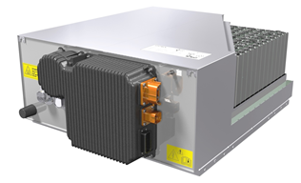
Figure 3 - NaNiCl2 battery
“Cold” cell
22. The sodium nickel chloride cell can only work at high temperature for three main reason:
- The sodium at the anode needs to be in liquid state. The melting point of the sodium is 98°C.
- The secondary electrolyte NaAlCl₄ in the cathode has to be in the liquid state. The melting point of the NaAlCl4 is 156.7°C.
- The conductivity of beta-alumina increase with the increase of the temperature according to the Arrenhius law.
23. Below 98 °C the cathode, the anode and the electrolyte are in the solid state and exhibit a really high resistance so that any charge transfer and ion conduction in the cell is prevented and the cell can be considered in the cold state.
24. All the component are solids preventing any possibility of chemical reaction or spillage in case of crash or incident. The battery do not contain any organic solvent. In such condition just a very small current can flow in the battery due to the high internal resistance of the cells (see graph below) at ambient temperature. There is no electrical risk (according to IEC/TS 60479-1 and IEC/TS 60479-5) below 90°C because the short circuit current is below 10 mA.
25. Since there is no possibility of any current to circulate through the cell at room temperature the sodium nickel chloride battery can be considered a non-battery.
26. For this reason all the danger related to the transportation of batteries cannot be considered

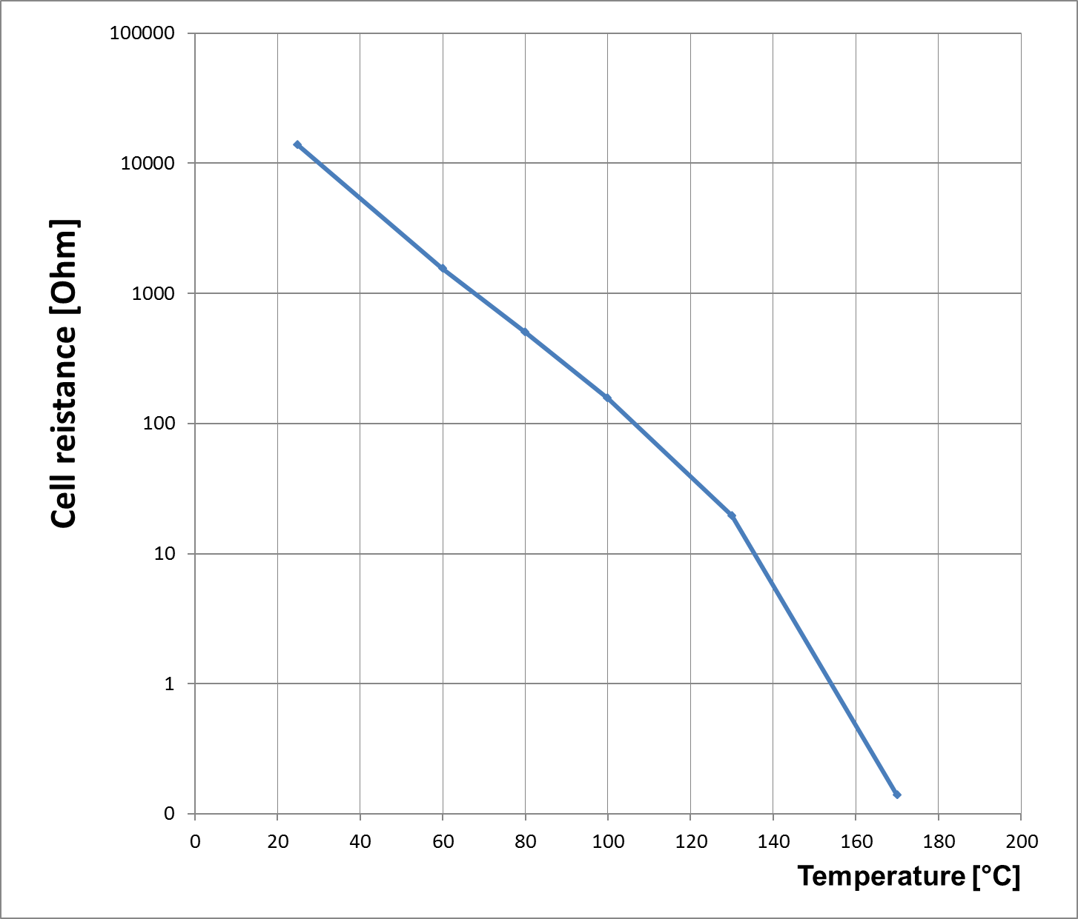

Figure 4 Cell Resistance vs Temperature
Market overview and application
27. In 2017, 60-70% of the total production of sodium nickel chloride batteries was employed for back-up power applications mostly in the telecom sector, but also to provide emergency back-up power for utilities, trains, etc. This sector is growing rapidly with an increasing annual growth rate due to the large global infrastructure investments required to match the ever increasing data traffic (+13% predicted globally in 2018 compared to 2017 and +77% predicted in 2021 compared to 2017 according to a study by Market Vision). A key advantage of the sodium nickel chloride batteries in this sector is their long shelf life without any degradation of the state of charge (no parasitic reaction in cold state), but also their high operational safety qualifying them for operation even in classified locations where explosive gases may be present. As no external temperature control is required, the battery offers lower cost of ownership compared to alternative battery technologies both in indoor as well as outdoor applications (i.e. telecom antenna tower in hot or cold weather). A stumbling block to the diffusion of Na-NiCl batteries in many developing countries (on top of the mentioned USA) is represented by the actual classification that require to be managed by trained employees and doesn’t facilitate the distribution on the territory.
28. Electric vehicles constitute a second important market segment for sodium nickel chloride batteries (20-30% in 2017). Their charge/discharge rate capabilities renders sodium nickel chloride batteries particularly well suited for electric light duty vehicles, fully electric buses, and special purpose vehicles requiring high safety (school buses, tunneling and mining machines, etc.). Currently the customer are placed both in Europe as well as in USA and for this reason less stringent prescriptions for the shipment and the "end of life" collecting of the battery would significantly benefit the market.
29. The stationary electricity storage market still represents an emerging market segment with a massive growth potential.
30. Applications can be divided into decentralized stationary systems that increase self-consumption, self-reliance, or decrease monthly maximum power consumption, etc. and stationary systems providing control services to transmission system operators. Market is currently dominated by early adopters that more and more often install a battery in combination with a photovoltaic system. Demand is not limited by technological limitations, but by economic considerations, but expected to gain substantial momentum in the coming years. Market development also depends on political decisions, e.g. incentive program for coupled photovoltaic + battery systems in Germany.
31. Currently, the only producer of sodium nickel chloride batteries in the world is FZSonick in Stabio, Switzerland. Several other players such as Battery Consult GmbH in Meiringen, Switzerland, Fraunhofer Institute for Ceramic Technologies and Systems (IKTS) in Hermsdorf, Germany, are actively looking for investors to ramp up production in Germany. Chinese battery manufacturer Chaowei Group recently acquired the IP portfolio of General Electrics and plans production in China. The Korean Posco Group is financing research projects in Korea and the USA
32. Active industries in this sector are T-Mobile, AT&T, Century link, Bombardier, etc.
Importance of this technology
33. The production of sodium nickel chloride cells will be increased from 815’000 in 2017 to 2’129’000 cells in 2021 to meet demand. At the same time, the number of employees is foreseen to grow.
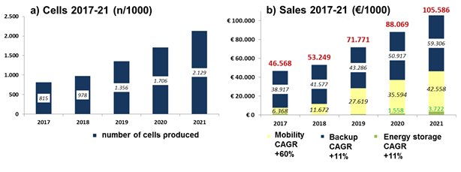Figure 5- Development of a) number of cells produced, b) sales (total and share of the different application fields: mobility (yellow), energy backup (dark blue), and energy storage (green)
Additional safety consideration during operation
34. Even if the following dangers will not appear in case of transports of “cold” batteries it is worth to consider them in order to distinguish the two kind of batteries included in the UN 3292
35. In the case of β”-alumina fracture, the anode material (liquid sodium), being of low viscosity, flows readily through the cracks into the positive electrode chamber, and into contact with the molten electrolyte (sodium tetrachloroaluminate). The sodium reacts primarily with the molten electrolyte, as opposed to the positive electrode material (nickel and iron, or chlorinated nickel and iron) as would be the case in a sodium/sulfur cell. The key element in the intrinsic safety of Na-NiCl2 technology is the presence of a secondary electrolyte in form of liquid salt, sodium-tetrachloroaluminate (NaAlCl4), added to the cathode compartment. This represents one of the major differences with the sodium-sulphur technology. The melting point of NaAlCl4 is 158 oC, corresponding to the theoretical minimum operating temperature of the cell. The molten NaAlCl4 dissociation involves the Na+ ions and AlCl₄⁻ ones conduction between the β”-alumina internal surface and the reaction zone of the NiCl2 porous cathode. In normal working condition, the secondary electrolyte does not participate to the charge/discharge reactions, but it has a key role in the most likely failure mode of sodium cells, which is the β”-alumina breaking. In this situation, if the cell is based on Na-S technology, sulphur gets in contact with sodium (even if the safety tube presence reduces this interaction). On the contrary, in NaNiCl2 cells, the presence of the secondary electrolyte (NaAlCl4) chemical reactions themselves reduces the effects of the exothermic re actions, which could be potentially dangerous. In fact, the secondary electrolyte reacts with the sodium and the products are sodium chloride and metallic aluminium through the following reaction. The reaction is (2):
(2) 3Na + NaAlCl4 -> 4NaCl + Al
36. This reaction is mildly exothermic, releasing about two-thirds of the energy of the normal electrode reaction, and produces solid, nonhazardous, noncorrosive products with low vapor pressures.
37. With regard to the sodium leakage from the cell to the external environment given by a strong external shock, it is worth noting that, in this occurrence, the β”-alumina would also break as well. Therefore the chemical reaction (2) excludes the sodium contact with the external environment that would have a theoretic speciﬁc energy equal to 3883 Wh/kg, through the reaction (3):
(3) 4Na + O24 -> 2 Na₂O
38. The fact that there are no concerns on the safety of this technology is demonstrated by the fact that this batteries with sodium/nickel chloride are used in military and civilians submarines Moreover, before the battery initial charge operations, there is no metallic sodium inside the cell because it is present in the form of sodium chloride in the cathode zone, whereas the anode zone is empty. The anode material, that is the metallic sodium, is produced during the ﬁrst charge operation. This means that new that sodium/nickel chloride cells and batteries do not even content sodium or only very fee contents after first tests. This again is a relevant difference between Na-S and Na-NiCl² technology.
39. It is worth noting that differently from Na-S technology, Na-NiCl2 batteries are not affected by repeated freeze-thaw cycles because of the moderate differences between the thermal expansion coefﬁcients of the ceramic separator, and the other battery components.
40. Furthermore, for the sodium metal chloride cell, the mechanical construction is very similar to the sodium sulphur cell, but the chemistry differs. The sodium metal chloride cell behaves as follows: A newly built cell begins in the fully discharged state, in contrast with the initially charged sodium sulphur cell. This means that the negative electrode of the Na-NiCl₂ cell compartment is completely empty of elemental sodium and the positive compartment is full of a non-flammable intimate mixture of a metal powder, sodium chloride (table salt) and sodium tetrachloroaluminate (see below). At room temperature (25°C) all components of the cell are solid. As the sodium metal chloride cell is heated, the sodium tetrachloroaluminate melts at 156°C but the remaining components remain solid. At this point there is still no sustainable voltage on the cell terminals. The sodium metal chloride cell cannot be practically used, however, until a temperature of at least 250°C is obtained, at which point the cell can be charged. In this process, the metal and sodium chloride are converted into metal chloride and elemental sodium and the sodium is transferred electrochemically through the solid beta alumina electrolyte to fill the negative electrode compartment. When fully charged, the negative compartment is partially full of sodium and the positive electrode comprises mainly metal chloride.
41. The following features have to be considered:
(a) Sodium Sulfur Cells are assembled in the Charge State and shipped in the charge state so with the maximum amount of Sodium in the anode;
(b) Sodium Nickel Chloride cells are assembled in the discharged state with no sodium on the anode. After the assembling the cell in battery are charged and discharged to test it before the shipping. During the shipment the cell are in discharged state with few grams of sodium. After the first charge the cell never have 0 g. of sodium in the anode during the life a small amount of sodium is always in the anode even in the discharged state. The amount of sodium in the discharged state is around 7 g (1% of the cell weight) while in the charged state is 40 g (6% of the cell weight).
42. Sodium Nickel Chloride cell typically operate above 260°C but are active above 156°C temperature at which the NaAlCl4 melt. In the range between 156°C and 260°C the resistance is considered too high to operate the cell with profit.
43. Furthermore the Sodium Nickel Chloride cell have been subject to tests. Following list of typical tests and results demonstrate the high safety level of this kind of cells:
44. Example of tests performed in industries show following results:
Test | Results | Battery/Cell Status
1,8 m cell drop | Minor scratches on side and bottom cell | Cold
10m Crated Battery Drop | • Shipping crate damaged.  • Battery dented.  • External battery case did not rupture. | Cold
10m Cold Battery Drop | • Battery dented.  • External battery case did not rupture. | Cold
10m Hot Battery Drop | • Battery dented.  • External battery case did not rupture. | Cold
6’10” Drop onto BMS, Hot, fully operational | • Significant mechanical damage.  • No fire.  • No explosion. | Hot
Overcharge Event  Exposed to 145% of nominal battery voltage for 1 h | • Battery resisted overcharge conditions  • No negative impact demonstrated | Hot
1.8m Battery Drop on concrete floor  rack’s top shelf | • Minor mechanical damage.  • No rise in surface temp.  • No fire or explosion. | Hot
Rod Penetration on hot, fully charged battery | • Observation period lasted 4 hours.  • External reaction noted after 23 minutes.  • Exposure produced water, steam and some smoke containing HCl. | Hot
Saltwater Exposure on hot, fully operational battery | • No fire.  • No explosion | Hot
Bullet Impact on hot, fully operational battery | • Shotgun fire did not penetrate battery case.  • Bullet penetration resulted in minor smoke.  • No uncontrolled fire or explosion. | Hot
Fire Exposure with Hose Down with hot, fully charged battery | • Mechanical weakening.  • Case did not rupture.  • No explosion. | Hot
45. These results could be summarized by saying that the Sodium Nickel Chloride batteries tested are highly rugged batteries. Even hot batteries tend to fail safely when exposed to extremely abusive conditions.
Sodium quantity in case of transport of “cold” batteries
46. Sodium is generated during the first charge at the final acceptance test.
47. The amount of sodium present at the anode during normal operation of the battery depend on the state of charge (SOC) of the cell. In a discharged cell, 0% SOC, about 8Ah of capacity are still present which corresponds to about 7 g of sodium (1% of the total weight of the cell), with a fully charged cell the amount of sodium is about 39g (6% of the total weight of the cell).
48. The sodium negative electrode is closed in a cell stainless steel case and the cell is closed in a stainless steel double-walled box with micro porous silica between the two walls.
49. It is really unlikely the perforation of the double wall box (External thickness 1 - 0.8mm; internal thickness 0.4mm) and the damage of the cell case (Thickness 0.4mm).
How would a “cold” battery contribute to the severity of the event in the event of a fire in transport?
50. Sodium/Nickel Chloride batteries operate at high temperature (250-350°C) and for this reason the cell pack is thermal insulated with a microporous silicate insulation material with a thickness, depending on the type of battery, from 25 to 50mm. The material is not inflammable (Class A1 DIN 4102-1) and can withstand to high temperature. The insulation material prevent battery also from the external temperature.
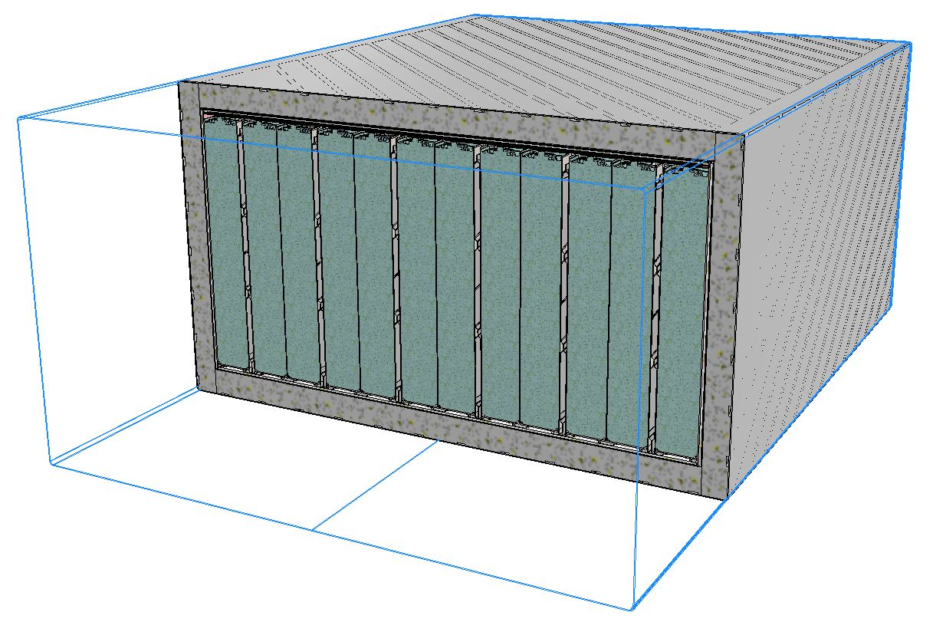
Figure 6: battery cross section: double wall battery case with insulation material in between and cell inside
51. Tests have been performed considering the worst case scenario that is a fire on “hot” batteries.
52. Test performed at MIRA (The Motor Industry Research Association) in 08/20/1992 have demonstrated that a hot battery (Internal temperature 250C°) can be exposed at a petrol fire for 30 minute without any damage of the cell pack.
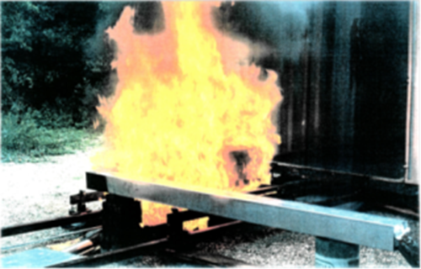
Figure 7 Petrol fire test performed at MIRA

53. Another test has been performed in 2016 from SGS (Société Générale de Surveillance) according to UNECE Regulation No. 100.2 without any damage of the battery.
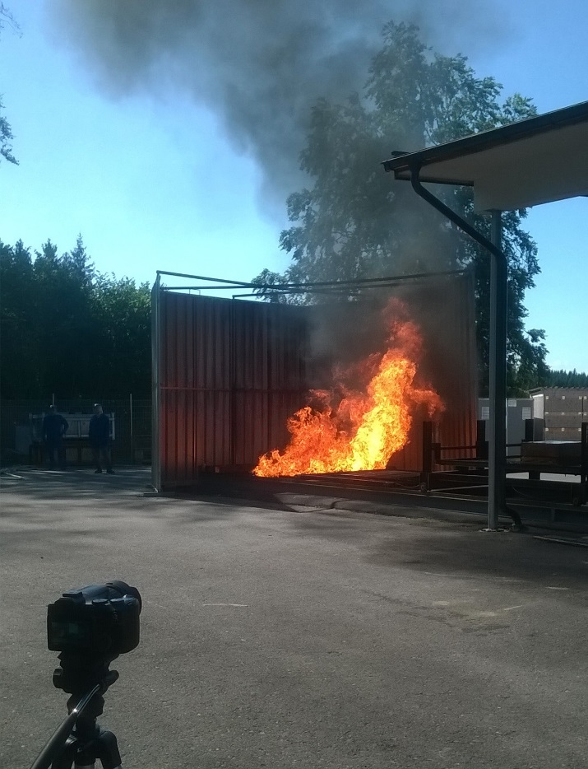
Figure 8- Petrol fire test performed at SGS
54. This demonstrates that the “cold” or “hot” Na-NiCl₂ batteries do not contribute to increase the severity of an incident.
Proposal
55. Based on the mentioned long experience, the characteristics of the cold battery described above and the test done in the recent past it is proposed to review the current classification of Sodium - Metal Chloride battery (UN3292, last discussed document: ST/SG/AC.10/C.3/2010/30) in order to apply less restrictive transportation conditions than those required by the current classification.
56. Add the following sentence at the end of special provision 239:
“Cells and batteries containing sodium tetrachloroaluminate when carried in cold state below 98°C are not subject to these Regulations”.

