UN/SCETDG/53/INF.43

Committee of Experts on the Transport of Dangerous Goods
and on the Globally Harmonized System of Classification
and Labelling of Chemicals 18 June 2018
Sub-Committee of Experts on the Transport of Dangerous Goods
Fifty-third session

Geneva, 25 June-4 July 2018
Item 2 (j) of the provisional agenda
Explosives and related matters: miscellaneous
A method for transporting controlled shipments of explosives that are not classified (≤ 25 grams)
Transmitted by the Sporting Arms and Ammunition Manufacturers’ Institute (SAAMI)
Introduction
- This informal paper is supplemental to working paper ST/SG/AC.10/C.3/2018/53. This paper provides the proposals for including this special shipping container and the associated provisions/specifications into the various applicable sections of the UN Model Regulations. All recommendations previously offered by the Explosives Working Group are addressed in this proposal.
Proposal
- Modify 2.1.3.4 “Assignment to hazard division” to include a new paragraph at the end:
“2.1.3.4.4 The competent authority may waive the tests for small amounts of explosives not exceeding 25 grams PETN or equivalent energy, and assign them to UN XXXX for solids or UN YYYY for liquids. The competent authority approval is based on the specialized packing instruction PXXX or PYYY and is not specific to the type of explosive.”
- Create two new UN Numbers:
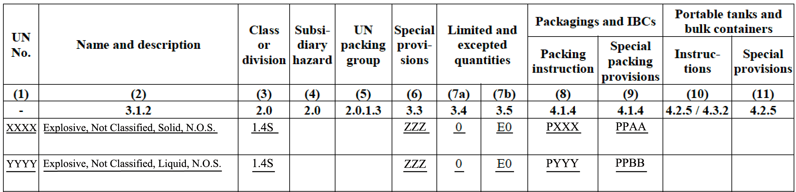
4. Create a new special provision ZZZ: “This designation shall only be used with the approval of the competent authority of the country of origin.”

5. Create the following packing instruction PXXX for UN XXXX:
PXXX Packing instruction PXXX
The following packagings are authorized, provided that the general packing provision of 4.1.1, 4.1.3, and special packing provisions of 4.1.5 are met:
Inner Packagings | Intermediate Packagings | Outer Packagings
Receptacles  Plastics | Schedule 80 seamless  steel pipe nipple (per  ASTM A106 Grade B)  closed at both ends with  forged steel end caps  (3,000 psi per ASTM A105) | Boxes  Steel (4A)  Aluminum (4B)  Natural wood, ordinary (4C1)  Plywood (4D)  Reconstituted wood (4F)  Fibreboard (4G)  Drums  Steel (1A1, 1A2)  Aluminum (1B1, 1B3)
Special packing provisions:
AA For UN XXXX
- Include the following inner packagings:
(a) Design Type 1: A 4-inch (10.16 cm) diameter x 14-inch (35.56 cm) long Schedule 80 seamless steel pipe nipple (per ASTM A106 Grade B) closed at both ends with 4-inch (10.16 cm) diameter forged steel end caps (3,000 psi (2.07 x 10⁷ Pa) per ASTM A105); or
(b) Design Type 2: A 6-inch (15.24 cm) diameter x 12 to 14-inch (30.48 to 35.56 cm) long Schedule 80 seamless steel pipe nipple (per ASTM A106 Grade B) closed at both ends with 6-inch (15.24 cm) diameter forged steel end caps (3,000 psi (2.07 x 10⁷ Pa) per ASTM A105):
or
- The explosive is sealed in a bag or other leak-proof receptacle and centered inside the container using packaging materials (which are comparable with the explosive) or other designed packaging so as to not be next to the walls or caps.
- The container is then placed in an outer package comprised of fiberboard, plywood, or metal. The outer package is to facilitate handling and has no bearing on the containment of an explosive event in the container.
6. Include the following packing instruction PYYY for UN YYYY
PYYY Packing instruction PYYY
The following packagings are authorized, provided that the general packing provision of 4.1.1, 4.1.3, and special packing provisions of 4.1.5 are met:
Inner Packagings | Intermediate Packagings | Outer Packagings
Receptacles  Plastics  Hard rubber  Glass | Not less than 4-inch (10.16 cm) diameter flanged Schedule 80 seamless carbon steel pipe section  not less than 15 inches (38.1 cm) in  length, capped on both  ends with 8-bolt 150 psi  ANSI B 16.5, ASTM A105  flange plates which are  sealed with high  temperature resistant  graphite gaskets, each  containing one  intermediate packaging. | Boxes  Steel (4A)  Aluminum (4B)  Natural wood, ordinary (4C1)  Plywood (4D)  Reconstituted wood (4F)  Fibreboard (4G)  Drums  Steel (1A1, 1A2)  Aluminum (1B1, 1B3)
Special packing provisions:
BB For UN YYYY:
- Put the receptacle (sealed with a suitable method of closure containing the liquid explosive in a plastic, wide mouth bottle which is centered inside the container using packaging materials or other designed packaging so as to not be next to the walls or caps.
- The packaging (e.g., sawdust, vermiculite or cellulosic materials) surrounding the wide mouth bottle should be compatible with the explosive and provide sufficient cushioning material to absorb all free liquid in the inner packaging.
- The container is then placed in an outer package comprised of fiberboard, plywood, or metal. The outer package is to facilitate handling and has no bearing on the containment of an explosive event in the container.

